

NATURAL HAZARD MITIGATION
POLICY AND PLAN FOR
THE FEDERATION OF ST.KITTS AND NEVIS

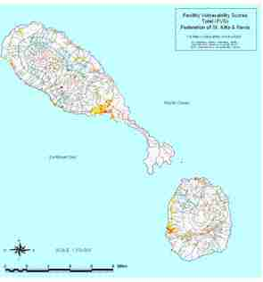

POST-GEORGES DISASTER MITIGATION PROGRAMME
GUIDANCE COMMITTEE

PREPARED BY: EUPHEMIA BRICE ROBERTS

JULY 2001

