Home Affairs Ministry receives equipment from OAS to boost crime fighting

Written by
Tuesday, 16 August 2011 01:45
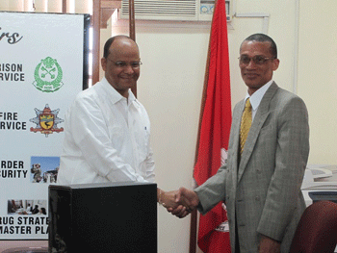
-as part of cooperation agreement
The Home Affairs Ministry yesterday received several pieces of hardware and software equipment from Country Representative of the Organisation of American States (OAS), Dennis Moses, as part of the cooperation agreement signed between the two parties in June. The agreement is one of OAS’ projects funded by the Canadian Government to assist Caribbean nations in strengthening, establishing, and implementing policies to fight crime and violence.
Minister of Home Affairs, Clement Rohee, in accepting the equipment, said that its presentation brings the ministry a step closer to the realisation of the establishment of the Public Security Observatory, which will complement the work of the Crime and Social Observatory, established under the Inter-American Development Bank (IDB) funded Citizens Security Programme.
Expressing his appreciation, he said that both projects show the interest which the donor community and multilateral organisations (financial and political) have with regard to security-related matters of the member states.
The project is aimed at gathering and accepting information on public security in Guyana. The next step will see the Ministry of Home Affairs, in collaboration with the OAS, procuring the services of a public security data coordinator, who will man the project at the ministry to ensure that the relevant data is collected and could be readily accessed for use by law enforcement agencies.
“We need to see this project as part of the improvement in the architecture of Guyana, particularly with respect to public safety and security. This project ought not to be seen in isolation, but as part and parcel of government’s move to bring a greater sense of structure to local law enforcement agencies,” Minister Rohee said.
Government, through the Home Affairs Ministry, has instituted several innovative measures to ensure greater safety and security. These include comprehensive pieces of anti-crime laws, reforms within the Guyana Police Force and the Home Affairs Ministry, and installation of CCTV cameras, among others.
Moses said that this initiative is a fulfilment of one of the mandates of the OAS, and that the organization is particularly happy to collaborate with the ministry in this important area of work.
“Our hope is that this equipment and the effort of the ministry will go somewhere in fulfilling the objectives set out in the project, and we look forward to more joint endeavours of this nature in the not too distant future,” the Country Representative said.
This project is a realisation of a 2008 Mexico meeting which saw the heads of security bodies across the region coming together. It will also help in the capacity building of the ministry and will support other programmes, such as the Citizen Security Programme, in fulfilling its mandate. (GINA)

