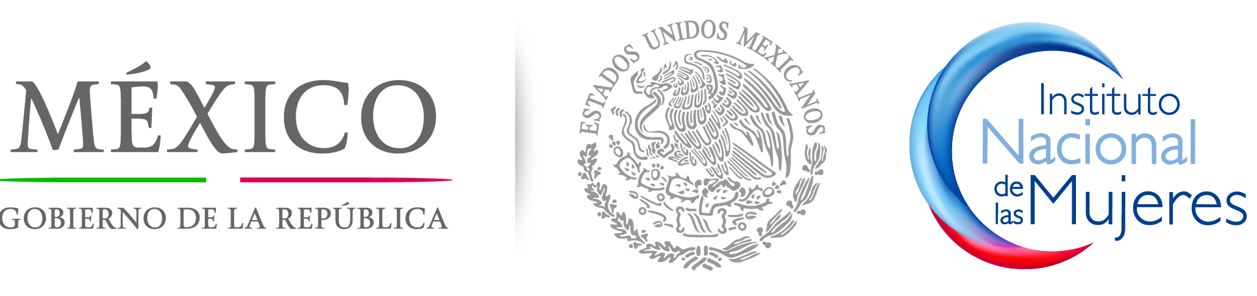
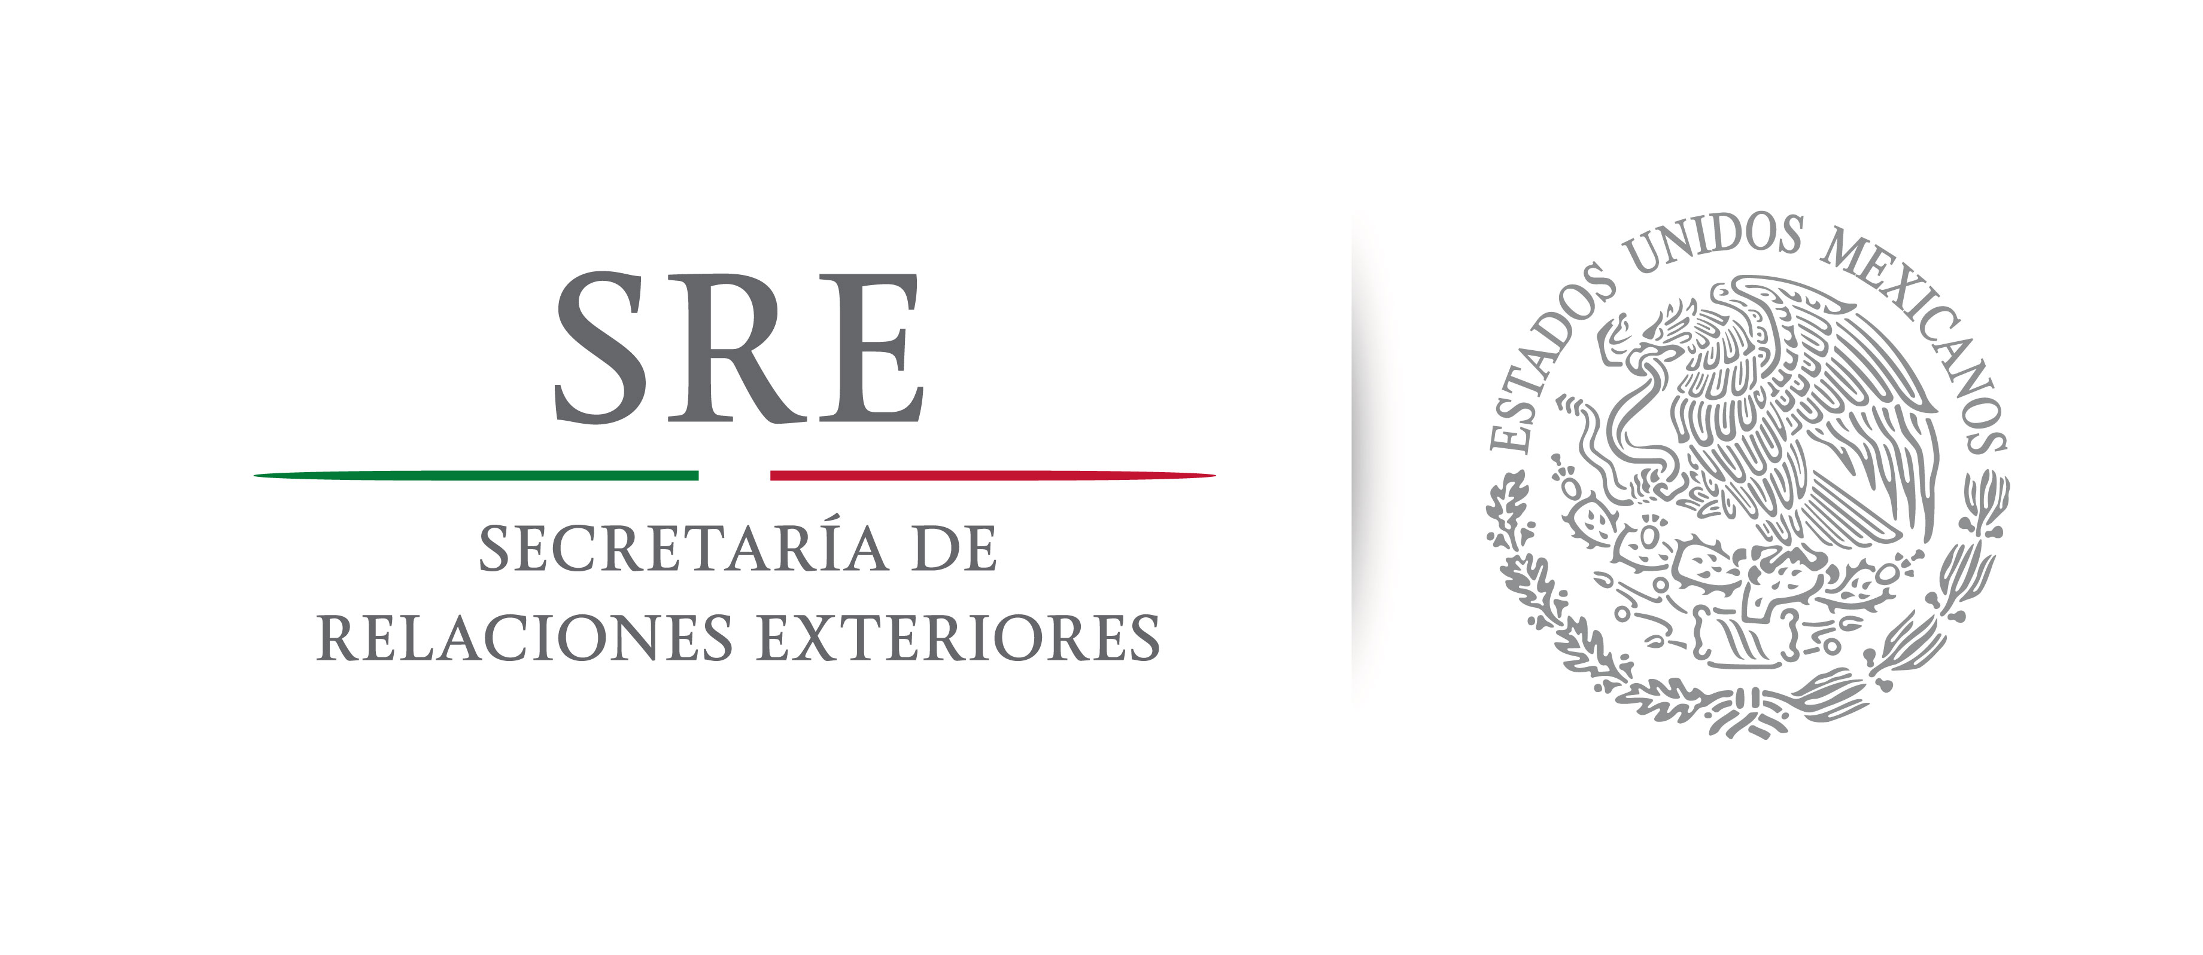


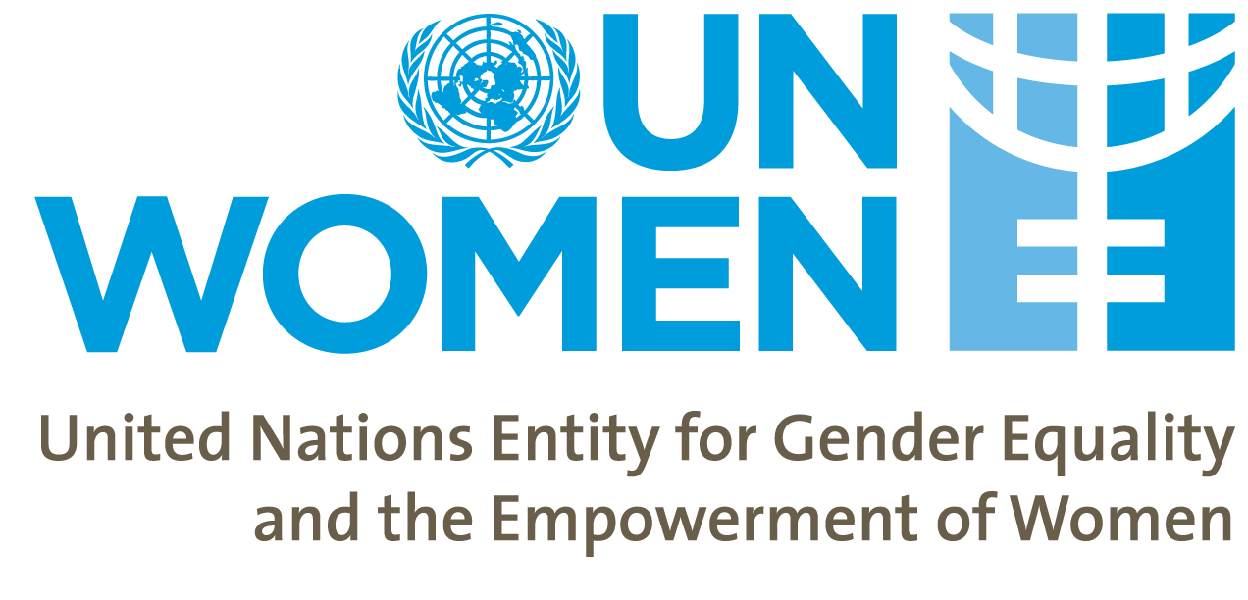
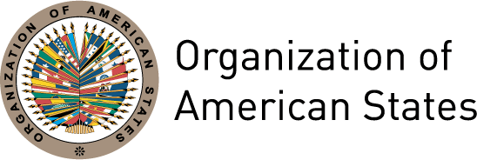
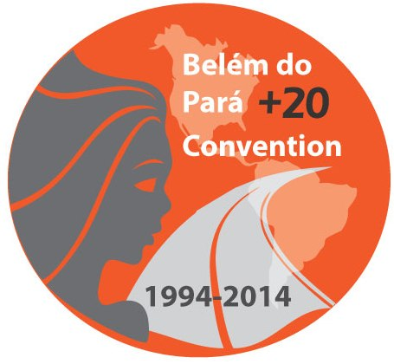

The Belém do Pará Convention and the Prevention of Violence against Women: Good practices and proposals for the future

May 14th to 16th 2014
Pachuca, Hidalgo

Violence against women is an offense to human dignity and a violation of human rights; it undermines development, generates social instability and impedes progress towards justice and peace. The different forms of violence against women are an obstacle to their individual development, weakens the exercise of their rights and freedoms, blocks the full development of their capacities and autonomy and limits their public, economic, social and political participation.

For the first time, the Inter-American Convention on the Prevention, Punishment and Eradication of Violence against Women (Belém do Pará Convention) established the right of women to be free from violence in both the public and private spheres. This historic agreement – until recently the only international legal instrument that specifically addresses the issue of violence against women – together with the Convention on the Elimination of all Forms of Discrimination against Women (CEDAW) and other pertinent instruments, has provided the basis for the adoption of laws and policies to combat discrimination and violence against women in the States of the region, as well as a policy and strategic framework for their implementation.

Over the last two decades, the Convention has spurred a new generation of integrated laws and, in this context, the establishment of legal standards at the national, regional and international levels, the formulation of public policies and national plans, the organization of information and awareness-raising campaigns, the development of specialized legal, care and support services, as well as countless other initiatives and activities.

The Belém do Pará Convention however remains an unfulfilled promise – and violence continues to be a daily reality for women in the Americas. This violence against women and girls reflects the persistence of unequal power relations and structural inequalities that are based on sex and gender, as well as multiple factors that expose women to other forms of discrimination besides that which is based on sex – such as ethnic, socio-economic, and age, among others.

Of the areas of work that are touched on by the Convention, it is in the area of prevention that we have made the least progress in terms of the goals that have been set. An effective violence prevention strategy includes, but also goes far beyond the formulation of laws, the increase of sentences and the training of justice officials, to encompass holistic efforts with the education and communications sectors to address and eliminate the gender-based prejudices and stereotypes that underlie inequality, discrimination and violence.

In this context, this Hemispheric Forum seeks to identify the advances – lessons learned, promising practices and experiences – and the persistent challenges to the effective prevention of violence from the key perspectives of education and communication, with a view to establishing concrete policy and program recommendations to strengthen work in this area at the national and regional levels

Draft agenda

Wednesday May 14th 2014

8:00-9:00 Registration

9:00-10:30 Inauguration

Moderator: President of the Inter-American Commission of Women (CIM), OAS
- José Francisco Olvera Ruiz, Governor of the State of Hidalgo
- José Miguel Insulza, Secretary General of the Organization of American States
- Rebecca Grynspan, Executive Secretary of the Ibero-American General Secretariat (SEGIB)
- Isabel Crowley UNICEF Representative in Mexico
- Moni Pizani, Regional Director for the Americas and the Caribbean, UN Women
- Lorena Cruz, President of the National Institute of Women (INMUJERES)
- Diva Hadamira Gastelúm, Senator
- Lía Limón, Under-Secretary for Legal and Human Rights Affairs, Department of the Interior of Mexico
- José Antonio Meade Kuribreña, Secretary of Foreign Affairs

10:30-11:30 Situation analysis: Violence against Women in the Americas

Davos-style moderated debate

Moderator: Lía Limón, Under-Secretary for Legal and Human Rights Affairs, Department of the Interior of Mexico
- Flor María Díaz Chalarca, President of the Committee of Experts of the Follow-up Mechanism to the Belém do Pará Convention (MESECVI), OAS
- Alessandra Guedes, Regional Advisor on Intra-family Violence, Pan American Health Organization (PAHO)
- Luz Angela Melo, Regional Gender Advisor, UNICEF
- Erika Rodríguez Hernández, Director of the Institute of Women of Hidalgo
- Nuvia Mayorga Delgado, Head of the National Commission for the Development of Indigenous Peoples

11:30-12:00 Plenary debate

12:00-13:00 Opportunities and challenges to prevention

Davos-style moderated debate

Moderator: Rebecca Grynspan, Executive Secretary of the Ibero-American General Secretariat (SEGIB)
- Barbara Evelyn Bailey, Expert of the CEDAW and MESECVI Committees
- Paloma Soria, Attorney, Women’s Link Worldwide
- Camille Morvan, Senior Academic Consultant, MOUSEION
- José Manuel Azpiroz Bravo, Deputy Director General, Under-secretariat for Prevention and Citizen Participation, Department of the Interior

13:00-13:30 Plenary debate

13:30-14:30 Lunch

14:30-15:30 Panel on “Promising practices in prevention: A view from the international level”

Moderator: María del Carmen Alanís Figueroa, Magistrate of the Federal Electoral Tribunal of Mexico
- “The International Violence against Women Act” (I-VAWA)
Esta Soler, President of Futures without Violence
- “Promising practices in prevention from the regional and national levels”
Adriana Quiñones, Regional Advisor for the Elimination of Violence Against Women, UN Women
- “The role of media in preventing and combating violence against women”
Carolina Lasen Diaz, Programme Officer, Gender Equality Unit, Directorate General for Democracy, Council of Europe
- “Indigenous Women's Watch against Violence”
Otilia Lux de Cotí, Executive Director, International Indigenous Women’s Forum

15:30-16:00 Plenary debate

16:00-17:00 Panel on “Promising practices in prevention from the national level: integrated laws and their application”

Moderator: Emma Saldaña Lobera, Director of the Institute of Women of Chihuahua
- Brazil: “Application of the Ley María da Penha and the perspective of neutrality”
Aparecida Gonçalves, National Secretary for Confronting Violence against Women, Secretariat for Policies on Women
- Bolivia: “Application of the Ley integral para garantizar a las mujeres el respeto, una vida digna y libre de violencia and the perspective of inter-culturalism”
Sandra Gutiérrez, Minister of Justice
- El Salvador: “Application of the Ley especial integral para una vida libre de violencia para las mujeres and citizen security”
Yanira Argueta Martínez, Executive Director of the Salvadoran Institute for Women and Development (ISDEMU)

17:00-17:30 Plenary debate

Thursday May 15th 2014

9:00-9:45 Panel on “Promising practices at the national level: A view from the sphere of justice”

Moderator: Alejandra Negrete Morayta, National Commissioner, Commission for the Prevention and Eradication of Violence against Women (CONAVIM)
- Argentina: “Capacity-building with the justice sector”
Flora Ascelrad, Office for Women, Supreme Court of Justice
- Mexico: “Protocol for Judging from a Gender Perspective”
Olga Sánchez Cordero, Minister of the Supreme Court of Justice

9:45-10:15 Plenary debate

10:15-11:30 Panel on “Promising practices at the national level: A view from the sphere of education”

Moderator: Verónica María Sobrado Rodríguez, Director of the Institute of Women of Puebla
- Brazil: “Transforming masculinities to prevent violence and sexual exploitation”
Gary Barker, International Director, Instituto PROMUNDO
- Mexico: “Elimination of gender stereotypes and sexist language in education curricula”
Ana Buquet Corleto, Director of the University Gender Program (PUEG), National Autonomous Univeristy of Mexico
- Chile: “Education for Non-Violence Program”
Ana María Arón, Centre for the Study and Promotion of Good Treatment
- Uruguay: “Situations of domestic violence among adolescents: Protocol for mid-level teaching”
Martín Prats, Director, Human Rights Directorate, National Office of Public Education
- Peru: “Educators promoting non-violence against women”
María del Carmen Omonte Durand, Minister for Women and Vulnerable Populations

11:30-12:00 Plenary debate

12:00-13:00 Panel on “Promising practices at the national level: A view from the sphere of communication and media”

Moderator: Fátima del Rosario González Huizar, Director of the Institute of Women of Durango
- Communication media and the gender-based murder of women: notes from Europe and Latin America
Patsilí Toledo
- Mexico (Hidalgo): “Prevention of Violence against Women Campaign”
TBD
- Argentina: “Media Observatory”
Cynthia Ottaviano, Public Ombudsperson for Audio-visual Communication Services

13:00-13:30 Plenary debate

13:30-14:30 Lunch
Keynote speech by Epsy Campbell Barr, Deputy-elect of the Citizen’s Action Party (Costa Rica)

14:30-16:30 Working groups: Guidelines for the prevention of violence

- Group 1: Legislation and public policy

Moderator: Susana Chiarotti, Principle Expert of Argentina to the MESECVI
Rapporteur: Paulina Duarte, Director of the Department of Public Security, OAS
  - What are the key elements of an effective violence-prevention policy?
  - What are the lessons learned and persistent challenges?
  - How do we evaluate the impact of policies?

- Group 2: Education

Moderator: Ana María Baiardi, Minister of Women of Paraguay
Rapporteur: TBD
  - What are the key elements of an effective violence-prevention curriculum?
  - What are the lessons learned and persistent challenges?
  - How do we evaluate impact?

- Group 3: Communication

Moderator: Epsy Campbell Barr, Deputy-elect of the Citizen’s Action Party (Costa Rica)
Rapporteur: Sandra Chaher, Journalist
  - What are the key elements of effective communication for violence-prevention?
  - How do we work with media, publicity firms and other key actors?
  - What are the lessons learned and persistent challenges?
  - How do we evaluate impact?

16:30-17:00 Results of the Working Groups: Guidelines for strengthening the prevention of violence against women
Moderators of the Working Groups

17:00-18:00 Pachuca Declaration “Strengthening the prevention of violence against women”
Plenary debate

18:00 Closing
Moderator: Carmen Moreno, Executive Secretary of the CIM
- Malu Micher, Congresswoman and President of the Gender and Equity Commission of the Chamber of Deputies
- President of the Inter-American Commission of Women
- Guadalupe Romero de Olvera, President of the DIF System in Hidalgo
- Vanessa Rubio, Under-secretary for Latin America and the Caribbean, Ministry of Foreign Affairs

Friday May 16th 2014

9:00-9:15 Opening session

9:15-11:30 Third Regular Session of the CIM Executive Committee

11:30-13:30 Preparatory meeting of the First Special Conference of States Party to the Belém do Pará Convention

http://www.futureswithoutviolence.org/section/ivawa
http://www.fimi-iiwf.org/observatorio.php
http://archivos.diputados.gob.mx/Comisiones_LXII/Igualdad_Genero/PROTOCOLO.pdf
http://www.buentrato.cl/

