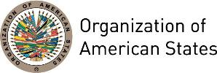

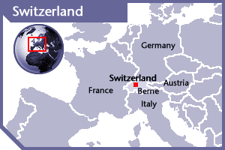


SWITZERLAND
PERMANENT OBSERVER

Date of Entry: September 13, 1978
National Holiday: August 1
Capital: Bern
Type of Government: Federal Republic, Directorial system
Head of State: President of the Swiss Confederation Doris Leuthard (January 1, 2017 for one year)
Head of the Federal Department of Foreign Affairs: Federal Councillor Didier Burkhalter (January 1, 2012)
Political Affairs Division, Director for the Americas: Ambassador Bénédict de Cerjat
Permanent Observer: Ambassador Martin Dahinden (November 2014)

ECONOMIC INDICATORS | 2010 | 2011 | 2012 | 2013 | 2014 | 2015 | 2016
Population (in millions) | 7.83 | 7.91 | 8.00 | 8.09 | 8.19 | 8.29 | 8.37
GDP (US$ in billions) | 581.21 | 696.28 | 665.05 | 684.92 | 702.706 | 670.79 | 659.82
GDP per capita (US$) | 74,276.7 | 87,998.4 | 83,164.3 | 84,658.8 | 85,814.5 | 80,989.8 | 78,812.6
Source: www.tradingeconomics.com | The World Bank Group

THE FEDERAL DEPARTMENT FOR FOREIGN AFFAIRS (FDFA):
- The FDFA formulates and coordinates Swiss foreign policy based on the instructions given by the Federal Council. Its activities are guided by the five principal foreign policy objectives as stated in the Federal Constitution:
- Peaceful coexistence among peoples;
- Respect for human rights and the promotion of democracy;
- Safeguarding the interests of the Swiss economy abroad;
- Relieving need and poverty in the world; and
- Preserving the natural environment.
- Swiss International cooperation steers bilateral cooperation with countries in the Middle East, Africa, Asia, and Latin America and encompasses humanitarian aid, technical cooperation and financial aid through the Swiss Agency for Development and Cooperation (SDC), and economic and trade policy measures in the framework of development cooperation through the State Secretariat for Economic Affairs (SECO). In regard to the multilateral cooperation, Switzerland has built relations with approximately 13 international institutions (international financing institutions, United Nations organizations, global networks and funds) in the form of financial participation and the joint formulation of policy and programs.
- Switzerland contributes to overcoming poverty-related problems and global risks, and its international cooperation commitment focuses on five goals:
- Preventing and overcoming crises, conflicts and catastrophes
- Creating access for all to resources and services
- Promoting sustainable economic growth
- Supporting the transition to democratic, free-market systems
- Helping to shape pro-development, environmentally friendly and socially responsible globalization
- In addition, Switzerland centers its support more strongly on countries and regions where state structures are fragile, because of weak governments, inadequate legal security and corruption that exacerbate poverty-related problems. Switzerland’s contribution is to be more strongly oriented towards overcoming global risks because developing countries are especially vulnerable to hazards that are not confined to national borders such as climate change, the lack of food and water security or health care facilities, migration, and economic instability.
- Following the adoption of the Message to the Confederation Parliament concerning the continuation of peace promotion and human security measures 2012–2016, Swiss foreign policy activities over the next few years will center around six priority themes corresponding to Switzerland’s recognized skills: peace and security; democracy, elections, and power-sharing; dealing with the past and prevention of atrocities; increased promotion and protection of human rights; protection of civilians in armed conflicts; migration and combating human trafficking.
- The Swiss Cooperation program in Latin America consists on giving financial and intellectual resources to a number of projects in Bolivia, Colombia, Cuba, Guatemala, Haiti, Honduras, Nicaragua and Peru. Each country’s budget depends on their needs as well as on their efficiency and effectiveness on the use of these resources. Total Projected resources for Latin America: CHF 121.89 million

INVOLVEMENT WITH THE AMERICAS:
- Switzerland maintains embassies in 17 countries of the Americas: Argentina, Bolivia, Brazil, Canada, Chile, Colombia, Costa Rica, Cuba, Dominican Republic, Ecuador, Haiti, Mexico, Paraguay, Peru, United States of America, Uruguay and Venezuela.

CURRENT COOPERATION AGREEMENTS WITH OAS:
- Contract between the General Secretariat of the OAS and the Swiss Federal Department of Foreign Affairs, Human Security Division, through which Switzerland will contribute up to US$101,587.00 to the project “Monitoring the situation of the right to Freedom of Expression in the Americas, and sharing experiences on access to information”. Implemented by the Office of the Special Rapporteur for Freedom of Expression of the Inter-American Commission on Human Rights between January 1, 2015 and December 31, 2016. Signed May 12, 2015.
- On December 19, 2013, the General Secretariat of the OAS and the Swiss Federal Department of Foreign Affairs signed a cooperation agreement through which Switzerland will contribute US$1 million to support the project National Identification Office in Haiti (ONI – Appui à l’Office National d’Identification (élections 2014)).
- Since early 2014, Switzerland is financing a secondment for a staff member to work as a Special Observer in Transnational Justice in the OAS Mission to Support the Peace Process (MAPP) in Colombia. The secondment will have a duration of 24 months and is valued at approximately CHF466,000 (US$495,350.00)

CASH CONTRIBUTIONS 2007-2016:
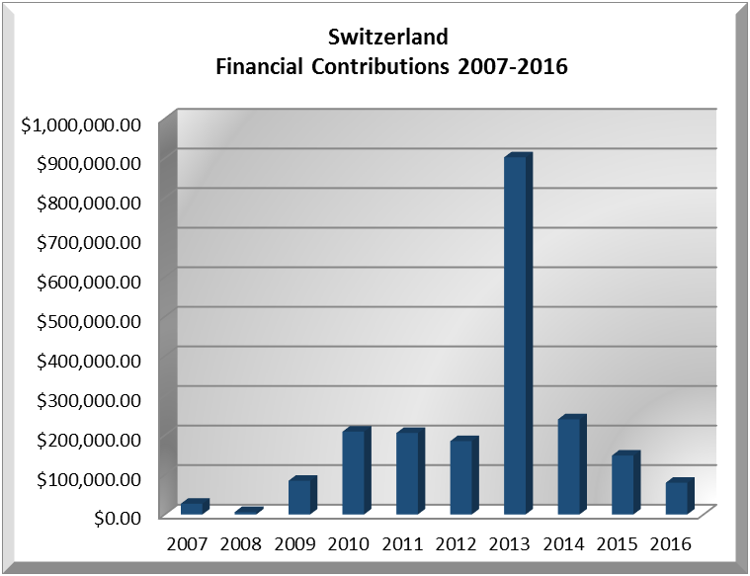
YEAR | SWITZERLAND | P.O. FINANCIAL CONTRIBUTIONS | %
2007 | $27,077.00 | $20,398,686.00 | 0.13%
2008 | $6,000.00 | $22,684,500.00 | 0.03%
2009 | $85,071.00 | $20,318,115.00 | 0.42%
2010 | $209,381.00 | $15,781,991.00 | 1.33%
2011 | $205,921.00 | $15,692,757.00 | 1.31%
2012 | $185,230.62 | $13,239,105.00 | 1.40%
2013 | $902,471.00 | $16,926,686.00 | 5.33%
2014 | $240,354.00 | $10,999,882.00 | 2.19%
2015 | $148,842.00 | $17,489,205.00 | 0.85%
2016 | $80,041.00 | $14,048,254.00 | 0.57%
Total US$ | $2,090,388.62 | $170,719,684.00 | 1.25%

SWITZERLAND CONTRIBUTIONS:
YEAR | PROJECTS |  | FINANCIAL CONTRIBUTIONS IN US$ | IN-KIND CONTRIBUTIONS  IN US$
2001 | Unit for the Promotion of Democracy (UPD)- Electoral Observation Mission, Nicaragua |  | $30,000.00
SUBTOTAL |  |  | $30,000.00
2002 | Unit for the Promotion of Democracy (UPD)- TCP II |  | $9,890.00
SUBTOTAL |  |  | $9,890.00
2003 | Unit for the Promotion of Democracy (UPD)-Support program, Elections Guatemala 2003 |  | $53,895.00
2003 | Unit for the Promotion of Democracy (UPD)- Electoral Observation Mission, Guatemala 2003 |  | $19,925.00
2003 | Office of the Assistant Secretary General- Special Mission in Haiti |  | $24,980.00
SUBTOTAL |  |  | $98,800.00
2004 | Department of Democratic and Political Affairs (DDPA) |  | $38,203.00
SUBTOTAL |  |  | $38,203.00
2007 | Office of the Assistant Secretary General |  | $5,000.00
2007 | Department for the Promotion of Democracy (DPD) |  | $22,077.00
2007 | Support on Electoral Observation Mission in Guatemala and Colombia |  |  | $63,500.00
SUBTOTAL |  |  | $27,077.00 | $63,500.00
2008 | Department of Electoral Cooperation and Observation (DECO) - Electoral Observation Mission to Paraguay |  | $6,000.00
SUBTOTAL |  |  | $6,000.00
2009 | Department of Electoral Cooperation and Observation (DECO)– Electoral Observation Mission to El Salvador |  | $19,385.00 | 2 LTOs and 4 STOs or 6 STOs
2009 | Inter-American Commission on Human Rights (IACHR), Office of the Special Rapporteur for the Freedom of Expression |  | $30,000.00
2009 | Department of Democratic Sustainability and Special Missions (DSDSM) - Mission to Support the Peace Process in Colombia (MAPP) |  | $35,686.00
SUBTOTAL |  |  | $85,071.00
2010 | Inter-American Commission on Human Rights (IACHR), Office of the Special Rapporteur for the Freedom of Expression – Access to Information: Stage II – Emphasis Judges |  | $29,950.00
2010 | Department for Electoral Cooperation and Observation (DECO) – OAS Electoral Observation Mission to Colombia |  | $15,975.00
2010 | Department for Electoral Cooperation and Observation (DECO) – OAS Electoral Observation Mission to Colombia – Presidential Runoff |  | $5,557.00
2010 | Inter-American Commission on Human Rights (IACHR), Office of the Special Rapporteur for the Freedom of Expression – Freedom of Expression in the Americas |  | $9,975.00
2010 | Department of Sustainability and Special Missions (DSDSM)- Mission to Support the Peace Process in Colombia (MAPP) |  | $135,539.00
2010 | Department for Electoral Cooperation and Observation (DECO), Electoral Observation Mission to Haiti |  | $12,385.00
SUBTOTAL |  |  | $209,381.00
2011 | Inter-American Commission on Human Rights, Office of the Special Rapporteur for the Freedom of Expression - Monitoring of the Situation of the Right to Freedom of Expression in the Americas and Annual Report of the Office of the Special Rapporteur for Freedom of Expression in the Inter American Human Rights System |  | $43,359.00
2011 | Secretariat for Political Affairs, Department of Sustainability and Special Missions (DSDSM)- Mission to Support the Peace Process in Colombia (MAPP) |  | $125,756.00
2011 | Secretariat for Political Affairs, Department for Electoral Cooperation and Observation (DECO) – EOM Guatemala |  | $13,775.00
2011 | Secretariat for Political Affairs, Department for Electoral Cooperation and Observation (DECO)- EOM Fund |  | $23,031.00
SUBTOTAL |  |  | $205,921.00
2012 | Electoral Observation Mission Mexico |  | $19,975.00
2012 | Monitoring the Situation of the Right to Freedom of Expression in the Americas and Annual Report of the Office of the Special Rapporteur for Freedom of Expression in the IAHRS |  | $46,235.00
2012 | OAS Strengthening of and Support to Victims and their Organizations in Colombia - MAPP |  | $119,020.62
SUBTOTAL |  |  | $185,230.62
2013 | Secretariat for Political Affairs, Department for Electoral Cooperation and Observation (DECO) – Electoral Observation Mission Paraguay (April 2013) |  | $16,188.00
2013 | Secretariat for Political Affairs, Department for Electoral Cooperation and Observation (DECO) - Electoral Observation Mission in Honduras |  | $20,000.00
2013 | Secretariat for Political Affairs / Department for Effective Public Management - National Identification Office in Haiti (Universal Civil Identity Program of the Americas (PUICA)) |  | $799,980.00
2013 | Inter-American Commission on Human Rights, Office of the Special Rapporteur for the Freedom of Expression - Monitoring of the Situation of the Right to Freedom of Expression in the Americas and Annual Report of the Office of the Special Rapporteur for Freedom of Expression in the Inter American Human Rights System |  | $48,034.00
2013 | Secretariat for Political Affairs, Department of Sustainability and Special Missions - Mission to Support the Peace Process in Colombia (MAPP)  -Secondment (CHF466,000, for a 24 months-period starting on July 2013) |  | $98,162.00 | $130,500.00
SUBTOTAL |  |  | $902,471.00 | $130,500.00
2014 | Secretariat for Political Affairs / Department for Electoral Cooperation and Observation (DECO) – Electoral Observation Mission for the Legislative Elections in Colombia March 2014 |  | $15,248.00
2014 | Secretariat for Political Affairs / Department for Electoral Cooperation and Observation (DECO) - Electoral Oversight Mission - Presidential Elections in Colombia May 2014 |  | $21,475.00
2014 | Secretariat for Political Affairs / Department for Electoral Cooperation and Observation (DECO) - Electoral Oversight Mission - 2nd Round Presidential Elections in Colombia May 2014 |  | $12,140.00
2014 | Secretariat for Political Affairs / Department for Electoral Cooperation and Observation (DECO) - Electoral Observation Mission - General Elections in Bolivia October 2014 |  | $28,748.00
2014 | Secretariat for Political Affairs / Department for Effective Public Management - National Identification Office in Haiti (Universal Civil Identity Program of the Americas -PUICA) |  | $149,980.00
2014 | Inter-American Commission on Human Rights, Office of the Special Rapporteur for the Freedom of Expression - Monitoring of the Situation of the Right to Freedom of Expression in the Americas and Annual Report of the Office of the Special Rapporteur for Fre |  | $12,763.00
2014 | Mission to Support the Peace Process in Colombia (MAPP) -Secondment (CHF466,000, for a 24 months - started early 2014) |  |  | $194,000.00
SUBTOTAL |  |  | $240,354.00 | $194,000.00
2015 | Secretariat for Political Affairs / Department of Sustainable Democracy and Special Missions - Mission to Support the Peace Process in Colombia (MAPP) Contract 81028998 |  | $55,359.85
2015 | Secretariat for Political Affairs / Department of Sustainable Democracy and Special Missions - Mission to Support the Peace Process in Colombia (MAPP) -Secondment (CHF466,000 for 24 months- Mar 2014 - Feb 2016) |  |  | $233,000.00
2015 | Secretariat for Political Affairs / Department of Electoral Cooperation and Observation - Electoral Observation Mission - Federal Elections in Mexico June 7, 2015 (1 regional coordinator & 4 observers) |  | $12,185.00
2015 | Secretariat for Political Affairs / Department of Electoral Cooperation and Observation - Electoral Observation Mission in Honduras 2013 (pending balance from 2013) |  | $8,000.00
2015 | Inter-American Commission on Human Rights - Monitoring of the situation of the right to freedom of expression in the Americas, and sharing experiences on access to information |  | $40,610.00
 | The Department of Electoral Cooperation and Observation – EOM 2014 Haiti |  | $26,343.00
 | The Department of Electoral Cooperation and Observation – EOM 2015 Guatemala |  | $6,344.00
SUBTOTAL |  |  | $148,842.00 | $233,000.00
2016 |  | The Executive Secretariat of the Inter‐American Commission on Human Rights IACHR (34B), Freedom of Expression 2015‐17 | $50,769
 |  | The Department of Electoral Cooperation and Observation (64C),  EOM 2016 Colombia | $8,568
 |  | The Department of Electoral Cooperation and Observation (64C),  EOM 2014 Haiti | $20,704
SUBTOTAL |  |  | $80,041
TOTAL |  |  | $2,267,281.62 | $388,000.00

SOURCES:
FEDERAL DEPARTMENT OF FOREIGN AFFAIRS OF SWITZERLAND  http://www.eda.admin.ch/eda/en/home.html  SWISS AGENCY FOR INTERNATIONAL DEVELOPMENT  http://www.sdc.admin.ch/index.php?n1 | EMBASSY OF SWITZERLAND IN WASHINGTON, D.C.  http://www.eda.admin.ch/washington  WORLD BANK – TRADING ECONOMICS  www.tradingeconomics.com

This page was last updated on July 5, 2017.

