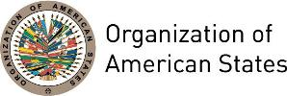

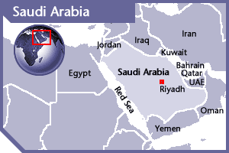
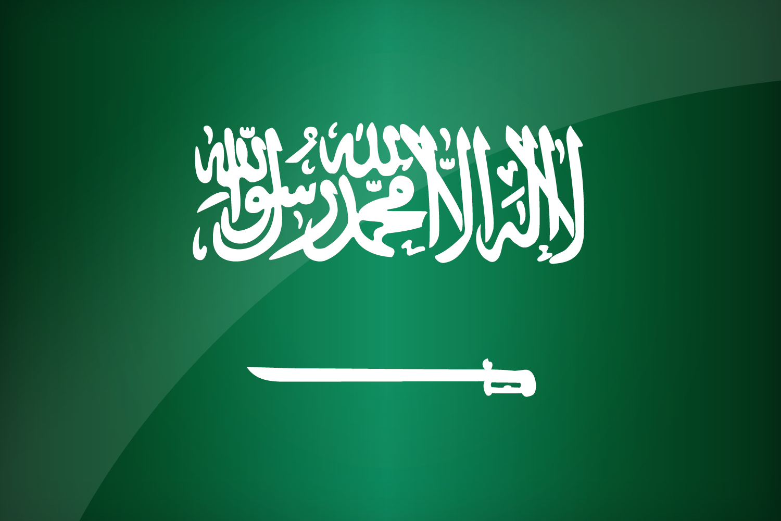

SAUDI ARABIA
PERMANENT OBSERVER

Date of Entry: October 22, 1980
National Holiday: September 23
Capital: Riyadh
Type of Government: Islamic Monarchy with a Consultative Council and a Council of Ministers
Head of State: King Salman bin Abdul-Aziz Al Saud (January 23, 2015)
Head of Government: Prime Minister Salman bin Abdul-Aziz Al Saud (January 23, 2015)
Minister of Foreign Affairs: Prince Faisal bin Farhan Al Saud (since October 23, 2019)
Permanent Observer: Ambassador Reema bint Bandar bin Sultan bin Abdulaziz Al Saud (February 23, 2019)

ECONOMIC INDICATORS | 2010 | 2011 | 2012 | 2013 | 2014 | 2015 | 2016 | 2017 | 2018 | 2019
Population  (in millions) | 27.43 | 28.23 | 29.1 | 29.94 | 30.78 | 31.6 | 32,28 | 33.1 | 33.7 | 34.3
GDP (US$ in billions) | 528.21 | 671.24 | 736 | 746.65 | 756.35 | 654.3 | 646.4 | 688.6 | 786.5 | 792.9
GDP per capita (US$) | 19,260 | 23,771 | 25,304 | 24,934.11 | 24,575.4 | 20,733 | 20,028 | 20,803 | 23,338 | 23,139
Source: www.tradingeconomics.com | The World Bank Group

FOREIGN RELATIONS POLICIES:
- The foreign policy of the Kingdom of Saudi Arabia is based on the good-neighbor policy, non interference in the internal affairs of other countries, strengthening relations with the Gulf States, the countries of the Arabian Peninsula, and Islamic countries, implementing a nonalignment policy, establishing cooperation relations with friendly countries, and playing an effective role in the international and regional organizations.
- Maintain security and its position on the Arabian Peninsula, defends and promotes solidarity and general Arab and Islamic interests, and maintain cooperative relations with other oil-producing and major oil-consuming countries.
- Promote peace and stability in areas beyond its borders, particularly among its immediate neighbors.
- Saudi Arabia is a founding member of the United Nations, having signed the United Nations Charter in 1945 and is a founder member of the Arab League, Persian Gulf Cooperation Council, Muslim World League, and the Organization of the Islamic Conference (now the Organization of Islamic Cooperation). As a founding member of OPEC, its oil pricing policy has been generally to stabilize the world oil market and try to moderate sharp price movements so as to not jeopardize the Western economies.
- It is a member of the International Monetary Fund and the World Bank, and in 2005 joined the World Trade Organization. Saudi Arabia supports the intended formation of the Arab Customs Union for 2015 and an Arab common market by 2020, as announced at the 2009 Arab League summit.

OBJECTIVES AND INITIATIVES WITH THE DEVELOPING WORLD:
- Saudi Arabia has been a principal donor of Overseas Development Aid (ODA) since the mid-1970s, in terms of both absolute volume of aid and relative volume of aid to its GDP. Most of this aid has gone to Islamic countries or communities in non-Islamic countries and it still gives some aid to a number of Arab, African, and Asian countries. Jeddah is the headquarters of the Secretariat of the Organization of Islamic Cooperation and its subsidiary organization, the Islamic Development Bank, founded in 1969.
- Saudi Arabia operates the Saudi Fund for Development, which contributes to the financing of 656 projects in 83 countries (46 African countries, 29 Asian countries, and 8 countries in other parts of the world).
- Saudi Arabia has most recently partnered with the World Bank to help implement an energy initiative for impoverished countries as well as with the World Food Program in order to provide relief for rising food prices.

INVOLVEMENT WITH THE AMERICAS:
- Saudi Arabia maintains embassies in Argentina, Brazil, Canada, Chile, Cuba, Mexico, Peru, United States of America, Uruguay and Venezuela.
- Saudi Arabia shares special ties with Venezuela, Ecuador and Mexico as major oil producers and exporters. Saudi Arabia, Venezuela and Ecuador cooperate under the framework of the Organization of the Petroleum Exporting Countries (OPEC).

SOURCES:
KINGDOM OF SAUDI ARABIA, MINISTRY OF FOREIGN AFFAIRS  http://www.mofa.gov.sa/  ROYAL EMBASSY OF SAUDI ARABIA IN WASHINGTON DC  http://www.saudiembassy.net/Index.asp | WORLD BANK – TRADING ECONOMICS  www.tradingeconomics.com

This page was last updated on November 18, 2020.

