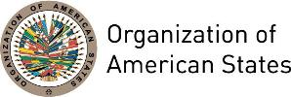

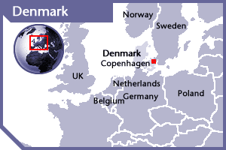


DENMARK
PERMANENT OBSERVER

Date of Entry: October 11, 2000
National Day: June 5
Capital: Copenhagen
Type of Government: Parliamentary Constitutional monarchy
Head of State: Queen Margrethe II (January 14, 1972)
Prime Minister: Lars Løkke Rasmussen (June 2015)
Minister for Foreign Affairs: Anders Samuelsen (November 28, 2016)
Permanent Observer: Ambassador Lars Gert Lose (March 24, 2015)

ECONOMIC INDICATORS | 2010 | 2011 | 2012 | 2013 | 2014 | 2015 | 2016
Population (in millions) | 5.54 | 5.57 | 5.59 | 5.61 | 5.64 | 5.68 | 5.73
GDP (US$ in billions) | 321.994 | 344.004 | 327.149 | 343.584 | 352.297 | 301.308 | 306.143
GDP per capita (US$) | 58,041.153 | 61,753.793 | 58,507.5 | 61,191.193 | 62,425.539 | 53,014.644 | 53,417.664
Source: www.tradingeconomics.com | The World Bank Group

FOREIGN RELATIONS AND DEVELOPMENT COOPERATION POLICIES:
- The Danish Government has presented its priorities for development cooperation for the years 2013-2017 through the implementation of its new strategy “The Right to a Better Life (2012)”. This policy has a European, a transatlantic and a global dimension, based on the promotion of Danish interests and values.
- The overall message of this strategy is that poverty must be fought with human rights and economic growth. Four strategic priority areas have special attention: Human rights and democracy, green growth, social progress and stability and protection.
- Through its policy the Danish Government promotes all human rights –economic, social, cultural, civil and political rights; a particular focus on women’s rights and equal access to resources and opportunities has been established, as well as the promotion of the accountability of the governments vis-a-vis their citizens, a focus on health care, education and strengthening democratic control mechanisms, public financial management and the fight against corruption.
- Denmark will maintain a special focus on the Climate Envelope and additional resources will be allocated to a follow-up on the Rio+20 conference. Furthermore, about 600 million extra will be allocated to activities in fragile states.
- Denmark cooperates with organizations of the United Nations (UNAIDS, UNICEF, UNFPA, UNESCO), the World Trade Organization, the World Bank, and other development banks. Furthermore, Denmark works with the European Union’s Common Foreign and Security Policy (CFSP) and Common Development Assistance Policy (CDAP), including EU-MERCOSUR, EU-Mexico, and the Asia-Europe Meeting.

INVOLVEMENT WITH THE AMERICAS:
- Denmark maintains embassies in eight countries of the Americas: Argentina, Bolivia, Brazil, Canada, Chile, Colombia, Mexico, and the United States of America.
- Latin America receives approximately 12.23% of total bilateral aid assistance. Bolivia and Nicaragua are included in Denmark’s 15 “Program Countries”. Sectors of assistance include agriculture, the environment, human rights, rights of indigenous people and union-based rights in Bolivia and Central America. Sectors of assistance to Nicaragua include agriculture, transport, and the environment. Approximately US$4.57 million was allocated in transitional assistance to Guatemala over the course of the past several years.

CURRENT AGREEMENTS IN AREAS OF COOPERATION WITH OAS:
- Grant Agreement between the Minister for Foreign Affairs and Trade as represented by Danida and the General Secretariat of the Organization of American States to support the Inter-American Commission on Human Rights through the project – Programa Regional de los Derechos Humanos en Centroamerica, (PRO-DERECHOS), from January 1st, 2013 to June 30, 2015.

CASH CONTRIBUTIONS 2005-2016:
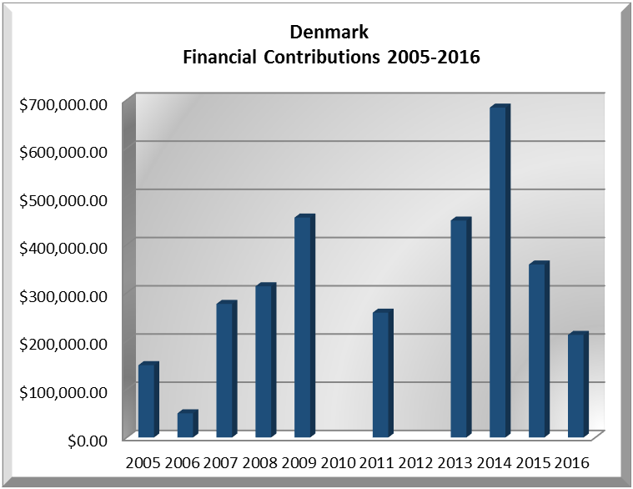
YEAR | DENMARK | P.O. FINANCIAL CONTRIBUTIONS | %
2005 | $150,000.00 | $11,650,039.00 | 1.29%
2006 | $50,000.00 | $19,060,470.00 | 0.26%
2007 | $277,051.00 | $20,398,686.00 | 1.36%
2008 | $313,557.00 | $22,684,493.00 | 1.38%
2009 | $456,175.05 | $20,318,115.00 | 2.25%
2010 |  | $15,781,991.00 | 0.00%
2011 | $258,878.00 | $15,692,757.00 | 1.65%
2012 |  | $13,239,105.00 | 0.00%
2013 | $449,940.00 | $16,926,686.00 | 2.66%
2014 | $684,213.00 | $10,999,882.00 | 6.22%
2015 | $358,820.05 | $17,489,205.00 | 2.05%
2016 | $212,681.00 | $14,048,254.00 | 1.53%
Total US$ | $3,211,315.10 | $198,289,683.00 | 1.62%

DENMARK CONTRIBUTIONS:
YEAR |  | PROJECTS | FINANCIAL CONTRIBUTIONS  IN US$ | IN-KIND CONTRIBUTIONS  IN US$
1999 |  | Unit for the Promotion of Democracy (UPD) | $881,175.00
SUBTOTAL |  |  | $881,175.00
2000 |  | Inter-American Commission on Human Rights (IACHR) | $191,500.00
 |  | Unit for the Promotion of Democracy (UPD) | $475,000.00
SUBTOTAL |  |  | $666,500.00
2001 |  | UPD – Electoral Observation Mission, Nicaragua | $60,000.00
 |  | Peace Fund | $100,000.00
 |  | UPD – Political Values, Guatemala | $31,000.00
SUBTOTAL |  |  | $191,000.00
2002 |  | UPD – Central American Program | $120,000.00
 |  | UPD – Political Management, Guatemala | $71,538.00
 |  | IACHR – Strengthening of Indigenous People’s Rights | $139,961.00
SUBTOTAL |  |  | $331,499.00
2003 |  | IACHR – Office of the Special Rapporteur for Freedom of Expression – Honduras | $4,000.00
 |  | IACHR | $138,777.00
SUBTOTAL |  |  | $142,777.00
2004 |  | IACHR – Freedom of Expression/Indigenous People’s Rights | $65,998.00
 |  | Department of Democratic Political Affairs (DDPA) | $84,485.00
SUBTOTAL |  |  | $150,483.00
2005 |  | DDPA – Electoral Observation Mission, Bolivia | $100,000.00
 |  | DDPA – Electoral Observation Mission, Honduras | $50,000.00
SUBTOTAL |  |  | $150,000.00
2006 |  | UPD – Electoral Observation Mission, Nicaragua | $50,000.00
SUBTOTAL |  |  | $50,000.00
2007 |  | IACHR | $277,051.00
SUBTOTAL |  |  | $277,051.00
2008 |  | IACHR | $313,557.00
SUBTOTAL |  |  | $313,557.00
2009 |  | Electoral Observation Mission to El Salvador | $50,000.00
 |  | IACHR – Strengthening Access to Justice in the Americas | $291,574.00
 |  | IACHR – Office of the Special Rapporteur of Indigenous People | $114,601.05
SUBTOTAL |  |  | $456,175.05
2011 |  | IACHR – Strategic Plan 2011-2015 | $258,878.00
SUBTOTAL |  |  | $258,878.00
2013 |  | Inter-American Commission on Human Rights (IACHR) Strategic Plan 2011-2015 - Pro-Derechos (2013-2015) (Human rights of indigenous people, women and human rights defenders in Central America -Guatemala, Honduras & Nicaragua) | $449,940.00
SUBTOTAL |  |  | $449,940.00
2014 |  | Inter-American Commission on Human Rights (IACHR) Strategic Plan 2011-2015 - Pro-Derechos (2013-2015) (Human rights of indigenous people, women and human rights defenders in Central America -Guatemala, Honduras & Nicaragua) | $684,213.00
SUBTOTAL |  |  | $684,213.00
2015 |  | Inter-American Commission on Human Rights (IACHR) - Pro-Derechos (2013-2015) (Human rights of indigenous people, women and human rights defenders in Central America -Guatemala, Honduras & Nicaragua) | $358,820.05
SUBTOTAL |  |  | $358,820.05
2016 | The Executive Secretariat of the Inter-American Commission on Human Rights IACHR – Program 2 – Individual Petition Syst. |  | $112,000.00
2016 | The Executive Secretariat of the Inter-American Commission on Human Rights IACHR – Program 3 – Monitoring Country |  | $42,400.00
2016 | The Executive Secretariat of the Inter-American Commission on Human Rights IACHR – Program 4 – 4.2 Women |  | $32,759.00
2016 | The Executive Secretariat of the Inter-American Commission on Human Rights IACHR – Strategic Plan – General Funds |  | $25,522.00
SUBTOTAL |  |  | $212,681.00
TOTAL |  |  | $5,574,749.1

SOURCES:
STATS MINISTERIET  http://www.stm.dk/_a_1644.html  DANIDA  http://um.dk/en/danida-en/  THE OFFICAL WEBSITE OF DENMARK  http://denmark.dk/en | MINISTRY OF FOREIGN AFFAIRS OF DENMARK  http://um.dk/en  EMBASSY OF DENMARK IN THE US  http://usa.um.dk/en/  WORLD BANK – TRADING ECONOMICS  www.tradingeconomics.com

This page was last updated on July 5, 2017.

