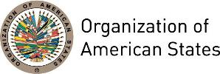

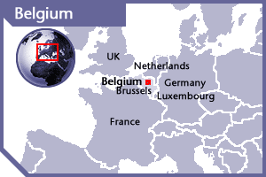


BELGIUM
PERMANENT OBSERVER

Date of Entry: December 20, 1972
National Day: July 21
Capital: Brussels
Type of Government: Federal parliamentary democracy under a constitutional monarchy
Head of State: King Philippe (July 21, 2013)
Head of Government: Prime Minister Charles Michel (October 11, 2014)
Deputy Prime Minister and Minister of Foreign Affairs and European Affairs: Didier Reynders (December 6, 2011)
Permanent Observer: Ambassador Dirk Wouters (September, 2016)

ECONOMIC INDICATORS | 2010 | 2011 | 2012 | 2013 | 2014 | 2015 | 2016
Population (in millions) | 10.89 | 11.04 | 11.12 | 11.18 | 11.20 | 11.27 | 11.34
GDP (US$ in billions) | 483.54 | 527.00 | 497.88 | 520.11 | 531.75 | 454.99 | 466.36
GDP per capita (US$) | 44,380.237 | 47,702.774 | 44,740.572 | 46,510.386 | 47,439.397 | 40,356.876 | 41,096.157
Source: www.tradingeconomics.com | The World Bank Group

Belgian Development Cooperation:
- Belgian development cooperation achieves its objectives with partnership with governments in developing countries and other donors present in the 18 partner countries (governmental cooperation); with non-governmental actors in Belgium and its partner countries (through NGOs, universities and community-based organizations); and with multilateral organizations.
- The activities covered by Belgian Development Cooperation can be divided into 12 topics: Millennium Development Goals; Agriculture and food security; Environment and climate change; Migration and development; Education and training; Healthcare; Infrastructure; Society building and conflict prevention; Gender: equal rights and opportunities for women and men; aid for trade; children’s rights; and private sector.
- The development cooperation policies of Belgium are the following: peace and security, human rights and promotion of the rule of law, with a view to striving for a fairer and more prosperous world.
- Belgium supports 18 partner countries and provides emergency and humanitarian aid to non-partner countries based on need.
- Development aid in the framework of the Millennium Development Goals (MDGs) is focused on five areas: healthcare; education and training; agriculture and food security; basic infrastructure; and society building.
- The execution of cooperation programs is entrusted to the Directorate-General for Development Cooperation (DGDC), which forms part of the Ministry of Foreign Affairs, Foreign Trade and Development Cooperation.
- Multilaterally, Belgium works with around 20 international organizations including UNICEF, World Health Organization (WHO), International Red Cross, Joint United Nations program on HIV/AIDS (UNAIDS), and the European Union (EU) through the European Development Fund. Belgium also co-finances programs with NGOs, principally for humanitarian aid including disaster prevention and emergency aid, as well as short-term assistance for reconstruction.

INVOLVEMENT WITH THE AMERICAS:
- Belgium maintains embassies in the 13 countries of the Americas: Argentina, Brazil, Canada, Chile, Colombia, Cuba, Ecuador, Jamaica, Mexico, Panama, Peru, United States and Venezuela.
- In Latin America, partner countries for development cooperation with Belgium are Bolivia (water, environment and culture), Ecuador (primary health and rural development) and Peru (health, economic and sustainable development, and domestic and sexual violence).

CURRENT AGREEMENTS IN AREAS OF COOPERATION WITH OAS:
- Financial Contribution Agreement between the Ministry of Foreign Affairs of the Federal Government of Belgium, and the Organization of American States to support the project Landmine Victim Assistance in Ecuador and Peru; Agreement signed on July 2, 2012 for a period of three years, for a total amount of €168,062.

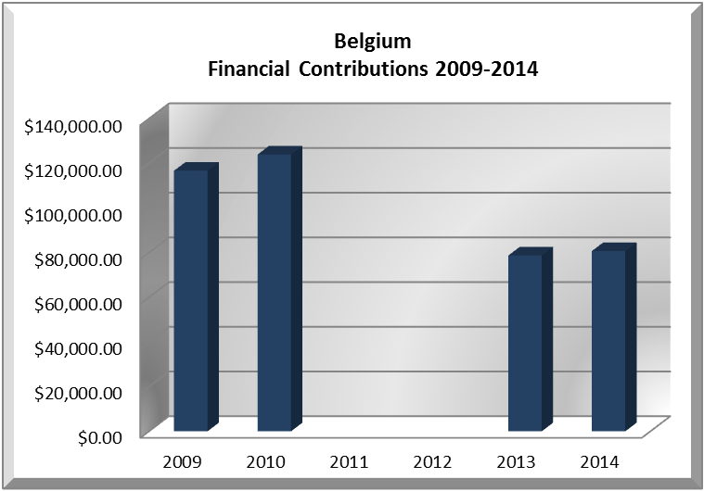
FINANCIAL CONTRIBUTIONS TO THE OAS 2009-2016:
YEAR | BELGIUM | P.O. FINANCIAL CONTRIBUTIONS | %
2009 | $116,625.00 | $20,318,115.00 | 0.57%
2010 | $123,892.00 | $15,781,991.00 | 0.79%
2011 |  | $15,692,757.00 | 0.00%
2012 |  | $13,239,705.00 | 0.00%
2013 | $78,696.00 | $16,926,686.00 | 0.46%
2014 | $80,658.00 | $10,999,882.00 | 0.73%
2015 |  | $17,489,206.00 | 0.00%
2016 |  | $14,048,254.00 | 0.00%
Total US$ | $399,871.00 | $124,496,596.00 | 0.32%

BELGIUM CONTRIBUTIONS:
YEAR | PROJECTS | FINANCIAL CONTRIBUTIONS  IN US$ | IN-KIND CONTRIBUTIONS  IN US$
2009 | Action against Antipersonnel Landmines - Humanitarian Demining - Ecuador & Peru | $58,312.50
2009 | Action against Antipersonnel Landmines - Humanitarian Demining - Ecuador & Peru | $58,312.50
SUBTOTAL |  | $116,625.00
2010 | Department of Public Security (DPS) – Comprehensive Action Against Antipersonnel Mines (AICMA) - Demining Assistance Program - Ecuador/Peru | $61,946.00
2010 | Department of Public Security (DPS) – Comprehensive Action Against Antipersonnel Mines (AICMA) - Demining Assistance Program - Ecuador/Peru | $61,946.00
SUBTOTAL |  | $123,892.00
2013 | Department of Public Security / Secretariat for Multidimensional Security - Landmine Victim Assistance in Ecuador and Peru - | $78,696.00
SUBTOTAL |  | $78,696.00
2014 | Department of Public Security / Secretariat for Multidimensional Security - Landmine Victim Assistance in Ecuador and Peru - | $80,658.00
2014 | Department of Human Development and Education / Executive Secretariat for Integral Development - Vrije Universiteit Brussel (17 scholarships awarded) |  | $690,455.00
SUBTOTAL |  | $80,658.00 | $690,455.00
TOTAL |  | $399,871.00 | $690,455.00

SOURCES:
ORGANIZATION FOR ECONOMIC COOPERATION AND DEVELOPMENT  http://www.oecd.org  DIRECTORATE-GENERAL FOR DEVELOPMENT COOPERATION OF BELGIUM  http://www.dgci.be/  MINISTRY OF FOREIGN AFFAIRS OF BELGIUM  http://www.diplomatie.be | UNITED NATIONS, OFFICE OF COORDINATION OF HUMANITARIAN ASSISTANCE  http://www.reliefweb.int/fts  WORLD BANK – TRADING ECONOMICS  www.tradingeconomics.com
This page was last updated on July 7, 2017.

