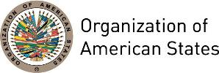

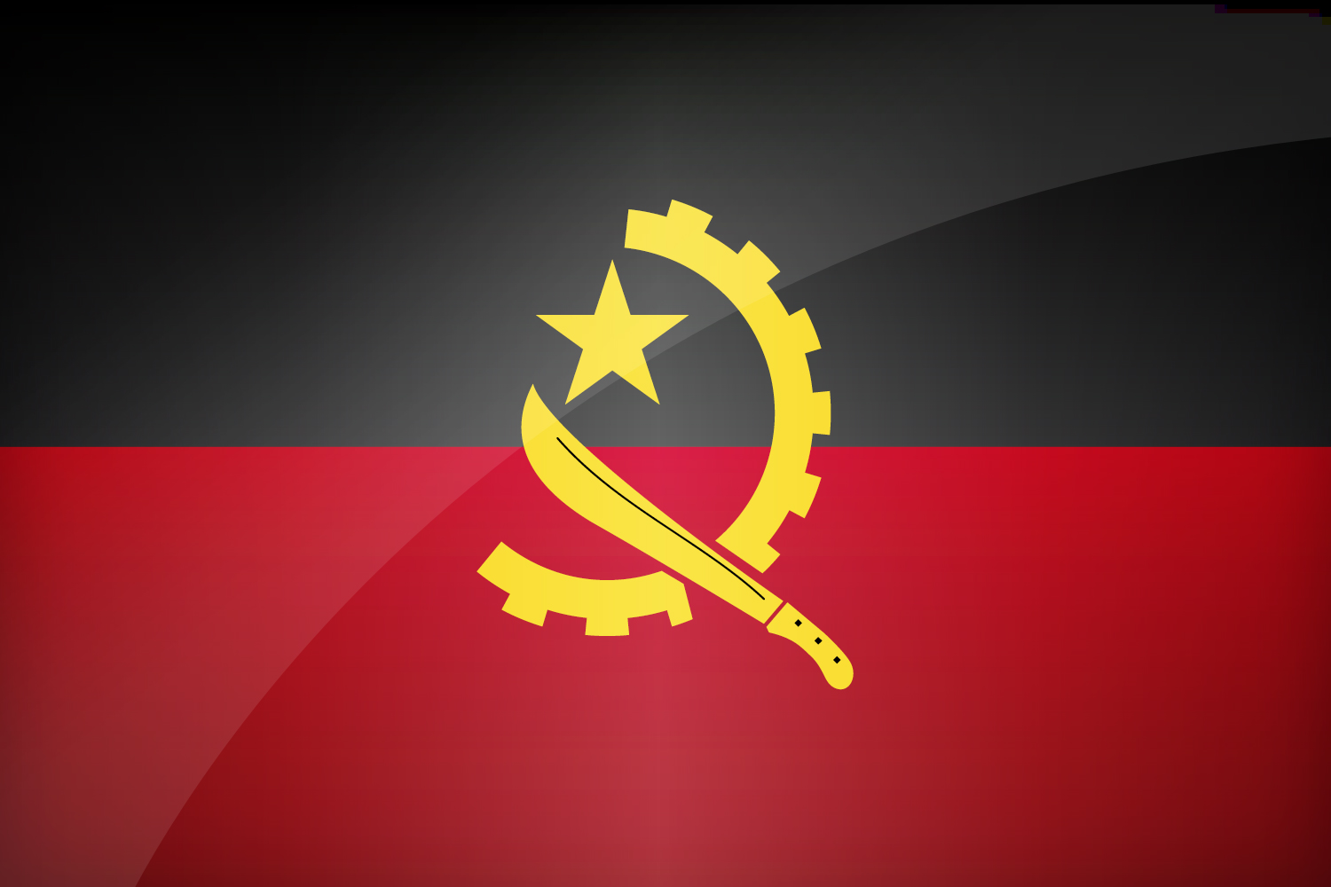
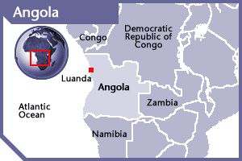

ANGOLA
PERMANENT OBSERVER

Date of Entry: December 10, 1991
National Day: November 11
Capital: Luanda
Type of Government: Democratic Republic
Head of State: President Jose Eduardo Dos Santos (September 21, 1979)
Minister of Foreign Affairs: Georges Rebelo Pinto Chicoti (since 2010)
Permanent Observer: Ambassador Agostinho Tavares da Silva Neto (November 18, 2014)

ECONOMIC INDICATORS | 2010 | 2011 | 2012 | 2013 | 2014 | 2015 | 2016
Population (in millions) | 23.37 | 24.21 | 25.09 | 25.99 | 26.92 | 27.85 | 28.81
GDP (US$ in billions) | 82.47 | 104.11 | 115.39 | 124.91 | 126.77 | 102.96 | 89.63
GDP per capita (US$) | 3,529.053 | 4,299.013 | 4,598.25 | 4,804.617 | 4,709.312 | 3,695.794 | 3,110.808
Source: www.tradingeconomics.com | The World Bank Group

FOREIGN RELATIONS POLICIES:
- The Ministry of Foreign Affairs is the government agency responsible in assisting the President in the coordination, formulation, planning, implementation and evaluation of its foreign policy and international cooperation in all aspects. It is based on the principle of unity, interdependence and collaboration between direct and indirect state agencies, and its seeks to reduce the dependency on oil and diversify the economy, by rebuilding its infrastructure, improving its institutional capacity, governance, public financial management systems, human development indicators and the living conditions of its population.
- Through its foreign policy the Government aims at promoting economic diversification by focusing international cooperation on the economic sector with a view to more investments leading to the creation of jobs in the country.
- Angola participates in international organizations such as the United Nations and some of its agencies: the UN Office on Drugs and Crime (UNODC), UN Industrial Development Organization (UNIDO), as well as the International Atomic Energy Agency (IAEA), the Preparatory Commission for the Comprehensive Nuclear Test-Ban Treaty (CTBTO), the Organization of the Petroleum Exporting Countries (OPEC) and the OPEC Fund for International Development (OFID).
- Angola is also a member in the Community of Portuguese-Language Nations (CPLP) and the Southern African Development Community (SADC).
- The country is committed to fulfilling the Millennium Development Goals by implementing programs to diversify its domestic production, expand employment opportunities, and decrease its dependence on imports of consumer products and oil.
- The Government develops programs aimed at reducing social inequality, fighting hunger and poverty, upgrading social infrastructure, including roads, railways, electricity, and water supply and distribution systems.

INVOLVEMENT WITH THE AMERICAS:
- Angola has diplomatic relations with all the OAS Member States and maintains diplomatic missions in the following countries: Argentina, Brazil, Canada, Mexico, and the United States.

ANGOLA CONTRIBUTIONS:
YEAR | PROJECTS | FINANCIAL CONTRIBUTIONS  IN US$ | IN-KIND CONTRIBUTIONS  IN US$
2013 | Secretariat for Legal Affairs - Indigenous Population | $1,000.00
SUBTOTAL |  | $1,000.00
TOTAL |  | $1,000.00

SOURCES:
PORTAL OFICIAL DO GOVERNO DA REPÚBLICA DE ANGOLA  http://www.governo.gov.ao/Default.aspx  MINISTÉRIO DAS RELAÇÕES EXTERIORES  http://www.mirex.gov.ao/ | EMBASSY OF ANGOLA IN WASHINGTON D.C.  http://www.angola.org/  WORLD BANK – TRADING ECONOMICS  www.tradingeconomics.com

This page was last updated on July 6, 2017.

