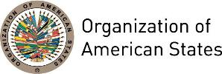

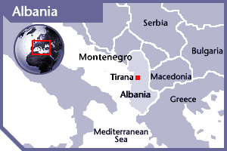
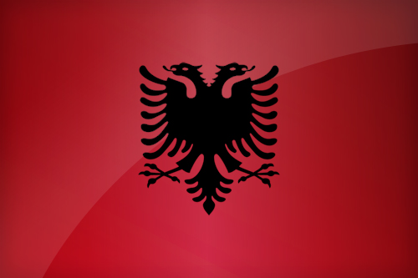

ALBANIA
PERMANENT OBSERVER

Date of Entry: October 19, 2011
National Day: November 28
Capital: Tirana
Type of Government: Parliamentary Republic
Head of State: President Bujar Nishani (July 24, 2012)
Head of Government: Prime Minister Edi Rama (September 15, 2013)
Minister of Foreign Affairs: Ditmir Bushati (September 15, 2013)
Permanent Observer: Ambassador Floreta Faber (May 18, 2015)

ECONOMIC INDICATORS | 2010 | 2011 | 2012 | 2013 | 2014 | 2015 | 2016
Population (in millions) | 2.91 | 2.90 | 2.90 | 2.89 | 2.88 | 2.88 | 2.87
GDP (US$ in billions) | 11.92 | 12.89 | 12.32 | 12.78 | 13.22 | 11.39 | 11.92
GDP per capita (US$) | 4,094.359 | 4,437.178 | 4,247.614 | 4,414.723 | 4,575.764 | 3,945.023 | 4,146.896
Source: http://data.worldbank.org/country/albania World Bank

FOREIGN RELATIONS POLICIES:
- The guiding principles of Albania’s foreign policy are international law, mutual understanding and respect among nations, respect for fundamental freedoms and human rights, good neighborly relations, regional cooperation and international solidarity.
- The priority areas for Albanian foreign policy include:
  - Strategic partnerships with the United States and the European Union to strengthen bilateral consultations, exchange of information, cooperation on NATO peacekeeping missions and accession into the EU.
  - Deepening economic cooperation with neighboring countries
  - Preservation and consolidation of peace and democratic stability through cooperation with NATO and the eu
  - Protecting the rights of Albanians in Macedonia, Montenegro and the Presevo Valley
  - Diplomacy to attract foreign investment and economic development in Albania
  - Modernizing armed forces in line with NATO standards to promote national security and contribute to global security.
- Albania participates in international organizations and coalitions such as the United Nations (UN), Council of Europe, Organization for Security and Cooperation in Europe (OSCE), Anti-Terror Coalition, UNESCO, Stability Pact, Adriatic Charter, World Trade Organization (WTO), Organization of Francophonie, among others.
- Albanian foreign policy pursues to maintain, enhance and enrich relations with a number of countries with a special weight in the current world economic and political developments, such as China, Israel, Japan, India, Middle East and Canada.

INVOLVEMENT WITH THE AMERICAS:
- Albania has diplomatic relations with the following OAS Member States: Argentina, Brazil, Canada, Ecuador, Mexico, the United States, and Uruguay. Albania maintains embassies in Brazil, Canada and the United States of America.

SOURCES:
MINISTRY OF FOREIGN AFFAIRS OF ALBANIA  http://mfa.gov.al/index.php?lang=en  OFFICE OF THE PRIME MINISTER OF ALBANIA  http://www.kryeministria.al/en  INSTITUTION OF THE PRESIDENT OF THE REPUBLIC OF ALBANIA  http://president.al/ | ALBANIAN EMBASSY, WASHINGTON DC  http://www.embassyofalbania.org/  WORLD BANK – TRADING ECONOMICS  www.tradingeconomics.com

This page was last updated on July 6, 2017.

