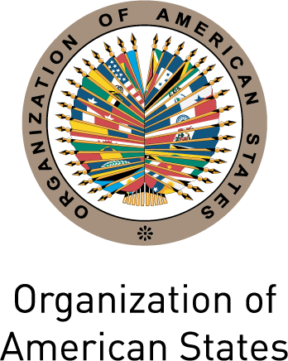
Secretariat for External Relations / Department of International Affairs

XXIII OAS POLICY ROUNDTABLE
"The European Union and the Americas:
The Challenges of Multilateralism”

Tuesday, May 4th 2010
3:00 pm
Hall of the Americas
17th Street and Constitution Ave. NW
Washington, DC 20006

3:00-3:20 pm Welcome remarks by Ambassador Alfonso Quiñónez, Executive Secretary for Integral Development, Organization of American States (OAS)

3:20-3:50 pm Presentation of Política Exterior magazine by Áurea Moltó,
Assistant Director of the magazine

3:50-4:30 pm Discussion panel:
Darío Valcárcel, Editorial Director, Estudios de Política Exterior S. A.
Guadalupe González, professor and researcher, Center for Research and Teaching in the Social Sciences (Centro de Investigaciones y Docencia Económicas (CIDE))
Peter Hakim, President Emeritus, Inter-American Dialogue
Moderated by Ambassador Alfonso Quiñónez, Executive Secretary for Integral Development, OAS

4:30-5:15pm Question and answer session

5:30 pm Reception offered by the Permanent Observer Mission of Spain to the OAS, at the Gallery of Heroes, OAS Main Building

Please register by clicking here or send an e-mail to SER-DIA@oas.org

