Secretariat for External Relations / Department of International Affairs
Organization of American States (OAS)

XXXIII OAS POLICY ROUNDTABLE
Peace and Security: the Kingdom of the Netherlands in the Caribbean; its geo-strategic importance in advancing security in the region

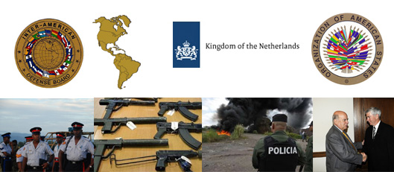

Thursday, October 13, 2011
10:00 – 11:30 AM
Hall of the Americas, 17th Street and Constitution Ave. NW
Washington, DC 20006
Program

10:00 am Welcoming remarks by Adam Blackwell, Secretary for Multidimensional Security, OAS

10:10 am Keynote Remarks by the Honorable Prime Minister of Aruba:
Michiel Godfried Eman
Panelists:
Colonel Jos Coumans (RNLMC), Naval Attaché and Assistant Defense Attaché for the Netherlands in the United States
Adam Blackwell, Secretary for Multidimensional Security, OAS

10:50 am Question and answer session

11:20 am Event closing by Lieutenant-General Guy Thibault, Chairman of the
Inter-American Defense Board

Please register here or send an e-mail to SER-DIA@oas.org

