**MEETING OF THE WORKING GROUPS 1 AND 2** OEA/Ser.L/XIX.VI.1

**OF THE XXI INTER-AMERICAN CONFERENCE** CIMT-21/GT1-GT2/doc.9/23

**OF MINISTERS** **OF LABOR** 17 September 2023

September 21 - 22, 2023Original: Spanish

Washington, D.C., United States of America

FINANCIAL STATUS OF THE INTER-AMERICAN NETWORK FOR LABOR ADMINISTRATION (RIAL) AS OF SEPTEMBER 2023

FINANCIAL STATUS OF THE INTER-AMERICAN NETWORK FOR LABOR ADMINISTRATION (RIAL) AS OF JANUARY 2023

(Updated: September 17th, 2023—All monetary figures are in US dollars)

**CONTENTS**

1. Summary ……………………………………………………………………………………. 2
2. Contributions ……………………………………………………………………………….. 3
3. Expenditures………………………………………………………………………………… 5
4. Budgeted resources …………………………………………………………………………. 8
5. Outlook and available resources ……………………………………………………………. 8

Appendix 1 - 2006-2010 Period…………………………………………………………………. 10

Appendix 2 – Details of costs by funding source from 2011 to September 2023 ….…………… 11

**I. Summary**

The RIAL is currently financed through a Voluntary Contribution Fund, created by a decision of the Inter-American Conference of Ministers of Labor (IACML) and constituted within the OAS since 2011. The Fund receives contributions from the Ministries of Labor, according to their availability and financial capacities, at any time of the year; the minimum contribution is US $5,000.

Between 2006 and 2010, before the creation of the Fund, the RIAL was financed with an important financial contribution from the Labour Program of ESDC/Canada, as detailed in Appendix 1.

The Voluntary Contribution Fund has received US **$1,126,112** to date; 22 countries provided $773,112 and the Government of Canada provided $353,000. Among the contributions to the Fund, a contribution of $100,000 from the United States in 2023 and the sum of $105,000 from Trinidad and Tobago over time are highlighted. Added to these Fund resources is co-funding of approximately **$422,000**, for a total budget of **$1,548,112.**

Decisions on the use of the Fund, in accordance with its Guidelines, are made at the Planning Meetings of the IACML, which are held immediately after each conference and include the participation of the Ministries that lead the Conference: the troika (past, present and future Chairs) and the Chairs and Vice Chairs of the Working Groups. Additionally, there are annual Meetings of the Authorities held with the objective of assessing the completion of the IACML Work Plan, review the RIAL financial status, and decide on the use of available resources. The last virtual annual Meeting of Authorities of the XXI IACML was held in January 2023.

The resources of the RIAL are divided into two areas: RIAL Activities (Workshops, Bilateral Cooperation, etc.) and operating costs, which partially cover the human-resources component of the RIAL and include administration, follow-up and communications.

Spent resources to date, amount to **$1,400,657** coming from the Voluntary Contribution Fund ($978,657, including Canada’s contribution) and other in-kind contributions valued at $422,000. In addition, in accordance with the decisions of the Meetings of Authorities of 2022 and 2023, there are currently budgeted resources of **$35,000** for activities in 2023 and 2024 of the IACML Work Plan 2022-2024. This leaves a balance of **$112,456.** It should be noted that the contribution of $100,000 from the United States in 2023 must be allocated to the RIAL’s actions contemplated in the 2022-2024 Work Plan of the IACML.

**II. Contributions**

To date, 23 Ministries of Labor have contributed to the Fund. As shown in **Chart No. 1**, some countries have made more than one contribution, and others have contributed much more than the established minimum. Canada has made two important contributions: $200,000 between 2012-2014 and $153,000 for 2018-2020. Given the large amount of the contributions, two separate projects were established for accounting purposes, but its use was also decided upon by IACML authorities. The total sum of contributions from Trinidad and Tobago for $105,000 and the recent contribution from the United States for $100,000 are highlighted, the latter is intended to cover the activities of the RIAL within the 2022-2024 Work Plan of the IACML.

**Chart No. 1**

**Contributions received by country**

*(In US dollars)*

|  |  |  |
| --- | --- | --- |
| **Country** | **Amount** | **Year** |
| 1.Argentina | 29,700 | 2011 |
| 2.Bahamas | 60,000 | 2011, 2012, 2016, 2017, 2019-2022 |
| 3.Barbados | 55,000 | 2011 to 2020, 2022 |
| 4.Belize | 7,492 | 2011, 2013 |
| 5.Bolivia | 39,995 | 2013 to 2018, 2020-2021 |
| 6.Brazil | 43,129 | 2013 |
| 7. Colombia | 7,669 | 2015 |
| 8. Chile | 15,000 | 2016, 2017, 2022 |
| 9. Ecuador | 10,000 | 2011, 2013 |
| 10. El Salvador | 5,000 | 2015 |
| 11. Grenada | 30,000 | 2016-2021 |
| 12. Guyana | 31,800 | 2016, 2017, 2022, 2023 |
| 13.Jamaica | 22,469 | 2012-2015, 2022 |
| 14.Mexico | 19,194 | 2011, 2013, 2014, 2015 |
| 15. Panama | 45,000 | 2011, 2013, 2015-2018, 2020-2022 |
| 16. Paraguay | 33,922 | 2015-2019, 2022 |
| 17. Peru | 54,700 | 2012-2022 |
| 18.Dominican Republic | 29,776 | 2012, 2013, 2018 – 2020-2021 |
| 19. S. Kitts and Nevis | 23,285 | 2017, 2019-2023 |
| 20.Suriname | 4,980 | 2011 |
| 21. Trinidad & Tobago | 105,000 | 2011 to 2018, 2020-2021, 2023 |
| 22.United States | 100,000 | 2023 |
| **TOTAL -Contributions to Voluntary Fund** | **$ 773,132** |  |
| 23. Canada | $353,000 | 2012-2014, 2018-2020 |
| **TOTAL** | **$1,126,112** |  |

Annual contributions vary considerably, as shown in **Chart No. 2 and Graph No.1**.Over the past years, contributions have been low, but have been compensated by Canada’s contribution for 2018-2020 and, in 2023, for the contribution of $100,000 from the United States. It is noteworthy that in 2020, a very difficult year for all Ministries, contributions of more than $40,000 were received. The Ministries of Labor of Trinidad & Tobago, Barbados and Peru have informed the Technical Secretariat that this item is already included in their annual budgets. The almost uninterrupted contributions of these countries are highlighted, as well as the Bahamas, Bolivia, Panama, and Grenada. It is expected that others may follow in making contributions on a consistent basis.

**Chart No. 2**

**Contributions received by year to the Voluntary Contribution Fund**

|  |  |  |
| --- | --- | --- |
| **Year** | **Amount** | **Canada’s contribution** |
| 2011 | 74,680.5 |  |
| 2012 | 34,940.0 | 200,000.0 |
| 2013 | 95,555.4 |  |
| 2014 | 34,970.0 |  |
| 2015 | 57,588.1 |  |
| 2016 | 55,011.0 |  |
| 2017 | 96,023.6 |  |
| 2018 | 45,155.0 | 153,000.0 |
| 2019 | 31,425.0 |  |
| 2020  2021  2022  2023 | 41,292.5  34,205.5  52,285.9  119,980.0 |  |
| ***Total contributions*** | ***773,112*** | ***353,000.0*** |

**Graph No. 1**

**Contributions received by year to the Voluntary Contribution Fund**

*(In US dollars)*

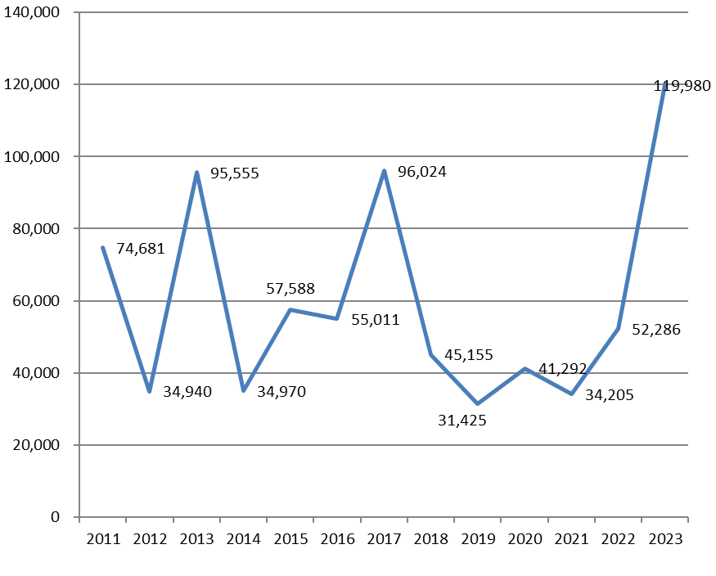

In-kind or financial contributions which have not entered the OAS accounting –valued at **$422,000**-, have allowed for the development of RIAL activities and should be accounted for as part of total contributions.

**III. Expenditures**

The authorities of the IACML, in accordance with the Guidelines of the Voluntary Contribution Fund, determine the allocation of the Fund’s resources during all the Planning Meetings, which follow the Ministerial Conferences, since 2012, dividing them among Hemispheric Workshops, bilateral cooperation activities, studies, communications and operation costs, the last of which partially cover RIAL’s human resources. In addition, during the annual virtual meetings, the IACML authorities have reviewed the financial status of the RIAL and also made decisions on its allocation.

RIAL’s expenditures between 2011 and September 2023 total **$1,400,657**, which come from the Voluntary Contribution Fund ($978,657, including Canada’s contribution) and from other in-kind contributions made by OAS, governments, or partner international organizations, calculated at $422,000 as specified in **Chart No. 3**.

**Chart No. 3**

**Total costs by category and funding source**

*(In US dollars)*

|  |  |  |  |  |
| --- | --- | --- | --- | --- |
| **CATEGORY OF COST** | **SOURCE** | | | **Total** |
| **Voluntary Fund**  (excluding Canada) | **Contribution from Canada** | **Other support** (in-kind or direct) |
| **Workshops** | 179,546 | 74,180 | 160,000 | **413,726** |
| **Bilateral cooperation** | 184,500 | 112,758 | 20,000 | **317,258** |
| **Studies** | 20,000 | 19,400 | 10,000 | **49,400** |
| **Courses** | 5,000 | 33,600 | 20,000 | **58,600** |
| **Communications** | 30,000 | 42,150 | 72,000 | **144,150** |
| **Operations (administration)** | 190,485 | 70,913 | 140,000 | **401,398** |
| **Others** | 16,125 |  |  | **16,125** |
| **TOTAL COSTS** | ***$625,656*** | ***$353,000*** | ***$422,000*** | **$1,400,657** |

Appendix 2 expands on this Chart and provides details about past costs according to their funding source, including resources that have been leveraged for each activity.

Figure No. 2 shows the distribution of expenses according to their component. The operation component is divided in 2: 1) the part that the OAS has covered in salaries of a consultant that supports the administration, logistics, and development of new RIAL products, and 2) the part that the RIAL Fund has covered for the same purpose. The time of the Coordinator of the RIAL is not counted.

**Figure No. 2**

**Distribution of RIAL expenditures**

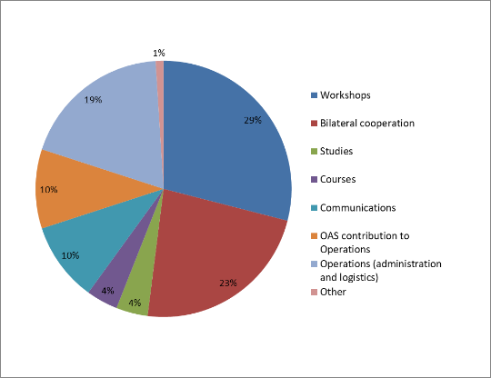

Some important facts about costs:

* In 2021, a new expense category was created, Courses, opening a new field of action for the RIAL. In that year the Virtual Course on Gender-Based Violence at Work was launched, developed by the OAS/RIAL with the Inter-American Commission of Women (CIM) and delivered on the Educational Portal of the Americas.
* Average cost of a 2-day RIAL in-person Workshop: $31,000. Includes the costs of simultaneous interpretation, equipment, materials and travel expenses covered by RIAL (this item has been reduced in relation to the first RIAL workshops and consists of co-financing for accommodation costs, and, in a small number of cases, airfare); the host country and/or partner institution cover other associated costs (Human resources not included).
* The cost of a virtual activity of approximately 4 hours is $3,000, including platform and simultaneous interpretation. During 2020, the first virtual hemispheric activities (Working Group Meetings and Gender Dialogue) and bilateral activities were carried out with very good results. It is worth mentioning that the decision to transfer face-to-face cooperation to the virtual space must consider the objectives and expected results.
* Average cost of an in-person bilateral cooperation activity: $6,500. Includes travel expenses in terms of airfare ticket, accommodation, and meals (Human resources not included).
* Operating costs, which as shown in Figure 1 are 29% of the total (distributed between the OAS with 10% and the RIAL Fund with 18%), refer to administration and follow-up on activities. That is, they concentrate the human-resource component of the RIAL and are essential for its development. This item also includes expenses associated with the development of new RIAL products. Within the Covid-19 pandemic, the RIAL designed two new products: The Portfolio of Responses from Ministries of Labor to the Covid-19 pandemic, and the Repository of Guidelines and Protocols for reopening and Return to Work; subsequently, in 2022 it launched the Portfolio of Telework Laws and Regulations and in 2023, the Repository of Actions on Paid Domestic Work, all of them human-capital intensive and which were covered by this item. In terms of the Guidelines of the Fund, 15% of contributions are designated for operating expenses, up to a maximum of $50,000 annually. The current level of contributions continues to be insufficient to cover RIAL’s operating costs, which is why the OAS has provided an important amount of resources and the RIAL authorities decided, at their 2020 and 2021 meetings, to allocate additional resources for it. The OAS’ contribution cannot be guaranteed in the future.
* The OAS supports the RIAL’s coordination in kind, which is calculated at approximately $80,000 annually and is not included in the amounts reported in this report.
* RIAL’s component of communications includes updating the website and the Portfolio of Programs, the elaboration of newsletter and social media managing. It is a component with increasing relevance, currently representing 10% of the RIAL’s expenses. As for the operations component, the OAS has provided important resources to the communications component. This contribution represents half of total communications costs.
* The Fund’s expenses have been consistently lower than the budgeted amounts, especially for Hemispheric Workshops, given important leveraging of resources.

**IV. Budgeted resources**

The IACML Work Plan 2022-2024 includes a budget for the different activities, as approved by the authorities at the February 2022 Planning Meeting, in addition, the Meeting of Authorities in January 2023 also decided on the use of available resources. The budgeted resources for 2022 and January-September 2023 activities were fully spent, as it can be corroborated in this document and in the Work Plan Performance Report (document: CIMT-21/GT1-GT2/doc.3/23). Below are the resources that are yet to be utilized.

**Chart No. 4**

**Budget for activities in 2023 and 2024 of the IACML Work Plan 2022-2024 according to source of financing**

*(In US dollars)*

|  |  |  |
| --- | --- | --- |
| **Activity** | **Budget approved by the RIAL** | **In kind or to be determined in the future** |
| RIAL Workshop– Enforcement of labor legislation | 10,000 | United States |
| RIAL Workshop – Future of work and new forms of employment | 10,000 | Costa Rica, to be confirmed |
| Preparatory Meeting of the XXII IACML |  | Colombia |
| XXII IACML |  | Host Country and OAS |
| Activities 16th and 17th RIAL Call (2023, 2024) * | 15,000 |  |
| **TOTAL:** | **$35,000** |  |

*\*These amounts were approved by the RIAL authorities before the contribution from the United States to cover RIAL activities within the 2022-2024 Work Plan was received.*

**V. Outlook and available resources**

Summarizing what has been reported, the total budget of the RIAL between 2011 and 2023 is **$1,548,112**, consisting of **$1,126,112** from contributions from 23 countries to RIAL’s Voluntary Fund and **$422,000** of in-kind co-funding resources.

Spent resources to date, amount to **$1,400,657** and the budgetallocated for activities in 2023 and 2024 is $35,000; thus, the balance of the RIAL Fund is **$112,456.** It should be noted that the contribution of $100,000 from the United States in 2023 must be allocated to the RIAL actions contemplated in the 2022-2024 Work Plan of the IACML.

As noted in previous Reports, the commitment of all Member States, as well as more consistent and stable financial contributions is crucial to ensure the sustainability of the RIAL in the future. To date, only 23 of the 34 OAS Member States have made contributions to the Fund, while all of them have participated in the RIAL.

The Fund should have a budget of no less than $120,000 per year to guarantee continuity of actions, according to the standards that have been established. Thus, contributions should be reinforced.

The RIAL calls on Ministries of Labor to make contributions in accordance with their national capacities. In this sense, it is hoped that more developed countries with more robust economies will make contributions above the established minimum of $5,000 per year.

**APPENDIX 1**

**2006 – 2010 Period**

The establishment of the RIAL and most of its activities in the period 2006-2010 were funded from a large contribution by the Canadian Labour Program, provided under four agreements with the OAS for a total of US$1.35 million. This funding covered RIAL’s activities and basic operating costs.[1]

|  |  |  |
| --- | --- | --- |
| ***Contribution by the Canadian Labour Program to the RIAL*** | | |
| **2006-2010** | | |
| **Agreement** | **Can$** | **US$** |
| RIAL 1 (2006) | 65,844.45 | 56,483.91 |
| RIAL 2 (2006 - 2007) | 310,800.00 | 265,812.91 |
| RIAL 3 (2007 - 2008) | 275,280.00 | 261,251.79 |
| RIAL 4 (2008 – 2010) | 890,000.00 | 771,851.92 |
| **TOTAL** | **$1,541,924.45** | **$1,355,400.53** |

During this period, financial contributions from the United States, Mexico, Argentina, and Brazil were also received. Additionally, the OAS has contributed financial resources for RIAL’s coordination and operations.

|  |  |  |
| --- | --- | --- |
| ***Other financial contributions to the RIAL*** | | |
| **May 2006- July 2010** | | |
| **County/organization** | **US$** | **Description** |
| United States | 171,680.00* | Most bilateral activities in 2006, contribution to the labor dimension workshop (July2006), and co-financing of the youth workshop (May 2008) and bilateral coop in 2010 |
| Mexico | 15,000.00 | Employment services workshop (November 2006) |
| Argentina | 12,000.00 | Bilateral activities co-financing |
| Brazil | 33,900.00 | Bilateral activities and youth workshop (May 2008) co-financing |
| OAS | 320,000.00 | RIAL coordination and operation |
| **TOTAL** | **$552,580.00** |  |

**Appendix 2 – details of costs AND funding sourceS 2011 - september 2023 (1/2)**

(*US dollars*)



**Appendix 2 – details of costs AND funding source 2011 - SEPTEMBER 2023 (2/2)**

(*US dollars)*



1. Operating expenses included the hiring of a person full time as technical and administrative support and a person part-time, who administers and updates the web page.