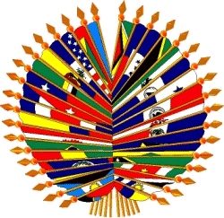
Organización de los Estados Americanos
Organização dos Estados Americanos
Organisation des États américains
Organization of American States

VI MEETING OF AUTHORITIES AND EXECUTIVE COMMITTEE
OF THE INTERAMERICAN COMMITTEE OF EDUCATION
April 27- 28, 2006

Information Flyer

1. Meeting Location

Organization of American States, Room Guerrero, 17th Street and Constitution Ave., NW, Washington, D.C., 20006, USA

2. Hotel Information

The Technical Secretary recommends making reservations at one of the following:

STATE PLAZA HOTEL
2117 E Street, N.W.
Washington, D.C.
Tel. (202) 861-8200 – Fax (202) 659-8601
Standard: US$ 143 + taxes (14.5%)

CONCORDIA HOTEL
1250 New Hampshire Avenue, N.W.
Washington, D.C.
Tel. (202) 973-5500 – 202-973-5401
Standard: US$ 124

CARLYLE SUITES
1731 New Hampshire Avenue, N.W.
Washington, D.C.
Tel. (202) 234-3200
Standard: US$ 179 + taxes (14.5%)

ONE WASHINGTON CIRCLE
1 Washington Circle, N.W.
(202) 872-1680
Standard: US$ 199 + taxes (14.5%)

3. Restaurants

Bobby Van’s Steakhouse (Steak, expensive) Downtown 809 15th St., NW Washington, DC. 202-589-0060
Gerard’s Place (French, very expensive) Downtown 915 15th St., NW Washington, DC
202-737-4445
Jaleo (Spanish, moderate) Downtown 480 Seventh St., NW Washington, DC 202-628-7949
Les Halles (French, moderate) Downtown 1201 Pennsylvania Ave., NW Washington, DC
202-347-6848

Luigino (Italian, moderate) Downtown 1100 New York Ave., NW Washington, DC

202-371-0595

4. U.S. entry and exit policies

The general U.S. entry requirements can be found in detail on the U.S. Department of State website: http://travel.state.gov/visa/index.html You can also find specific information on the North American embassy’s webpage in your country.

5. Participant Registration

You are asked to send your registration information via email or fax to rreyes@oas.org, dedwards@oas.org ; Fax (202) 458- 3476/ 3167. The registration form is attached to the back of this flyer and can also be found on the OECT website: www.oest.oas.org

6. Languages and Working Documents

There will be simultaneous interpretation in English and Spanish.

7. Climate

April in Washington is Spring. The average temperatures is around 18 C° or 65 F.

8. Local Time

Washington DC is on Eastern Standard Time.

9. Electrical current

110 volts and 220 volts.

10. Places of Interest

National Gallery of Art
National Air and Space Museum
Museum of the American Indian
American History
Hirschhorn Museum and Sculpture
Ford’s Theater
National Cathedral
Pentagon City Mall
Arena Theater
The Corcoran

11. Business Hours

From 8 AM to 7 PM in Washington DC.

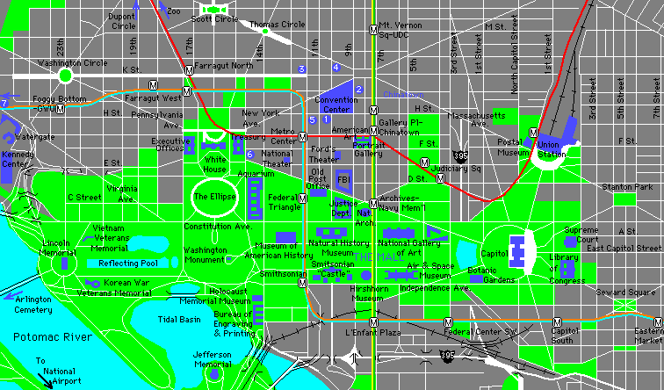
OAS
OAS/GSB

OAS: OAS Main Building: 17th and Constitution Ave. NW
OAS/GSB: OAS General Secretariat Building: 1889 F. st. NW

Please note that these prices are approximate and are subject to change.

