NINTH REGULAR MEETING OF OEA/Ser.W/XIII.6.9
THE INTER-AMERICAN COMMITTEE ON EDUCATION CIDI/CIE/doc. 9/21
November 18-19, 2021 10 November 2021 Washington, D.C., United States of America Original: Spanish
VIRTUAL

PROCESS FOR BUILDING THE SECOND PHASE OF THE
INTER-AMERICAN EDUCATION AGENDA
PERIOD: July 2019 – April 2022

Methodology established by the Officers of the Inter-American Committee on Education (CIE)

(Document prepared by the Technical Secretariat at the request of the Officers of CIE)

TABLE OF CONTENTS

A. OBJECTIVE 1
B. BACKGROUND 1
C. FORUMS FOR DIALOGUE: SYSTEMATIZATION AND BUILDING PROCESSES 2
D. METHODOLOGY ESTABLISHED BY CIE OFFICERS 3
E. CONCLUSIONS 4
F. FIRST ANALYSIS OF COMMON AND CONTRASTING ELEMENTS 5

PROCESS FOR BUILDING THE SECOND PHASE OF
THE INTER-AMERICAN EDUCATION AGENDA
PERIOD: July 2019 – April 2022

OBJECTIVE

The objective of this document is to present officials from the member state ministries of education with a chronology of the process carried out since the last meeting of the ministers of education held in July 2019. It describes through different stages the process of collectively building the second phase of the Inter-American Education Agenda. This document recaps the different modalities of member states participation during said period.

BACKGROUND

The Meeting of Ministers of Education held in Panama in 2015 saw the approval of resolution CIDI/RME/RES. 1/15 rev. 1, “Building an Inter-American Education Agenda: Education with Equity for Prosperity”… a “forum for policy dialogue in order to define priority lines of action to guide the Inter-American cooperation in education over the next five years according to the following existing mandates: quality, inclusive and equitable education; strengthening of the teaching profession; and comprehensive early childhood care.”

At this same meeting the Inter-American Committee on Education was entrusted “with building the Inter-American Education Agenda (IEA), and established three working groups to carry out that task. The working groups were defined in accordance with the existing mandates that were prioritized for the development of the IEA… The IEA shall be implemented for a period of five years, commencing in 2017, after which it will be revisited by the member states …”/

In February 2017, at the Ministerial Meeting held in The Bahamas under the banner of “The Inter-American Education Agenda: Building Alliances and Advancing Towards the Sustainable Development Goals” the Inter-American Education Agenda was approved. This Agenda’s Plan of Action,/ “The Inter-American Education Agenda: Building Sustainable Partnerships through Cooperation, with Renewed Focus on Education and Skills Development for Better Citizenry,” was adopted during the Meeting of Ministers that took place in July 2019 in Washington, D.C.

In keeping with the guidelines established for member states for ministerial-level processes, the 2019-2022 Work Plan of the CIE/ was developed, negotiated and adopted. This Work Plan is an instrument, which, through the process of dialogue among officials of the ministries of education to foster “collective reflection and definition of concerted actions focused on three core themes: (1) To share concrete initiatives for the implementation of the IEA; (2) to deepen synergies among global, hemispheric, and subregional educational initiatives; and (3) to promote inter-sectoral cooperation…,” enabled progressive consensus-building based on national public policies and programs with the potential to become hemispheric actions.

Once the Work Plan of the CIE had been approved, the Committee’s officers spearheaded virtual meetings in July and August of 2020 after the advent of the pandemic. Twenty-four projects with hemispheric potential were presented at these meetings for comments by focal points and representatives of the ministries of education.

Officials participated to learn from the lessons other countries shared, contributing their particular perspectives on the topic. At the same time they noted the challenges and/or specific needs that were not fully reflected in the topics approved for the 2019-2022 period.

Reaffirming this collective building process based on the forums for dialogue the IEA provided for, on October 20, 2020, the OAS General Assembly,/ pursuant to resolution AG/RES. 2955 (L-O/20) Articles 21-23/26),/ instructed the Executive Secretariat for Integral Development (SEDI) to continue to support the work plan of the CIE,/ as well as to support education ministries and institutions in charge of education in the region in promoting the Hemispheric Action Plan for the Continuity of Education (PHACE) in the context of the coronavirus pandemic.

Finally, the resolution also instructed SEDI, as the Technical Secretariat of the CIE, to begin planning the second phase of the IEA by proposing guidelines for the next five-year period (2022-2027).

FORUMS FOR DIALOGUE: SYSTEMATIZATION AND BUILDING PROCESSES

Based on the guidelines authorities established to implement the Work Plan of the CIE—specifically, by creating virtual forums for dialogue for specialists from ministries of education to share experiences and systematize knowledge—coordination and implementation of different projects went forward. Listed below are different forums for dialogue on public policies associated with this process:

- Global Education Futures Forums: Re-envisioning Education to Create Resilient and Responsive Systems. Collaborative initiative between the OAS, through the CIE, and the Massachusetts Institute of Technology’s Abdul Latif Jameel World Education Lab (MIT J-WEL), which brought together public policy leaders and decision makers in the field of education from OAS member states. The symposium’s objective was to explore new visions for education in a post-pandemic world and to strengthen the definition of policies, research, capacities, practices, and the infrastructure needed to make these visions a reality in our region.

- Towards a Culture of Digital Accessibility: Experiences and Educational Challenges for Persons with Disabilities during the Pandemic.

- Virtual Roundtable and Sharing of Experiences on Inclusion and Equity in Education.

- Roundtable: Exchanges and Thoughts on the Return to In-person Education.

- Virtual Roundtable “The Path to Bilingualism in Costa Rica: An Educational Experience with a National Approach”.

- Education-health intersectoral dialogue: “Promoting school environments for healthy nutrition and physical activity.”

- Education-health intersectoral dialogue: “Promoting skills for a healthy life through physical and nutritional education at school.”

- Education-health intersectoral dialogue: “Policies and programs for implementing applicable regulations and standards to nutrition at schools.”

METHODOLOGY ESTABLISHED BY CIE OFFICERS

It bears noting that under the leadership of the CIE Officers; the forums for dialogue have established a very clear dynamic that has been strengthened and consolidated in the forums’ successive versions, using the following structure:

- The country spearheading the project presents a concept note to the OAS. The note is worked on in conjunction with the Technical Secretariat to devise the conceptual framework, discussion questions, expected achievements of the gathering, and the subsequent formulation of the methodology and work agenda. Once the note has been agreed upon, the work teams from the country/countries summon the region to a virtual dialogue.

- The dynamic of the dialogue and shared experiences process is structured around the following elements:

- Framing the conversation: consisting of a panel in which the country leading the topic/experience of the specific CIE work plan project presents its experiences, lessons learned, and the challenges it faced to the participating officials. This may also include the participation of one or more countries that are spearheading initiatives related to that topic.
- Group or round table discussions: officials from countries participating at the meeting are divided into groups and provided a period of time to undertake dialogue and debate based on discussion questions related to the topic of the event. The aim is to identify lessons learned, challenges faced, and contrasting elements in comparison to the experiences of their own countries. To this end, each discussion group will have a moderator and a person responsible for taking notes.
- Conclusions: the meeting ends with the presentation of the main points addressed in the discussion groups and the conclusions that the participants drew.
- Systematization: carried out after the event and consisting of a detailed compilation of the contributions countries made during the virtual dialogue: the challenges identified, the lessons learned, and the next steps based on said contributions. The outcome document is sent to officials and authorities that participated in the meeting for their review and validation. These systematizations are expected to be inputs for the ministerial process and may eventually become recommendations.

CONCLUSIONS

In keeping with the original mandate of the ministers of education that defined the Inter-American Education Agenda (IEA) as “a forum for policy dialogue in order to define priority lines of action to guide inter-American cooperation on education over the next five years,” we instruct the Technical Secretariat of the CIE to convene a meeting of the Committee officers and working groups prior to the Preparatory Meeting of the Meeting of Ministers of Education, scheduled to take place in March 2022.

The meeting’s objective will be to confirm the priorities of the IEA, its elements, and emerging needs, as well as to determine the actions needed to ensure educational continuity over the next five years; the foregoing with a particular focus on vulnerable populations and in keeping with the topics discussed at the forums for dialogue held over the last 18 months.

The stages of the second phase of the IEA building process are:

- FIRST STAGE: Global Education Futures Forums: Re-envisioning Education to Create Resilient and Responsive Systems

- SECOND STAGE: Implementation of the CIE Work Plan, building from the local towards the hemispheric (July 2020 – September 2021).

- THIRD STAGE: Systematization, discussion, and validation of the documents that systematize virtual dialogues among participating member state officials under the CIE Work Plan (January-July 2021).

- FOURTH STAGE: Distribution and consideration of the final proposals of documents prepared during the Ninth Regular Meeting of the Inter-American Committee on Education (November 2021).

- FIFTH STAGE: Convening of a special virtual meeting of CIE officers and working groups with authorities from the ministries of education in the region to discuss the draft document of the Second Phase of the Inter-American Education Agenda (January-February 2022).

- SIXTH STAGE: Formulation of the final document of the Second Phase of the Inter-American Education Agenda during the Preparatory Meeting of the Meeting of Ministers of Education, to be held in March 2022.

- SEVENTH STAGE: Adoption of the Second Phase of the Inter-American Education Agenda, with a renewed focus on emerging needs in the current contexts of change, during the Meeting of the Ministers of Education, to be held in April 2022.

FIRST ANALYSIS OF COMMON AND CONTRASTING ELEMENTS

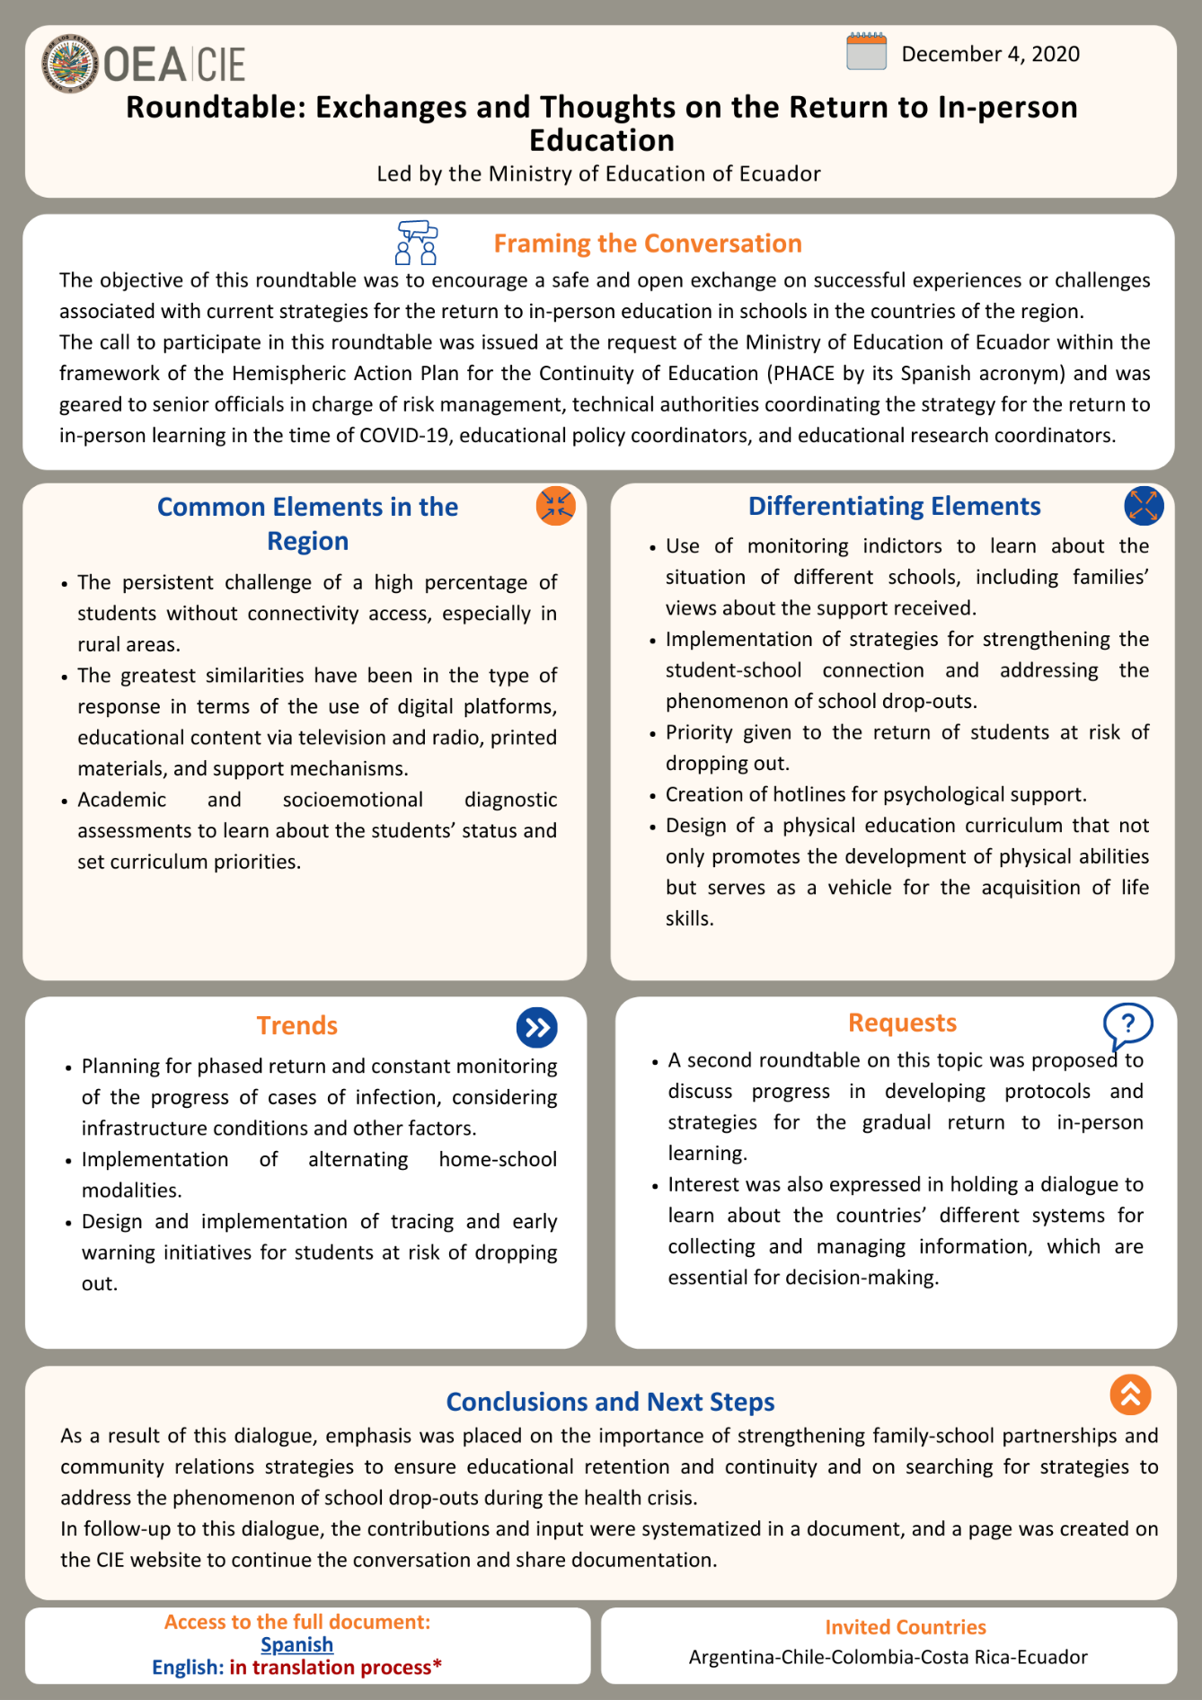
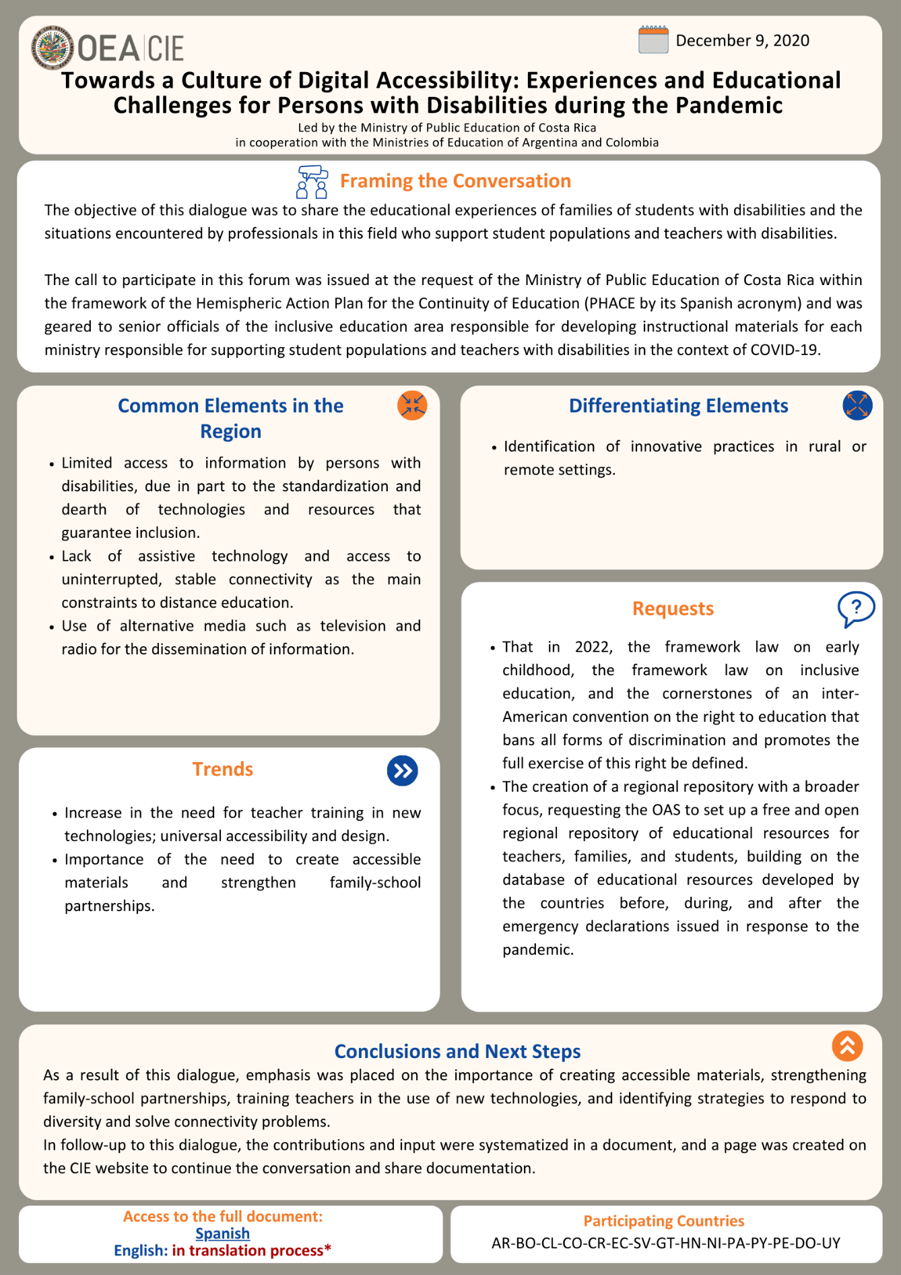
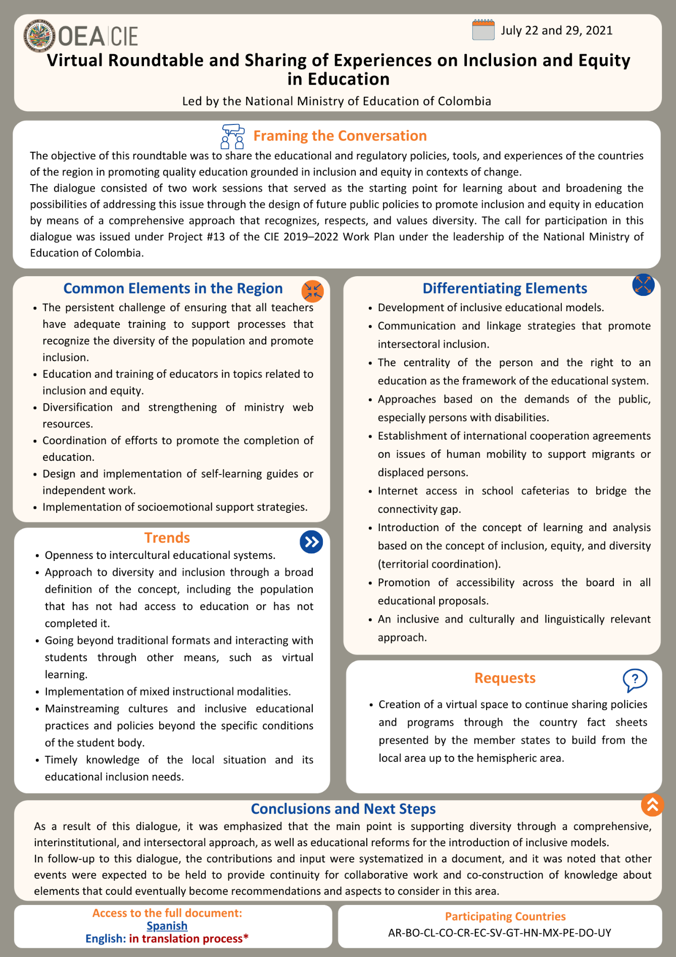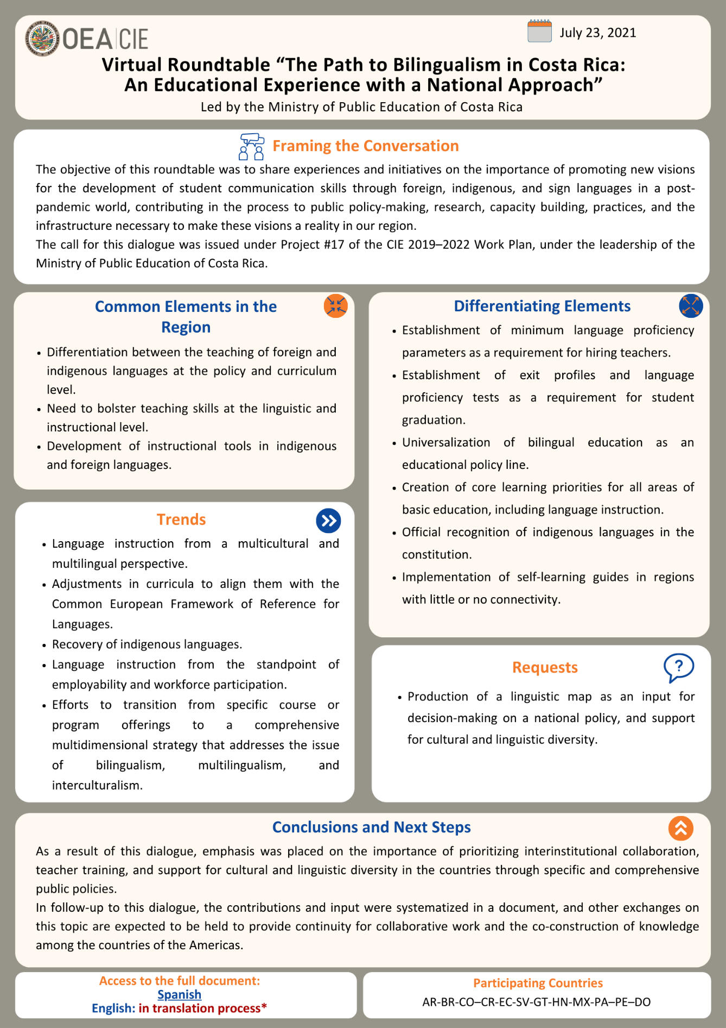
Education-Health Intersectoral Dialogue: Towards Healthy School Environments: in translation process*
CIDED00225E01

. http://scm.oas.org/IDMS/Redirectpage.aspx?class=V.13.1%20CIDI/RME/doc&classNum=6&lang=e
. http://scm.oas.org/IDMS/Redirectpage.aspx?class=V.13.1%20CIDI/RME/doc&classNum=6&lang=e
. http://www.oas.org/en/sedi/dhdee/cie/PLAN%20TRABAJO%20CIE%202019-2022-APROBADO-CIDED00212-ING.docx.
. AG/RES. 2955 (L-O/20) ADVANCING HEMISPHERIC INITIATIVES ON INTEGRAL DEVELOPMENT: PROMOTING RESILIENCE (Adopted at the first plenary session, held on October 20, 2020) AG/RES. 2955 (L-O/20) http://www.oas.org/en/sla/docs/AG08273E10.pdf
. http://scm.oas.org/IDMS/Redirectpage.aspx?class=AG/doc.&classNum=5717&lang=e
. http://www.oas.org/en/sedi/dhdee/cie/PLAN%20TRABAJO%20CIE%202019-2022-APROBADO-CIDED00212-ING.docx

