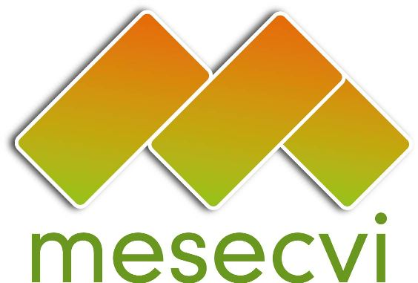
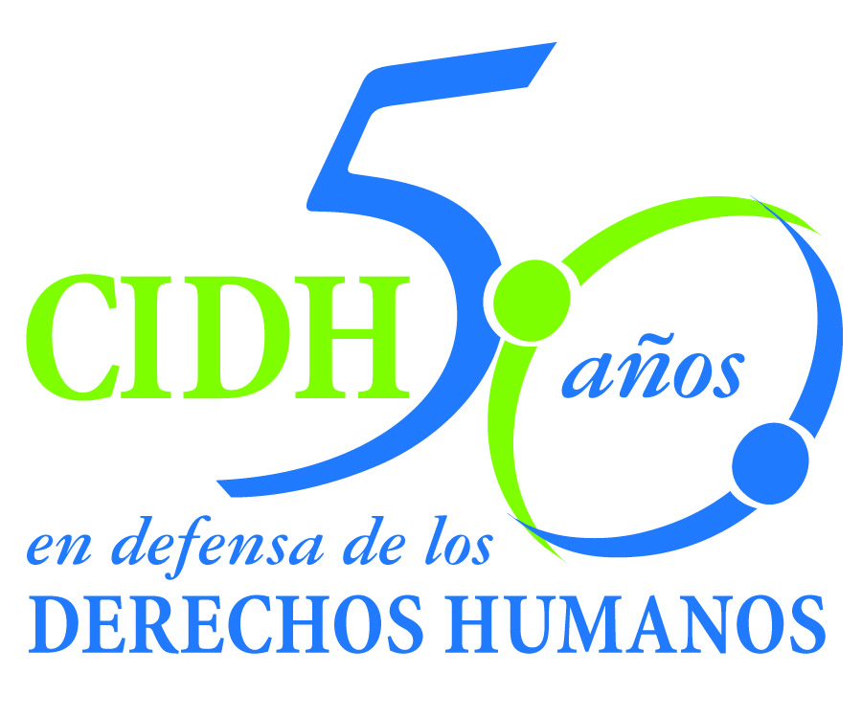
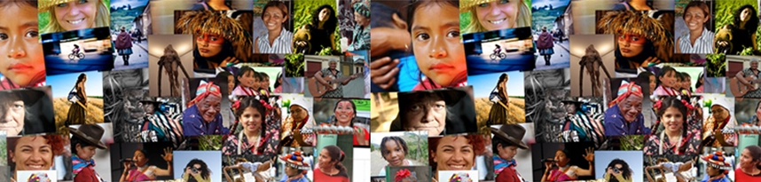
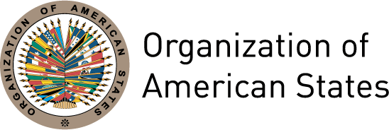

Human Rights, Violence against Women and Access to Justice

Tuesday, September 27th 2011

9:30am – 5:30pm

OAS Headquarters, Rubén Darío Room

1889 F Street NW, Washington, DC

Program

Violence against women is the maximum expression of gender-based discrimination, a violation of their fundamental rights and an obstacle to their full political, economic and social participation. With a view to combating it, Article 7 of the Inter-American Convention for the Prevention, Punishment and Eradication of Violence against Women (Belém do Pará Convention, 1994) sets forth the obligations of the State to establish just and effective legal procedures for women who have been subjected to violence. The same article also obliges States to establish the judicial and administrative mechanisms necessary to ensure that women have effective access to just and effective compensation or reparation.

The countries of Latin America and the Caribbean have gradually adapted their national legislation to the international and inter-American juridical framework on women’s rights, within which particular reference is made to the Convention on the Elimination of all Forms of Discrimination against Women (CEDAW) and the Belém do Pará Convention. According to the OECD, in the developing world, Latin America and the Caribbean is the region that has made the most progress in the formal recognition of women’s rights. Nevertheless, 15 years after the entry into force of the Belém do Pará Convention, little progress has been made in the effective and sustainable implementation of its provisions.

In its report on “Access to Justice for Women Victims of Violence” (2007), the Inter-American Commission of Human Rights found that the majority of cases of violence against women are not formally investigated, judged or sentenced by justice administration systems. This situation promotes a culture of impunity and tolerance for violence against women, as well as growing mistrust of the justice sector among women.

An analysis of the progress and challenges to the implementation of the Belém do Pará Convention reveals a number of problems, including an inadequate number of installations that attend women who wish to file complaints; the need to strengthen the capacities of justice sector personnel to address violence against women; the lack of protocols for the care of women victims of violence, particularly in indigenous languages; the use of conciliation or other measures of compromise between the aggressor and victim; and the lack of resources and mechanisms to implement effective protection measures.

An effective and transparent justice sector that responds to women’s rights on the basis of international and national legal and policy commitments is essential to ensuring that women have real access to justice. Based on an analysis of the state of the art, this seminar on Human Rights, Violence against Women and Access to Justice seeks to identify interventions and actions that guarantee an appropriate, immediate, opportune, exhaustive, serious and impartial judicial response to violence against women, within a framework of human rights and fundamental freedoms.

To register for the event, please send an e-mail to the Inter-American Commission of Women:

spcim@oas.org

The event will also be Webcast on:

http://www.oas.org/en/media_center/webcast.asp

Program

9:30-10:00 | Opening session  - Rocío García Gaytán, President of the Inter-American Commission of Women (CIM)  - Victor Rico Frontaura, Secretary, Secretariat for Political Affairs on behalf of José Miguel Insulza, Secretary General of the Organization of American States (OAS)
10:00-11:00 | Women, violence and access to justice  Moderator: Carmen Moreno, Executive Secretary of the Inter-American Commission of Women (CIM)  - Progress of the World’s Women 2011, “In pursuit of justice”  Laura Turquet, Principal Author, UN Women  - Access to Justice for Women Victims of Violence in the Americas  Elizabeth Abi-Mershed, Deputy Executive Secretary of the Inter-American Commission on Human Rights (IACHR)  - Indicators to evaluate State compliance with the Belém do Pará Convention  RoseMary Madden, Special Program for the Human Rights of Women, Inter-American Institute for Human Rights (IIDH)
11:00-12:00 | Jurisprudence on violence against women  Moderator: Elizabeth Abi-Mershed, Deputy Executive Secretary, IACHR  - Tracy Robinson, IACHR Commissioner-elect  - Pablo Navarrete Gutiérrez, Coordinator of Legal Affairs, National Institute of Women (INMUJERES), Mexico
12:00-1:00 | Plenary debate
1:00-2:30 | Lunch
2:30-3:30 | Perspectives from the justice sector  Moderator: Jean-Michel Arrighi, Secretary for Legal Affairs, OAS  - Mónica Maccise Duayhe, Secretary for the Follow-up of Gender Equity Programs, Judicial Power of the Federation of Mexico  - Elizabeth W. Millard, Acting Executive Director, Cyrus R. Vance Center for International Justice  - Paula Vial, President of the Association of Women Lawyers of Chile
3:30-4:30 | Perspectives from the grassroots  Moderator: Hilda Morales-Trujillo, Coordinator of the Committee of Experts of the MESECVI  - Susana Chiarotti Boero, Member of the Committee of Latin America and the Caribbean for the Defense of Women’s Rights (CLADEM)  - Pedro Vuskovic, Coordinator of the Inter-American Program of Judicial Facilitators, OAS  - Ana Evelyn Jacir de Lovo, Director of the Department of Social Development and Employment, OAS
4:30-5:30 | Plenary debate

Biographies of the panelists and moderators

María del Rocío García Gaytán
President of the CIM, 2011-2012
President of the National Women’s Institute, Mexico

Rocío García Gaytán was appointed President of the National Women’s Institute (Inmujeres) of Mexico in February 2007. In her career, she has served as delegate of the State of Jalisco to Congress, where she promoted the formation of the Committee on Equity and Gender and legislation against gender-based violence. Beginning in 2002, she headed the Jalisco Women’s Institute, where she implemented the “women’s line” and the on-site assistance program to guide and advise women on matters such as violence in the family, education, health, and labor. She was a federal delegate to the 57th Legislature of the Mexican Congress, where she served as Secretary of the Committee on Equity and Gender and member of the Committee on Population, Borders, and Migration.

Victor Rico Frontaura
Secretary, Secretariat for Political Affairs, OAS
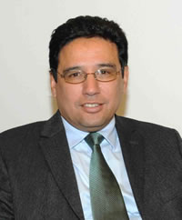
In September 2005, Victor Rico was appointed by the Secretary General of the OAS as Director of the Department of Democratic Sustainability and Special Missions of the Secretariat for Political Affairs. He studied economics at the Universidad Católica Boliviana (Bolivian Catholic University) and holds a Master's degree in International Relations from the Universidad de Belgrano in Buenos Aires, Argentina. He also pursued postgraduate studies on the European monetary system, at The London School of Economics. His professional positions include serving as Director General for Integration, Undersecretary for Integration, Deputy Minister of International Economic Relations, and Deputy Minister of Foreign Affairs in his native Bolivia. He was later appointed as Consul General-Ambassador in Santiago, Chile, where he served until 2005.

Carmen Moreno
Executive Secretary, Inter-American Commission of Women (CIM)
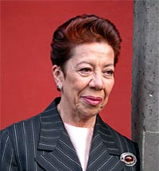
Carmen Moreno, an internationalist and diplomat, began her career in women’s rights and gender equality as a member of the Mexican delegation to the First World Conference on Women (1975). Since then she has served as the Mexican Ambassador to Costa Rica and Guatemala, as well as the Permanent Representative of Mexico to the OAS. In 2003, Carmen Moreno was appointed by the Secretary-General of the United Nations to serve as Director of the UN International Research and Training Institute for the Advancement of Women (UN-INSTRAW, now part of UN Women). In July 2009, Ms. Moreno was appointed by the Secretary General of the OAS, José Miguel Insulza, as Executive Secretary of the Inter-American Commission of Women (CIM).

Laura Turquet
Lead author, Progress of the World’s Women Report, UN Women
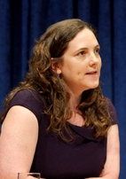
Laura Turquet is the manager and lead author of UN Women's flagship report, Progress of the World's Women. The latest edition of the report, launched in July 2011, focuses on women’s access to justice. Laura has worked for UN Women and its predecessor UNIFEM in New York for the past two years. Laura has worked on women's rights for 10 years, including at the international NGO ActionAid UK, at the Institute of Development Studies at the University of Sussex and for a UK feminist campaigning organization, the Fawcett Society. She has published many reports and briefings on gender equality issues, including on violence against women, access to justice and the Millennium Development Goals.

Elizabeth Abi-Mershed
Assistant Executive Secretary, Inter-American Commission on Human Rights
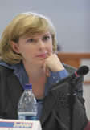
As Assistant Executive Secretary of the IACHR, Dr. Abi-Mershed examines and handles cases before the Commission, writes reports, and participates in the litigation of cases before the Inter-American Court of Human Rights. She also supports the work of the Special Rapporteur on the Rights of Women. A specialist in women’s rights, she teaches at the Washington College of Law at American University. Since 1992, Dr. Abi-Mershed has been a principal specialist in human rights at the OAS IACHR. She is a graduate of the Washington College of Law and Georgetown University and has published several articles on the human rights of women.

Rose Mary Madden Arias
Special Program on the Human Rights of Women
Inter-American Institute of Human Rights (IIHR)
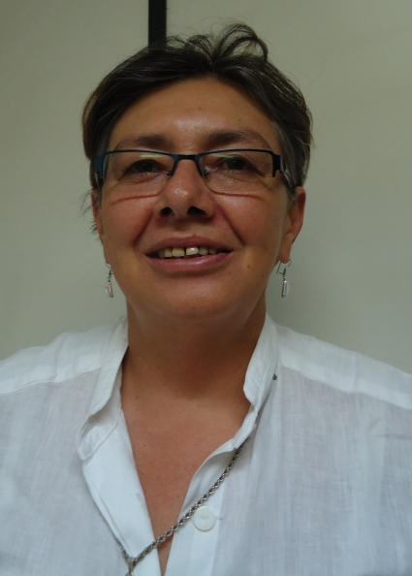
Since 2010, Ms. Madden has been in charge of the Program on the Human Rights of Women at the Inter-American Institute of Human Rights, where she has placed special emphasis on educating women on human rights. Until May 2010, she was a member of the team against sexual harassment at the Women’s Studies Center (CIEM) at the University of Costa Rica. She has participated in drafting a number of laws, such as the law on domestic violence, the law on responsible fatherhood, and the criminal law on violence against women, among others. She was an official delegate of the Government of Costa Rica to the expanded leadership of ECLAC in Santiago, Chile, and at the third preparatory meeting for the Fourth World Conference on Women.

Tracy Robinson
Commissioner-elect, Inter-American Commission of Human Rights

Tracy Robinson is the second Jamaican to be elected to as a member of the IACHR, during the 41st Regular Session of the Organization of American States (OAS) General Assembly in San Salvador (June 2011). She is a Senior Lecturer in the Faculty of Law at the University of the West Indies. Robinson has served as consultant to a number of projects for international organizations, including UN Women, the United Nations Children's Fund and the Organization of Eastern Caribbean States (OECS). She has also helped to produce a number of reports on child support, poverty and gender equality, sex work and the law and family law in the OECS, among others. Robinson was the recipient of the Rhodes Scholarship in 1992 while studying Law at Oxford University, and holds a Masters of Law degree from Yale University. She was admitted to the Jamaican Bar in 1997.

Pablo Navarrete Gutiérrez
Coordinator for Legal Affairs, National Institute of Women (INMUJERES) Mexico
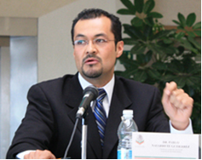
Graduate in law of the University of Guadalajara in Mexico, Mr. Navarrete specializes in democracy and human rights issues. He is a member of Amnesty International Mexico. Mr. Navarrete has collaborated with the State Commission of Human Rights in Jalisco, the Commission to Prevent and Eradicate Violence against Women in Ciudad Juarez and the Secretariat of the Interior of Mexico. He currently serves as Coordinator of Legal Affairs at INMUJERES, which he has represented as part of various national-level delegations to regional and international human rights bodies, including the public audience of the Inter-American Court of Human Rights in the “Campo Algodonero” case (Gonzalez et. Al v. Mexico) in April 2009.

Jean-Michel Arrighi
Secretary, Secretariat for Legal Affairs, OAS

Attorney and Doctor of Laws and Social Sciences and Professor at the Universidad de la República Oriental del Uruguay. Has lectured, among others, at the Universidad Federal de Rio Grande do Sul, Universidad de Buenos Aires, the University of Ottawa, the University of Paris II and at The Hague Academy of International Law. Former National Director of Commerce and Suppliers in Uruguay (1985 - 1990). Legal adviser to to the General Secretariat of the OAS (1993 - 1996). From 1996 to 2005, he was the Director of the Department of International Law of the General Secretariat of the OAS. Since 2005, he was then Director of the Department of International Legal Affairs until his appointment as Secretary for Legal Affairs in 2008. Author of books and articles on international law, consumer law and Inter-American law, published in journals in the Americas and Europe.

Mónica Maccise Duayhe
Secretary for the Follow-up of Gender Equity Programs, Judicial Power of the Federation of Mexico
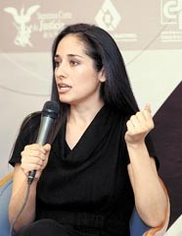
Mónica Maccise graduated in political science from the Autonomous Technological Institute of Mexico and has a Masters degree in Political Sociology, with studies in psychoanalysis. She has worked on human rights issues with several civil society organizations, including Servicios y Asesoría para la Paz (SERAPAZ) and Centro de Derechos Humanos Miguel Agustín Pro Juárez (Centro Prodh). She has conducted qualitative and quantitative research for the Applied Research and Opinion Area of the Institute for Juridical Research of the National Autonomous University of Mexico. In government, Ms. Macisse has served with the Secretariat for Finance of the government of the Federal District. In 2008, she began working with the Supreme Court of Justice of the Nation and in October of the same year was appointed General Coordinator of the Gender Equity Program.

Elizabeth W. Millard
Acting Executive Director, Cyrus R. Vance Center for International Justice
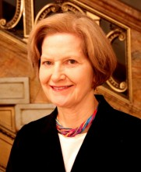
Ms. Millard oversees program development and fundraising for the Center and manages the Center’s institutional relationships with the New York City Bar, U.S. law firms, and other partners. She leads the Center's creation of collaborative ventures among law societies, law firms, and NGOs in Africa and Latin America and coordinates the Center's Africa program. Ms. Millard came to the Center in 2006 after retiring from Credit Suisse, where she was a Managing Director. She had previously worked at the law firm of Shearman & Sterling. Ms. Millard, who holds an M.A. in South Asian Studies from the University of Pennsylvania as well as a J.D. from Brooklyn Law School, is a member of the Steering Committee of the CARE Women's Initiative of New York and chair of its education and outreach efforts.

Paula Vial
President of the Association of Women Lawyers of Chile
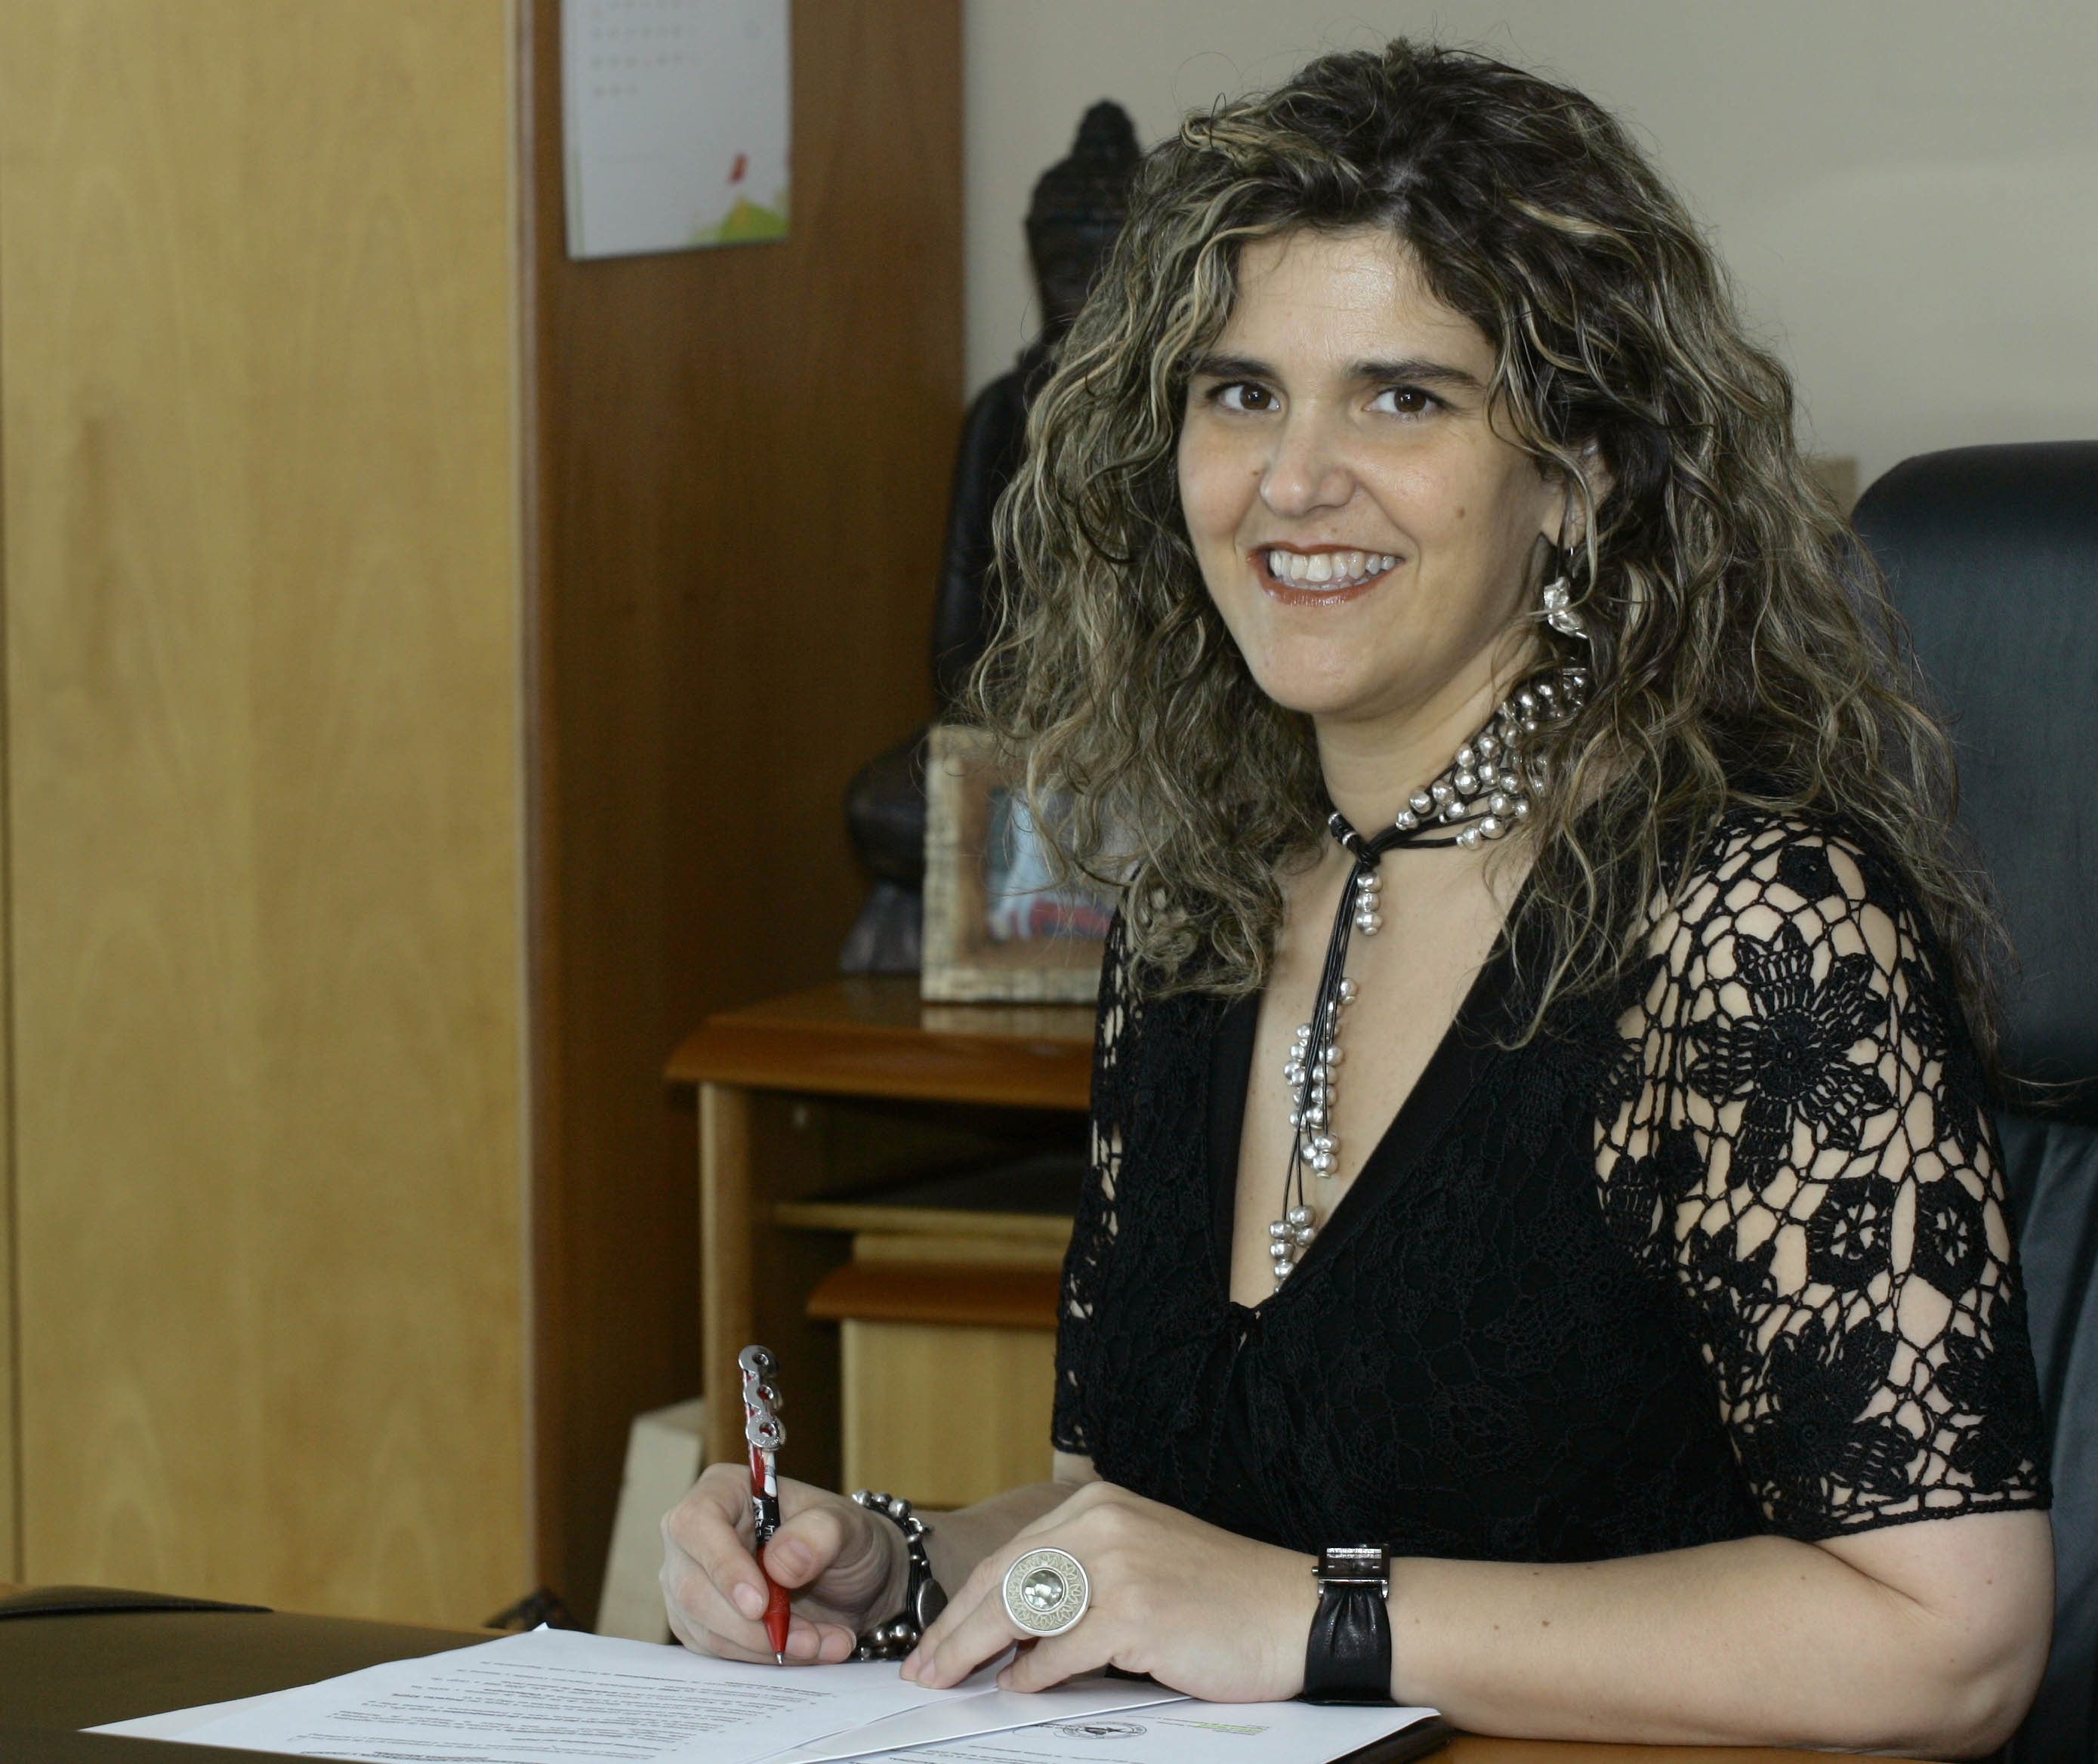
Paula Vial Reynal was the first woman elected to serve as National Advocate (Defensora Nacional). Ms. Vial is a lawyer with specialization in criminology, a Masters in Law and is a doctoral candidate in Criminal Law at the Universidad Complutense de Madrid. In 2011, Ms. Vial was elected President of the Association of Women Lawyers of Chile. She is a permanent columnist for a number of communication media in Chile (The Clinic and El Mercurio, among others). In 2005 and 2006 she was selected from among 100 women to win the Premio Cuerpo Economía y Negocios and in 2007 won the Premio Responsabilidad Social en Reinserción, which is awarded by SIGES, a company that works with prisons in several regions of the country.

Hilda Morales Trujillo
Coordinator, Committee of Experts of the Follow-up Mechanism to the Belém do Pará Convention (MESECVI)
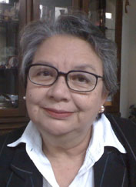
Originally from Guatemala. Lawyer and notary. MSc in Human Rights. University Lecturer and activist in women’s human Rights. Member of the Network for Non-Violence against Women in Guatemala. Promoter of legal reforms that favour women. Has authored a number of books and essays, including: Gender, Women and Justice, Addressing Violence against Women, the Gender Perspective and its Application to Litigation. Has held the post of Director of the Office of the National Coordinator for the Prevention of Intra-Family Violence and Violence against Women. Currently serves as Chief of the Department for the Coordination of the Care of Victims and the Public Ministry and as Coordinator of the Committee of Experts of the Follow-up Mechanism to the Belém do Pará Convention (MESECVI). In 2004, Ms. Morales received the Ambassador of Conscience prize from Amnesty International.

Susana Chiarotti
Latin American and Caribbean Committee for the Defense of Women’s Rights (CLADEM)
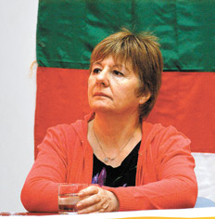
Lawyer with post-graduate negree in Family Law. Director of INSGENAR (Instituto de Genero, Derecho y Desarrollo). Part of the Consultative Council of the Latin American and Caribbean Committee for the Defense of Women’s Rights (CLADEM). Among her academic activities, Ms. Chiarotti is a Professor of the Masters Program on Power and Society from a Gender Perspective of the Faculty of Philosophy at the University of Rosario. She is a guest lecturer at the PRIGEPP program (Diplomados de Género y Justicia) coordinated by the Latin American Faculty of Social Sciences (FLACSO). Member of the Committee of Experts of the MESECVI and of the UN Secretary-General’s Advisory Group for the Global Study on Violence against Women.

Pedro Vuskovic Céspedes
Representative SG/OEA/Ecuador
Coordinator, Inter-American Program of Judicial Facilitators
Secretariat for Legal Affairs
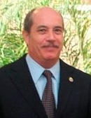
Chilean, Economist and Lawyer. He has served as Instructor and Researcher on economic matters for the Center for Research and Teaching in Economics (CIDE) and various other Mexican universities. Independent Consultant on Formulation, Project Management and Management Development Programs on Micro-Small and Medium Enterprises. He was Consultant and Project Manager for the GS/OAS in Nicaragua: International Commission of Support and Verification and River Children Program. In 2003 he was appointed Representative, GS/OAS Office in Nicaragua and in 2010 Representative, GS/OAS Office in Ecuador. He is also Coordinator of the Inter-American Program of Judicial Facilitators, Secretariat for Legal Affairs.

Ana Evelyn Jacir de Lovo
Director, Department of Social Development and Employment, OAS
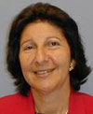
An Economist and Sociologist with a Masters in International Economic Relations and Doctoral Studies in Economic Development, Ms. Jacir has served in a number of international-level positions, including as First Vice President of the Inter-American Commission for Social Development (CIS), Chairperson of the Council of Ministers of Education from Central America, and Plenipotentiary Ambassador of Women's Affairs to the Secretary General of the United Nations Commission on the Status of Women (49th Session), among others. In addition to her international service, Ms. Jacir held a number of positions within the Government of her native El Salvador and has participated as a researcher and lecturer at several Regional Research Centers, including: the Center for Economic Research and Teaching (CIDE) in Mexico, INIES-CRIES in Nicaragua, and INCAE Operations Coordinator in Mexico.

OECD. Atlas of gender and development: How social norms affect gender equality in non-OECD countries. Paris: Organization for Economic Cooperation and Development, 2010, p. 92, http://www.oecd.org/document/50/0,3746,en_2649_33935_44810034_1_1_1_1,00.html
IACHR. Access to Justice for Women Victims of Violence. Washington, DC: Inter-American Commission of Human Rights, Organization of American States. 2007, p. viii. http://www.cidh.oas.org/women/Access07/tocaccess.htm
http://progress.unwomen.org/centro-de-la-prensa/?lang=es
http://www.cidh.oas.org/women/Acceso07/indiceacceso.htm

