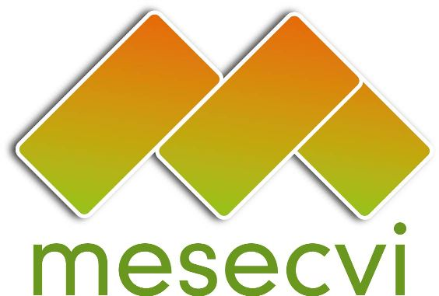
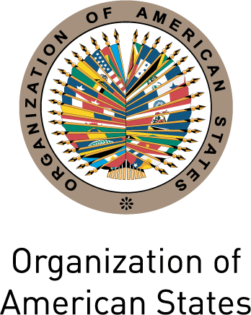

FOLLOW-UP MECHANISM OEA/Ser.L/II.7.10
BELÉM DO PARÁ CONVENTION (MESECVI) MESECVI/CEVI/doc.197/14
Eleventh Meeting of the Committee of Experts (CEVI) September 12th 2014
September 18th – 19th 2014 Original: Spanish
Montevideo, Uruguay

ORGANIZATION OF WORK
(Draft)

Date: September 18th – 19th 2014

Time: 9:00 – 17:00

Venue: Centro de Formación de la Cooperación Española
Located on 25 de Mayo #520 Montevideo. Zip code 11000.

Thursday September 18th, 2014

8:30 – 9:00 Registration of Participants

9:00 - 10:00 Opening Ceremony
- Welcome remarks by Daniel Olesker, Minister for Social Development of Uruguay
- Beatriz Ramírez, Director of the National Institute for Women and National Competent Authority of the Follow-Up Mechanism to the Belém do Pará Convention (MESECVI)
- Alejandra Mora Mora, Minister for the Status of Women, National Institute for Women (INAMU) and President of the Inter-American Commission of Women (CIM) (TBC)
- Flor de María Díaz Chalarca, President of the Committee of Experts of the MESECVI
- Ambassador John Biehl del Río, Representative of the Organization of American States in Uruguay
- Ambassador Roberto Varela Fariña, Ambassador of Spain to the Republic of Uruguay
- Silvana Guerra, Chair of the Commission of the Ministry of Gender Affairs of the Republic of Uruguay.
- Collin Cadier, Mercado Común del Sur (MERCOSUR)
- Luz Patricia Mejía, Technical Secretary of the MESECVI

10:00 – 10:15 Break

10:15-12:00 Forum on Women’s Human Rights: Violence and Sexual and Reproductive Rights
Moderator: Luz Patricia Mejía, Technical Secretary of the MESECVI
- Sergio Araujo Gambaro, Legal Advisor on Sexual and Reproductive Health, Ministry of Public Health
- Soledad García Muñoz, Inter-American Institute of Human Rights (IIDH)
- Diana González Perrett, Principal Expert of Uruguay to the CEVI
- Barbara Bailey, Principal Expert of Jamaica to the CEVI
- Susana Chiarotti, Principal Expert of Argentina to the CEVI
12:00-13:00 Question and Answer Session

13:00-14:30 Lunch

14:30-15:30 Forum: Dialogue with civil society organizations on violence and sexual and reproductive rights

15:30-16:00 Question and Answer Session
input.doc
16:00-16:15 Adoption of the Draft Agenda and Organization of Work

16:15-17:30 Presentation of the Draft Declaration on Violence and Sexual and Reproductive Rights
Luz Patricia Mejía, Technical Secretary of the MESECVI

Comments and agreements

Friday, September 19th, 2014

9:00 - 9:30 Presentation of the Report on the Work of the President of the CEVI
Flor de María Díaz, President of the Committee of Experts of the MESECVI

9:30 -12:30 Implementation of the Second Follow-Up Round
- Adoption of the Final Country Reports

12:30 - 14:00 Lunch

14:00 - 16:00 Presentation of the Draft Second Follow-up Report on the Recommendations of the Committee of Experts
Luz Patricia Mejía, Technical Secretary of the MESECVI

Comments and agreements

16:00 - 17:00 Presentation of the Guide to the Interpretation of the Inter-American Convention on the Prevention, Punishment and Eradication of Violence Against Women (Belém Do Pará Convention)
Flor de María Díaz, President of the Committee of Experts of the MESECVI

17:00 – 17:30 Other issues

