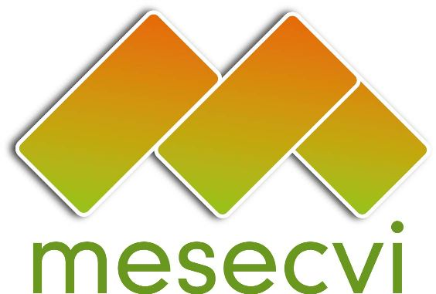
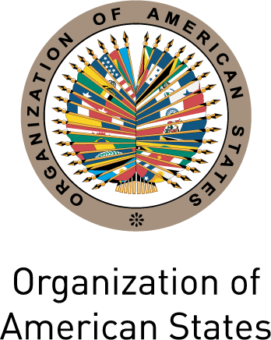

FOLLOW-UP MECHANISM OEA/Ser.L/II.7.10
BELÉM DO PARÁ CONVENTION (MESECVI) MESECVI/CEVI/doc.189/13 rev.1
Tenth Meeting of the Committee of Experts (CEVI) September 5th 2013
September 11th – 12th 2013 Original: Spanish
Washington D.C.
CIM03475E01
Agenda
(Draft)

- Adoption of the draft agenda and organization of work

- Forms of operation of the mechanisms to follow-up Inter-American agreements

- Report of the Technical Secretariat of the Follow-up Mechanism to the Belém do Pará Convention (MESECVI)

- Consideration of the proposal for the Modification of the Legal Instruments

- Consideration of the proposal for the “Declaration on Violence and Sexual and Reproductive Rights”

- Status of responses of the States to the Progress Indicators for measuring the Implementation of the Belém do Pará Convention and adoption of the Methodology for the Follow-up Report

- Determination of the composition of subgroups to analyze the information received from the States Parties they have been assigned to review, and election of the Coordinators and Alternate Coordinators of subgroups as necessary (Art. 3e) Rules of Procedure of the Committee)

- Evaluation of the Two-Year Work Plan for the CEVI (2013-2015).

- Election of authorities.

- Other matters.

- Adoption of agreements of the X meeting of the CEVI.

