
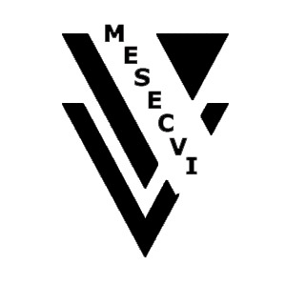
INTER-AMERICAN COMMISSION OF WOMEN

MECHANISM OF THE FOLLOW UP OAS/Ser.L/II.7.10
CONVENTION BELEM DO PARÁ (MESECVI) MESECVI-II/doc.13/07 rev. 4
SECOND CONFERENCE OF STATES PARTIES 25 June 2008
July 9-10, 2008 Original: Spanish
Caracas, Venezuela.

DRAFT AGENDA

(Considered at the Preparatory Meetings of the Conference of States Parties
held on April 16, 2007, and on June 25, 2008)

- Election of Authorities of the Conference: President, Vice-presidents, Rapporteur.
input.doc

- Approval of the draft agenda and the draft calendar of activities.

- Adoption of the Rules of Procedure of the Conference of States Parties.

- Report of the Coordinator of the Committee of Experts (CEVI). Progress, obstacles and proposals.

- Report of the Technical Secretariat. Status of the Implementation of the Mechanism. Analysis of the implementation of the MESECVI. Lessons learned financing and challenges.

- Adoption of the Conclusions and Recommendations of the Second Conference of States Parties.

- Report of the Rapporteur of the Conference.

  - Other topics.

