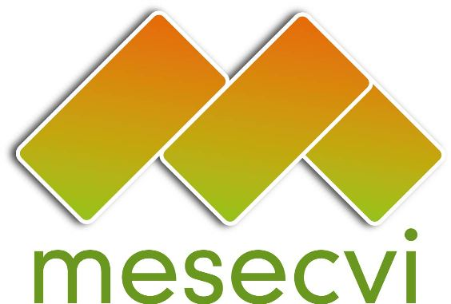
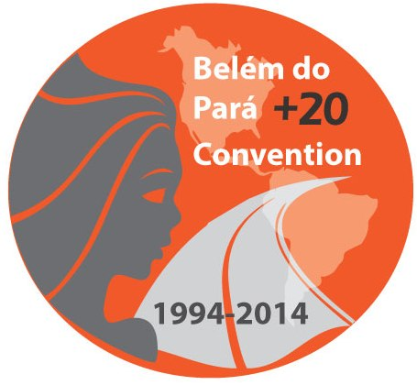
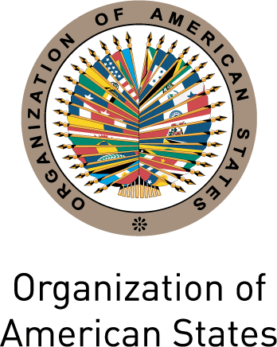

FOLLOW-UP MECHANISM TO THE OEA/Ser.L/ II.7.10
BELÉM DO PARÁ CONVENTION (MESECVI) MESECVI/I-CE/doc.3/14
FIRST SPECIAL CONFERENCE OF October 17th 2014
STATES PARTY TO THE BELÉM DO PARÁ CONVENTION Original: Spanish
October 22nd, 23rd and 24th 2014

Mexico City

ORGANIZATION OF WORK

(Draft)

Date: October 22nd, 23rd 24th 2014
Time: 8:30am to 6:00pm
Venue: Hotel Camino Real Polanco

Wednesday October 22nd

19:00 Launch of the “Guide to the application of the Inter-American Convention
on the Prevention, Punishment and Eradication of Violence against Women (Belém do Pará Convention)”
Hotel Camino Real Polanco

Thursday October 23rd

8:30 Participant registration

9:00-13:00 Inauguration

9:00-10:00 Opening plenary
- Carmen Moreno Toscano, Executive Secretary of the CIM, Representative of the Secretary General of the Organization of American States (OAS)
- Lorena Cruz Sánchez, Principal Delegate of the CIM and President of the National Institute of Women of Mexico (INMUJERES)
- Alejandra Mora Mora, Chair of the Conference of States Party, President and Principal Delegate of the CIM, Minister for the Status of Women of Costa Rica
- Ambassador Juan Manuel Gómez Robledo, Under-Secretary of Multilateral Affairs and Human Rights of the Ministry of Foreign Affairs

10:00-10:30 Keynote speech: Genesis of the Belém do Pará Convention
Linda Poole, Executive Secretary of the CIM 1986 – 1996

10:30-12:00 The Belém do Pará Convention: Impact and good practices
- Elizabeth Odio Benito, Judge, International Criminal Court 2003-2012
- Virginia Meneces Mendoza, Coordinadora Nacional Nicaragua, Comité de América Latina y el Caribe para la Defensa de los Derechos de la Mujer (CLADEM)
- Juliana Bravo Valencia, Centro por la Justicia y el Derecho Internacional (CEJIL)

12:00-13:00 Plenary debate

13:00-14:00 Lunch offered by the National Institute of Women of Mexico

14:00-18:00 First Plenary Session

14:00-14:15 Adoption of the Draft Agenda and Organization of Work
(Item 1 of the Agenda)

14:15-14:35 Presentation of the Report of the Technical Secretariat of the MESECVI (MESECVI/I-CE/doc.9/14) (Item 2 of the Agenda)
- Luz Patricia Mejía, Technical Secretary of the MESECVI

14:35-14:55 Report of the Working Group on Strengthening of the MESECVI (Item 2 of the
Agenda)
- Marisol Nieto, Alternate Representative of the Permanent Mission of Ecuador to the Organization of American States (OAS), Delegate of the Working Group

14:55-18:00 Strengthening Process of the Follow-Up Mechanism for the Implementation of the Belem do Para Convention (Item 3 of the Agenda)

Consideration and approval of documents:
- “Guidelines for carrying out dialogues between the Competent National Authorities (CNA) and the CEVI”
(MESECVI/I-CE/doc.6/14)
- “Strategic Plan of the MESECVI 2014-2017” (MESECVI/I-CE/doc.4/14)
- “Procedure and criteria for the use of funds allocated for the special financing of the participation of experts in the meetings of the Committee of Experts of the MESECVI (CEVI)” (MESECVI/I-CE/doc.5/14)
- “Recommendations on the tools to promote broad participation of the experts in CEVI meetings” (MESECVI/I-CE/doc.8/14)

19:00 Gala Supper offered by the National Institute of Women of Mexico

Friday, October 24

[8:00-11:00 Fourth Regular Session of the CIM Executive Committee]

11:00-13:30 Second Plenary Session

11:00-11:45 Presentation of the Second Follow-up Report on the Recommendations of the Committee of Experts (MESECVI/I-CE/doc.10/14) (Item 4 of the Agenda)
- Flor de María Díaz Chalarca, President of the Committee of Experts of the MESECVI

Inputs from civil society organizations to the Second Follow-up Report on the Recommendations of the Committee of Experts
- Juliana Bravo Valencia, Centre for Justice and International Law (CEJIL)
- Virginia Meneces Mendoza, National Coordinator in Nicaragua, Latin American and Caribbean Committee for the Defense of Women’s Rights (CLADEM)

11:45-13:30 Plenary debate

13:30-15:00 Lunch offered by the National Institute of Women of Mexico

15:00-18:00 Third Plenary Session

15:00 – 15:30 Definition of the date of the Sixth Conference of States (Item 5 of the Agenda)

15:30-16:45 Adoption of Agreements of the First Special Conference of States Party to the MESECVI (MESECVI/I-CE/doc.11/14) (Item 6 of the Agenda)

16:45–17:15 Report of the Rapporteur of the First Special Conference of States Party to the MESECVI

17:15-17:45 Other matters (Item 7 of the Agenda)

17:45-18:00 Closing remarks
Alejandra Mora Mora, President of the Conference of States Party, President and Principal Delegate of Costa Rica to the CIM, Minister for the Status of Women of Costa Rica

input.doc

