
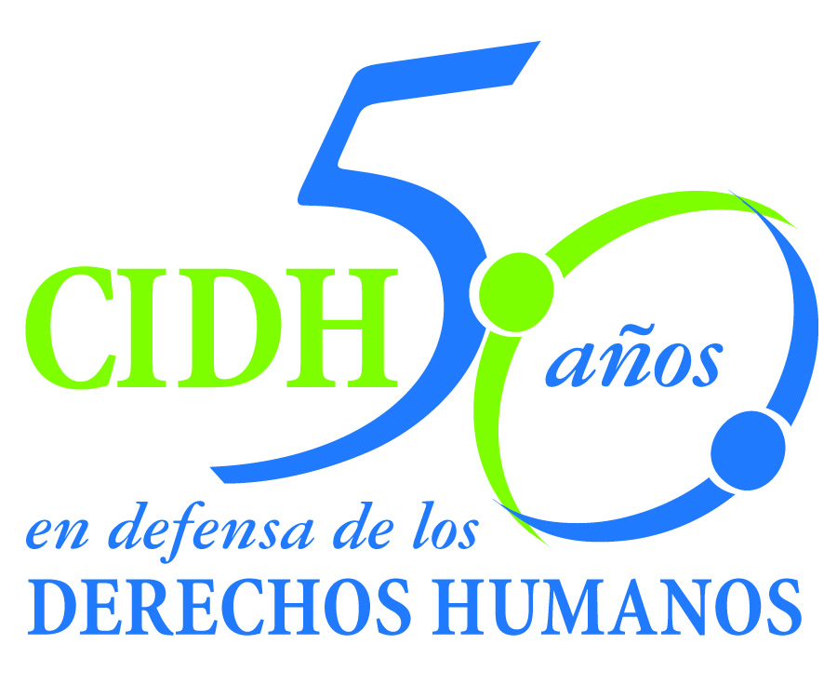
INTER - AMERICAN COMMISSION ON HUMAN RIGHTS
COMISION INTERAMERICANA DE DERECHOS HUMANOS
COMISSÃO INTERAMERICANA DE DIREITOS HUMANOS
COMMISSION INTERAMÉRICAINE DES DROITS DE L'HOMME

ORGANIZACIÓN DE LOS ESTADOS AMERICANOS
WASHINGTON, D.C. 2 0 0 0 6 EEUU

July 17, 2012

Ref.: Case No. 12.775
Florentín Gudiel Ramos, Makrina Gudiel Álvarez y otros
Guatemala

Mr. Secretary:

I am pleased to address you on behalf of the Inter-American Commission on Human Rights in order to file Case No. 12.775 Florentín Gudiel Ramos, Makrina Gudiel Álvarez, et al. v. Guatemala (hereinafter “the State”, “the Guatemalan State” or “Guatelama”) before the jurisdiction of the Honorable Inter-American Court of Human Rights. The instant case refers to the international responsibility of the State of Guatemala for the failure to prevent the assassination of human rights defender Florentín Gudiel Ramos, which occurred on December 20, 2004. The assassination of Mr. Gudiel Ramos is shrouded in impunity as a result of the irregularities committed at the outset of the investigation and the lack of a diligent investigation into the hypotheses related to the motive behind the assassination. In addition, the investigation was not carried out in a reasonable time, and was compromised by the lack of protection of persons who participated actively in the process. The lack of any protection for the family members led to their displacement, in violation of the right to freedom of movement and residence. The Commission also concluded that the facts constituted a violation of the duty to guarantee political rights, by virtue of the public position held by Mr. Gudiel, and the fact that it became impossible for his daughter, Makrina Gudiel Álvarez, to continue to exercise her political rights.

The State ratified the American Convention on Human Rights on May 25, 1978 and accepted the contentious jurisdiction of the Court on March 8, 1987.

The Commission has designated Commissioner Dinah Shelton as its delegate. Likewise, Elizabeth Abi-Mershed, Deputy Executive Secretary, y Silvia Serrano Guzmán, Isabel Madariaga y Jorge Humberto Meza, attorneys of the Executive Secretariat of the IACHR, have been designated to serve as legal advisors.

Mr.
Pablo Saavedra Alessandri, Secretary
Inter-American Court of Human Rights
P.O. Box 6906-1000
San José, Costa Rica

Enclosure

In accordance with Article 35 of the Rules of Procedure of the Inter-American Court, the Commission is enclosing a copy of Merits Report No. 174/10, prepared in compliance with Article 50 of the American Convention, as well as a copy of the entire file before the Inter-American Commission (Appendix I.) The Merits Report of November 2, 2010, was notified to the State by means of communication of November 11, 2010. After granting an extension, the IACHR determined that the term had elapsed and the State had not complied with the recommendations.

The Commission refers the instant case to the jurisdiction of the Inter-American Court based on the State’s failure to comply with the recommendations and the resulting need to obtain justice in the instant case.

As for the recommendation to “make comprehensive reparations for the violations of human rights presented in the … report both in [their] material and moral aspects,” the State indicated that on March 21, 2012, it called the petitioners to a meeting to “engage in dialogue” and “express its interest in reaching consensus on the possibility of signing an “Agreement on Compliance with Recommendations.” The State indicated that said meeting was held on June 1, 2012. It added a list of considerations said to have been stated by the petitioners at that meeting. Those considerations can be summarized by noting their interest in referring the case to the Inter-American Court; their view that the facts had not been cleared up and that there is an intention to divert the information; and their lack of trust in the state organs. In addition, the State indicated that the petitioners reaffirmed their decision in writing on June 6, 2012.

On the recommendation to “develop and complete a full, thorough and impartial judicial investigation, in a timely way, with the aim of establishing the circumstances surrounding Mr. Florentín Gudiel Ramos' death; perform a complete investigation with the logic investigation hypothesis in relation with the case; and identify all persons involved therein at the different planning and execution stages, and apply the appropriate punishments,” the State merely reiterated information already in the record before the Commission. Specifically, the State reiterated the hypotheses that were pursued in the domestic investigation, indicating that one of them was discarded, while the other continues being investigated.

On the recommendation to “issue the appropriate administrative, disciplinary or criminal measures with regard to the acts or omissions of the state officials who contributed to the denial of justice and impunity surrounding the events of the case,” the State did not submit any information.

On the recommendation to “adopt measures of a legislative, institutional or judicial character aimed at reducing the exposure to risk facing human rights defenders who are in a vulnerable situation, and the three more specific recommendations that follow”, the State reported on a series of general measures adopted most of them prior to the report on the merits. With respect to 2012, the State referred to the proposal to adopt and implement a National Policy for Prevention and Protection.
Accordingly, the Inter-American Commission asks the Court concludes that the States of Guatemala has not showed progress on the compliance with the recommendations.

The Commission submits to the Inter-American Court all the facts and violations of Human Rights stated in the Report on the Merits 56/12 and request that the Inter-American Court declare that the State of Guatemala is responsible for:

  - The violation of the rights to judicial guarantees and judicial protection (Articles 8 and 25 of the American Convention), in relation to Article 1.1, to the prejudice of María Agripina Álvarez, Yolanda Gudiel Álvarez; Beatriz Gudiel Álvarez; Makrina Gudiel Álvarez; José Franciso Gudiel Álvarez; Florentino Gudiel Álvarez; Ana Patricia Gudiel Álvarez; Vladimir González Gudiel and his siblings; Ileana Concepción Pérez Gudiel; Rodrigo Pérez Gudiel; Carlos Ernesto Cruz Gudiel; Oscar Cruz Gudiel, and José Gabriel Cruz Gudiel.

  - The violation of the right to life (Article 4 of the American Convention), in relation to Article 1.1 of the same treaty, to the prejudice of Florentín Gudiel Ramos.

  - The violation of the right to freedom of movement and residence (Article 22 of the American Convention in relation to Article 1.1, to the prejudice of María Agripina Álvarez, Beatriz Gudiel; Makrina Gudiel; José Franciso Gudiel, Florentino Gudiel; Ana Patricia Gudiel; Ileana Concepción Pérez Gudiel; Rodrigo Pérez Gudiel; Carlos Ernesto Cruz Gudiel; Oscar Cruz Gudiel, and José Gabriel Cruz Gudiel.

  - The violation of the right to humane treatment (Article 5.1 of the American Convention), in relation to Article 1.1 of the said treaty, to the prejudice of María Agripina Álvarez, Yolanda Gudiel; Beatriz Gudiel; Makrina Gudiel; José Franciso Gudiel, Florentino Gudiel; Ana Patricia Gudiel; Vladimir González Gudiel and his siblings; Ileana Concepción Pérez Gudiel; Rodrigo Pérez Gudiel; Carlos Ernesto Cruz Gudiel; Oscar Cruz Gudiel, and José Gabriel Cruz Gudiel.

  - The violation of the right to participate in government (Article 23 of the American Convention), in relation to Article 1.1, to the prejudice of Florentín Gudiel Ramos, and Makrina Gudiel Álvarez.

Based on the foregoing conclusions, the Commission recommended to the State:

- Make comprehensive reparations for the violations of human rights presented in the current report both in its material and moral aspects.

- Develop and complete a full, thorough and impartial judicial investigation, in a timely way, with the aim of establishing the circumstances surrounding Mr. Florentín Gudiel Ramos' death; perform a complete investigation with the logic investigation hypothesis in relation with the case; and identify all persons involved therein at the different planning and execution stages, and apply the appropriate punishments.

- Issue the appropriate administrative, disciplinary or criminal measures with regard to the acts or omissions of the state officials who contributed to the denial of justice and impunity surrounding the events of the case.

- Adopt measures of a legislative, institutional or judicial character aimed at reducing the exposure to risk facing human rights defenders who are in a vulnerable situation. In this sense, the State must:

4.1 Strengthen the institutional capacity to combat the pattern of impunity surrounding cases of threats and murders of defenders, through the elaboration of investigatory protocols, which take into account the risks inherent in the work of human rights defenders, in order to allow a comprehensive development of the investigation under this hypothesis.

4.2 Strengthen the mechanisms for the effective protection of persons whose declarations have a relevant impact to the investigations, and who are at risk as a result of their connection to investigations.

4.3 Develop swift and adequate institutional response measures, which allow effective protection for human rights defenders in situations of risk.

In addition, from the foregoing and as supplemental criteria regulated at Article 45 of the Rules of Procedure, the Secretariat considers that the case has important implications related to inter-American public order.

Specifically, the instant case incorporates an analysis of the state obligations to prevent and investigate in relation to the right to life and political rights, from a differentiated perspective, considering Mr. Gudiel Ramos’s status as a human rights defender. In addition, in the instant case a broad and inclusive characterization of a person as a human rights defender was adopted, in view of the victim’s status as a community leader who defended human rights in many ways, including from public office. In that regard, the instant case will enable the Court to strengthen its case-law on the duty to guarantee in relation to human rights defenders, in light of the particularities the case poses in both prevention and investigation not only in relation to the right to life, but also as regards the exercise of political rights

- Hina Jilani, who will testify on the international and comparative understanding of the “right to defend human rights” and its protection under the American Convention. The expert will analyze the facts of the case in light of the understanding and its implications for state obligations under the Convention.

- Renzo Poni, who will testify on the international standards applicable to the duty to prevent and investigate as means of ensuring the right to life of a human rights defender. The expert will refer specifically to the elements that should be taken into account when evaluating whether a state has or has not fulfilled its duty to prevent and investigate in circumstance such as those of the instant case. In addition, the expert will refer to the appropriate measures of non-repetition in situations such as those of the instant case.

The Commission requests that the Inter-American Court give consideration to the expert testimony offered in the case of Luna López et al. v. Honduras. As it is general expert testimony and relevant to the analysis of the instant case, the Commission asks the Inter-American Court that if it is accepted, said expert testimony be incorporated into this record.

The curricula vitarum of the experts’ will be included in the appendix of the Merit Report 56/12.

Finally, the petitioners expressed the victims’ interest in the submission of the present case to the Inter-American Court and informed that the following shall be representatives of the victims:

Makrina Gudiel Álvarez
Claudia Samayoa
xxxxxxxxxxxxxxxxxxxx

Signed in the original

Elizabeth Abi-Mershed
Executive Deputy Secretary

The expert testimony refers to the “link between the right to defend human rights and the right to political participation, as well as the effects of the attacks on human rights defenders who pursue or seek to pursue their work of promoting and protecting human rights from public office.”

