
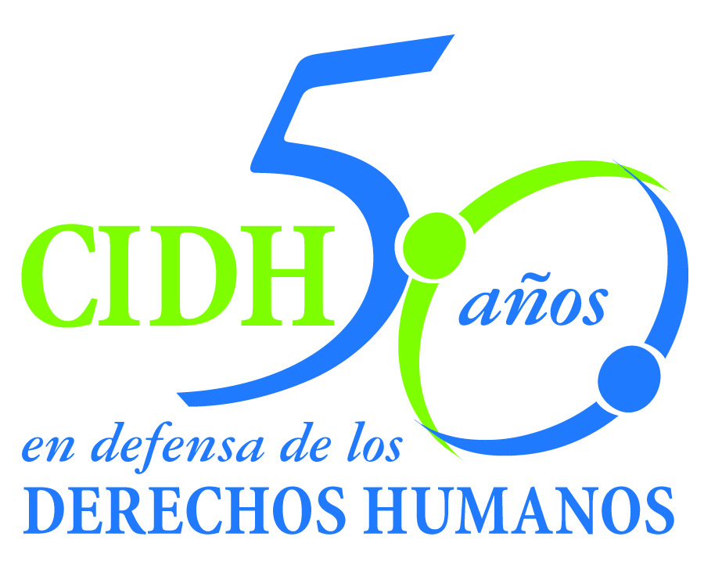
INTER - AMERICAN COMMISSION ON HUMAN RIGHTS
COMISION INTERAMERICANA DE DERECHOS HUMANOS
COMISSÃO INTERAMERICANA DE DIREITOS HUMANOS
COMMISSION INTERAMÉRICAINE DES DROITS DE L'HOMME

ORGANIZACIÓN DE LOS ESTADOS AMERICANOS
WASHINGTON, D.C. 2 0 0 0 6 EEUU

February 13, 2014

Ref.: Case No. 12.679
José Agapito Ruano Torres y familia
El Salvador

Señor Secretario:

The instant case involves several violations of the American Convention to the detriment of José Agapito Ruano Torres and the effects of said violations on his family. Mr. Ruano Torres was deprived of his liberty in the early hours of the morning of October 17, 2000, while being mistreated in front of his son. The Commission concluded that the physical and verbal mistreatment constituted torture. Subsequently, Mr. Ruano Torres was criminally tried and convicted in violation of the minimum requirements of his due process rights. Mr. Ruano Torres is currently continuing to serve his sentence.

Specifically, Mr. Ruano Torres was convicted without the minimum steps being taken to verify his identity as the person who was actually accused of committing the crime. Additionally, the only two pieces of evidence upon which the conviction was based were gathered by using several irregular methods. Regarding these aspects, the Commission concluded that the State violated the right to the presumption of innocence. The Commission also found that the failure of the Office of the Public Defender to adequately perform its duties amounted to a violation of the right to a defense. In the view of the Commission, the sentence of deprivation of liberty he is serving as a result of the conviction, which was handed down in violation of said fair trial rights, was and continues to be arbitrary. The Commission also found that the State did not provide effective remedies either to investigate the torture inflicted upon the victim, protect him from due process violations, or to review the deprivation of liberty.

The Salvadoran State ratified the American Convention on Human Rights on June 23, 1978 and accepted the jurisdiction of the Court on June 6, 1995.

Señor
Pablo Saavedra Alessandri, Secretario
Corte Interamericana de Derechos Humanos
Apartado 6906-1000
San José, Costa Rica

Anexos
La Comisión ha designado a la Comisionada Rosa María Ortiz y al Secretario Ejecutivo Emilio Álvarez Icaza L. como sus delegados. Asimismo, Elizabeth Abi-Mershed, Secretaria Ejecutiva Adjunta, y Silvia Serrano Guzmán y Erick Acuña Pereda, abogada/o de la Secretaría Ejecutiva de la CIDH, actuarán como asesora/r legales.

De conformidad con el artículo 35 del Reglamento de la Corte Interamericana, la Comisión adjunta copia del informe 82/13 elaborado en observancia del artículo 50 de la Convención, así como copia de la totalidad del expediente ante la Comisión Interamericana (Apéndice I) y los anexos utilizados en la elaboración del informe 82/13 (Anexos). Dicho informe de fondo fue notificado al Estado de El Salvador mediante comunicación de 12 de noviembre de 2013, otorgándole un plazo de dos meses para informar sobre el cumplimiento de las recomendaciones.

El Estado de El Salvador presentó un informe mediante el cual indicó que remitió oficios a la Corte Suprema de Justicia, la Fiscalía General de la República, la Academia Nacional de Seguridad Pública, el Consejo Nacional de la Judicatura, la Policía Nacional Civil y la Procuraduría General de la República. Precisó que en cuanto a las recomendaciones relacionadas con la situación jurídica del señor Ruano Torres, remitió el informe de fondo al Tribunal Segundo de Sentencia de San Salvador, a fin de que evalúe su cumplimiento conforme a los instrumentos legales. El Estado informó sobre tres reuniones sostenidas con el señor Ruano Torres y su representante.

En dicho escrito el Estado salvadoreño solicitó una prórroga para dar cumplimiento a las recomendaciones. Sin embargo, se abstuvo de renunciar expresamente a interponer excepciones preliminares con base en el plazo establecido en el artículo 51 de la Convención Americana. Tal como lo establece el artículo 46 del Reglamento de la Comisión, esta renuncia es condición indispensable para que la Comisión considere posibles solicitudes de prórroga de los Estados en esta etapa del procedimiento.

En consecuencia, ante la imposibilidad de otorgar una prórroga al Estado de El Salvador y la ausencia de información sobre avances concretos y sustantivos sobre el cumplimiento de las reocmendaciones, la Comisión decidió someter el presente caso a la jurisdicción de la Corte Interamericana por la necesidad de obtención de justicia para la víctima y su familia. La Comisión Interamericana somete a la jurisdicción de la Corte la totalidad de los hechos y violaciones de derechos humanos descritos en el informe de fondo 82/13.

The Commission request the Court to state that the State of El Salvador: 1. is responsible for violating the rights to a fair trial, to judicial protection, to personal liberty, and to humane treatment of Mr. José Agapito Ruano Torres; 2. is responsible for violating the right to mental and moral integrity of his wife María Maribel Guevara de Ruano, his son Oscar Manuel Ruano Guevara, his daughter Keili Lisbet Ruano Guevara, and his cousin Pedro Torres Hércules.

Based on the foregoing conclusions, the Commission request to the Court to recommended the State:

1. Adopt, as promptly as possible, the measures necessary to cancel the effects of Mr. Ruano Torres’s conviction, including the alternative measures to incarceration which remain in force.

2. In light of the time that Mr. Ruano Torres has been deprived of his liberty under the sentence imposed, the Commission recommends that, should the victim so desire, the sentence be revised to bring it into line with the standards governing the presumption of innocence and the right of defense in the terms set out in this report.

3. Provide the victims in this case with integral reparation, including both the material and nonmaterial aspects.

4. Conduct a serious, diligent, and effective investigation, within a reasonable time, to cast light on the acts of torture described by Mr. Ruano Torres, identify the guilty, and impose the corresponding penalties.

5. Take the applicable administrative, disciplinary, and criminal steps in connection with the actions and omissions of the state agents (police officers, prosecutors, public defenders, and judges of the various courts) whose actions contributed to the violations of José Agapito Ruano Torres’s rights.

6. Take the necessary steps to prevent similar incidents in the future, in compliance with the duty of preventing and guaranteeing the fundamental rights enshrined in the American Convention. Specifically, develop training programs for state officials that include the international provisions established in the Principles on the Effective Investigation and Documentation of Torture and Other Cruel, Inhuman or Degrading Treatment or Punishment and the Istanbul Protocol.

In addition to the need to obtain justice as a result of the failure to comply with the recommendations of the merits report, the Commission deems that the case raises issues of Inter-American public order.

Specifically, the instant case would be an opportunity for the Court to engage in a novel examination on the right to the presumption of innocence. The Honorable Court is called upon to rule on the minimum investigatory requirements the State must fulfill in order to verify the identity of an individual before moving forward in a criminal proceeding and handing down a conviction against the individual. The case also raises the opportunity to analyze the scope of State responsibility for actions and omissions that may be committed by a public defender of an individual.

Inasmuch as these issues have a consequential effect on Inter-American public order, as provided under Article 35.1.f of the Rules of Procedure of the Inter-American Court, the Commission proffers the following expert witness:

1. xxxxxxxxxxxx, who will provide testimony on international standards pertaining to the presumption of innocence and the right of defense. In particular, the expert will address the minimum steps that must be taken in an investigation in order to verify the identity of an individual in a criminal proceeding. The witness will also flesh out the criteria used in other human rights protection systems to differentiate between cases of violations of the presumption of innocence from cases of discrepancy in the assessment of the evidence. The expert will also discuss the right to defense and, specifically, how actions and omissions in the technical defense could entail international responsibility of the State. The expert will apply said standards to the facts of the instant case.

Signed in the original

Elizabeth Abi-Mershed
Secretaria Ejecutiva Adjunta

