
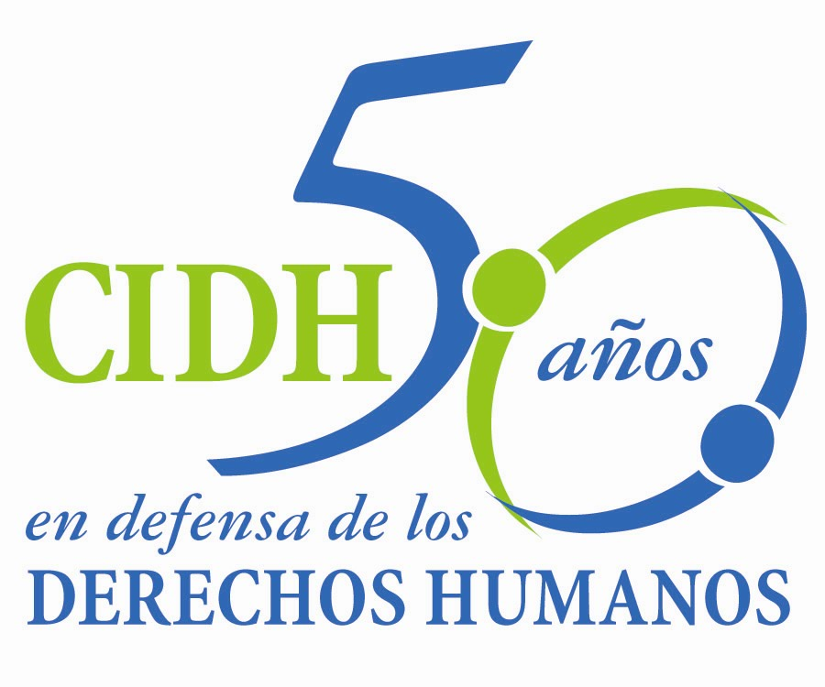
INTER - AMERICAN COMMISSION ON HUMAN RIGHTS
COMISION INTERAMERICANA DE DERECHOS HUMANOS
COMISSÃO INTERAMERICANA DE DIREITOS HUMANOS
COMMISSION INTERAMÉRICAINE DES DROITS DE L'HOMME

ORGANIZACIÓN DE LOS ESTADOS AMERICANOS
WASHINGTON, D.C. 2 0 0 0 6 EEUU

March 21, 2013

Ref.: Case No. 12.577
Rochac Hernández et al
El Salvador

Mr. Secretary:

I have the honor to address you on behalf of the Inter-American Commission on Human Rights to submit to the jurisdiction of the Inter-American Court of Human Rights Case No. 12.577 Rochac Hernández et al concerning El Salvador (hereinafter “the State,” “the Salvadoran State,” or “El Salvador”), which involves the forced disappearance of the boys José Adrián Rochac Hernández, Santos Ernesto Salinas, Manuel Antonio Bonilla Osorio, and Ricardo Ayala Abarca, and the girl Emelinda Lorena Hernández between 1980 and 1982 in circumstances with similar characteristics: within the context of an armed conflict, after the execution of military operations in the so-called “counter-insurgency,” in which their relatives were either killed or managed to escape, and who were last seen with members of the armed forces, who abducted them and decided on their fate.

More than 30 years have passed since the disappearance of the five victims in this case, but their fate and whereabouts have never been established. These crimes remain in impunity, given that the State did not conduct a serious and diligent investigation, within a reasonable period, on the forced disappearance of the victims, as a mechanism to guarantee their rights and to ensure the family members’ rights to truth, justice, and reparation. The Commission also concluded that El Salvador violated the right to family and special protection of the boys and the girl, because it was the State that, through the actions of its Armed Forces, separated the victims from their families by their forced disappearance.

The State of El Salvador ratified the American Convention on Human Rights on June 23, 1978, and accepted the Court’s jurisdiction on June 6, 1995. Since on the latter date the boys and girl who were victims continued in forced disappearance, the Court is competent ratione temporis to rule on the instant case.

Mr.
Pablo Saavedra Alessandri, Secretary
Inter-American Court of Human Rights
Apartado 6906-1000
San José, Costa Rica

Attachments

The Commission has designated Commissioner Rosa María Ortiz and Executive Secretary Emilio Álvarez Icaza L. as its delegates. Elizabeth Abi-Mershed, Assistant Executive Secretary, and Silvia Serrano Guzmán and Isabel Madariaga, attorneys of the Executive Secretariat of the IACHR, will be legal advisers.

In accordance with Article 35 of the Inter-American Court’s Rules of Procedure, the Commission attaches a copy of Report 75/12 prepared per Article 50 of the Convention, and a copy of the Inter-American Commission’s entire case file (Appendix I) and the appendixes used in preparation of Report 75/12 (Appendixes). That Report on the Merits was transmitted to the State of El Salvador in a communication of November 21, 2012, giving it a period of two months to report on compliance with the recommendations. The Commission has not received any information from the State of El Salvador. Available information indicates that there has been no progress in compliance.

Given this situation, the Commission decided to submit the case to the jurisdiction of the Inter-American Court in order to obtain justice for the victims.

The Commission submits to the Inter-American Court all the facts stated in the Report on the Merits 75/12, which constitute ongoing violations.

The Commission therefore requests that the Inter-American Court declare that the State of El Salvador

In addition, the Commission requests that the Inter-American Court order the following reparation measures:

- Conduct a thorough, impartial, and effective investigation into the fate or whereabouts of José Adrián Rochac Hernández, Santos Ernesto Salinas, Emelinda Lorena Hernández, Manuel Antonio Bonilla, and Ricardo Ayala Abarca and, if they are found, make the necessary efforts to ensure family reunification. If it is established that any of them is not alive, take the measures necessary to deliver their remains to their next-of-kin.

- Conduct a thorough, impartial, and effective investigation into the facts to determine the responsibility and to punish all the perpetrators of the human rights violations to the detriment of the victims in the instant case, including the investigations necessary to determine the responsibility and punish the persons who participated in covering up the facts and in the denial of justice.

- Make adequate reparation to the victims of the instant case, including both the material and non-material aspect.

- Adopt the measures necessary for ensuring the effectiveness and permanence for the time necessary of the search commission, the search webpage, and the genetic information system being implemented in the framework of what was ordered by the Inter-American Court of Human Rights in the judgment of the case of the Serrano Cruz Sisters. In particular, ensure that these measures are established through the legal mechanisms that provide legal certainty in its functioning and sufficient budget.

- Adopt non repetition measures to ensure that the integral protection system of children is implemented effectively, including the strenghtening and adequacy with the international standards of the Civil Registry system and the adoption system.

In addition to the need for obtaining justice for the victims, the IACHR notes that the instant case also involves matters of the inter-American public order of human rights.

The Commission notes that the facts in the instant case occurred in the context of an armed conflict in which State authorities committed grave human rights violations, including the practice of forced disappearance of boys and girls. In the cases of the Serrano Cruz sisters and Contreras et al, the Inter-American Court declared the international responsibility of the Salvadoran State for facts similar to those of this case. Although the Court ordered the State to take several reparation measures, El Salvador has not carried out the comprehensive and sustainable action required to remedy a context of the magnitude and severity such as the forced disappearance of boys and girls. In particular, the State of El Salvador has not removed the structural obstacles that maintain impunity for the facts.

Since these questions have significant impact on the inter-American public order of human rights, in accordance with Article 35.1.f of the Inter-American Court’s Rules of Procedure the Commission offers expert testimony on:

A State such as El Salvador, where there has been a systematic and generalized practice of forced disappearance of boys and girls, needs adequate and sustainable legal and institutional facilities to apply the comprehensive set of reparations required in these circumstances. Indispensable elements are the search for the victims, removal of the structural causes of impunity, and possible reconstruction of the victims’ identity.

The currículum vitae of the proposed expert witness will be included in the appendixes to the Report on the Merits 75/12.

The Commission puts at the Court’s disposal the following identification of the persons who have acted as petitioners in the processing and their contact information:

Asociación Pro-Búsqueda
xxxxxxxxxxxxxxxxxxxxxxxxxxxxxxxxxx

Signed in the original

Emilio Álvarez Icaza L.
Executive Secretary

