
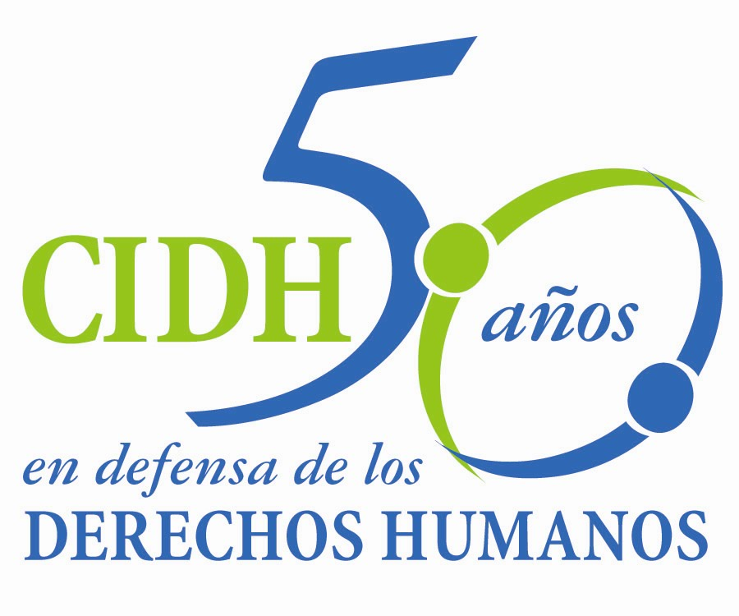
INTER - AMERICAN COMMISSION ON HUMAN RIGHTS
COMISION INTERAMERICANA DE DERECHOS HUMANOS
COMISSÃO INTERAMERICANA DE DIREITOS HUMANOS
COMMISSION INTERAMÉRICAINE DES DROITS DE L'HOMME

ORGANIZACIÓN DE LOS ESTADOS AMERICANOS
WASHINGTON, D.C. 2 0 0 0 6 EEUU

February 26, 2013

Ref.: Case No. 12.354
Kuna de Madungandí and Emberá de Bayano Indigenous Peoples and Their Members
Panama

Mr. Secretary:

On behalf of the Inter-American Commission on Human Rights, I am pleased to address you in order to submit to the jurisdiction of the honorable Inter-American Court of Human Rights, case no. 12.354 against the Republic of Panama (hereinafter, “the State,” “the Panamanian state,” or “Panama”), related to the ongoing violation of the right to collective property of the Kuna de Madungandí and Emberá de Bayano indigenous peoples and their members as a result of the State of Panama’s failure, to date, to pay the financial compensation stemming from the dispossession and flooding of the victims’ ancestral territories.

The case also has to do with the failure to recognize, award title for, and demarcate the lands granted to the Kuna de Madungandí indigenous people over the course of a lengthy period of time that falls within the Court’s ratione temporis jurisdiction, as well as the failure, up through the present time, to recognize, demarcate, and award title for the lands granted to the Emberá de Bayano indigenous people. The failure on the part of the State to meet these obligations regarding the collective property of the indigenous peoples was accompanied, simultaneously, by the State’s decision to systematically ignore the multiple legal commitments it had assumed even up through 2010.

In addition to the foregoing, and as a corollary to its obligation to effectively protect the territory and natural resources of the Kuna de Madungandí and Emberá de Bayano indigenous peoples and their members, the Panamanian state failed in its obligation to prevent the intrusion of colonists and illegal logging. This situation worsened beginning in the 1990s.

The Commission also concluded that the State of Panama failed to fulfill its obligation to provide the Kuna de Madungandí and Emberá de Bayano indigenous peoples and their members with an appropriate and effective mechanism for accessing territorial property and for obtaining a response with regard to the multiple complaints of intrusion by third parties into their territories and natural resources. Lastly, the case was analyzed by the Commission from the vantage point of the right to equality and non-discrimination and in light of the series of violations committed as a manifestation of discrimination against the two indigenous peoples. Such discrimination is likewise echoed in the existence of provisions that reflect an “assimilationist-type” policy that helps promote violations of indigenous peoples’ rights to their ancestral territory and natural resources.

The State ratified the American Convention on Human Rights on June 22, 1978 and accepted the Court’s jurisdiction on May 9, 1990.

The Commission has appointed Commissioner José de Jesús Orozco Henríquez and Executive Secretary Emilio Álvarez Icaza L. as the delegates in this case. In addition, Deputy Executive Secretary Elizabeth Abi-Mershed as well as Silvia Serrano Guzmán and Isabel Madariaga, attorneys with the IACHR Executive Secretariat, are to serve as legal advisors.

Pursuant to Article 35 of the Rules of Procedure of the Inter-American Court, the Commission encloses herewith a copy of report 125/12 prepared under Article 50 of the Convention, together with a copy of the entire record of the proceedings before the Inter-American Commission (Appendix I) and the annexes used in the preparation of report 125/12 (Annexes). The State of Panama was notified of the above merits report by means of a communication dated November 26, 2012, wherein it was given two months to report on steps taken to implement the recommendations. The information furnished by the State following notification of the merits report was limited to the applicable regulatory framework and to events that had occurred prior to issuance of said report, with no concrete response regarding implementation of the seven recommendations made by the Commission having been provided.

Accordingly, the Commission submits the instant case to the jurisdiction of the Inter-American Court in view of the need to obtain justice for the victims in the absence of specific information on implementation of the recommendations.

The Inter-American Commission submits to the jurisdiction of the Court all of the facts and human rights violations described in report on the merits no. 125/12. Even though the factual framework established by the Inter-American Commission refers to events that occurred prior to the date of acceptance of jurisdiction, such references are made in order to provide context for the reporting of subsequent facts and violations.

It warrants mention that even though some of the obligations regarding the right to property that have not been met were themselves rooted in an earlier event–the hydroelectric plant and flooding of ancestral lands–the lack of compensation persists. In addition, in the case of the Kuna de Madungandí people, there was a failure to demarcate, award title for, or protect [their land] over the course of the more than 10 years the Court was competent ratione temporis and such situation continues through the present day in the case of the Emberá de Bayano people. Hence, Court is competent ratione temporis with respect to violations of the right to property of these two indigenous peoples. All of the remaining facts of the case tied to the lack of protection vis-à-vis the incursion of third parties and the absence of legal protection in such cases fall under the Court’s purview.

In this regard, the Commission requests that the Court conclude and declare that:

    - The State of Panama violated Article 21 of the Convention, in relation to Article 1(1) of the same instrument, to the detriment of the indigenous peoples Kuna of the Madungandí and the Emberá of Bayano and their members on having failed to grant just and prompt compensation, more than 40 years after their ancestral territories were alienated.

    - The State of Panama violated the right to property enshrined in Article 21 of the American Convention on Human Rights in relation to Articles 1(1) and 2, to the detriment of the Emberá people of Bayano and its members, for not having providing them effective access to collective property title to their territories; and for having failed to delimit, demarcate, and effectively protect their territories.

    - The State of Panama violated the right to property enshrined in Article 21 of the American Convention on Human Rights, in relation to its Articles 1(1) and 2, to the detriment of the Kuna indigenous people of Madungandí and its members, on having failed to promptly recognize, delimit, and demarcate their territory; and on having failed to provide effective protection for the territories of the Kuna Comarca of Madungandí vis-à-vis third persons.

    - The State of Panama violated Articles 8 and 25 of the American Convention, in connection with Articles 1(1) and 2, due to the failure to provide for an adequate and effective procedure for acceding to their property rights over the ancestral territory, and for their protection vis-à-vis third persons, to the detriment of the indigenous peoples Kuna of the Madungandí and the Emberá of Bayano and their members.

    - The State of Panama violated Article 24 of the American Convention, in connection with Article 1(1) of the Convention, for breaching its obligation to ensure and respect the rights, without any discrimination based on ethnic origin, and to provide equal protection before the law, to the detriment of the indigenous peoples Kuna of the Madungandí and the Emberá of Bayano and their members.

Therefore, the Commission requests that the Inter-American Court order the following reparation measures:

- Promptly conclude the process of formalizing, delimiting, and physically demarcating the territories of the indigenous peoples Kuna of the Madungandí and the Emberá of Bayano and their members, bearing in mind the inter-American standards noted in this report.

- Grant the indigenous peoples Kuna of the Madungandí and the Emberá of Bayano and their members prompt and just compensation for the removal, resettling, and flooding of their ancestral territories; the amount owed should be determined through a process that ensures their participation, in keeping with their customary law, values, and uses and customs.

- Adopt the measures necessary for ensuring the effective protection of the territory of the indigenous peoples Kuna of the Madungandí and the Emberá of Bayano for the purpose of guaranteeing their physical and cultural survival, as well as the development and continuity of their cosmovision, so that they can continue living their traditional way of life and preserve their cultural identity, social structure, economic system, customs, beliefs, distinct traditions and justice system. Similarly, adopt the necessary measures to ensure that the Kuna de Madungandí and Embera peoples of Bayano have access to culturally pertinent health and education programs.

- Halt the illegal entry of non-indigenous persons in the territories of the indigenous peoples Kuna of the Madungandí and the Emberá of Bayano and move the current occupant settlers to territories that do not belong to the indigenous peoples. In addition, ensure the free, prior, and informed consent of the the indigenous peoples Kuna of the Madungandí and the Emberá of Bayano to the plans, programs, and projects sought to be developed in their territories.

- Establish an adequate and effective remedy that protects the rights of the indigenous peoples of Panama to claim and accede to their traditional territories, and protect their territories and natural resources from third persons, including respecting the right of indigenous peoples to enforce their customary laws through their justice systems.

- Make individual and collective reparations for the consequences of the violations of human rights found in this report. In particular, repair the lack of protection of ancestral territories of the indigenous peoples Kuna of the Madungandí and the Emberá of Bayano, the lack of effective and prompt response by the authorities, and the discriminatory treatment to which they were subjected.

- Adopt the measures necessary to prevent similar events from occurring in the future, in keeping with the duty to prevent violations and ensure the exercise of the fundamental rights recognized in the American Convention.

Besides the need to secure justice for the victims, the IACHR notes that this case includes issues of inter-American public order.

Specifically, the case affords the Court an opportunity to assess the scope and content of the obligation to provide redress to indigenous peoples when a determination has been made that it is not possible to return to them the lands and territories they traditionally occupied and used. The Court will be able to examine how failure to meet this obligation to provide redress constitutes an ongoing violation to the right to collective property of indigenous peoples who have been dispossessed of their ancestral lands and territories, as does a State’s failure to adopt measures that enable them to exercise their right to property when it is not possible to recover such lands and territories.

Moreover, this case is representative of the intrinsic relationship between the effective and timely fulfillment of the obligations to recognize, award title for, demarcate, and protect the lands and territories of indigenous peoples and the situation of vulnerability and defenselessness [of such peoples] in the face of actions taken by third parties that have a profound impact on their traditional means of subsistence and on their social and cultural life.

Because these matters have an important impact on inter-American public order, pursuant to Article 35.1(f) of the Rules of Procedure of the inter-American Court, the Commission would like to offer the following expert testimony:

- An expert witness, whose name shall be provided as soon as possible, who will testify about the scope and content of the obligation to provide redress to indigenous peoples when a determination has been made that it is not possible to return to them the lands and territories they traditionally occupied and used. The expert will discuss how the failure to meet the obligation to provide redress constitutes an ongoing violation of the indigenous peoples’ right to collective property. The expert will likewise provide an analysis of the intrinsic relationship between the effective and timely fulfillment of the obligations to recognize, award title for, demarcate, and protect the lands and territories of indigenous peoples and their situation of vulnerability and defenselessness in the face of actions taken by third parties.

The Commission also wishes to request the forwarding of the expert testimony to be prepared by expert witness José Aylwin in case 12.548 (Garífuna Community of “Triunfo de la Cruz” and its Members v. Honduras), should the Court accept it at an opportune moment during the proceedings.

The curriculum vitae of the expert proposed will be included in the annexes to the report on the merits 125/12.

The Commission wishes to provide the Court with the following information on those who have acted as petitioners throughout the proceedings, as well their respective contact information:

Emberá de Alto Bayano General Congress
Kuna de Madungandi General Congress
American University, Washington College of Law

Xxxxxxxxxxxxx
Xxxxxxxxxxxxxxxxxxx
Xxxxxxxxxxxxxxxxxxx
xxxxxxxxxxxx

Original signed

Elizabeth Abi-Mershed
Deputy Executive Secretary

