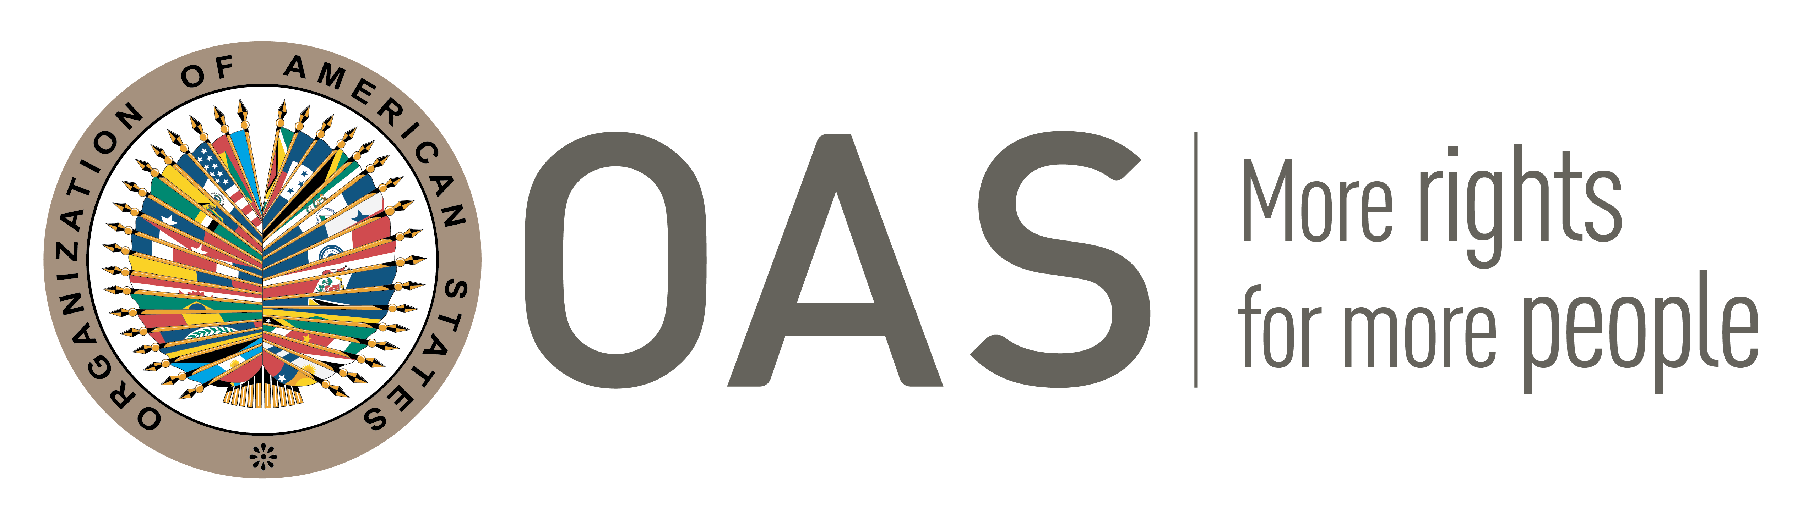

AUTHORITIES
Virtual moas for the English-speaking Caribbean and HBCUs 2022
April 4-6, 2022

MOAS Secretary General
Gabrielle Welzijn
Anton de KomUniversity of Suriname
Welzijnelisa@gmail.com
MOAS President
Junior Bharratt
Anton de KomUniversity of Suriname
bharratt.junior@gmail.com

GENERAL COMMITTEE
Vice Chair:
Karina Espat
Belize High School
kespat@belizehighschool.edu.bz
COMMITTEE on juridical and political affairs
Chair:  Pilay Todd  University of Guyana  pilaytodd@gmail.com | Vice Chair:  Taylor Arguelles  Belize High School  targuelles@belizehighschool.edu.bz
INTER-AMERICAN COUNCIL FOR INTEGRAL DEVELOPMENT
Chair:  Janae Farley  University of Guyana  janae.farley@yahoo.com | Vice Chair:  Davis Courtenay  Belize High School  acourtenay@belizehighschool.edu.bz

