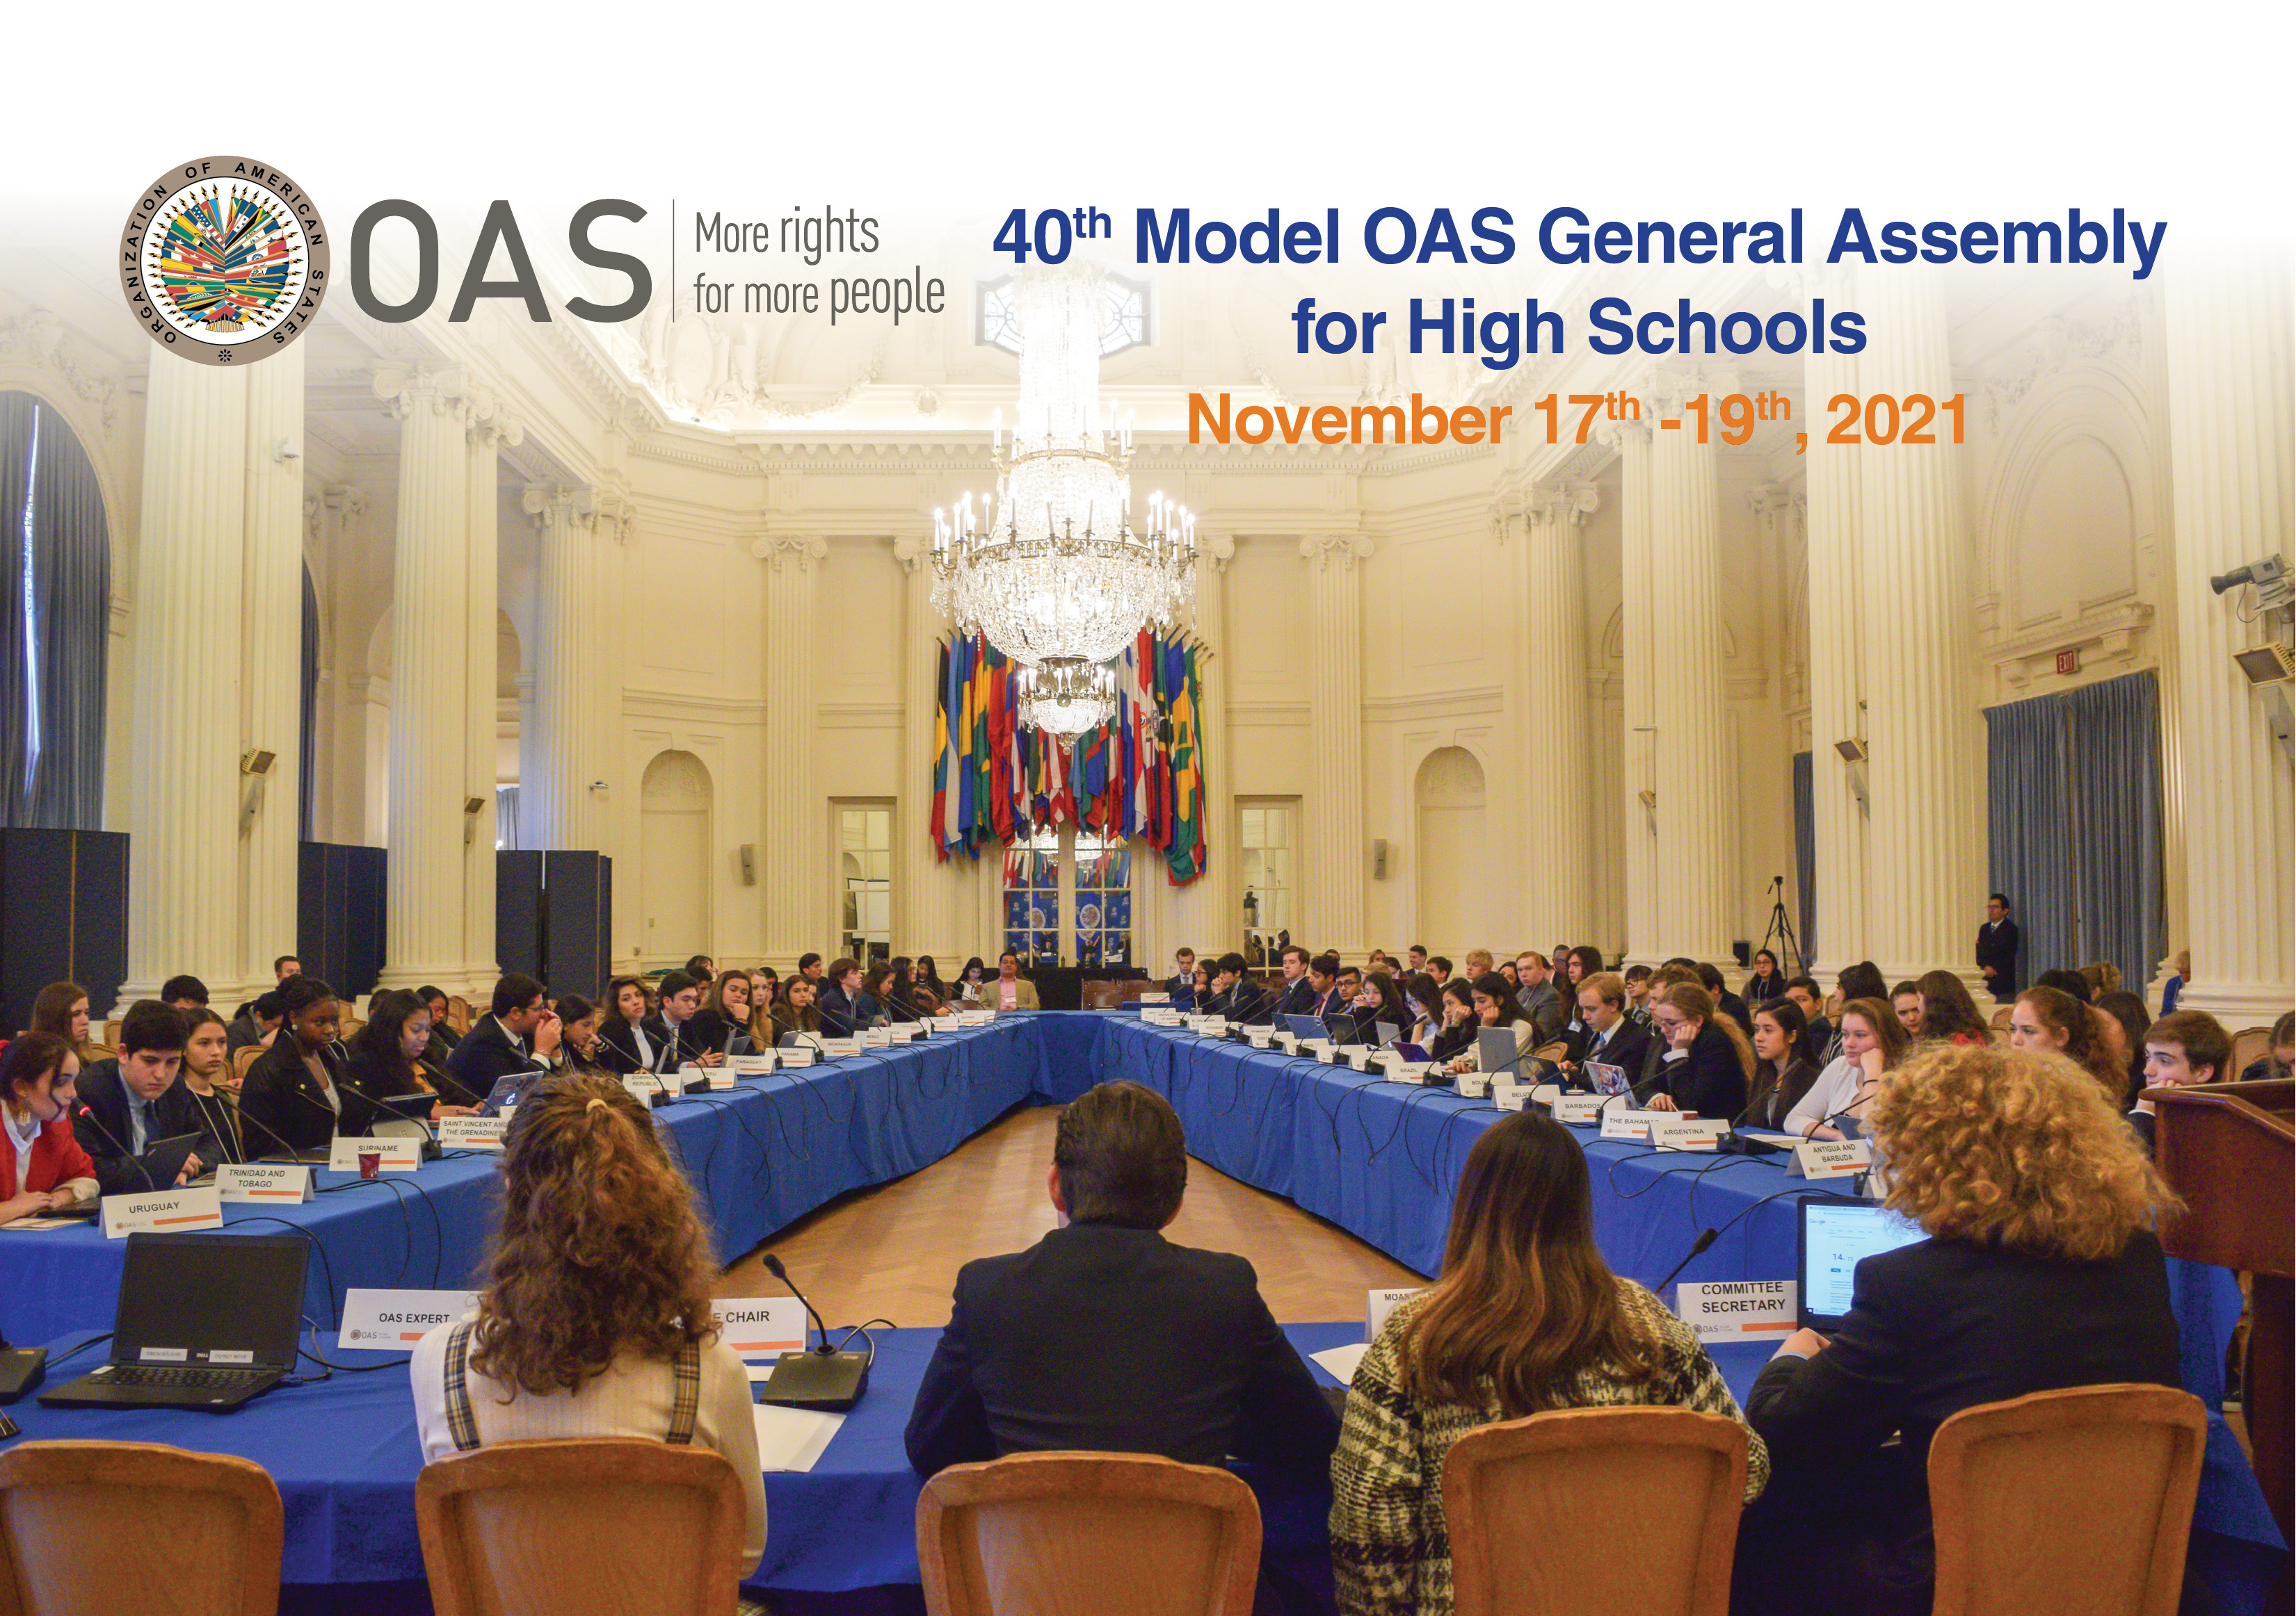

GENERAL COMMITTEE

- Joint actions to ensure the application of the principles of the Inter-American Convention for the eradication of all forms of discrimination and intolerance among Member States.
- Measures to accelerate progress on the Sustainable Development Goals despite the setback caused by the pandemic in the Americas.
- Strategies to increase safe and reliable humanitarian and other kinds of assistance due to crisis levels of hunger across the region.

COMMITTEE ON JURIDICAL AND POLITICAL AFFAIRS

Human Rights and the Environment

- Actions to promote the ratification of the Escazú Agreement on access to information, public participation, and justice in environmental matters among Member States.
- Public-private initiatives to promote the generation of youth employment in Member States.
- Measures to eliminate all forms of discrimination that may affect indigenous people and promoting access to justice in defense of their rights.

COMMITTEE ON HEMISPHERIC SECURITY

Security Challenges

- Initiatives to address mental health difficulties facing the youth during the pandemic, including the prevention of suicide among adolescents.
- Efforts to achieve a more orderly, legal, and safe migration among countries in the region.
- Measures to protect displaced persons, refugees, asylum seekers and migrants who can be exposed to various forms of human trafficking, including sexual and labor exploitation.

