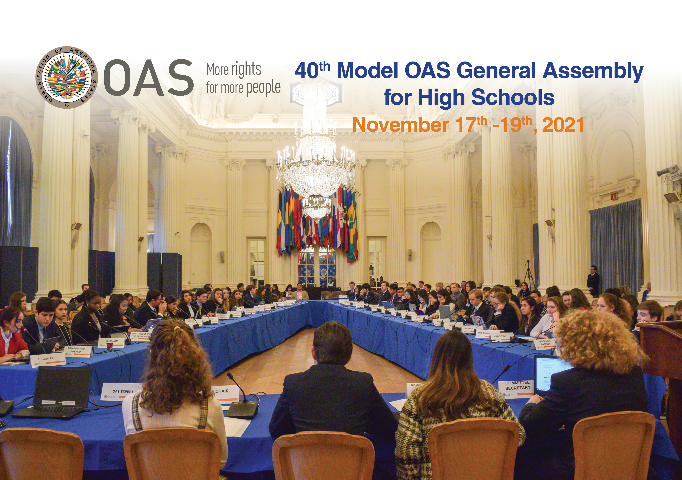

40th MODEL OAS ASSEMBLY FOR HIGH SCHOOLS
November 17th-19th, 2021

SCHEDULE OF EVENTS

VIRTUAL FORMAT

Thursday, November 18th:
Committee on Juridical and Political Affairs

Friday, November 19th:
and All Committee delegates

THURSDAY, NOVEMBER 18th, 2021

COMMITTEE ON JURIDICAL AND POLITICAL AFFAIRS
TIME | ACTIVITY
8:30 am | Delegates of the Committee on Juridical and Political Affairs log into Microsoft Teams through this link and enter the virtual room to ensure access to all features.
8:45 am | Microphone and camera test
9:00-10:15 am | FIRST SESSION OF THE COMMITTEE ON JURIDICAL AND POLITICAL AFFAIRS
- Remarks by Committee Chair (2 min).
- Introduction of Committee officers (Vice Chair and Committee Secretary) (1 min).
- Establishment of quorum
- Establishment of Order of Precedence of delegations (alphabetically by country).
- Approval of the Schedule of Events and the Agenda of Topics (1 min).
- The Chair announces the opening statements by Head delegates.
- General Statements by Head delegates, on the assigned topic by the MOAS Coordination team, according to the Order of Precedence (1 min).

10:15-10:45 am | SECOND SESSION
- The Chair announces the opening statements by Alternate delegates.
- Statements by Alternate delegates, on the assigned topic by the MOAS Coordination team, according to the Order of Precedence (1 min).

10:45-11:45 am | THIRD SESSION
Presentation of the Instructions for Debate (Article 54, 55 and 57) of the Rules of Procedure) (6 min).
Debate of draft resolution # 1 (CAJP – Res.1) presented by the Working Group 1 Leader, Head Delegate of Costa Rica (Jehismar Gonzalez).
Draft resolutions will be shared on the screen
(The MOAS Team will upload the draft resolutions in the MOAS Website) (A draft copy will be sent to delegates’ emails prior to the MOAS)
11:45-12:20 pm | LUNCH BREAK
12:20 – 2:00 pm | FOURTH SESSION
Debate of draft resolution # 2 (CAJP – Res.2) presented by the Working Group 2 Leader , Head Delegate of Guatemala (Ryan Chan). (1 hour per resolution)

Debate of draft resolution # 3 (CAJP – Res.3) presented by the Working Group 3 Leader, Head Delegate of The Bahamas (Ianmikel Benet). (1 hour per resolution)
2:00 -2:15pm | ELECTORAL PROCESS  The Committee Secretaries read the Instructions for the Election of the MOAS Authorities (Article 79 – 85 of the Rules of Procedure) (2 min).  The MOAS President calls the delegates who wish to run for Chair and Vice Chair and introduces them to the Committee.  Each of the candidates receives his/her electoral nomination form and gets the support of four (4) delegations in addition to his own delegation for the nomination to be valid.  Candidates must not have more than five (5) signatures on their nomination form.
2:15-2:35 pm | BREAK
2:35- 2:55 pm | The Chair validates the supporting countries of each candidate by making them raise their hands when they are called.  Valid candidates make a three (3) minute presentation about their qualifications for the position for which they are running.  Election of Chair and Vice Chair of the Committee on Juridical and Political Affairs for the 41st MOAS 2022.
*2:55-3:15 pm | Closing remarks by the Chair and Vice Chair  The Chair reminds the delegates that they must participate in the Opening Session of the 40th General Assembly as well as the Plenary and Closing Sessions, scheduled for Friday at 2:30pm

* All Committee delegates and Authorities are required to participate in the Opening Session of the 40th General Assembly as well as the Plenary and Closing Sessions on Friday, November 19th, at 2:30pm.

