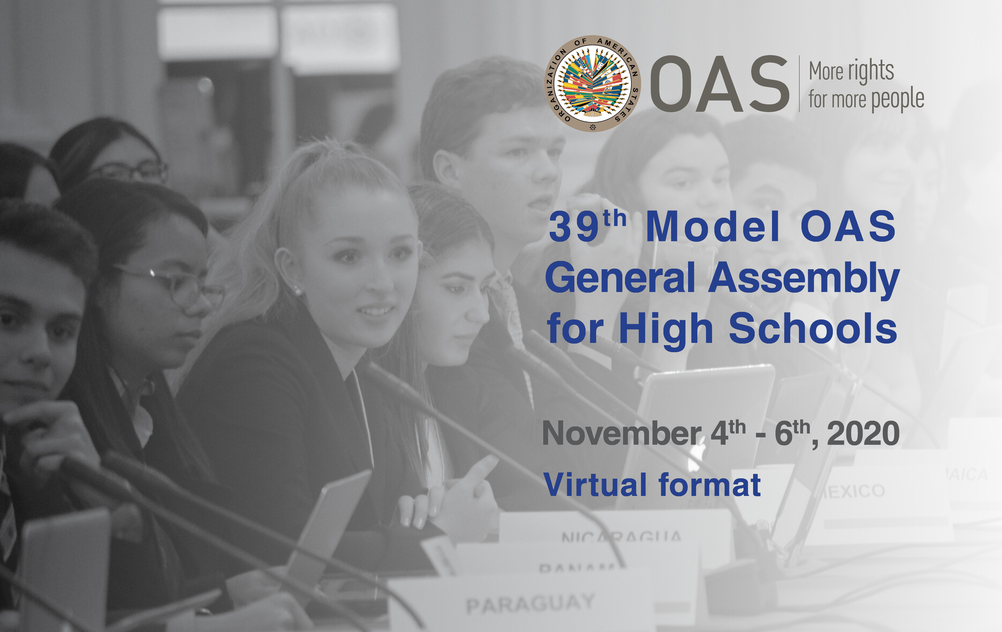

READING MATERIAL
39th MODEL OAS GENERAL ASSEMBLY FOR HIGH SCHOOLS
Washington, D.C, November 4th, 5th - 6th, 2020

GENERAL COMMITTEE

Pandemics and the role of individuals/States

- Best practices in increasing the capacity of healthcare systems to be better prepared to confront a health crisis.
- Inter-American program on Access to Public Information – Resolution adopted at the second plenary session of the General Assembly in 2016.
- Essential steps for developing or updating a national pandemic influenza preparedness plan - by the World Health Organization
- A WHO guide to inform & harmonize national & international pandemic preparedness and response – by the World Health Organization
- Reorganization and Progressive Expansion of Health Services for the Response to the COVID-19 Pandemic – by the Pan American Health Organization
- Recommendations for medical surge capacity and deployment of emergency medical teams – by the Pan American Health Organization

- Addressing the need to ensure educational continuity, equity and inclusion due to the pandemic, focusing on access as well as quality of education.
- Education in the time of COVID-19. – by the Economic Commission for Latin America and the Caribbean (ECLAC).
- Health and the economy: A convergence needed to address COVID-19 and retake the path of sustainable development in Latin America and the Caribbean – Report by the Economic Commission for Latin America and the Caribbean and the Pan American Health Organization
- A framework to guide an education response to the COVID-19 Pandemic of 2020 – by the Organization for Economic Cooperation and Development (OECD).
- Member State´s initiatives in response to the COVID-19 crisis. – OAS Education
- Framework for Reopening of Schools in the Caribbean – Framework developed by the Caribbean Development Bank in cooperation with United Nations Educational, Scientific, and Cultural Organization and the International Institute for Educational Planning.

- Measures to revive the economy at the regional and national levels after COVID-19.
- The economic recovery after COVID-19: the role of the energy sector. – Virtual dialogue organized by the Inter-American Development Bank (IDB), OAS and the Americas Business Dialogue.
- Health and the economy: A convergence needed to address COVID-19 and retake the path of sustainable development in Latin America and the Caribbean – Report by the Economic Commission for Latin America and the Caribbean and the Pan American Health Organization
- Measuring the impact of COVID-19 with a view to reactivation – by the Economic Commission for Latin America and The Caribbean
- Coronavirus (COVID-19): SME policy responses – by the Organization for Economic Cooperation and Development (OECD).

Committee on Juridical and Political Affairs

Democracy and Human Rights

- Measures to respect fundamental freedoms and the full observance of human rights during the emergency caused by COVID 19.
- Practical Guide to inclusive and rights-based responses to COVID-19 in the Americas. – by the Secretariat for Access to Rights and Equity, Department of Social Inclusion, OAS.
- Pandemic and Human Rights in the Americas – by the Inter-American Commission on Human Rights
- CP/RES. 1151 (2280/20) The OAS Response to the COVID-19 Pandemic – Resolution adopted by the Permanent Council of the OAS.
- IACHR Calls for Guarantees for Democracy and the Rule of Law during the COVID-19 Pandemic – Press release by the Inter-American Commission on Human Rights.

- The role of the States and international organizations to guarantee access to official, up-to-date and reliable information on COVID-19.
- COVID-19 Factsheets: Understanding the Infodemic and Misinformation in the fight against COVID-19 – by the Pan American Health Organization
- the Right To Access To Information In The Americas: Inter‐American Standards and Comparison of Legal Frameworks – Report by the Inter-American Commission on Human Rights
- Declaration of Principles of Freedom of Expression – Special Report by the Inter-American Commission on Human Rights

- Actions to ensure transparent and inclusive electoral processes during the pandemic.
- Guide to Organizing Elections in Times of Pandemic (only in Spanish at the moment) – by the General Secretariat of the OAS
- OAS Electoral Observation Mission Recognizes Successful Dominican Elections in the Context of a Pandemic – Press release by The Electoral Observation Mission of the Organization of American States (OAS)
- Secretariat for Strengthening Democracy

Committee on Hemispheric Security

Cybersecurity and other Security Challenges

- Public-private measures to strengthen cyber-security capacity in Member States to promote faster digital transformation and ensure a safe access to essential information.

- Guide for Cybersecurity Event Recovery – by the National Institute of Standards and Technology, U.S. Department of Commerce
- Technical Information Document Network/System Access Security – document published by National Emergency Number Association
- Key Role of Digital Technologies in the COVID-19 Pandemic – document presented by the Economic Commission for Latin America and the Caribbean
- IDB-OAS: Efforts to improve cybersecurity in the Americas increase, but work is needed – Joint report by the IDB and the OAS (only in Spanish at the moment)

- Actions to support the countries of the Hemisphere to address the challenges that COVID-19 represents regarding operations of emergency and security systems.
- OAS to Launch Virtual Community of the Emergency and Security Systems of the Region – Press Release by the Organization of American States
- Virtual Community of the Emergency and Security Systems of the Region – materials and tools addressing the challenges of the pandemic.

- Measures to prevent, address and punish violence against women and girls during the pandemic.
- Violence Against Women and the Measures to Contain the Spread of COVID-19 – by the Inter-American Commission of Women (CIM)
- COVID in Women's Lives: Reasons to Recognize the Differential Impacts – by the Inter-American Commission of Women (CIM)
- Women integral to battling coronavirus and pushing for lasting peace and security –article by United Nations.
- The COVID-19 response: Getting gender equality right for a better future for women at work – Policy Brief by the International Labour Organization

