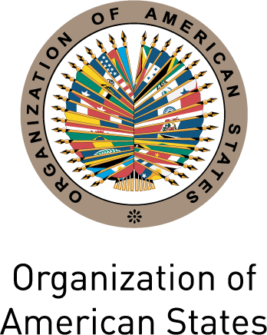
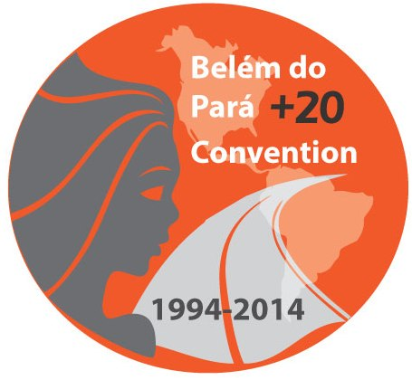
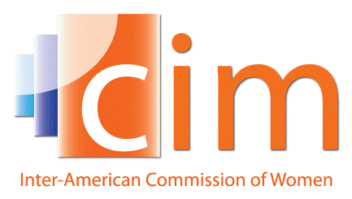

INTER-AMERICAN COMMISSION OF WOMEN

EXECUTIVE COMMITTEE 2013-2015 OEA/Ser.L/II.5.32
THIRD REGULAR SESSION CIM/CD/doc.16/14
Pachuca, Hidalgo May 5th 2014
May 16th 2014 Original: Spanish

Declaration of Pachuca
“Strengthening efforts to prevent violence against women”
(Proyecto)

WE, THE PRINCIPAL AND ALTERNATE DELEGATES OF THE INTER-AMERICAN COMMISSION OF WOMEN (CIM) AND THE EXPERTS OF THE COMMITTEE OF EXPERTS OF THE FOLLOW-UP MECHANISM TO THE BELÉM DO PARÁ CONVENTION (MESECVI) OF THE ORGANIZATION OF AMERICAN STATES (OAS), gathered in Pachuca, Hidalgo, Mexico, on may 16th 2014, on the occasion of the Third Regular Session of the CIM Executive Committee 2013-2015;

BEARING IN MIND:

That twenty years ago, the Inter-American Convention on the Prevention, Punishment and Eradication of Violence against Women (Belém do Pará Convention) established the right of women to be free from violence;

That on ratifying the Belém do Pará Convention, States Party committed to adopting policies to prevent, punish and eradicate violence against women and:
- apply due diligence to prevent, investigate and impose penalties for violence against women (article 7, paragraph b); and
- take all appropriate measures, including legislative measures, to amend or repeal existing laws and regulations or to modify legal or customary practices which sustain the persistence and tolerance of violence against women (article 7, paragraph e).

and that they agreed to undertake progressively specific measures, including programs to:
- promote awareness and observance of the right of women to be free from violence, and the right of women to have their human rights respected and protected (article 8, paragraph a);
- modify social and cultural patterns of conduct of men and women, including the development of formal and informal educational programs appropriate to every level of the educational process, to counteract prejudices, customs and all other practices which are based on the idea of the inferiority or superiority of either of the sexes or on the stereotyped roles for men and women which legitimize or exacerbate violence against women (article 8, paragraph b);
- promote the education and training of all those involved in the administration of justice, police and other law enforcement officers as well as other personnel responsible for implementing policies for the prevention, punishment and eradication of violence against women (article 8, paragraph c); and
- encourage the communications media to develop appropriate media guidelines in order to contribute to the eradication of violence against women in all its forms, and to enhance respect for the dignity of women (article 8, paragraph g).

That through the Declaration and Platform for Action of the Fourth World Conference on Women, held in Beijing in September of 1995, the participating Governments declared their commitment to:
- elaborate recommendations and develop curricula, textbooks and teaching aids free of gender-based stereotypes for all levels of education (paragraph 83a);
- introduce and promote training in peaceful conflict resolution (paragraph 83e);
- develop human rights education programmes that incorporate the gender dimension at all levels of education (paragraph 83j);
- encourage the establishment of media watch groups that can monitor the media and consult with the media to ensure that women's needs and concerns are properly reflected (paragraph 242a);
- encourage the media to refrain from presenting women as inferior beings and exploiting them as sexual objects and commodities (paragraph 243d);
- establish, consistent with freedom of expression, professional guidelines and codes of conduct that address violent, degrading or pornographic materials concerning women in the media, including advertising (paragraph 244b)

That through the Santo Domingo Consensus, adopted during the 12th Regional Conference on Women in Latin America and the Caribbean in October 2013, the participating Governments agreed to strengthen the mainstreaming of gender across all areas of public policy in connection with information and communications technologies (paragraph 34);

That through the Agreed Conclusions of the 58th Session of the United Nations Commission on the Status of Women (E/CN.6/2014/L.7), the Member States declared their commitment to:
- implement concrete and long-term measures to transform discriminatory social norms and gender stereotypes (paragraph 42d);
- fully engage men and boys, including community leaders, as strategic partners and allies in the elimination of all forms of discrimination and violence against women and girls (paragraph 42e);
- promote and protect women’s and girls’ right to education on the basis of equal opportunity and non-discrimination throughout their life cycle at all levels…eliminating gender stereotypes in the curriculum; mainstreaming a gender perspective into education and training programmes (paragraph 42u);
- recognize the important role the media can play in the elimination of gender stereotypes, and to the extent consistent with freedom of expression, increase the participation and access of women to all forms of media, and encourage the media to increase public awareness of the Beijing Platform for Action, the Millennium Development Goals, gender equality and the empowerment of women and girls (paragraph 42xx).

TAKING NOTE WITH SATISFACTION:

That over the last two decades, the Belém do Pará Convention has paved the way for a new generation of integrated laws and, in that context, for the establishment of legal standards at the national, regional and international levels, the formulation of public policies and national plans, the organization of information and awareness-raising campaigns, the development of specialized care and support services and other initiatives and activities;

Of the positive results of these efforts in terms of increasing the visibility of violence against women as a social problem and a violation of human rights, as well as the inter-sectoral response to this problem in terms of prevention, punishment and care;

Of the results of the Belém do Pará +20 Hemispheric Forum “The Belém do Pará Convention and the Prevention of Violence against Women: Good practices and proposals for the future,” including the ideas, experiences and methodologies exchanged to foster education based on human rights and free from gender stereotypes, train different sectors on the nature and extent of violence against women and how to prevent it, work with communications media and publicity agencies to promote gender-sensitive communication that is free of discrimination, and how to evaluate the impact of prevention efforts in order to identify good practices and lessons learned.

RECOGNIZING

That violence against women is an offense to human dignity and a violation of human rights; it undermines development, generates social instability and impedes progress towards justice and peace;

That the different forms of violence against women are an obstacle to their individual development, weakens the exercise of their rights and freedoms, blocks the full development of their capacities and autonomy and limits their public, economic, social and political participation; and

That of all the areas of work that are touched on by the Belém do Pará Convention, it is in the area of prevention that we have made the least progress in terms of the goals that have been set and the we still possess little systematized knowledge on how to conduct prevention and how to measure the impact of prevention efforts.

DECLARES THEIR COMMITMENT TO:

- Reaffirm the provisions of the Inter-American Convention on the Prevention, Punishment and Eradication of Violence against Women and the Declaration and Platform for Action of the Fourth World Conference on Women, in light of the twentieth anniversaries;

- Strengthen the focus on prevention of violence against women as part of integrated response, without detracting from existing punishment and care efforts, on the basis of proven experiences and methodologies and taking into account the ensemble of agreed commitments on the promotion of and education in human rights and the elimination of gender stereotypes in education and communication;

- Fight the culture of impunity for violence against women and the utilization of discriminatory stereotypes and sexist media coverage of women, through the communications media at our disposal;

In the area of legislation and public policy
[CONTENT WILL BE PROVIDED BY THE WORKING GROUPS HELD ON THURSDAY MAY 15TH IN THE AFTERNOON]

In the area of education
[CONTENT WILL BE PROVIDED BY THE WORKING GROUPS HELD ON THURSDAY MAY 15TH IN THE AFTERNOON]

In the area of communication
[CONTENT WILL BE PROVIDED BY THE WORKING GROUPS HELD ON THURSDAY MAY 15TH IN THE AFTERNOON]

WE REQUEST THAT THE EXECUTIVE COMMITTEE 2013-2015 AND THE EXECUTIVE SECRETARIAT OF THE CIM:

- Follow-up the results of the Belém do Pará +20 Hemispheric Forum “The Belém do Pará Convention and the Prevention of Violence against Women: Good practices and proposals for the future” through the Platform on Good Practices in the Implementation of the Belém do Pará Convention (http://www.belemdopara.org), by distributing the practices presented during the Forum and compiling and organizing additional information; and

- Strengthen the utilization of traditional and new communications media to increase the visbility of the Belém do Pará Convention and the achievements of its Follow-up Mechanism (MESECVI)

input.doc

