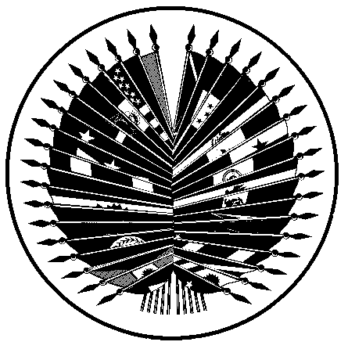
ORGANIZATION OF AMERICAN STATES
Inter-American Council for Integral Development
(CIDI)
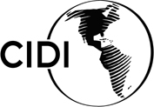

PREPARATORY MEETING OF THE THIRD OEA/Ser.K/XXVII.3
INTER-AMERICAN MEETING OF MINISTERS REMIC/RP/doc. 8/06
OF CULTURE AND HIGHEST APPROPRIATE AUTHORITIES 11 August 2006
August 17 and 18, 2006 Original: English
Washington, D.C.

“PRELIMINARY LIST OF PRIORITY ACTIVITIES FOR 2006-2008”

(Presented by the Delegation of Canada)

Preliminary List of Priority Activities for 2006-2008
(DRAFT – For discussion at the CIC meeting, August 2006)

As agreed by CIC Member States in March 2006, one of the official outcomes of the Third Inter-American Meeting of Ministers of Culture and Highest Appropriate Authorities will be a List of Priority Activities that will set out programming priorities for the Inter-American Committee on Culture (CIC) for the following two years. This document will be discussed and agreed upon by CIC Member States as part of the preparatory process for the Ministerial.

Below is a Preliminary List of Priority Activities that was prepared as a basis for discussion. The listed items correspond to the outstanding activities from the CIC Work Plan. Member States are invited to add to this list by suggesting any additional activities they are willing to lead, particularly with regard to the four themes of the Ministerial (as marked in the chart below).

Activity | Status
A) THEME I – Preservation and protection of cultural heritage

Tangible Heritage
- Regional Workshops: Experiences in Defending Cultural Heritage (proposed by the United States)  Sub-regional workshop to share best practices in cultural heritage preservation and safeguarding. Topics to include law enforcement, regional mechanisms of cooperation, education, and technical capacity building. First workshop to focus on Central American Region. | Awaiting revised proposal
- Linking Heritage and Communities Across Borders: Sister Parks for the Americas (proposed by the United States)  Conference that will focus on sustaining leadership and collaboration across borders, in particular, the preservation of three world heritage sites in the Unites States and Mexico and a world-class site in Belize. | To be confirmed

Others...

B) THEME II – Culture and the enhancement of dignity and identity of our people

- International Seminar on Cultural Diversity / Practices and Perspectives (proposed by Brazil) | To be confirmed
- Regional Meeting: Exploring Best or Desired Practices in the Integration of Cultural Identity and Diversity in Educational Programmes (proposed by Jamaica)  Paper to be presented at the Third Ministerial, followed by a special meeting of representatives of culture and education sectors and an Integrated Education and Culture Regional Conference | To be held in 2007 (third quarter)
Others...
C) THEME III – Culture and the creation of decent jobs and the overcoming of poverty

- Workshop – Program of Rescue and Promotion of the Artisan, Indigenous and Traditional Production of Honduras (PROPAITH) | To be held in November 2006
- Program to promote micro, small and medium sized cultural enterprises: Include specific initiatives that address the needs of cultural enterprises in existing programs from different organizations.  CIC Chair to explore with the IDB, the OAS and other regional organizations how their programs for micro, small and medium enterprises could include the topic of cultural industries. Find successful experiences on promotion of micro, small and medium-sized cultural and show how these (i) generate jobs and growth, and (ii) use culture to promote social inclusion. Could administer a survey of Member States and prepare a document to share with the IDB. | CIC Chair to meet with IDB (August 2006)
- Satellite accounts to reflect contribution of culture to national economies (with CAB and Inter-American Foundation)  Methodology developed by a few countries to be extended to the Member States of the CIC. | Ongoing
Others...

D) THEME IV – Culture and the role of indigenous people

To be determined

E) ADDITIONAL PRIORITY AREA – Cultural information systems

- Workshop to share experiences of South American countries | To be held by Chile (date to be determined)
- Inter-American Cultural Policy Observatory (ICPO) / Network of Cultural Observatories  The role of the Virtual Forum could be discussed, as well as the need for a paper on the role and benefits of cultural policy observatories based on the Network Survey, and for a database of country cultural policy profiles. | Next steps to be determined
Others...

