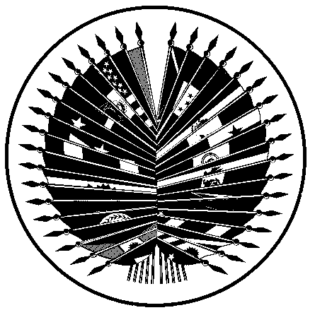
ORGANIZATION OF AMERICAN STATES
Inter-American Council for Integral Development
(CIDI)
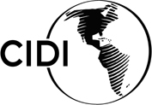

THIRD REGULAR MEETING OF THE OEA/Ser.W/XIII.6.3
INTER-AMERICAN COMMITTEE ON EDUCATION CIDI/CIE/INF. 4/06
October 26 – 27, 2006 19 October 2006
Washington, D. C. Original: English

PROGRESS REPORT 2005-2006 – “INTER-AMERICAN PROGRAM ON EDUCATION FOR DEMOCRATIC VALUES AND PRACTICES”

Inter-American Program on Education for Democratic Values and Practices
Progress Report 2005-2006

Purpose: This report seeks to inform member states on progress in the execution of the Inter- American Program on Education for Democratic Values and Practices and the use of resources approved by the Authorities and Executive Committee to support the initial activities of the Program in 2005 and 2006.
Background:

The Inter-American Democratic Charter of the Organization of American States emphasizes the important role played by education in developing and sustaining a culture of democracy in the countries of the Americas. In August 2005, the Ministers of Education of the hemisphere committed themselves to adopting a hemisphere-wide program of education for democratic values and practices -- the culmination of a broad range of activities undertaken within the framework of the OAS to strengthen democracy through education. The Program would have three mutually reinforcing components:/

- Research component
- Professional development and educational resource component
- Information exchange component.

Ministers asked the Inter-American Education Committee (CIE) to facilitate the development of a detailed and feasible work plan, benchmarks for progress, a proposed budget and sources of financing for the program’s first phase.

Ministers further specified, in their Declaration of Scarborough and Commitments to Action, that these items should be developed by “a working group of interested member countries led by Colombia, with assistance from the Department of Education and Culture (DEC) of the OAS in collaboration with the Department for Governance, and with guidance from an Advisory Group composed of citizenship education officials from member states, academic and civil society experts, and other appropriate, interested partners. The work plan, including specific initial activities and proposed sources of financing, should be presented to the CIE executive committee and authorities, before the end of this year (2005). Among the initial activities in the work plan, to hold, in Mexico in the first quarter of 2006, a meeting of representatives of member states on successful experiences in citizenship education.” (CIDI/RME/doc.13/05 rev. 2) The Ministers also requested that the CIE report on progress in implementing the Program at the V Meeting of Ministers of Education in 2007.

In response to this mandate, the Authorities and Executive Committee of the CIE at their V meeting in November 2005 approved $57,100 in order to support some activities of the first phase of the Inter-American Program. This phase included the formation of a coordinating group of ministry representatives, the first meeting of the Advisory Board of the Inter-American Program held April 17-19, 2006 in Bogotá, Colombia, the development of a Web Portal for the Program launched in June 2006, a mapping of current policies and programs in the hemisphere in education for democratic citizenship (in process), and the organization of an International Seminar on Best Practices in Citizenship Education held July 2006 in Mexico City.

Summary of activities and results 2005- 2006:

Phase 1: (November 2005-December 2006)

Activities Funded by the CIE in 2005 - 2006

- Creation of working group made up of interested member countries
- Creation of an advisory group of experts in the area of citizenship education and organization of first on-site meeting to develop work plan and budget
- Development and maintenance of an Inter-American Program Web Portal
- Development of Information Exchange Component: mapping of promising policies and practices in citizenship education, on-line bulletin, and web portal

Activities Funded by other donors in 2005 - 2006

- International Workshop on Good Practice in Citizenship Education, Mexico Knowledge-Sharing Seminar
- On-line Pilot Course for teachers in Peru 2006
- On-line Course for Teachers and Trainers on Citizenship Education for the Caribbean

Related Initiatives
- Latin American Observatory on Citizenship Education

Progress on Activities in 2007

- Inter-American Journal on Education for Democracy
- Inter-American Summit on Conflict Resolution, Ohio, March 14-17

Activities Funded by CIE 2005 - 2006

Description of activities for Phase 1:

Activity 1: Creation of CIE working group made up of interested member countries

- Date of execution: on-going
- Total cost of the activity per object of expenditure (in US $): 0

Description: All CIE member countries were invited to participate in the working group led by Colombia. The coordinating group is composed of representatives designated by Ministers of Education. These individuals are the main point of contact in each ministry and have an important role in overseeing the development of the Program. They will provide key information regarding the status and needs of the sector and will receive updated information on the advances and various activities of the Program. Eight countries have designated a representative to form part of the working group.

Activity 2: First Advisory Board Meeting

- Date of execution: April 17-19, 2006
- Total Cost of activity in (US $): $50,000
- Total contribution of CIE: $16,150
- Counterpart funding:
  - $ 28,800 Center for Civic Education
  - $ 5,050 Ministry of National Education, Colombia

Description:

The first meeting of the Advisory Board, organized by the Department of Education and Culture and the Department for Good Governance of the OAS, was held in Bogotá, Colombia on April 19-21, 2006 and was sponsored by the Inter-American Committee on Education (CIE), the Ministry of Education of Colombia, and the Center for Civic Education. The Advisory Board consists of renowned experts from ministries of education, universities, civil society groups, and others working in the field of education for democratic citizenship in the Americas.

The main objective of this first Advisory Board meeting was to generate a consensus on concrete recommendations and suggestions to be used in the design of the action plan of the Inter-American Program. The Advisory Board members discussed the state of the art in education for democratic values and practices, and analyzed the challenges (gaps) to and opportunities (resources) for citizenship education, through small group and plenary sessions. The Advisory Group recommended activities that should be undertaken within the Inter-American Program’s three components. (see events section at www.educadem.oas.org for final report and recommendations).

Activity 3: Develop and maintain Inter-American Program web portal
- Date of Execution: June 2006 – present
- Total cost of the activity per object of expenditure (in US $): $15,000
- Total Contribution of CIE: $10,000 (design and programming)
- Counterpart funding:
  - $5,000 OAS (Includes Hosting Fees, technical assistance, maintenance, and other associated costs)

Description: The Inter-American Program’s web portal at www.educadem.oas.org was launched in June 2006 and is becoming a one-stop source of information on efforts to promote the development of a democratic culture through education, and for dialogue among diverse actors in this field. One of the main features of the website is its interactive features that include on-line forums, on-line distance education courses in education for democracy, and research databases.

Activity 4: Development of Information Exchange Component: mapping of promising policies and practices in citizenship education, on-line bulletin, and web portal
- Date of execution: January-December 2006
- Total cost of the activity per object of expenditure (in US $): $35,000
- Total Contribution of CIE: $30,000 (Consultant in citizenship education)
- Counterpart funding:
  - $5,000 OAS (office, computer, communications, travel)

Description: One of the major responsibilities of the consultant (or consultants) in citizenship education was to investigate, develop and manage the contents of the third main component of the Inter-American Program, the Information Exchange Component. The principal activities of the consultant included:

  - Compilation of promising international, national, and local programs and practices in the formal and non-formal education sectors and population of an on-line database
  - Development of online database of research in education for citizenship
  - Development of contents for a bimonthly on-line bulletin on education for citizenship in the hemisphere, based on the resources identified. (see Annex 1 and 2)
  - Development of contents of Web Portal of the Inter-American Program (see Annex 3)

These activities are well underway, as well as a survey of member states regarding their citizenship education policies. The Web Portal, online bulletin, and initial population of the databases are available at www.educadem.oas.org. Final reports from these activities will be delivered to the CIE in early 2007.

Activities funded by other donors 2005 - 2006

Activity 5: International Workshop on Best Practices in Citizenship Education, Mexico

- Date of Execution: July 5-7, 2006
- Total cost of the activity per object of expenditure (in US $): 90,000
- Total contribution of the CIE: $0
- Counterpart funding:
  - $80,000 Mexico
  - $10,000 OAS Department of Education (Website, meeting preparation, participation of OAS specialists, consultants and Director)

Description: Thanks to a generous contribution from the Secretary of Public Education of Mexico, the International Workshop on Best Practices in Citizenship in Mexico brought together experts from around the hemisphere to share and analyze best practices in policies and programs and to reflect on the Mexican experience in promoting a democratic culture through education programs such as “Formación Cívica y Ética”, “Cultura de la Legalidad”, and other inter-sectoral programs. In total there were 88 participants representing 20 countries of the Americas. For detailed information on the event and the final report consult the web page at http://www.educadem.oas.org/mexico/.

This workshop forms part of the Information Exchange component of the Inter-American Program.

Activity 6: On-line Pilot Course on Teaching Democratic Values and Practices in Peru 2006

- Estimated date of execution: January 2005-December 2006

Description: A pilot project to train teachers rooted in the principles of the Inter-American Democratic Charter is currently being implemented and monitored in Peru, supported by funding from the U.S. Mission to the OAS and with partners including Fe y Alegria of Peru and the National Distance Education University of Spain (UNED). The project seeks to implement a distance education course, for primary and secondary teachers, to provide them with the basic pedagogic tools for teaching democratic values and practices in their classrooms. The lessons learned from the course will be presented to the CIE through the Inter-American Program in order to inform policy debates in the hemisphere on teaching democratic citizenship. Future versions of the course would be available to all OAS member states, pending availability of funds. For more detailed information on the course see www.educadem.oas.org

Activity 7: On-line Course on Citizenship Education for the Caribbean

- Estimated date of execution: 2007-2009

Description: Thanks to a generous grant from the Canadian International Development Agency (CIDA), the Department of Education and Culture will begin adapting the Spanish version of the distance course for teachers for the English-speaking Caribbean. This project aims to strengthen teaching practices at the classroom level so that teachers and students become more reflective. The project will accomplish this goal by developing an on-line multimedia system for distance education, to be supported by on-site tutors, which among its principal elements includes:

- A virtual classroom in which the students will find the tools for information, communication, learning and evaluation.
- On-line and “real” tutors.
- Support and reading materials.
- Printed material, videos or discs may also be used either to complement the contents of the course, or to disseminate it in remote regions
- Network of teacher trainers, trained teachers, and democratic classrooms.

This course forms a part of the Professional Development and Educational Resources Component of the Inter-American Program on Education for Democratic Values and Practices.

Related Initiatives

Activity 8: Proposal by Member States to IDB for a Regional System for Evaluation and Development of Citizenship Competencies.

- Estimated date of execution: 2006-2009 (42 months)

Description: The project proposes participation by member countries in Latin America in the next administration of an assessment of citizenship knowledge, skills and attitudes by the International Association for the Evaluation of Educational Achievement (IEA), with the IDB requested to help fund country participation in the study as well as development of a special module of the study focused specifically on Latin America. The project also would integrate activities designed to define competencies that participating countries expect students to develop and activities to make use of the information generated for purposes of policy making. The OAS Technical Secretariat participated in the initial phase of project development along with several member countries and the IDB technical team. This IDB project and its outcomes would be particularly important to the Inter-American Program’s research component.

Final Note: In fulfillment of the request by Ministers of Education, the Technical Secretariat has worked with Colombia on the development of a proposed Work Plan and budget for the Inter-American Program for the period 2007-2010, which will be available for discussion at the III CIE Meeting in October 2006.
input.doc

Activity 9. Inter-American Journal on Education for Democracy, Progress in 2007

Description:
Progress has been made in 2007 towards the launching of the Inter American Journal on Education for Democracy, which forms part of the research component of the Inter American Program. The objective of the journal is to promote quality research in the Americas on education for democratic citizenship. The development of the journal is guided by the following specific recommendations of the Advisory Board (see Recommendations at www.educadem.oas.org/events)

Currently the DEC and its partners are working to identify and select distinguished researchers in the field of education for democratic citizenship to form part of the Editorial Board for the Journal. In the final selection process, the OAS and its three University partners will strive for balance in the Editorial Board members in terms of gender, culture, political orientation, and geography. A timeline for 2007 has been established with the first inaugural edition to be published in September 2007 and the second edition in December 2007. The initial call for papers is currently being distributed throughout OAS Member States (see annex 4).

- Estimated date of execution: January 2007 to November 2008
- Total estimated costs of activity per object of expenditure (in US $):
Per year: $45,000
- 10,000 (Request OAS (Res.831) for 2007 Journal administration and coordination
- 10,000 Editorial costs
- 10,000 Journal design / Programming / Web page
- 10,000 Translation and limited publication for Ministers of Education
- 5,000 Dissemination, communications, misc.

Activity 10. Inter-American Summit on Conflict Resolution Education: International Innovations and Challenges, Cleveland, Ohio, March 14-17, 2007.

Description:

This Summit, organized by a strategic alliance of partners, is the second horizontal workshop of the information exchange component of the Program. It will bring together specialists and policymakers in Conflict Resolution Education, and related fields, from the Americas and other world regions. The primary objective of the Summit is to promote capacity building in the area of the conflict resolution education through the exchange of best practices and opportunities for dialogue among policymakers.

Six teams of Government – NGO partners from the Americas were selected to participate through an open call for proposals (Mexico, Costa Rica, St. Lucia, Colombia, Argentina and Chile). Eight US-state teams and seven teams from other regions will also participate. Best practices will be exchanged at an open conference during March 14 -15, and the government-NGO teams will discuss challenges and lessons learned in focused policy meetings on March 16 – 17.

The outcomes of the Summit will be presented at The Organization of American States V Meeting of the Ministers of Education, in October 2007 in Colombia. A report/book on the state of policy in conflict resolution education in the Americas with lessons, challenges and suggestions to move forward will be published and distributed to key stakeholders in the region. More information may be found at: www.educadem.oas.org

- Estimated date of execution: March 14 – 17, 2007.
- Total cost of the activity per object of expenditure (in US $): 50,000
- Total contribution of the CIE (Request OAS (Res.831): $15,000
- Counterpart funding:
  - $30,000 Global Issues Resource Center.
  - $5,000 Other Sources from the Alliance of Partners.
  - $25,000 UNDP (pending confirmation).

Annex 1: First Issue of the Online Bulletin

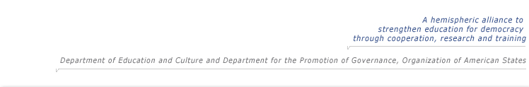

Español |  | English | July - September 2006, Edition Nº 1

 |  |     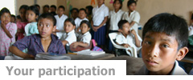
  Welcome to the Bulletin of the Inter-American Program on Education for Democratic Values and Practices.
  Welcome to the first edition of this online Bulletin. We hope this bulletin will strengthen cooperation among our countries by enhancing the dialogue on the role of education in promoting a culture of democracy. It will also provide updates on the progress of our hemispheric alliance to strengthen education for democracy, the Inter-American Program on Education for Democratic Values and Practices. We hope you enjoy this inaugural edition, which will focus on the Inter-American Program as an opportunity for hemispheric dialogue and cooperation.
  Subsequent editions will focus on specific themes within Education for Democratic Citizenship that are of interest to the member countries. The theme for our second edition will be how to involve youth in democratic participation.
  We look forward to establishing an ongoing and fruitful dialogue with all of you,
  Lenore Yaffee García
  Director, Department of Education and Culture
  Organization of American States
  Inter-American Program Launches Webpage.
  More information >>
  Inter - American Seminar held in Mexico, July 5-7, 2006
  See the Seminar Web Page >>
  Approved Resolution of Support for Inter-American Program
  See the resolution >>
  What is the Inter-American Program?
  The Inter-American Program on Education for Democratic Values and Practices is an alliance officially adopted by the ministers of education of OAS member states through CIDI/RME/RES. 12 (IV-O/05) at the IV Meeting of the Ministers of Education held in Scarborough, Trinidad and Tobago on August 11th and 12th , 2005. In the Commitments to Action from Scarborough, ministers asked the Inter-American Committee on Education (CIE) to launch the Inter-American Program, which supports and builds upon significant ongoing local, national and international efforts in formal and non-formal education for democracy. The Program has three components: (1) Research and analysis, (2) Professional development and educational resources, and (3) Cooperation and information exchange.
  Structure of the Program
  An interdisciplinary, cross-national Advisory Board of 40 members provides guidance for the Program, as does the Coordinating Group of Countries which each of the 34 OAS member states is invited to join.
  More information on the Program and its achievements is available at: www.educadem.oas.org
  Interested institutions and individuals are encouraged to join this hemispheric alliance by contacting the Inter-American Program's technical secretariat at the OAS. Please contact us at education@oas.org
  Send us recommendations of promising initiatives (programs, practices and others) to education@oas.org
  Please send us at least the name of the initiative, contact person if possible, correct contact email and phone number if available, so we may send them the questionnaire.
. Country Highlights
Guatemala
Within the framework of the Strategy for Improvement of Educational Quality, APRENDO, the Ministry of Education of Guatemala launched its Strategy on Values and Citizenship Education for preprimary, primary and secondary education. The strategy will strengthen the area of Citizenship Education in the revised Basic National Curriculum being implemented since 2005.
More information >>
Survey of Policies in Democratic Citizenship Education and similar areas
More information >>

. Promising Educational Initiatives
Portfolio of Promising Policies, Programs and Practices
More information >>
(We are collecting information to develop an updated portfolio)

. Events
Program's Advisory Board met in Bogotá, Colombia, April 19 – 21, 2006.
The Program's Advisory Board convened for 3 days in April to provide recommendations for the Inter–American Program's future action plan. The recommendations provided by the inter-disciplinary, cross-national team of approximately 35 experts, include publication of an Inter-American Journal in the field. The Program is moving forward with these recommendations and is seeking funding to implement the 2007 – 2008 action plan.
More information >>
• Previous Inter-American Program events >>
In other regions
• Democratic Citizenship Education In Other Regions >>
• Citizenship Education in Northern Ireland >>
• UNESCO Case Studies >>
• Conflict Resolution Education around the World >>

. Be Part of the Dialogue
What would you like to see in this bulletin? We welcome your suggestions and active participation in the construction of this publication. Contact us at: education@oas.org
Second edition: The theme of our second edition will be involving youth in democratic participation.
Find details on how to contribute and themes of future issues at http://www.educadem.oas.org/english/cpo_boletin.asp
Find other publications of interest and links to resources at www.educadem.oas.org
If you would like to add others to the list serve for this bulletin or if you wish to unsubscribe from this bulletin, send us an email to education@oas.org
• Team >>
First edition Quote
"I see injured and wounded schools. At the base of the sustainability of democracy is confidence. To generate confidence is a condition of learning..."

About the OAS
The Organization of American States (OAS) brings together the countries of the Western Hemisphere to strengthen cooperation and advance common interests. It is the region's premier forum for multilateral dialogue and concerted action. Although the idea of Inter-American cooperation dates back much further, the OAS came into being in 1948, evolving from the Pan American Union. Countries from all around the world are permanent observers , closely following the issues that are critical to the Americas.
• Find out more about the OAS>>
Please click here if you would like to unsubscribe from this Distribution List.

Annex 2: Second Issue of the Online Bulletin


Español |  | English | October - December, 2006, Edition No.2

 |  |     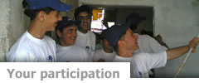
  How to Involve Youth
  in Democratic Participation
  Dear colleagues:
  Citizen polls in the region indicate that many youth do not believe they can influence political affairs (as definitions of “youth” vary , the term is used broadly in this bulletin). There may be several reasons for this perception of a lack of political efficacy, but researchers often point to the lack of structured opportunities for youth, both inside and outside of schools, to actually engage in democratic decision-making with adults. If these opportunities do exist, they are often decorative or tokenistic and thus do not provide youth with the authentic experience of exercising democratic rights and responsibilities.
  We believe that if we are truly serious about education for democracy, then we must consider concrete and viable ways to move from the traditional “education about citizenship” towards “education in and for citizenship”. This implies creating spaces for youth to participate in a meaningful way in our schools and communities. This edition provides you with interesting resources and ideas from adults and youth in the Americas who are already doing this (also see an expanded version of this bulletin below).With best wishes,
  Lenore Yaffee García
  Director, Department of Education and Culture
  Organization of American States
  OAS Youth Monitor Election in Nicaragua
  More information >>
  US Civic Health Index Presented
  More information >>
  What is the Inter-American Program?
  The Inter-American Program on Education for Democratic Values and Practices is an alliance officially adopted by the ministers of education of OAS member states through CIDI/RME/RES. 12 (IV-O/05) at the IV Meeting of the Ministers of Education held in Scarborough, Trinidad and Tobago on August 11th and 12th, 2005.
  The Program has three components: • Research and analysis
  • Professional development and educational resources, and
  • Cooperation and information exchange.
  Structure of the Program
  An interdisciplinary, cross-national Advisory Board of 40 members provides guidance for the Program, as does the Coordinating Group of Countries which each of the 34 OAS member states is invited to join.
  More information on the Program and its achievements is available at: www.educadem.oas.org
  Highlighted Program Activities
  Inter-American Summit on Conflict Resolution Education: International Innovations and Challenges.
  March 14 – 17, 2007, Ohio, USA. http://www.educadem.oas.org/
  In Debate
  Join the debate. Open discussion virtual forum, February 1 – 15, 2007.
  Join us if you have a position on the issue of youth participation or an interesting resource.
  Interested institutions and individuals are encouraged to join this hemispheric alliance by contacting the Inter-American Program's technical secretariat at the OAS. Please contact us at education@oas.org
  If you would like to add others to the list serve for this bulletin or if you wish to unsubscribe from this bulletin, send us an email to education@oas.org
. International Legal Framework
• Convention on the Rights of the Child >>
• Inter-American Democratic Charter >>

. Regional Country Highlights
• Global Youth Service Policy Scan >>
• Schools for Solidarity in Argentina (Spanish only) >>
• X-Change: Non-violence in the Caribbean >>

. Other Promising Educational Initiatives
• Children’s Participation Standards >>
• How to Involve Children in Research >>
• Project Citizen >>
• Lessons Learned: Youth Engagement Initiatives >>

. Events
• Model OAS for Universities, April 9 – 13, 2007, Washington, DC >>
• International Youth Volunteerism Summit, Feb. 22 – 25, 2007 >>
• UNICEF G8 Youth Event, 2007, Germany >>
• Other Events >>

. In Other Regions
• What Works: Youth Participation Around the World >>
• Participation in the UK Curriculum >>

. Be Part of the Dialogue
What would you like to see in this bulletin? We welcome your suggestions and active participation in the construction of this publication. Contact us at: education@oas.org
Third edition: The theme of our third edition will be Promising Policies and Programs in the Hemisphere.
• Find details on how to contribute and themes of future issues
• Team >>

. Other Resources
Find other publications of interest and links to resources on how to involve youth in democratic participation, and other topics, at www.educadem.oas.org

Second edition Quote
"A complex aspect of youth participation proposals is the risk of simulation, constructing an apparent participation (Ball, S. 1989) which only accentuates the discrediting of school authority. How to differentiate between real participation and apparent participation? There are forms of participation which only serve to reinforce the status quo and make it more presentable. "Consultations", for instance, may become effective strategies of apparent participation."
Fernando Onetto, Ministry of Education of Argentina.
• Other quotes >>
About the OAS
The Organization of American States (OAS) brings together the countries of the Western Hemisphere to strengthen cooperation and advance common interests. It is the region's premier forum for multilateral dialogue and concerted action. Although the idea of Inter-American cooperation dates back much further, the OAS came into being in 1948, evolving from the Pan American Union. Countries from all around the world are permanent observers , closely following the issues that are critical to the Americas.
• Find out more about the OAS>>
See the expanded version of the bulletin >>
Please click here if you would like to unsubscribe from this Distribution List.

Annex 3: Web Portal for the Program

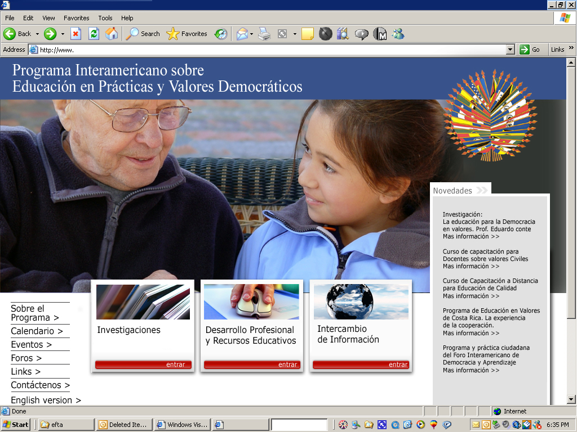

Annex 4: Call for Papers for the Inter-American Journal on Education for Democracy

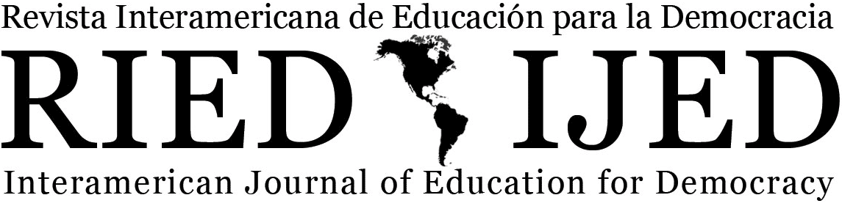

Call for Papers
for the Inaugural Issue of the

Inter-American Journal of Education for Democracy

We welcome submissions for the first and second issues of this new journal, which is affiliated with the Inter-American Program on Education for Democratic Values and Practices, of the Organization of American States (OAS). The Journal will be hosted initially by Indiana University, which has a long and distinguished record of contribution to education for democracy. The Journal will begin as an on-line resource and move to a paper format at a future date. The first issue will be published by late August, 2007 and the second issue will be published at the end of 2007.
The goal of the Journal is to foster intellectual discussion and exchange about efforts to promote education for democratic citizenship across the Americas. We invite research-based or conceptual articles that advance the discussion about education for democracy. Such articles may focus on schools and formal educational processes, or non-formal educational processes; on public, state programs, or non-governmental initiatives; on programs that highlight education for democracy, per se, or that highlight other dimensions which clearly articulate with education for democracy (e.g., intercultural education, human rights education, peace education, gender equity education, etc.).
Articles may be submitted either in the category of “critical” or “review” essay, with an extension of approximately 3,000 words, or in the category of “research article,” with an extension of approximately 10,000 words. Articles may be submitted for consideration in Spanish, English, or Portuguese; at this time, however, we only have enough funding for translation of select articles.[We only accept previously unpublished articles. Each manuscript will be reviewed in two stages, first by the Editors, and then in double-blind manner by 2 other specialists.]

April 15: Deadline for manuscripts, Issue #1
May 30: Final editorial decision and notification of authors
July 15: Deadline for final drafts of articles for Issue #1
Editors:
Roberto González (Pontificia Universidad Católica de Chile)
Bradley A.U. Levinson (Indiana University, USA)
Daniel Schugurensky (Ontario Institute of Studies in Education—University of Toronto, Canada)
Submissions and queries to: ried@indiana.edu and education@oas.org

? Details on the Program’s objectives and components in CIDI/RME/RES.12 (IV-O/05)
See Final Report and Agreements from the V Meeting of the Authorities on the CIE homepage at http://www.oas.org/udse/espanol/cpo_cie.html
Information Exchange Component
This alliance is led by the Organization of American States, the Global Issues Resource Center and the International Network on Conflict Resolution and Peace Education (INCREPE) in collaboration with the Global Partnership for the Prevention of Armed Conflict (GPPAC).

