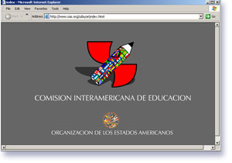
JULY-OCTOBER 2006 SECOND EDITION FirsSEdition
CIE Quarterly Bulletin

Events
July 2006
Seminar on Good Practices in Citizenship Education (Mexico)

September 2006
Teacher Educators Seminar (Trinidad and Tobago)

October 2006
PRIE Steering Committee Meeting (Mexico)
III CIE Meeting (Washington, DC)

March 2007
Symposium on Early Childhood Education (Caracas, Venezuela)
Summit on Peace and Conflict Resolution Education (Ohio, USA)

See CIE calendar for specifics.

Introduction
“To enable the results that we envision, we need to be explicit about the professionals who are the linchpin for our educational success. We need to be unambiguous about who are our teacher educators. …Moreover, this vision includes seeing teaching as a learning profession, profoundly rooted in the knowledge of teaching pedagogy, multiple subject matters and child development; it requires teacher educators to be actively engaged in the real work of schools, and makes us all deeply conscious of the fact that our very democracies rest on our ability and courage to teach all children to attain high levels regardless of their socioeconomic backgrounds and experiences.”
The Honorable Sen. Hazel Manning, Minister of Education of the Republic of Trinidad and Tobago

Welcome to the Second Edition of the Bulletin of the Inter-American Committee on Education (CIE). This edition focuses on the topic of teacher education; it also introduces you to the CIE’s current activities.

The CIE is composed of representatives of the Ministries of Education of the Member States of the OAS. It is dedicated to promoting Inter-American dialogue and cooperation, in order to promote sound policies, build human capacity, and strengthen institutions in the field of education in the Americas.

What is CIE?
For more information on what CIE is click here
Topics

- Teacher Education
- Education for Democratic Citizenship
- Early Childhood Development and Education
- Literacy
- Education Indicators and Evaluation
- Political Dialogue
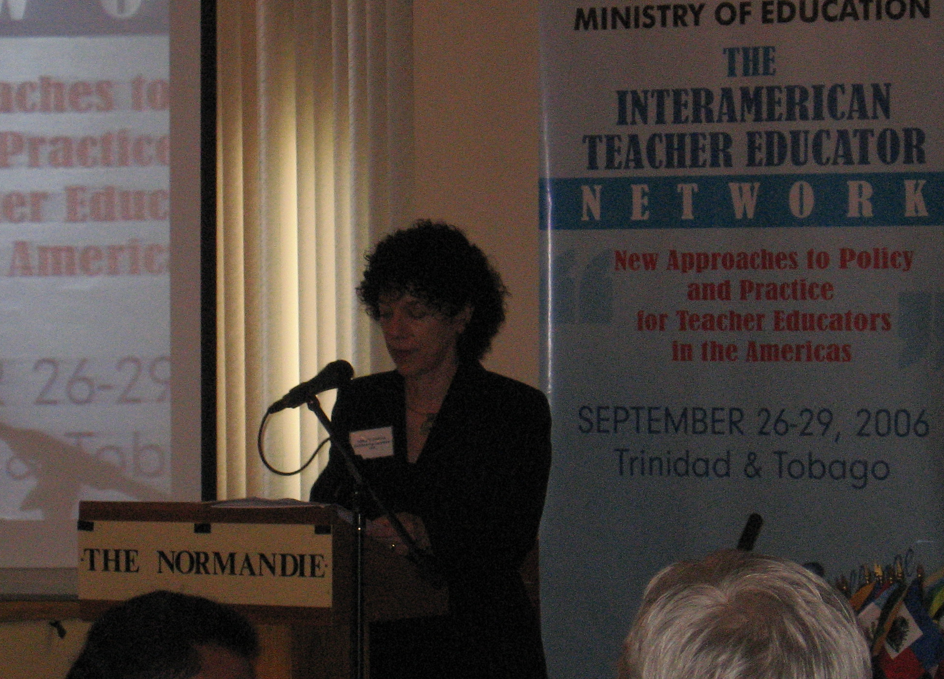
Teacher Education

The Ministry of Education of Trinidad and Tobago and the Department of Education and Culture of the OAS presented New Approaches to Policies and Practices: A Seminar to launch the Inter-American Teacher Educator Network. This seminar, which was held on September 26th to September 29th, 2006 at the Hotel Normandie and the University of Trinidad and Tobago, provided a week of dialogue, research, and planning, and included the discussion of findings from a survey of teacher educators in the Americas. The focus was on teacher educators (“who are teaching the teachers?”) and on strengthening a network of individuals and institutions involved in teacher education.

One hundred participants from 25 countries of the Caribbean and North, South, and Central America included university presidents, teacher educators, government policymakers, researchers, and international organizations dedicated to the improvement of education in the hemisphere.

Funded as a joint venture between the Inter-American Committee on Education of the OAS (which Trinidad and Tobago chairs), the Ministry of Education of Trinidad and Tobago, the Inter-American Organization for Higher Education (OUI), the OAS Human Development Department, and the University of Maryland, the seminar sought to support participants’ development of national and regional action plans for teacher professionalization. This project builds on the FEMCIDI-financed “hemispheric project” on teacher preparation and certification. (For Seminar Report click here)

The following articles were submitted by experts who participated in the Teacher Educator Seminar.

Article: Challenges and New Directions for Teacher Education in the Caribbean
Dr. Paula Mark, Caribbean Sub-regional consultant, OAS Teacher Education Hemispheric Project

The Hemispheric Teacher Education Project has provided the Caribbean sub-region with the opportunity to focus some much-needed attention onto the critical issues related to the education and retention of competent teachers in the education systems of member countries in the Caribbean Community (CARICOM). (For full article click here)

Article: Colombia: The National Teacher Training System (SNFE)
Oscar Armando Ibarra Russi, Chancellor, Universidad Pedagógica Nacional, Colombia
At the end of the 1990s, the teacher training scenario in Colombia was not too promising. Myriad training programs at a variety of institutions made up the supply, according to the diagnostic assessment carried out by the Science, Education, and Development Mission, which characterized this situation as one of generalized disorder (“anomy”). (For full article click here)

Article: Uruguay: Reinterpretation of the Role of the Teacher in a High School Setting
Lic. Mónica Esquibel and Mag. Cristina Maciel de Oliveira

The demands currently placed on Uruguayan teachers call for a reinterpretation of what a teacher is and does. Educational contexts require observation and critical analysis of pedagogic practice. Such demands pose a challenge for educators, who must adopt an investigative approach in the sense suggested by Stenhouse (1991).

Studying the pedagogic setting or atmosphere is understood to be useful when it comes to rethinking the role and functions of middle and high school teachers. The investigatory stance suggested responds to that need in that it seeks to provide educators with a useful tool. The subject of the investigation is: the perceptions of the adolescent pupils attending middle/high school. The instrument has been developed since 2001, and currently the focus is on its construction and validation as a tool for teacher insight into the pedagogic setting. (For full article click here)

Article: The “Transformation of Pre-Service Teacher Training in Nicaragua” and “New Approaches to Policies and Practices for Teacher Educators in the Americas”
MSc. Nidia Mejía Arias, Teacher Educator, Ministry of Education, Culture, and Sport, Nicaragua

As of 2000, pre-service teacher training in Nicaragua embarked on a transformation, as in other Central American countries. First, improvements were made to the curriculum, the training given to teacher trainers, and teaching aids. It was decided that a master’s would culminate in a dissertation. Opportunities were created for new inter-institutional relations between teacher training schools and the state universities that train teachers. We began analyzing and discussing the current situation in light of the new trends in pre-service teacher training in the subregion. We also began a research study of the feasibility of institutionalizing the training at the post-secondary education level. (For full article click here)

Education for Democratic Citizenship
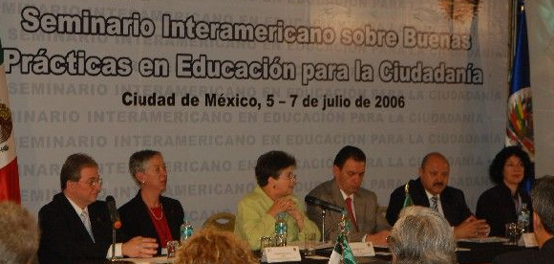

The Inter-American Program on Education for Democratic Values and Practices, mandated by Ministers of Education and supported by the recent General Assembly of the OAS, has been successfully launched as an alliance of governments, civil society and international organizations, schools, universities, and others who work to promote the development of a culture of democracy through education. The Program includes three components: research, professional development and educational resources, and the exchange of experiences and information. An Advisory Board includes representatives of such international entities as the Inter-American Institute on Human Rights, UNICEF and UNESCO; representatives of member states’ Education Ministries; and experts from academia and civil society from across the hemisphere.

At present, the OAS Department of Education and Culture is “mapping” member-country policies and promising programs and practices in education for democratic citizenship. An international seminar on good practices in citizenship education was held in Mexico on July 5-7 http://www.educadem.oas.org/mexico/ The Inter-American Program’s web portal at www.educadem.oas.org and its on-line bulletin are becoming a one-stop source of information on efforts to promote the development of a democratic culture through education, and for dialogue among diverse actors in this field. Support has been provided by the Inter-American Committee on Education, the Governments of Colombia and Mexico, the U.S.-based Center for Civic Education, and others. The next event sponsored by the Inter American Program will be an International Summit on Peace and Conflict Resolution Education to be held from March 14-17 in Ohio, USA. For more information see events section at www.educadem.oas.org

Article: Policy Survey for Ministries of Education
Adriana Cepeda, Education Consultant for the Department of Education and Culture, OAS

The Inter-American Program on Education for Democratic Values and Practices is currently conducting a Policy Survey. The purpose of this survey is to document current national, regional, or local policies in education for democratic citizenship, and related areas, throughout the Hemisphere, and to identify common challenges and priority needs which the Inter-American Program could help address. This survey seeks to identify and document each country’s unique approach so as to recognize, respect, and respond to it.

The Ministers of Education of the 34 member countries of the OAS received a letter explaining the survey from the Department of Education and Culture of the OAS in June, 2006. Their delegates, usually the national coordinators for these policies, answered the 23-question survey using our online tool. As of October 1st, we have received substantial information from thirteen countries: Argentina, Commonwealth of the Bahamas, Canada, Chile, Colombia, Costa Rica, Ecuador, Guatemala, Honduras, Nicaragua, St. Lucia, Trinidad and Tobago, and the United States of America.

Some of the preliminary findings for these thirteen countries are as follows. Eleven reported having a national policy - in place or in construction - on the teaching of education for democratic citizenship or related areas. The two that did not indicate a national policy were Canada and the USA, which have diverse regional policies. Of the countries indicating a national policy was in place, ten stated these national policies applied to primary levels (6-12), nine to secondary levels (13-17), seven to preprimary levels (0-5), four to adults and one to post-secondary education (18-22). Although almost all stated that implementing this policy is mandatory for the actors involved, only two indicated the overall impact of the policy has been evaluated. The complete report of these initial findings may soon be found at: www.educadem.oas.org

Early Childhood Development and Education
Research shows that the first six years of life are critical to developing the capacity to learn and adjust in later life. With support from the Inter-American Education Committee of the OAS, the Department of Education and Culture (DEC), in cooperation with the governments of Venezuela and Barbados and several international organizations, is about to launch a new hemisphere-wide project entitled “Policies and Strategies for a successful transition of young children toward socialization and school.” The intent is to build more coherent policies by bringing together directors of early childhood programs and directors of basic education. A Symposium on Early Childhood, concentrating on ages 0 to 3, is planned to be held in Caracas, Venezuela on March 4-10, 2007. The Department of Education and Culture also provides advice to member countries on early childhood development and education, and supports the Spanish-language version of the World Bank’s early childhood website.

Literacy
The OAS received a new mandate from the Heads of State in the Mar del Plata Summit of the Americas and from the 2006 OAS General Assembly: to undertake a study of successful programs and practices in developing literacy skills in adult or youth populations in the hemisphere. Since this is an area in which many governments and nongovernmental organizations are actively involved, the CIE will discuss practical implications for work in this field within the OAS context at its October meeting.

Education Indicators and Evaluation
The OAS, the Government of Mexico, UNESCO/OREALC, and USAID have collaborated to fund and execute the Regional Education Indicators Project (PRIE), to develop and publish indicators of OAS member-country progress toward achieving the education goals of the Summits of the Americas, as well as to provide technical assistance to member countries in order to strengthen their capacity to collect, analyze, and use good data in decision-making. The project’s website, with a searchable database, can be found at www.prie.oas.org. The project steering committee met in Mexico on October 11-12, 2006 to plan the next year’s work.

Political Dialogue
The Inter-American Committee on Education (CIE), with a representative from each Education Ministry of the 34 OAS member countries, will meet this fall for the III CIE Meeting in Washington (October 26-27) to discuss achievements and next steps under the 2005-2007 CIE Work Plan developed to implement the education mandates of the Summits and the Ministers of Education. The CIE is chaired by Trinidad and Tobago with Vice Chairs Brazil and Venezuela. Each of five sub regions is represented on the CIE Executive Committee.

The V Ministerial will be held in 2007; the CIE Chair is actively canvassing member countries for interest in hosting this important event.

Article: The Education Sector of MERCOSUR and the OAS
Claudia Paes de Carvalho Baena Soares, Ministry of Education of Brasil, Vicepresident of the CIE

The Education Sector of MERCOSUR (SEM) was started in 1992 with the vision of being a regional space where equity and quality education could be offered and guaranteed, characterized by reciprocal knowledge, diverse cultures, respect towards diversity, and cooperation in solidarity. Up until 2005, three Educational Plans served as the framework of the initiatives, projects, and actions that went on in its member countries. There have been advances: agreements based on different levels of teaching; the Experimental Mechanism of Accreditation for Careers in Agriculture, Engineering and Medicine; the harmonization of technical profiles; the capacity of teachers in technical education; the updating of the skills of Spanish and Portuguese teachers as foreign language educators; the creation of the School Libraries of MERCOSUR; and the “System of Education Indicators of MERCOSUR”, among others.

The challenges marked in the SEM Plan 2006-2010 and those underlined in the documents of the OAS in the education sphere present similarities: equity and quality education that promote human and productive development; social inclusion with special attention to vulnerable populations and with respect to diversity; education that promotes regional integration, solidarity, and collective construction towards peace and democracy, human rights, and the environment.

This was the consensus in the recent meeting of the Department of Education and Culture of the OAS with SEM, when initiatives were identified in the areas of education for democratic values and practices; teacher education; early childhood education; knowledge networks; and education indicators and literacy.

The association of initiatives between these two organizations may greatly contribute to the development of education in the hemisphere, with important impacts on our societies.
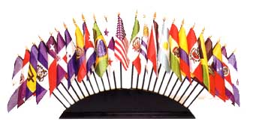

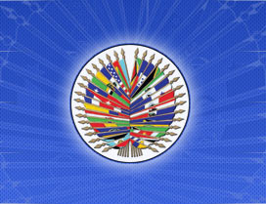

CALENDAR OF ACTIVITIES – EDUCATION 2006

Teacher Education
Teacher Education Seminar…………………………………………………………………September 26-29
Education for Democratic Citizenship
Seminar on Good Practices in Citizenship Education…………… ……………………………...…...July 5-7
International Summit on Peace and Conflict Resolution Education……………………….March 14-17 2007
Early Childhood Development and Education
Symposium on Early Childhood Education……………….. .................................................March 4-10 2007
Literacy
Literacy Study……………………….…………………………………………………….……...………TBD
Education Indicators and Evaluation
PRIE Country Coordinating Group meeting…………………...…………….….….……….....October 11-12
Political Dialogue
MERCOSUR and OAS Video Conference…………………………………………. …September 5
III CIE Meeting…….. ………….…………...………………………………..………..…..October 26-27
V Ministerial…………………………………………………………………………………3rd Quarter 2007

Contact Information

CIE Representation

Marva Ribeiro
CIE President
Trinidad and Tobago
Marva_ribeiro@yahoo.co.uk
Claudia Baena Soares
CIE Vice President
Brazil
claudiasoares@mec.gov.br
Marianela León
CIE Vice President
Venezuela
mleon@me.gob.ve

OAS Department of Education and Culture

Lenore Yaffee Garcia
Director, Department of Education and Culture
lgarcia@oas.org

Gaby Fujimoto-Gómez
Education Specialist
gfujimoto@oas.org

David Edwards
Education Specialist
dedwards@oas.org

Jorge Baxter
Education Specialist
jbaxter@oas.org

Mónica Villegas
Culture Specialist
mvillegas@oas.org

Juliana Bedoya
Culture Consultant
jbedoya@oas.org

Charles André Goulet
Culture Intern
oestint3@oas.org

Roxana Reyes
Department Assistant
rreyes@oas.org

Adriana Cepeda
Education Consultant
acepeda@oas.org

Kiran Badwal
Education Intern
oestint7@oas.org
Vanessa Benedick
Education Intern
oestint1@oas.org
Dulce Jimenez
Education Intern
oestint2@oas.org

