

FINAL

Procedure Documentation

Developing a GIS Database

In MS Access 2000TM and ArcView 3.2TM

For

Hazard Vulnerability Assessment

A sub-component of The Post Georges Disaster Mitigation Program

for

Antigua and Barbuda

Eva Hodgkinson-Chin MSc

30thApril, 2001

1.0 Introduction

The Post Georges Disaster Mitigation (PGDM) program is one of three components of The Hurricane Georges Reconstruction and Recovery in the Eastern Caribbean program. The PGDM is responsible for implementing the disaster mitigation capacity building component and seeks to reduce the vulnerability of population and economic activities to natural hazards. As a result, the PGDM includes a hazard vulnerability assessment component.

The hazard vulnerability assessment component requires that critical facilities be identified and data on their disaster history, structural and operational vulnerability be collected. This data is to be entered into a database and integrated into a GIS. The key layers in the GIS are to be hazard vulnerability maps prepared by specialists in the areas of wind, drought, storm surge, floods, coastal and stream erosion and earthquakes. These layers will assess the locational vulnerability of critical facilities. Other spatial layers of features would be included such as agricultural land, major roads, bridges and telecommunication installations.

The hazard vulnerability assessment project utilizes the approach of developing a database of critical facilities in MS Access 2000 and linking the data required for spatial analysis to a theme table in ArcView 3.2. The database is extensive and includes data on facilities, their individual buildings and contact information. It provides the basis for a facilities management system.

2.0 Vulnerability Assessment Process
The vulnerability assessment process was established by Dr. C. Rogers and presented at a Hazard Mapping Prioritization Workshop in Antigua during August, 2000. The vulnerability assessment process as set out in the workshop consists of the following:

- Identification and prioritization of hazards
- Creation of an inventory of critical facilities
- Assessment of each facility in terms of damage history, structural vulnerability and operational vulnerability for each hazard identified.
- The creation of hazard specific vulnerability zone maps
- The locational assessment of facilities within hazard zones
- The calculation of a total facility vulnerability score (FVS) for each facility and each hazard.

The vulnerability assessment process is defined by the formula :

FVS = (L+V)HPS
Where “FVS” is the Facility Vulnerability score, “L” is the Locational Vulnerability, “V” is the Facility Vulnerability and “HPS” is the Hazard Priority Score.

The forms utilized at the workshop are attached at Appendix 1. Three forms were provided a hazard prioritization table and two forms for facilities analysis. The hazard prioritization table produces a weighted listing of hazards and the facility forms calculate the “V”, “L” and “FVS” values.

The workshop generated a priority listing of the six hazards listed below. As indicated, the hazards were weighted from 1 to 6 to generate a Hazard Priority Score (HPS). These are the values utilized in this assessment. The Coastal and Stream Erosion value was applied to Inland Erosion. The Wave hazard generated by storms was assumed to have a value of “1” as it was not considered separately by the workshop. The values can be replaced and the assessment regenerated.

- Winds / Hurricanes (6)
- Drought (5)
- Storm Surge (4)
- Floods (3)
- Coastal and Stream Erosion (2)
- Earthquakes (1)

The design of the GIS database seeks to automate the assessment process. It facilitates the database requirements of The National Office for Disaster Services (NODS) in Antigua and Barbuda and through tabular query provides the spatial data required for vulnerability analysis. Finally, in the spatial environment it facilitates the conduct of spatial and tabular analysis to calculate the FVS.

3.0 Methodology
The development of the GIS database involved the creation of a database in MS Access 2000 and an ArcView 3.2 project which included a point feature theme of critical facilities. A query was created in the MS Access 2000 database of the data required for spatial analysis and linked to the ArcView 3.2 project using the “SQL Connect” function. The query table was then joined to the critical facilities theme table in ArcView 3.2 on the common data item of GIS_ID. Figure 1 summarizes the initial database development procedure.

Figure 1. Initial Database Development

The joining of the Access Facilities table to the Spatial Facilities table allows for the spatial analysis of the Critical Facilities with regards to hazard vulnerability maps. Figure 2 details the analysis conducted.

The Geo-processing wizard in ArcView is used to assign the hazard vulnerability scores from the hazard maps to the features of the critical facilities table on the basis of location. This procedure adds the scores as a field to the facilities table. A new field is then added to the table and calculated to the FVS formula.
Assign data from hazard theme to facilities theme on basis of location
Add new numeric item to facilities table
Calculate new item to
(V+L)HPS
Total Facility Vulnerability Score (FVS)

Figure 2. Spatial Manipulations in ArcView 3.2

4.0 MS Access 2000 Database Development
As Figure 1 indicates, the procedure within MS Access 2000 included:

- The review of existing data
- The identification of entities and their attributes
- The classification of attribute data and the creation of codes
- The creation of tables, primary and foreign keys
- The definition of relationships
- Creation of data entry and retrieval forms
- Data entry
- Creation of GIS query

4.1 Data Review
Data was reviewed to identify entities, attributes and facilitate the classification and coding of data. At the start of the project the data for Antigua had been entered into a single MS Access 2000 table and the decision was made to avoid the re-entry of data as far as possible. A cut and paste approach was utilized to move the data from the original single table to the normalised tables. This created two issues:

- The Facility ID could not be defined as an autonumber field that would have facilitated data entry.
- The data in the final tables required further cleaning.

However, it was determined that it was easier to deal with these issues than to re-enter all the data.

4.2 Entity and Attribute Identification
Entities were identified and attributes determined. The objective was to create normalized, non-redundant table structures. Three entities were identified Facilities, Buildings and Contacts.

4.3 Attribute Classification and Coding
Attributes were classified and coded to facilitate data entry and analysis. To minimize the number of tables required attribute codes were entered as look-up fields within the table structure. The only exceptions were Districts and Facility type that was created as look-up tables because of their size. District and Facility Codes are attached at Appendix 2 and 3 respectively. All other look-up codes are indicated in the data dictionary attached at Appendix 4. The training manual “Introductory training in database design and development” covers the procedures of normalization, classification and coding.

4.4 Table and Key Creation
On the basis of the entities determined three tables were created, Facilities, Buildings and Contacts. The original table was cut and pasted to create the tables and minimize data re-entry. A primary key was established for each table as indicated in the data dictionary. The primary keys of the Building and Contact tables were defined as “Autonumber” field types to facilitate data entry. The “cut and paste” creation of tables prevented the primary key of the Facilities table from being defined as an “Autonumber” field type. Primary keys were posted into related tables to enable linkages and a “GIS_ID” key was established in the Facilities table to enable the linkage with the ArcView 3.2 theme table.

4.5 Relationship Definition
Table linkages were defined utilizing the Tools Relationships window in MS Access 2000. Figure 3. indicates the tables and relationships established. Update and delete referential integrity was enforced between the Facility and Building tables. Delete referential integrity was enforced between the Facilities table and the Contact table.

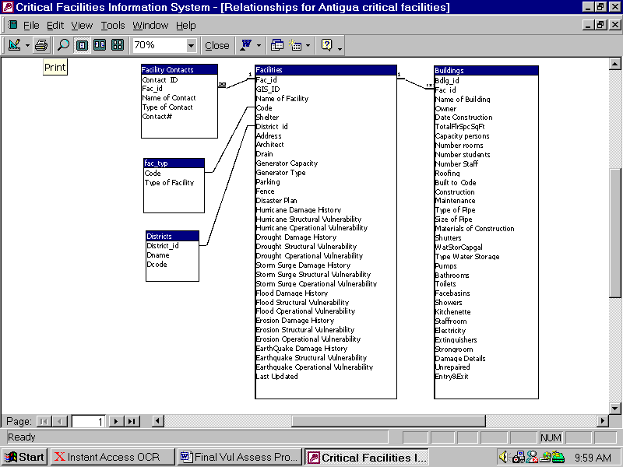
Figure 3. Critical Facilities Database – Tables and Relationships

4.6 Forms
The following forms were created to facilitate data entry and retrieval.

- Adding / Editing Facilities with a linked Building Form
- Adding / Editing Facility Contacts
- Facility Vulnerability Assessment
Adding / Editing Facilities is the main Facility form. As Figure 4 indicates, it contains a button which launches a linked Building Form. (See Figure 5.)
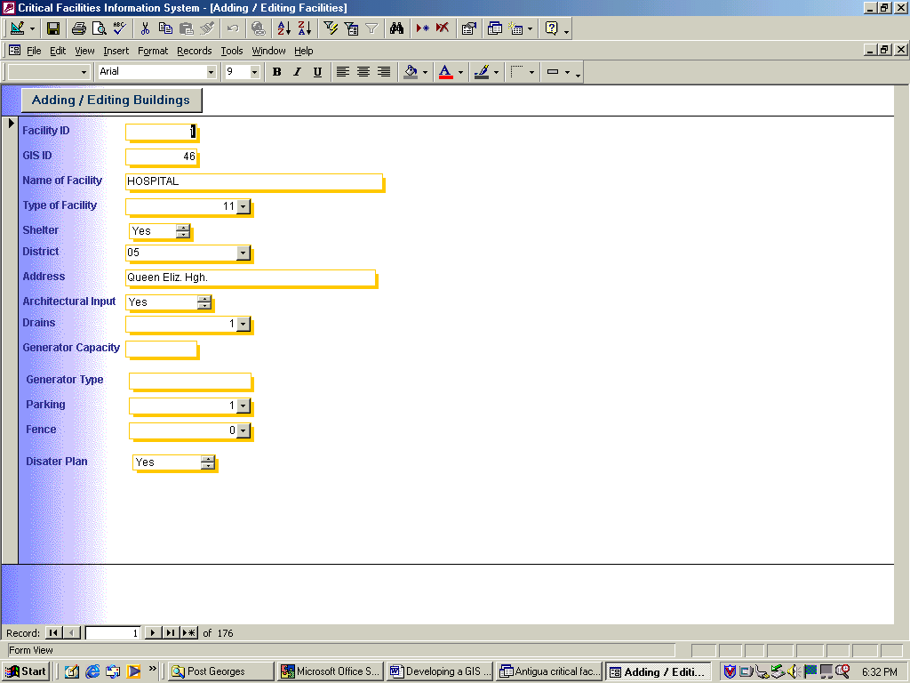
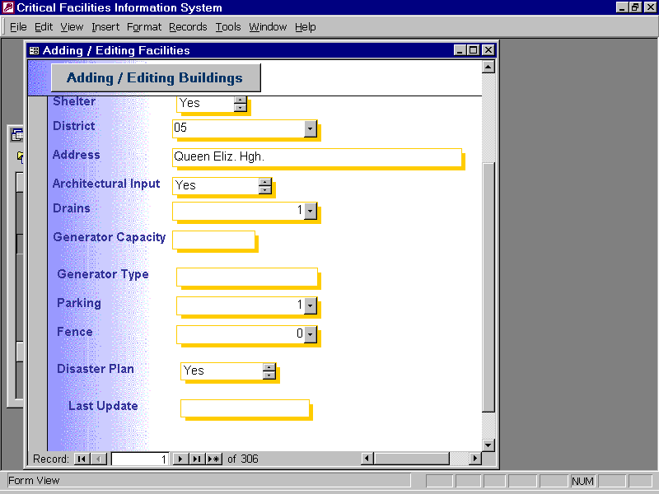

Figure 4. Adding / Editing Facility Form

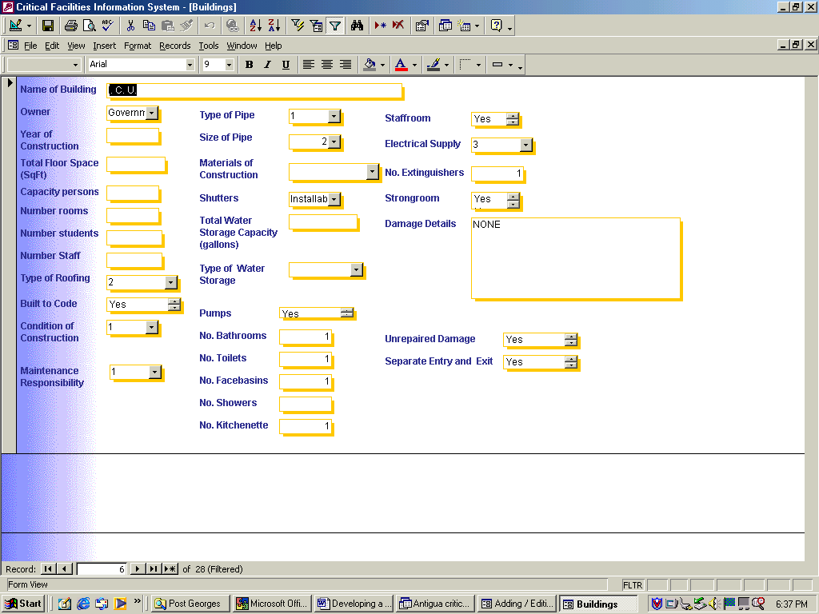
Figure 5. Adding / Editing Facility Building Information Form
Figure 6. indicates the Facility Contact Form and Figure 7. indicates the Vulnerability Assessment Form. The Facility name and address fields on the Contact and Vulnerability Assessment Forms are read-only. All the forms utilize drop down lists where applicable to facilitate data entry and error catching. Check boxes were not utilized, as ArcView 3.2 tables do not recognize the data type and spatial analysis cannot be conducted on data entered in this manner.

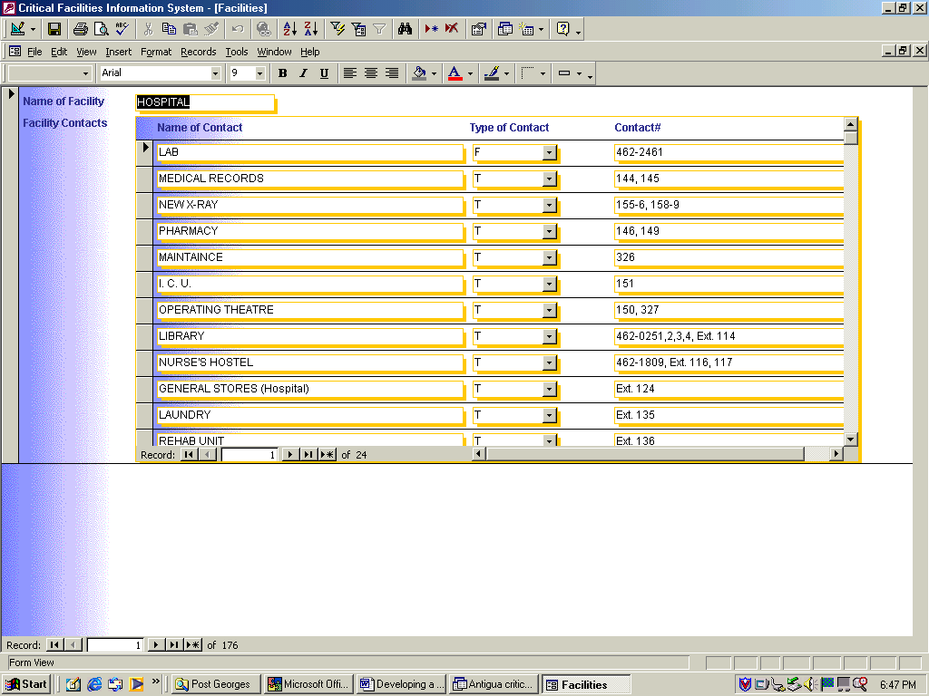
Figure 6. Facility Contacts Form

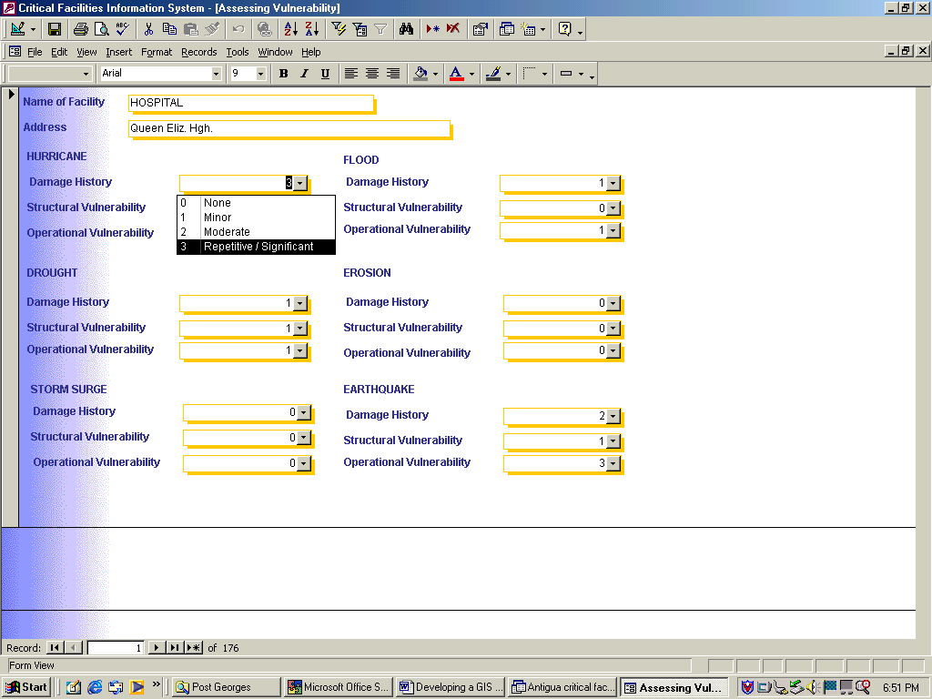
Figure 7. Vulnerability Assessment of Facilities Form

It was envisaged that the vulnerability of critical facilities would be assessed subsequent to initial data entry, as expert knowledge is required to assess facilities. The assessment form facilitates this process. As Figure 7 indicates, users select descriptive text but numeric values are entered into the database.

Each facility is assessed in terms of its damage history, structural vulnerability and operational vulnerability. A facility is assessed separately for each hazard. Table 1 indicates the assessment categories and scores assigned. Values are incrementally numbered with “0” representing no history or no vulnerability.

Table 1 – Vulnerability Assessment Factors, Descriptions and Scores
Vulnerability | Description | Score
Damage History | None | 0
 | Minor | 1
 | Moderate | 2
 | Repetitive / Significant | 3
Structure | No | 0
 | Yes | 1
Operational | No Effect | 0
 | Minimal | 1
 | Significant | 2
 | Life Threatening | 3

Operational vulnerability is the most subjective of the assessment factors. It is defined as the extent to which the functions of a facility will be affected by a hazard. It ‘factors in’ damage history and structural vulnerability. The operational vulnerability score for facilities that function as shelters reflects this function. The subjectivity of the assessment procedure is balanced by the system design, which allows for the re-assessment of facilities at any time.

4.7 GIS Query
Two queries were developed in the initial system. A “GIS” query to facilitate the vulnerability assessment process and a “Building” query to facilitate the spatial analysis of buildings within NODS on-going facility management program.

The “GIS” query consisted of calculated fields which totaled the disaster history score, structural vulnerability score and operational vulnerability score of each facility for each hazard type. This generates the hazard specific facility vulnerability score or “V” in the hazard assessment formula. Figure 8. illustrates a section of this query in design mode showing the calculation of “V” for Flood Vulnerability.

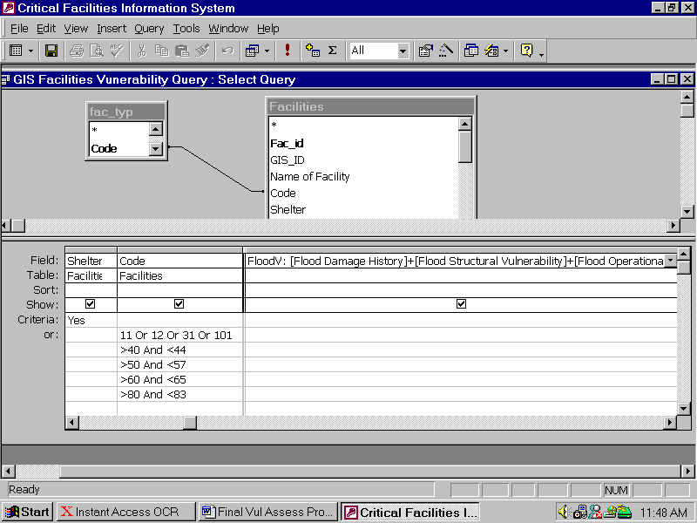

Figure 8. Section of GIS Query in Design View

In addition, the query selected from the NODS Facilities database those facilities that were defined as critical for the vulnerability assessment. Figure 8. indicates how this was included in the query design using the shelter and code fields.

For the purpose of the Vulnerability Assessment critical facilities were defined as the following:
- Any facilities that functioned as a shelter
- Hospitals and clinics
- Government administrative buildings
- Airports, Sea ports and Bridges
- Power, Water and Telecommunication Installations
- Oil and Gas Companies
- Protective Services
- Hotels and Guest Houses
- Historical Sites

The SQL code for the GIS query is listed below:
SELECT Facilities.GIS_ID, Facilities.[Name of Facility], Facilities.Shelter, Facilities.Code, fac_typ.[Type of Facility], Facilities.Address, [Hurricane Damage History]+[Hurricane Structural Vulnerability]+[Hurricane Operational Vulnerability] AS HurricaneV, [Drought Damage History]+[Drought Structural Vulnerability]+[Drought Operational Vulnerability] AS DroughtV, [Storm Surge Damage History]+[Storm Surge Structural Vulnerability]+[Storm Surge Operational Vulnerability] AS StormV, [Flood Damage History]+[Flood Structural Vulnerability]+[Flood Operational Vulnerability] AS FloodV, [Erosion Damage History]+[Erosion Structural Vulnerability]+[Erosion Operational Vulnerability] AS ErosionV, [EarthQuake Damage History]+[Earthquake Structural Vulnerability]+[Earthquake Operational Vulnerability] AS EarthquakeV
FROM fac_typ INNER JOIN Facilities ON fac_typ.Code = Facilities.Code
WHERE (((Facilities.Shelter)=Yes)) OR (((Facilities.Code)=11 Or (Facilities.Code)=12 Or (Facilities.Code)=31 Or (Facilities.Code)=101)) OR (((Facilities.Code)>40 And (Facilities.Code)<44)) OR (((Facilities.Code)>50 And (Facilities.Code)<57)) OR (((Facilities.Code)>60 And (Facilities.Code)<65)) OR (((Facilities.Code)>80 And (Facilities.Code)<83));

5.0 ArcView 3.2 Development

The database development conducted within ArcView 3.2 includes connecting the GIS query to the facilities theme table and the spatial processing of the hazard vulnerability and critical facilities layers. The GIS query calculates the “V” vulnerability value of facilities. The ArcView 3.2 environment is utilized to determine the locational vulnerability of facilities and calculate the final FVS.

5.1 Connecting to the GIS Query
The SQL Connect function of ArcView 3.2 is utilized to connect the ArcView 3.2 project to the MS Access 2000 database. The project is connected to all fields in the GIS query. The training manual details the process of setting up the ODBC connection and the SQL Connect function. Once the ArcView 3.2 project is saved with the connection established the project will seek to connect to the database every time it is opened.

The SQL Connect function makes the query available as a table in the ArcView 3.2 project window. This table is then joined to the critical facilities theme table on the common data item of GIS_ID. Please refer to the training manual for detailed instructions on joining tables in ArcView 3.2. The resulting critical facilities theme table includes “V” values for each hazard.

5.2 Assessing Locational Vulnerability
Determining the hazard zone within which a facility is located assesses the locational vulnerability. Overlaying the facilities on the hazard vulnerability themes can visually assess this. However, the vulnerability assessment procedure requires that a score be calculated to reflect the relative degree of vulnerability.

Separate hazard themes were prepared by specialists for each of the hazards identified and provided to the project. Each theme was zoned in terms of degree of vulnerability and each zone was numerically scored. The themes were categorized in terms of no vulnerability, low vulnerability, medium vulnerability, high vulnerability and very high vulnerability and allocated the numeric values 0, 1, 2, 3 and 4 respectively. The geo-processing extension of ArcView 3.2 was used to assign the hazard zone values to the critical facilities theme table. This process was done with each hazard theme.

After processing, the critical facilities table has assigned to it the locational vulnerability scores from each hazard zone. The locational vulnerability score field of each hazard theme must be named differently to ensure that the fields are retained when the facilities table is subjected to further processing. The Table | Start Editing command is used to edit the structure of the table. The Edit | Add Field command is used to add a new field to the table and the field values are calculated to be equal to the locational scores field. A naming convention of “hazardtype+L” is used e.g: WindL

5.3 Calculating the FVS
The FVS for each hazard is calculated by adding a new numeric field to the facilities table. One field for each hazard FVS. The Table | Start Editing command is used to edit the structure of the table. The Edit | Add Field command is used to add the new field. Figure 9 illustrates adding the new field for WindFVS.

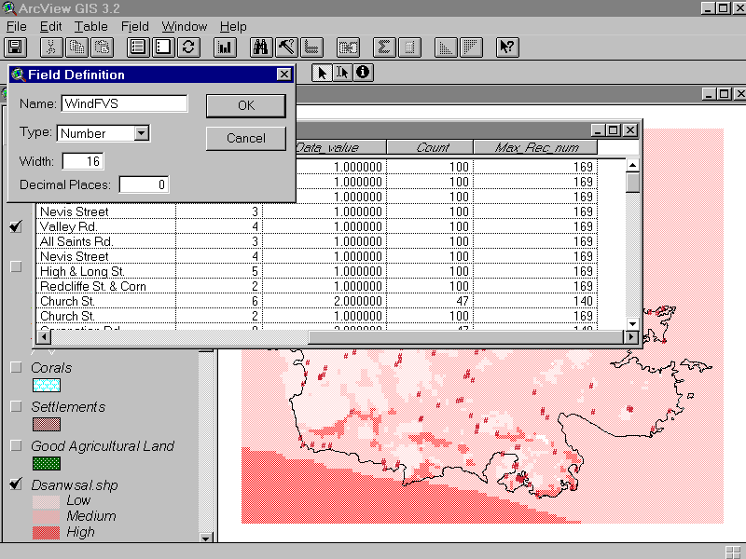

Figure 9. Adding the Wind FVS Data Item

The field is calculated to the FVS formula: (V+L)HPS using the Field | Calculate command. The “V” value originates from the GIS query, the “L” value is assigned by geo-processing and the HPS is determined by the hazard prioritization workshop weighting. Figure 10. indicates the Field Calculation window in ArcView 3.2 . It illustrates the entry of the WindFVS formula. Note that the hazard priority score for Hurricane / Wind was 6.

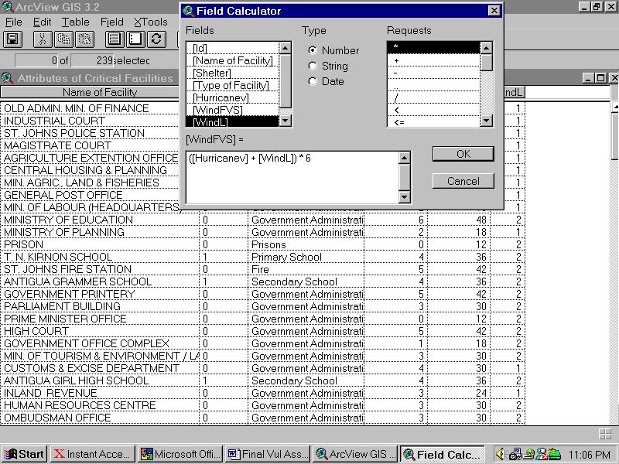

Figure 10. Calculating WindFVS
In order to screen table fields for a particular hazard the Table | Properties command is used to manipulate the fields that are visible. Figure 11. indicates an example of the calculated WindFVS value.

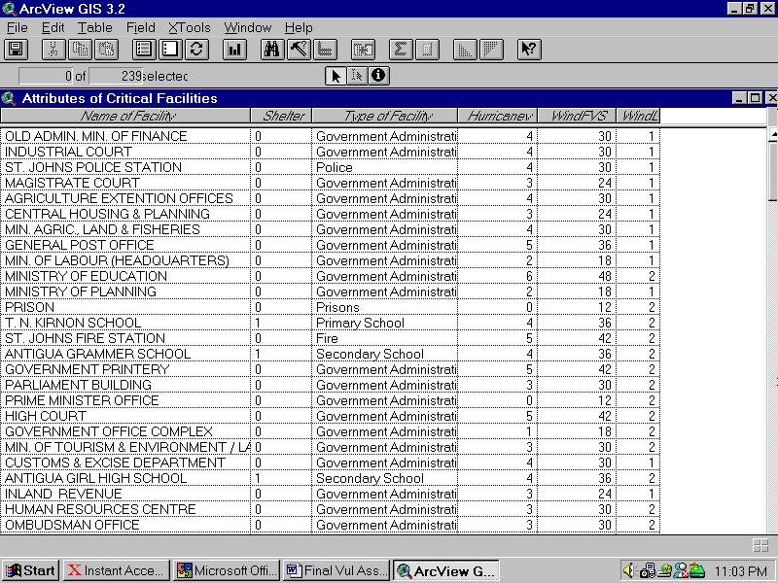

Figure 11. An example of WindFVS Value

6.0 Hazard Mapping

6.1 Data Formats and Conversion
Hazard maps were provided to the project in two formats ArcView shape files and Erdas “.lan” files. The process of assigning hazard zone weights to facilities requires that the hazard layer be in a shape file format. This required that the Erdas files be converted to shapefiles. The Erdas files were converted to grids and then from grids to shape files. While this is possible using the Spatial Analyst Extension of ArcView 3.2, error messages were encountered with the inland erosion files and ArcInfo 8.0 Toolbox Conversion tools were utilized to resolve the error.

6.2 Dissolving Polygons
To facilitate the data assign process hazard map layers were dissolved on the hazard zone weights. This reduced the number of records / polygon features to be processed and processing time.

6.3 Beach Erosion Layer
The Beach erosion layer was provided as a line theme which represented the monitored beaches. It was necessary to convert these to erosion zones. The process consisted of the following:

- Add a new “setback” field to monitored beach table and enter setback values.
- Buffer monitored beach theme on basis of setbacks, (buffer polygons not merged).
- Add new “beach_id” field to buffer table and enter relevant “beach_id” from monitored beach table.
- Join monitored beach table to Beach buffer table on “beach_id”.

6.4 Critical Facilities Layer
The AccessTM Critical Facilities query table is joined to a point feature Facilities table in ArcView 3.2TM . As new facilities are added to the AccessTM Database point features must be added to the ArcView 3.2TM project. Instructions on adding new features are attached at Appendix 4.

7.0 Conclusions and Further Work

The vulnerability assessment process has two products:

- Zoned hazard maps
- Facility Vulnerability Scores

The GIS database developed for hazard vulnerability assessment produces through a mix of tabular and spatial manipulations hazard specific FVS scores for critical facilities. Although these scores are a measure of relative vulnerability they can be utilized to identify facilities at highest risk. Map 1 represents the Wind FVS values of critical facilities.

The vulnerability of some features such as roads, agricultural lands, settlements and sensitive environmental areas will require visual interpretation, as they cannot be assessed as proposed by this project. The layers must be manipulated in ArcView to determine this vulnerability.

The project produces a wealth of data for Antigua and Barbuda. This data can be spatially manipulated and analyzed to generate additional information. Further work should include the examination of information requirements and spatial analysis possible. For example, Map 1 can be queried to select shelters with a high FVS score and the data fed into a shelter review program.

The system is designed to allow for the re-assessment of facilities. The assessment is subjective and should be subject to review. This review may also include hazard mapping. Map layers can be added or deleted from the project at any time. Improvements in models and the availability of data may make available refined mapping and improve the quality of the assessment process.

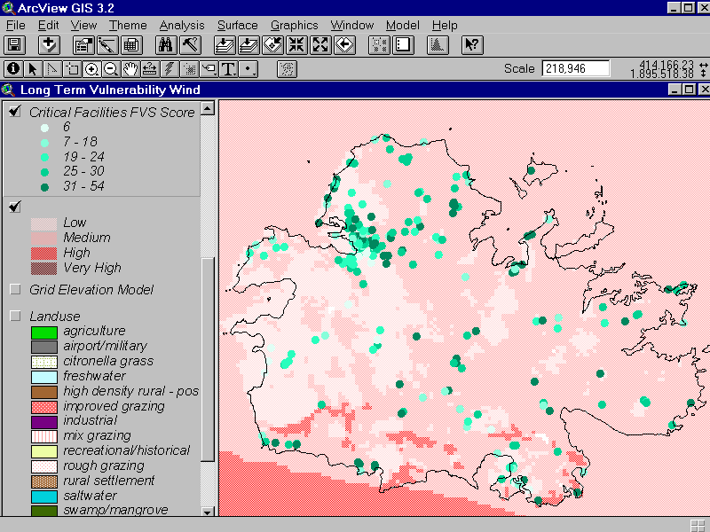
Map 1. Wind / Hurricane Vulnerability Assessment of Critical Facilities

Appendix 1 – Hazard Prioritization Workshop Forms

Hazard Prioritization Table
Hazard | Probability | Frequency | Area Impact | Magnitude | Total | Hazard Priority Score
T = ( P+F+A ) M

Critical Facilities Analysis – Sheet 1
CATEGORY:
HAZARD:
 | DH | S | O | V | L | FVS
1
2
3
4
5
6
FVS = Facility Vulnerability HPS = Hazard Priority Score DH = Damage History
S = Structural Vulnerability O = Operational Vulnerability L = Locational Vulnerability
V = DH+S+O FVS = (L+V) HPS

Critical Facilities Analysis – Sheet 2 FVS
CATEGORY:
HPS | EQ | TSUN | VOLC | STORM SURGE | WIND | RIVERINE FLOOD | LANDSL | DROUGHT
1
2
3
4
5
6
7
8
Appendix2 –Districts Code Listing
Codes District
01 All Saints East and St.Luke
02 All Saints West
03 Barbuda
04 City East
05 City South
06 City West
07 Rural East
08 Rural North
09 Rural South
10 Rural West
11 St.George
12 St. Mary's North
13 St. Mary's South
14 St.Paul
15 St.Peters
16 St. Phillip North
17 St. Phillip South
Appendix 3 – Facility Type Code Listing

Facility | Code | Type of Facility | Description
10 Medical Facilities | 11 | Hospitals
 | 12 | Clinics
 | 13 | Other medical facilities
20 Education | 21 | Nursery
 | 22 | Primary
 | 23 | Secondary
 | 24 | Technical
 | 25 | Other schools
30 Government | 31 | Administration
 | 32 | Residential
 | 33 | Other government
40 Infrastructure | 41 | Airport | Including aircraft approach
 | 42 | Sea Port
 | 43 | Bridges
 | 44 | Roads
 | 45 | Other Infrastructure
50 Utilities | 51 | APUA
 | 52 | Electricity | Electricity stations and sub-stations
 | 53 | Water | Water catchments, booster stations
 | 54 | Telecommunication
 | 55 | Petroleum | Petroleum Refineries / re-distribution centers
 | 56 | Gas | Gas stations
 | 57 | Other Utilities
60 Protective | 61 | Police | Police stations and posts
 | 62 | Fire | Fire stations
 | 63 | Military | Military installations
 | 64 | Prisons | Rehabilitation centers and prisons
 | 65 | Other Protective
70 Hazardous Chemicals | 71 |  | e.g. Antigua gases
80 Tourism | 81 | Hotels
 | 82 | Guest Houses
 | 83 | Other tourism facilities
90 Community | 91 | Community Centres
 | 92 | Churches
 | 93 | Cemeteries
 | 94 | Other community facilities
100 Historical and Archaeological | 101 | Historical Sites
 | 102 | Archeological Sites
 | 103 | Other historical and archaeological sites

Appendix 4 – Adding Point Features To a Theme
POST-GEORGES DISASTER MITIGATION PROJECT - ANTIGUA AND BARBUDA
Plotting a New Facility in ArcView
In Access
- Open the Critical Facilities Database in Access and print the “Facilities without GIS_ID report”
- Ensure that you have entered the GIS_ID for any Facilities that have already been plotted before generating report.
- Close Access.

Starting ArcView and Opening the Project File
- Start ArcView. Select Start | Programs | ESRI | ArcView
- Click Open existing project. If your project is listed click on it and click OK. Otherwise navigate to project and select it. Open Project c:\PGDM\ Antigua\Nantigua.apr for Antigua data and Project c:\PGDM\ Barbuda\Nbarbuda.apr for Barbuda data.

Determining last ID Issued
- Select View from Project window and open the Facilities View by double clicking on it.
- Ensure that the Critical facilities theme is drawn by clicking on the check box to the left of the theme in the legend.
- Click on the Critical facilities theme to ensure that is the active theme. (The theme should have a box around it.)
- Select Theme | Table to open the Critical Facilities table. Click on the column name ID and click on the Sort button to sort the data in ascending order. Go to the last record and determine the last ID issued. Note this number, you will issue the next sequential number to the new facility.
- Use the Access Report and enter the New GIS_ID next to each Facility. This list will be used for the data entry in ArcView.
Adding New Facilities to the Critical Facilities theme
- If the Critical Facilities table is joined you need to remove joins. With the Theme table open and active select Table | Remove all joins. When you have finished adding facilities you may wish to re-join the table before saving the project.
- Select File | Extensions and Select the Digitizer Extension. Click OK. Wait while it is loaded.
- Open the Facilities View and make the window active by clicking on it. Click on the Critical Facilities Theme to make it active. Select Theme | Table to open the theme table. (Two windows should now be open on screen.)
- Click on the View window and Select Theme | Start Editing. A broken line should appear around the Critical Facilities theme to indicate that it is being edited.
- Click on the Draw tool and select the point option. Move the cursor on to the View and carefully Click on the location of the new facility. You may need to zoom in to select the site accurately. You can use Edit | Undo Feature Edit to remove the point and try again.
- You may wish to add all points or after every point enter the relevant ID and Facility name in the table.
- When you have completed adding points Select Theme | Stop Editing and Click on Yes to save the edits to your theme.
- You can also save your work intermittently by selecting Theme | Save Edits and Yes and then continue editing.

Adding New Facilities to the Theme Table
- A new record is added to the theme table when a new feature is added to the theme. You can either add the data to the record after every feature is added or add all the records after you have added the features. The menu that is available is dependant on the active window.
- Click on the Edit Tool Icon and then on the record you wish to edit. Add your new ID and Facility name. Click on another record before moving back to the View.
- Note that Clicking on a record in the table will highlight the feature on the View. Use this feature to ensure that you are entering data for the correct feature.

Exiting ArcView
After entering new facilities on the theme and into the table save the project and exit ArcView. Select File | Save Project and then File | Exit.

Enter New GIS_ID in Access Database
In order for the Access database to connect to ArcView it is necessary to enter the GIS_ID into the Access database.
- Open the Critical Facilities Database
- Use the Add / Edit Facilities Form and enter the new GIS_ID numbers for each Facility listed on the “Facilities without GIS_ID” report.
- Exit Access

“V” is defined as the total of the damage history, structural vulnerability and operational vulnerability scores.
V = DH+S+O where DH is damage history, S is structural vulnerability and O is operational vulnerability
Hodgkinson-Chin, E. 2001, Introductory Training in Database Design and Development, Vulnerability Assessment Sub-Component, Post Georges Disaster Mitigation Project
Development Control Authority, Government of Antigua and Barbuda, 2001, Setback Categories for Beaches in Antigua and Barbuda, Draft National Physical Development Plan: Volume 3 – Policies and Proposals.

