


Antigua/Barbuda Hazard Vulnerability Assessment Project: Final Report

Post-Georges Disaster Mitigation Project
in Antigua & Barbuda and St. Kitts & Nevis

May 2001

Post-Georges Disaster Mitigation in Antigua & Barbuda and St. Kitts & Nevis is implemented by the Organization of American States, Unit for Sustainable Development and Environment for USAID-Jamaica/Caribbean Regional Program

Organization of American States
Unit of Sustainable Development and Environment
1889 F Street NW Washington DC 20006
http://www.oas.org/pgdm

This report was prepared under contract with the OAS by Eva Hodgkinson-Chin, MSc. [gce@trinidad.net]

Table of Contents

Part I – Project and Methodology Page

1.0 Introduction 1
1.1 Post Georges Disaster Mitigation Program 1
  - Hazard Vulnerability Assessment Project 1
    - Hazard Identification and Prioritization 1
    - Hazard Analysis 2
    - Facility and Resource Identification and assessment 2
  - Methodology 3
    - Theory 3
    - Automation 4
1.4 Format of Analysis 5

Part II – Antigua
- Antigua - Hurricane and Storms 7
  - Hazard Zones 7
  - Wind 7
    - Wind Zones 7
    - Wind FVS 9
    - Feature Vulnerability to Wind 10
  - Storm Surge 11
    - Storm Surge Zones 11
    - Storm Surge FVS 12
    - Feature Vulnerability to Storm Surge 13
  - Waves 13
    - Wave Zones 13
    - Wave FVS 15
    - Feature Vulnerability to Waves 15
- Antigua – Drought 16
  - Drought Zones 16
  - Drought FVS 16
  - Feature Vulnerability to Drought 17
- Antigua – Flooding 19
  - Flood Zones 19
  - Flood FVS 19
  - Feature Vulnerability to Floods 21
- Antigua – Inland Erosion 21
  - Inland Erosion Zones 21
  - Inland Erosion FVS 21
  - Feature Vulnerability to Inland Erosion 22
- Beach Erosion 23
  - Beach Erosion Zones 23
  - Beach Erosion FVS 23
  - Feature Vulnerability to Beach Erosion 24

Part III – Barbuda Page
- Barbuda - Hurricane and Storms 25
  - Wind 25
    - Wind Zones 25
    - Wind FVS 26
    - Feature Vulnerability to Wind 26
  - Storm Surge 27
    - Storm Surge Zones 27
    - Storm Surge FVS 28
    - Feature Vulnerability to Storm Surge 28
  - Waves 29
    - Wave Zones 29
    - Wave FVS 30
    - Feature Vulnerability to Waves 31
  - Barbuda – Drought 31
  - Drought Zones 31
  - Drought FVS 31
  - Feature Vulnerability to Drought 32
- Barbuda – Flooding 32
  - Flood Zones 32
  - Flood FVS 33
  - Feature Vulnerability to Floods 34
- Barbuda – Inland Erosion 34
  - Inland Erosion Zones 34
  - Inland Erosion FVS 35
  - Feature Vulnerability to Inland Erosion 35
- Beach Erosion 35
  - Beach Erosion Zones 35
  - Beach Erosion FVS 35
  - Feature Vulnerability to Beach Erosion 35

Part IV - Summary
12.0 Summary 37
12.1 Cumulative Vulnerability 37
12.2 Antigua 37
12.2.1 Facilities 37
12.2.2 Hazard Zones 38
12.3 Barbuda 39
12.3.1 Facilities 39
12.3.2 Hazard Zones 40

List of Tables
Table 1 - Vulnerability Assessment Factors, Categories and Codes 3
Table 2- Hazard Priority Scores 4
Table 3- Highest Possible Facility Vulnerability Score 6
Table 4- Wind, Waves and Storm Surge Hazard Categories 7
Table 5- Saffir / Simpson Hurricane Scale 8
Table 6- Flood Plain Water Depth and Hazard Category 19

List of Maps
Map 1- Antigua Wind / Hurricane Vulnerability by Return Period 8
Map 2- Antigua Long Term Vulnerability to Hurricane / Wind and Facility FVS 9
Map 3- Antigua Facilities with Wind FVS Greater then 21 10
Map 4- Antigua Storm Surge Vulnerability by Return Period 11
Map 5- Antigua Long Term Vulnerability to Storm Surge and FVS 12
Map 6- Antigua Feature Vulnerability to Storm Surge 13
Map 7- Antigua Wave Vulnerability by Return Period 14
Map 8- Antigua Long Term Vulnerability to Waves 15
Map 9- Antigua Drought Zones and Facility FVS 17
Map 10- Antigua Location of Facilities with FVS Greater than 15 17
Map 11- Antigua Location of Existing Agriculture and Grazing 18
Map 12- Antigua Location of Good Agricultural Land 18
Map 13- Antigua Flood Vulnerability Zones and Facility FVS 20
Map 14- Antigua Inland Erosion Zones and Facility FVS 22
Map 15- Antigua Location of Facilities with FVS Greater than 7 22
Map 16- Facilities most Vulnerable to Beach Erosion in Antigua 23
Map 17- Barbuda Wind / Hurricane Vulnerability by Return Period 25
Map 18- Barbuda Long Term Vulnerability 26
Map 19- Barbuda Facilities with Wind FVS Greater then 21 26
Map 20- Barbuda Storm Surge by Return Period 27
Map 21- Antigua Long Term Vulnerability to Storm Surge 28
Map 22- Barbuda Facilities with Highest Storm Surge FVS 29
Map 23- Barbuda Wave Vulnerability by Return Period 30
Map 24- Barbuda Long Term Vulnerability to Waves 30
Map 25- Barbuda Drought Vulnerability Zones and Facility FVS 31
Map 26- Barbuda Flood Vulnerability Zones 32
Map 27- Barbuda Flood FVS 33
Map 28- Barbuda Inland Erosion and Facility FVS 34
Map 29- Barbuda Beach Erosion Zones 36
Map 30- Total “V” of Facilities in Antigua 37
Map 31- Total FVS of Facilities in Antigua 38
Map 32– Facility FVS “Hotspots” in Antigua 38
Map 33- Total Hazard Vulnerability in Antigua 39
Map 34- Distribution of Facility Total FVS in Barbuda 39
Map 35- Total Hazard Vulnerability in Barbuda 40

List of Figures
Figure 1- Antigua Shelters with Wind FVS 36 10
Figure 2- Antigua Facilities with High Storm Surge FVS 12
Figure 3- Antigua Facilities with High Wave FVS 15
Figure 4- Antigua Facilities with High Flood FVS 20
Figure 5- Barbuda Listing of Facilities with High Flood FVS 33

List of Appendices
Appendix 1 – Antigua Facilities by Type and Hazard FVS
Appendix 2 – Barbuda Facilities by Type and Hazard FVS

PART I – PROJECT AND METHODOLOGY

- Introduction
1.1 Post Georges Disaster Mitigation Program
The Post Georges Disaster Mitigation (PGDM) program is one of three components of The Hurricane Georges Reconstruction and Recovery in the Eastern Caribbean program. The PGDM is responsible for implementing the disaster mitigation capacity building component and seeks to reduce the vulnerability of population and economic activities to natural hazards. Towards this end, the PGDM includes a hazard vulnerability assessment component.

1.2 Hazard Vulnerability Assessment Project
The Hazard Vulnerability Assessment Project consists of an assessment of the hazards to which Antigua and Barbuda are prone and the vulnerability of critical facilities and resources to the hazards. In order to conduct this assessment the project consisted of the following activities:
- Hazard identification and prioritization
- Hazard analysis
- Facility and resource identification and vulnerability assessment

1.2.1 Hazard Identification and Prioritization
Hazard identification and prioritization was conducted during a Hazard Mapping Prioritization Workshop in Antigua during August 2000. The workshop produced a list of six hazards which are listed in order of priority below:
- Winds / Hurricanes
- Drought
- Storm Surge
- Floods
- Coastal and Stream Erosion
- Earthquakes

1.2.2 Hazard Analysis
Specialists in the areas of wind, storm surge, drought, flooding and erosion were contracted to study the vulnerability of Antigua and Barbuda to the hazards and produce detailed reports and hazard vulnerability zone maps. The vulnerability categories used for the maps produced were No vulnerability, low, moderate, high and very high. These reports and maps are available at http://www.oas.org/pgdm.

Hazard vulnerability maps were produced for the following hazards:
- Wind
- Storm surge
- Waves
- Drought
- Flooding
- Inland erosion
- Beach erosion

Wind, storm surge and waves are caused by hurricane and tropical storm activity and are closely related. The Taos model was used to generate the vulnerability maps. Drought was analyzed on the basis of watersheds and considered environmental, meteorological, hydrological, infrastructural, human and land use factors. Flooding considered factors such as slopes, drainage, ratio of watershed area to flood plain and run-off rates and potential. The Hurricane Lenny rainfall event was used as the basis of classification. Inland erosion examined sheet and rill erosion, gullying and landslides. Beach erosion considered only those beaches that are monitored by The Fisheries Department of Antigua and Barbuda.

1.2.3 Facility and Resource Identification and Assessment
The process of facility and resource identification and assessment consisted of the definition of the facilities and resources to be considered, data collection, data automation and finally vulnerability assessment. The facilities and resources to be considered were identified with The Development Control Agency (DCA), The National Office of Disaster Services (NODS) and The Environment Division.

The resources included in the assessment were constrained by the availability of digital mapped resource data. Digital land capability and land use maps provided by the DCA were used as the main source maps. These maps enabled the inclusion of such resources as forestry, tourism and agriculture.

Critical facilities were defined as the following:
- Any facilities that functioned as a shelter
- Hospitals and clinics
- Government administrative buildings
- Airports, Sea ports and Bridges
- Power, Water and Telecommunication Installations
- Oil and Gas Companies
- Protective Services
- Hotels and Guest Houses
- Historical Sites

NODS conducted a survey of all facilities and data on their disaster history, structural and operational vulnerability. The data was collated, coded and entered into a database that was then integrated into a Geographic Information System (GIS). The categories for each of the vulnerability assessment factors and their codes are indicated in Table 1.

Table 1 – Vulnerability Assessment Factors, Categories and Codes
Factor | Category | Code
Damage History | None | 0
Damage History | Minor | 1
Damage History | Moderate | 2
Damage History | Repetitive / Significant | 3
Structural Vulnerability | No | 0
Structural Vulnerability | Yes | 1
Operational Vulnerability | No Effect | 0
Operational Vulnerability | Minimal | 1
Operational Vulnerability | Significant | 2
Operational Vulnerability | Life Threatening | 3

1.3 Methodology
1.3.1 Theory
The vulnerability assessment process was established by Dr. C. Rogers and presented at the Hazard Mapping Prioritization Workshop in Antigua during August 2000. The methodology as set out in the workshop consists of the following steps:

- Identification and prioritization of hazards
- Creation of an inventory of critical facilities
- Assessment of each facility in terms of damage history, structural vulnerability and operational vulnerability for each hazard identified.
- The creation of hazard specific vulnerability zone maps
- The locational assessment of facilities within hazard zones
- The calculation of a total facility vulnerability score (FVS) for each facility and each hazard.

The vulnerability assessment process is defined by the formula :

FVS = (L+V)HPS
Where “FVS” is the Facility Vulnerability score, “L” is the Locational Vulnerability, “V” is the Facility Vulnerability and “HPS” is the Hazard Priority Score.

The “FVS” is a relative score given to each facility to represent its vulnerability to a hazard. The formula incorporates subjective weightings such as the operational vulnerability of the “V” factor and the hazard priority score. The “FVS” should be used as an indication of the need for further examination of facilities. It should be analyzed in terms of the relative scores of locational vulnerability as opposed to facility vulnerability factors such as damage history, structural and operational vulnerability. The analysis of these scores will indicate the most important contributing factor to the vulnerability of the facility and provide a guide to mitigation.

As previously indicated, the workshop generated a priority listing of the six hazards and the hazards were weighted from 1 to 6 to generate a Hazard Priority Score (HPS) as listed below. These are the values utilized in this assessment. The Coastal and Stream Erosion value was applied to Inland Erosion. The Wave hazard generated by storms was assumed to have a value of “1” as it was not considered separately by the workshop.
Table 2 – Hazard Priority Scores
Hazard | Hazard Priority Score (HPS)
Winds / Hurricanes | 6
Drought | 5
Storm Surge | 4
Floods | 3
Coastal and Stream Erosion | 2
Earthquakes | 1

1.3.2 Automation
The Vulnerability Assessment Project automates the procedure established by Dr. Rogers. It is automated within a GIS environment to allow for the integration and analysis of data with hazard mapping. The system is designed within Microsoft Access TM and ArcView 3.2TM It consists of a Microsoft Access TM database and an ArcView 3.2TM project for each island.

The Microsoft Access TM database stores the facility data collected by NODS and calculates the “V” of each facility for each hazard. A table consisting of the hazard specific “V” scores is linked to each ArcView 3.2TM project. The ArcView 3.2TM project consists of digital maps and linked data tables.

Maps on the following features were integrated into the project in order to identify the features vulnerable to hazards:
- Critical facilities
- Roads
- Settlements
- Corals
- Topography
- Drainage
- Land Use / Land Cover

The GIS facilitates the overlay of hazard maps on the location of features and critical facilities. Visual interpretation determines which features are located in the various hazard zones. Spatial and tabular manipulations in the GIS identify facilities in each hazard zone and calculate the “FVS” of each facility.

  - Format of Analysis
The analysis considers Antigua and Barbuda separately. It considers each hazard and the features and facilities that are most vulnerable to the hazard. The vulnerability of features is indicated by their location in high and very high hazard zones. The vulnerability of facilities is indicated by the value of their “FVS”. Table 3 indicates the highest possible “FVS” for each hazard type. “FVS” are ranked and the facilities with the highest scores are indicated. A FVS was considered high if it was more than 50% of the total possible. A listing of each facility by type, hazard and FVS is attached at Appendix 1.

Table 3- Highest Possible Facility Vulnerability Score

Hazard | Highest Possible FVS
Wind | 42
Drought | 35
Storm Surge | 28
Floods | 21
Inland and Beach Erosion | 14
Waves | 7
Total FVS | 147

In order to identify facilities most vulnerable to all hazards the total FVS was calculated and the facilities noted. The total FVS values were used to create a contour map to easily identify total FVS “hotspots”. A similar approach was used for hazards. The individual hazard maps were converted to grid maps and the scores for all hazard maps were summed to generate a total “vulnerability” map and identify zones most vulnerable to all hazards.
PART II – ANTIGUA

- Antigua - Hurricanes and Storms
2.1 Hazard Zones
Three hazards related to hurricanes and storms were studied: wind, storm surge and waves. Storm surge and waves are dependent upon wind for their generation and the hazards are closely related. Table 4 indicates the categories used to zone these hazards. It indicates the lower and upper bounds of each of the categories and provides a reference for the hazard maps produced. Table 5 describes the Saffir / Simpson Hurricane Scale, it can be used to convert the categories and bounds in Table 4 to measurements and damage estimates.
Table 4 – Wind, Waves and Storm Surge Hazard Categories
Source: Wagenseil, R. 2001. Wind and Storm Surge Technical Report. http://www.oas.org/pgdm.

2.2 Wind
2.2.1 Wind Zones
Map 1 indicates the vulnerability of Antigua to winds by the return periods of 10 years, 25 years, 50 years and 100 years. The 10-year return period subjects the entire island to low vulnerability that is of the tropical storm and hurricane category 2 wind strength. Minimal damage would be expected. The 25-year return period would generate low vulnerability for most of the island with some sections of the southern range experiencing moderate vulnerability. This would create hurricane category 2 winds and moderate damage. For the 50-year return period most of Antigua would be of moderate vulnerability. The western coast would have a low vulnerability with sections of the southern coast subjected to high vulnerability. Category 3 and 4 winds would be expected with extensive and extreme damage. The 100-year storm would place most of the island within the high vulnerability zone. The western third of the island and pockets in the central and eastern districts would have a medium vulnerability. Category 4 winds with extreme damage would be expected.

Table 5- Saffir/ Simpson Hurricane Scale
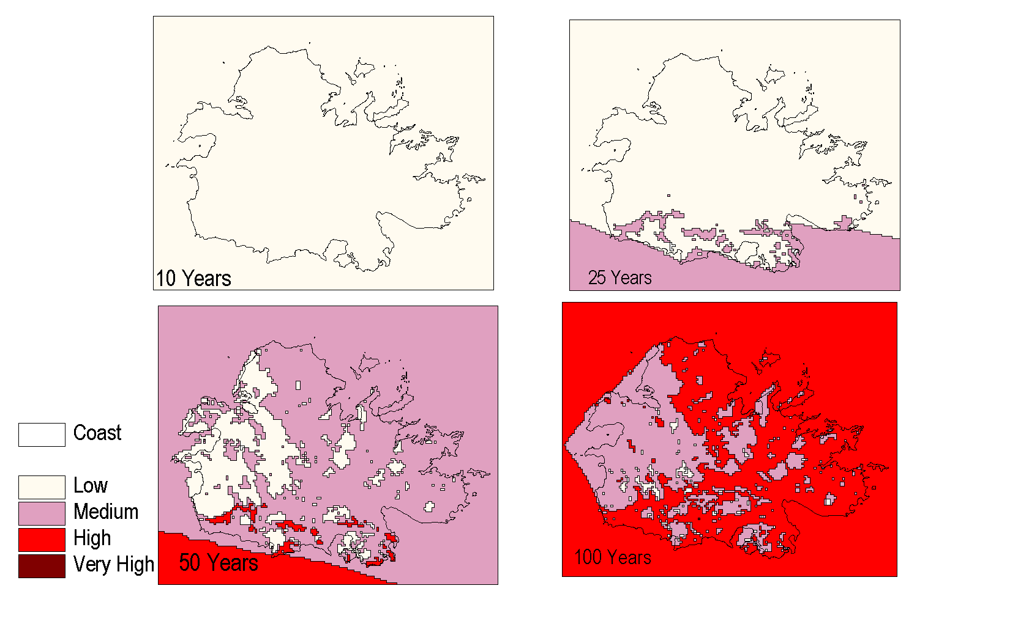
Map 1- Antigua Wind / Hurricane Vulnerability by Return Period
The long-term vulnerability is similar to the 50-year storm. As Map 2, indicates the central and eastern districts of the island are within the moderate vulnerability zone. The western section of the island is low and some sections of the southern range are within a high vulnerability zone.

2.2.2 Wind FVS
Map 2 indicates the distribution of facilities by wind FVS and the long-term vulnerability to wind. It indicates that facilities with the higher FVS are fairly evenly distributed throughout the north, west and southern sections of the island. Map 3 indicates the location of facilities which have an FVS of more than 50% of the possible wind FVS (42). They are clustered around St. John’s and scattered evenly throughout the southern half of the island.

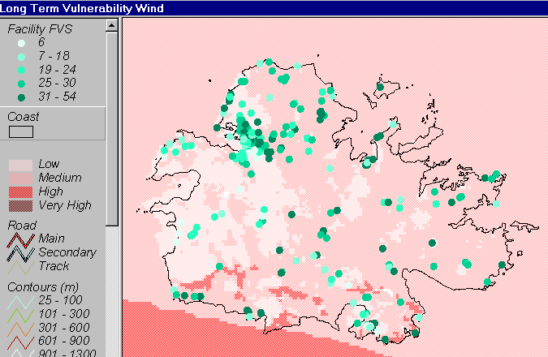
Map 2- Antigua Long Term Vulnerability to Hurricane / Wind and Facility FVS
The analysis reveals that several key critical facilities have extremely high FVS. The facilities and their FVS are listed below:
Holberton Hospital - 54
Crabbs and Cassada Power Stations - 48
Crabbs Desalination Plat – 48
Friars Hill Power Station - 42
V.C. Bird International Airport – 42

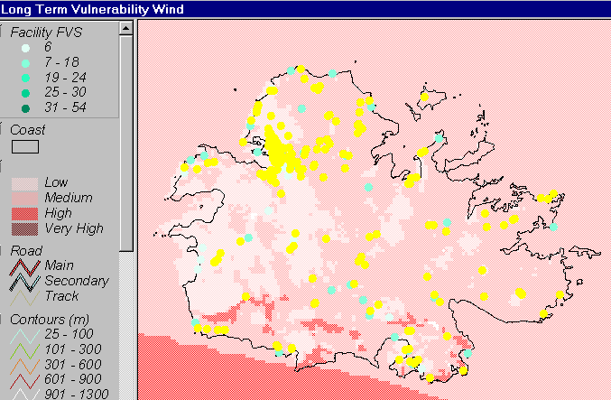
Map 3. Antigua Facilities with Wind FVS Greater than 21

In addition, several Shelters had FVS of 36 and are listed below in Figure 1.

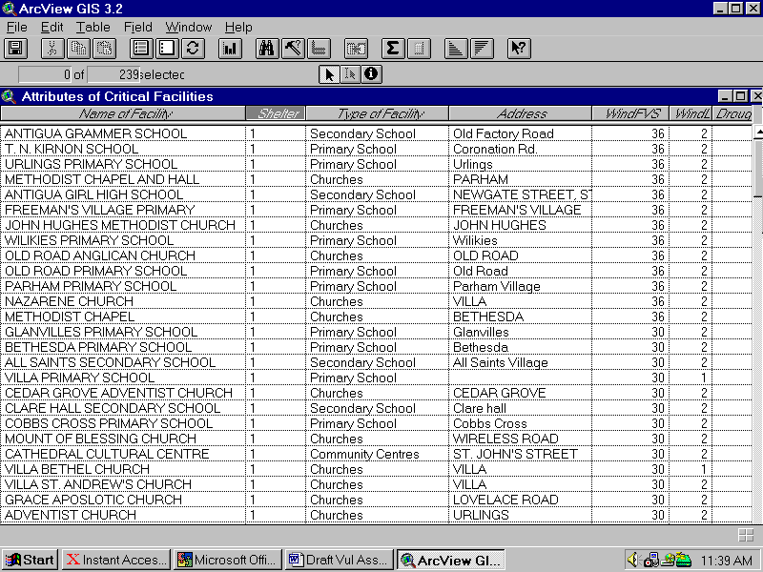
Figure 1. Antigua Shelters with Wind FVS of 36

2.2.3 Feature Vulnerability to Wind
In the long term most of Antigua is moderately vulnerable to winds. The high vulnerability zones consist largely of woodland and grazing lands. The exception is along the southeast coast where the southern section of Dockyard and Shirley Heights are highly vulnerable. Most of St. John’s is vulnerable to low winds.

2.3 Storm Surge
2.3.1 Storm Surge Zones
Map 4 indicates storm surge vulnerability by return period. It indicates that for the 10-year period the entire coast with the exception of the Fitches Creek / Parham Harbour area would experience low storm surge vulnerability. It would be similar to that experienced in a tropical storm with some damage and surge to the heights of 0.1 to 0.5 meters. The Fitches Creek / Parham Harbour area would experience medium storm surge vulnerability with surge varying between 0.5 and 1.5 meters minimal damage.

The 25-year return period would place most of the coast within a moderate vulnerability storm surge zone and the southwestern section of Parham Harbour would be subjected to High vulnerability. Intrusions of moderate storm surge would be expected in the Hanson’s Bay and Jolly Harbour areas. The sea would surge in Parham Harbour to 3.0 meters and cause extensive damage. The 50-year return period increases the area of intrusion around Parham Harbour, Hanson’s Bay and Jolly Harbour. The 100-year return period increases the vulnerability of the Hanson’s Bay area to high and results in high storm surge throughout Parham Harbour.
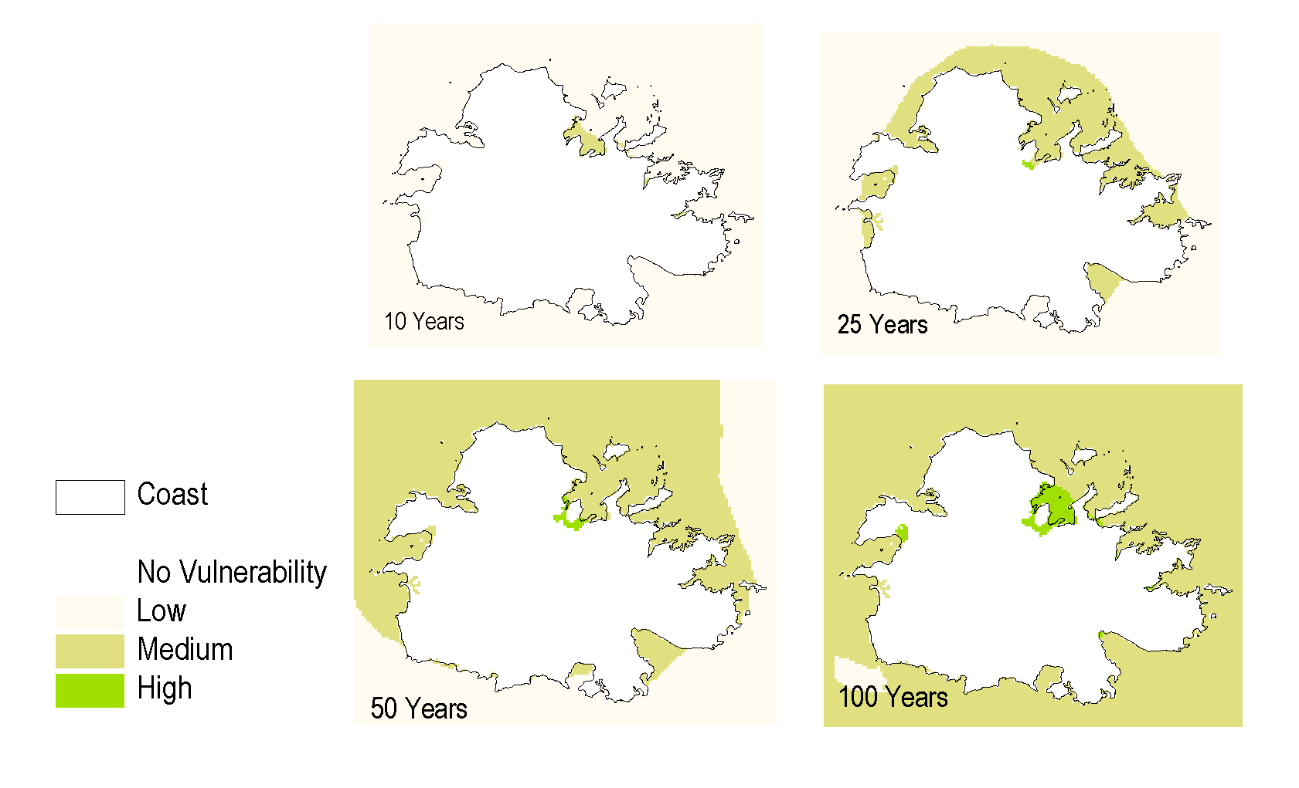

2.2.1 Storm Surge FVS

2.2.2 Feature Vulnerability to Storm Surge

2.3 Waves

Map 4- Antigua Storm Surge Vulnerability by Return Period

Map 5. indicates the long term vulnerability of Antigua to storm surge it indicates that Hanson’s Bay and Jolly Harbour are moderately vulnerable to storm surge. It indicates Parham Harbour with a high vulnerability and an inland area to the southwest with moderate and low vulnerability. All bays along the coast would be subjected to moderate storm surge with the exception of those on the southwest that would be low.

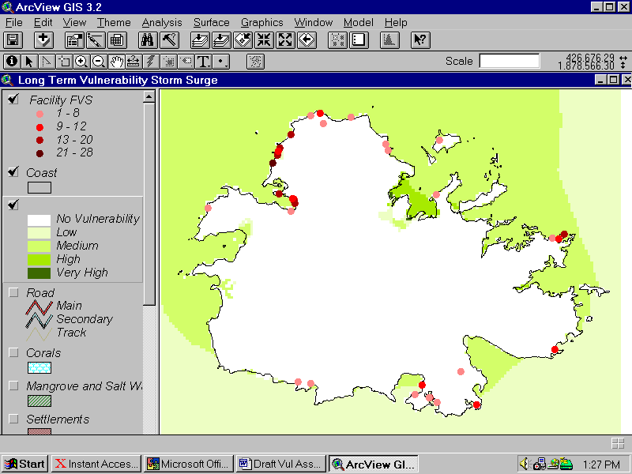
Map 5- Antigua Long Term Vulnerability to Storm Surge and FVS

2.3.2 Storm Surge FVS
Eleven facilities have an FVS of more than 14 and Map 5. indicates their distribution. Six of these facilities are hotels on Dickenson Bay / Runaway Bay. Figure 2. lists the facilities. It indicates that the Port of St. John’s, Heritage Quay and adjacent government facilities also have high FVS. Nelson’s Dockyard has an FVS of 16.

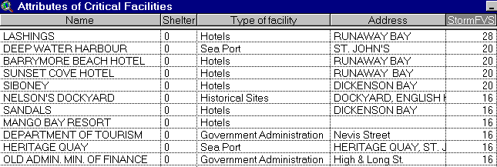
Figure 2- Antigua Facilities with High Storm Surge FVS
2.3.3 Feature Vulnerability to Storm Surge
Most of the coastal features of Antigua are vulnerable to moderate and high storm surge. All the Harbours are vulnerable to moderate storm surge. Parham Harbour is vulnerable to high storm surge. In terms of settlement English Harbour and Parham appear to be the only settlements affected. Map 6 indicates that areas of mangrove along the coast will be flooded.

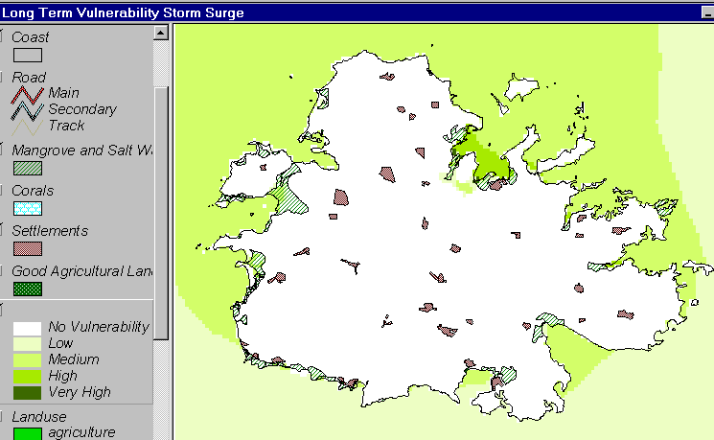
Map 6- Antigua Feature Vulnerability to Storm Surge

2.4 Waves
2.4.1 Wave Zones
Map 7 indicates the vulnerability of Antigua to the various storm return periods. The 10-year return period indicates high vulnerability and very high wave vulnerability on Northern Runaway Beach. Wave vulnerability is high in the center of Parham Harbour and St. John’s Harbour with a mix of low and moderate vulnerability along the coast. Moderate wave vulnerability intrudes into Hanson’s Bay and Jolly Harbour. Very high vulnerability is experienced at the mouth of English Harbour and decreases inland.

Very high vulnerability zones will experience waves between 2.0 and 10.0 meters. High zones will have waves between 1.5 and 2.0 meters. Moderate vulnerability zones can expect waves between 1.0 and 1.5 and low vulnerability zone will have wanes below 1.0 meters.

The 25-year return period intrudes high waves further into Parham Harbour and low waves inland. This intrusion increases with the 50-year storm and with the 100-year storm some high vulnerability can be expected inland of Parham Harbour. The 100-year storm also results in the intrusion of the high vulnerability zone into St. John’s Harbour, Jolly Harbour and English Harbour.

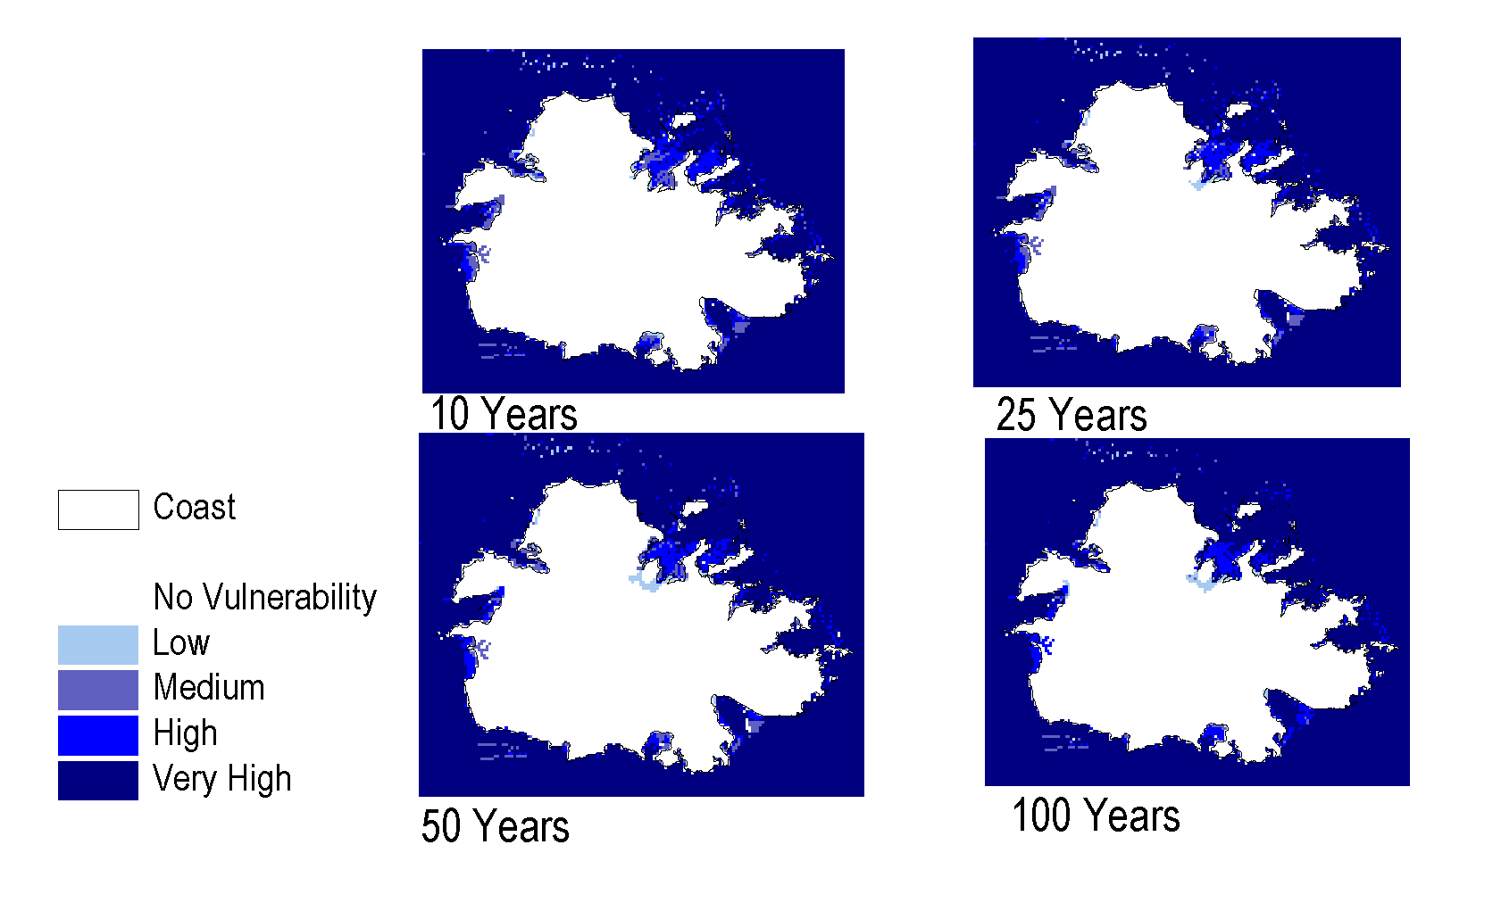
Map 7- Antigua Wave Vulnerability by Return Period

Map 8 indicates the long-term vulnerability of Antigua to waves. It indicates the intrusion of a zone of very high vulnerability into Parham Harbour, English Harbour and most of St. John’s Harbour. Jolly Harbour is located in a zone of high vulnerability and there is a zone of low vulnerability to the south and southwest of Parham.
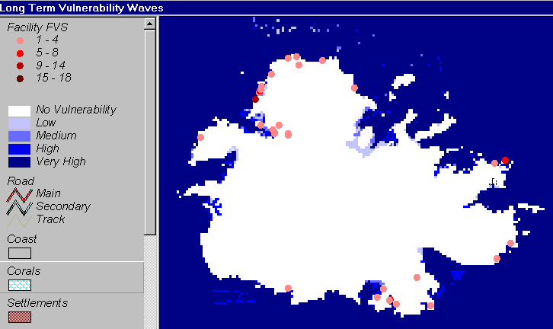
Map 8- Antigua Long Term Vulnerability to Waves

2.4.2 Wave FVS
Seven facilities have high FVS and are listed in Figure 3. They are located on Runaway Bay, Blue Waters Bay, Mango Bay, Dockyard and Coolidge. As expected the locations are closely related to those subjected to storm surge.

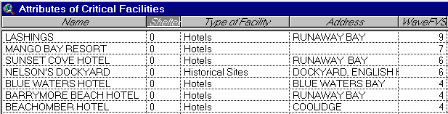
Figure 3. Antigua Facilities with High Waves FVS

2.4.3 Feature Vulnerability to Waves
Areas with off shore reefs are somewhat protected but the storm surge does raise the sea level and reduce protection. Very high waves are experienced at sea and within the inner areas of habours. Jolly Harbour and Parham experience very high waves. There is an intrusion of low waves into the area south west of Parham Harbour that is subjected to storm surge.
- Antigua – Drought
3.1 Drought Zones
Drought was analyzed on the basis of watersheds. Antigua was divided into 13 watersheds and the hazard assessed in terms of the “spatial occurrence of vulnerability” factors. The types of factors considered were:
- Environmental and Meteorological
- Hydrological and Infrastructural
- Human and Land Use

Environmental and meteorological factors identified areas with an annual rainfall below 35 inches, exposed to wind and marine influences with shallow soils, slopes greater than 11⁰ and with cactus scrub vegetation. Hydrological and infrastructural factors identified areas with limited water resources and inadequate dams or ponds for livestock. The human and land use factors considered grazing, crop location and areas with a population density of more than 5,000 persons per square mile.

The northeast and southwest of Antigua are most vulnerable to drought. The eastern and western areas are within a high zone of vulnerability. Jackson identifies an area at the southeast of Antigua between English Harbour and St. James Club as the watershed most vulnerable to drought.

3.2 Drought FVS
There is a close correlation between high FVS and high vulnerability as indicated in Map 9 below. Most of the facilities with more than 50% of the possible FVS are located within the Very High vulnerability drought zone indicating the strong effect of location on drought FVS. The exceptions are four hotels, Yepton Hotel, Mango Bay Hotel, Half Moon Bay Hotel and Long Bay Hotel. These facilities are located in a high vulnerability zone as indicated on Map 10.
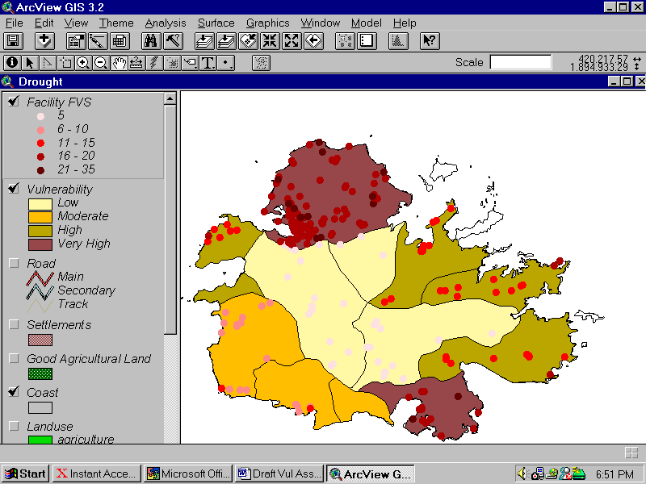
Map 9. Antigua Drought Zones and Facility FVS

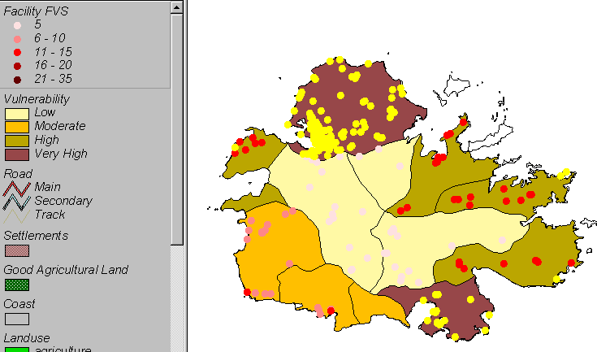
Map 10. Antigua Location of Facilities with FVS Greater than 15

3.3 Feature Vulnerability to Drought
The settlements of Coolidge, Piggotts, Potters and Falmouth are located in the “Very High” vulnerability zone. Map 11 Indicates that approximately 50% of the existing agriculture and grazing is located within high and very high vulnerability zones.
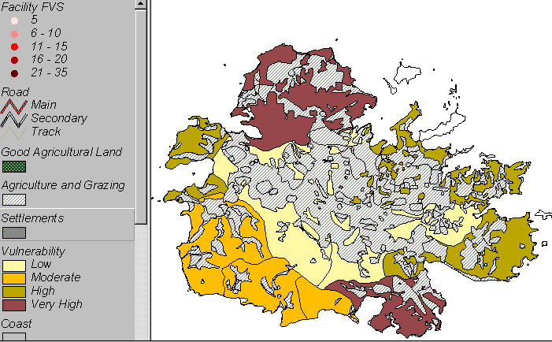
Map 11. Antigua Location of Existing Agriculture and Grazing

Map 12. Indicates the location of good agricultural land in relation to drought vulnerability zones. Good agricultural land was defined by DCA on the land capability map as Class 2 and 3 lands, slopes A, B and C and erosion class 01. It suggests that development of agriculture should be encouraged on good agricultural land with low and moderate drought zone.

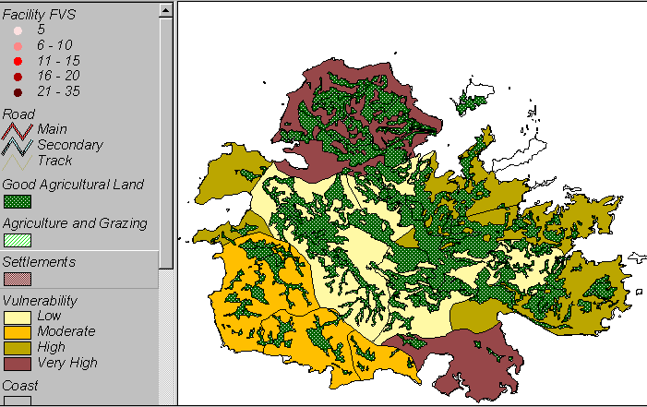
Map 12. Antigua Location of Good Agricultural Land
4.0 Antigua - Flooding
4.1 Flood Zones
Cooper indicates that the data required for traditional floodplain mapping was not available for Antigua. As a result, the flood analysis “was restricted first to identifying the areas that would generally flood and then to further categorize these areas according to rough estimates of the flood levels expected within the areas”. Areas prone to flooding were identified as those with gentle slopes, poor drainage, large ratios of watershed area to flood plain, rapid run-off to flood plain with high run-off potential.

The hazard category was determined by the water depth of each flood plain on the basis of the Hurricane Lenny rainfall event, using the classification indicated in Table 6. Cooper indicates that this method of categorization provides a measure of the magnitude of flooding to be expected from such an event and provides a measure of the severity of flooding among the identified zones.

Table 6. Flood Plain Water Depth and Hazard Category

Water Depth (mm) | Hazard
>1200 | Very High
1200-600 | High
600-300 | Moderate
300-100 | Low
<100 | Very Low

4.2 Flood FVS
Map 13 indicates the distribution of flood zones and the Facility FVS. The zone of very high vulnerability to flooding is to the north of Bendals Bridge. Most of the island has been categorized as a low vulnerability zone.

Figure 3 lists the facilities with high Flood FVS. Four shelters are included on the list, Villa Primary School, Piggots Seventh Day Adventist Church, Valley High School and New Winthropes Seventh Day Adventist Church. Other facilities with high FVS include Friars Hill and Cassada Power Stations, Crabbs Desalination Plant and Liberta Police Station.

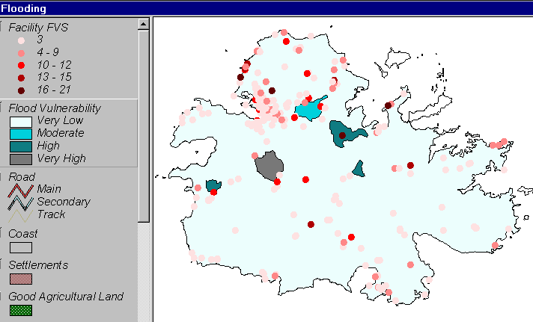
Map 13. Antigua Flood Vulnerability Zones and Facility FVS

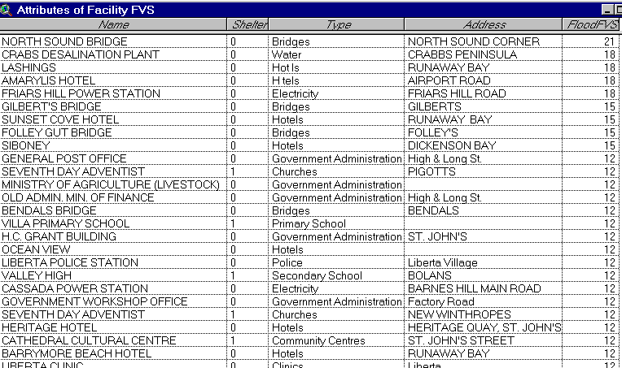
Figure 4. Antigua Facilities with High Flood FVS

4.3 Feature Vulnerability to Floods
Flooding occurs in the areas upstream of swamps and mangroves. High flooding vulnerability zones exist around North Sound Bridge and North of Bendals Bridge. The areas affected by flooding are generally agriculture and grazing lands.

5.0 Antigua - Inland Erosion
5.1 Inland Erosion Zones
Lang indicates that “simple empirical models were used to produce hazard scores for each land unit” and that “the models integrate the estimated effects of elements of the environment which cause or influence the hazard and produce a score”. The final score is an estimate of the likely occurrence of the hazard at the location. The scores were classified into 5 equal area classes, very low, low, medium, high and very high groupings. Adding classes and then reclassifying produced the final map. It combines gullying, mass movement and to some extent stream bank erosion. Map 14 indicates the inland erosion zones established. The areas with high and very high vulnerability to inland erosion are located within the southwest half of Antigua.

5.2 Inland Erosion FVS
Map 15 indicates that most of the facilities with the highest vulnerability to inland erosion are located within the southwestern half of Antigua. The facility with the highest FVS (12) is the Copper and Lumber Inn located in Dockyard.

Unfortunately, the database assessment of the “V” factor did not differentiate between coastal and inland erosion. As a result, facilities such as Lashings Hotel on Runaway Bay have a high inland erosion FVS. The assumption must be made because of its location on the coast that it is subject to coastal / beach erosion not inland erosion. Therefore, facilities located on the coast should be ignored.

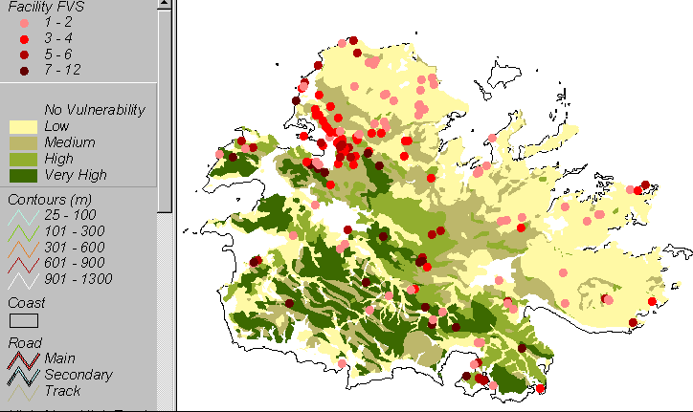
Map 14. Antigua Inland Erosion Zones and Facility FVS

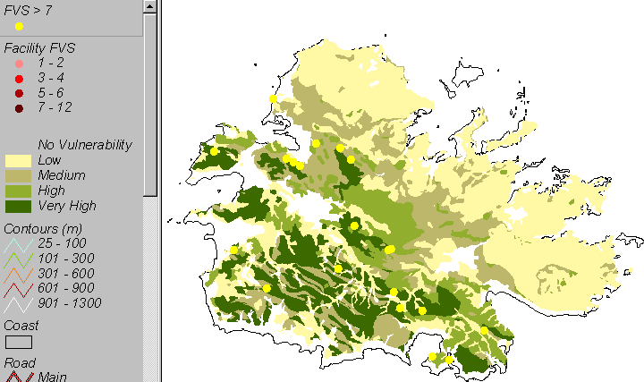
Map 15. Antigua Location of Facilities with FVS Greater than 7

5.3 Feature Vulnerability to Inland Erosion
Mainly woodland and rough grazing occupy the zones with high and very high vulnerability to inland erosion. Some central settlements such as Potter’s, Sea View Farm and Freeman’s are located within these zones. The condition of roads in these areas is adversely affected by erosion.
6.0 Antigua - Beach Erosion
6.1 Beach Erosion Zones
Beach erosion zones are established with the beach setbacks recommended by The DCA and applied to the beaches monitored by The Fisheries Division of Antigua and Barbuda. The Fisheries Division monitors the beach profiles of sixteen beaches in Antigua on a quarterly basis. Emphasis is placed on changes to the beach profile width and data has been collected since 1992. Most of the beaches in Antigua are categorized as medium to high erosion zones. Table 7 indicates the hazard categories and their respective rates of change.

Table 7. Hazard Category and Percentage Change in Beach Profile Width
Hazard Category | Rate of Change
Very Low | +3.38 to +5.28
Low | +1.18 to +3.37
Moderate | -0.43 to +1.47
High | -2.34 to –0.44
Very High | -4.25 to –2.35

Nine erosion zones have some effect on facilities and features:
- Dickenson Bay
- Runaway Bay North
- Runaway Bay South
- Lignumvitae Bay
- Crab Hill Bay
- Half Moon Bay South
- Dutchman Bay North
- Long Bay
- Fort James Beach

6.2 Beach Erosion FVS
Only two facilities have a FVS of more than 50% of total possible score. These facilities, Lashings and Sunset Cove are both located on Runaway Bay that has a medium rate of erosion. Sunset Cove is the only facility in Antigua located within a beach erosion zone. Map 16 indicates these facilities.

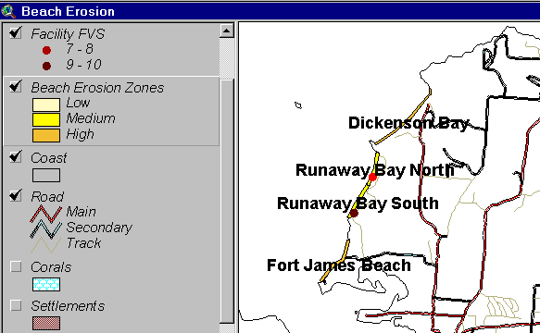
Map 16. Facilities Most Vulnerable to Beach Erosion in Antigua
6.3 Feature Vulnerability to Beach Erosion
The areas affected by the beach erosion zones are generally tourism development areas such as Dickenson Bay / Runaway Bay on the west coast and Long Bay on the east coast. Other features affected are the airport / military zone in the northeast, swamp and mangrove in the southwest and Crab Hill Bay settlement on the south coast. Dickenson Bay, Long Bay and Deep Bay are the areas with high erosion rates that affect facilities and features.

PART III – BARBUDA
7.0 Barbuda - Hurricanes and Storms
7.1 Wind
7.1.1 Wind Zones
Map 17. indicates the expected vulnerability to winds of Barbuda for various return periods. The 10-year and 25-year storms are predicted to place Barbuda in an area of low vulnerability with winds between 17 and 43 meters/second. The 50-year storm will subject most of the island to moderate vulnerability with an area south of Codrington in a low vulnerability zone. Moderate winds are between 43 and 50 meters / second and would be categorized as a category 2 hurricane. The 100-year storm would place most of Barbuda into a zone of high vulnerability to winds which would be of category 3 hurricane force and extensive damage could be expected.
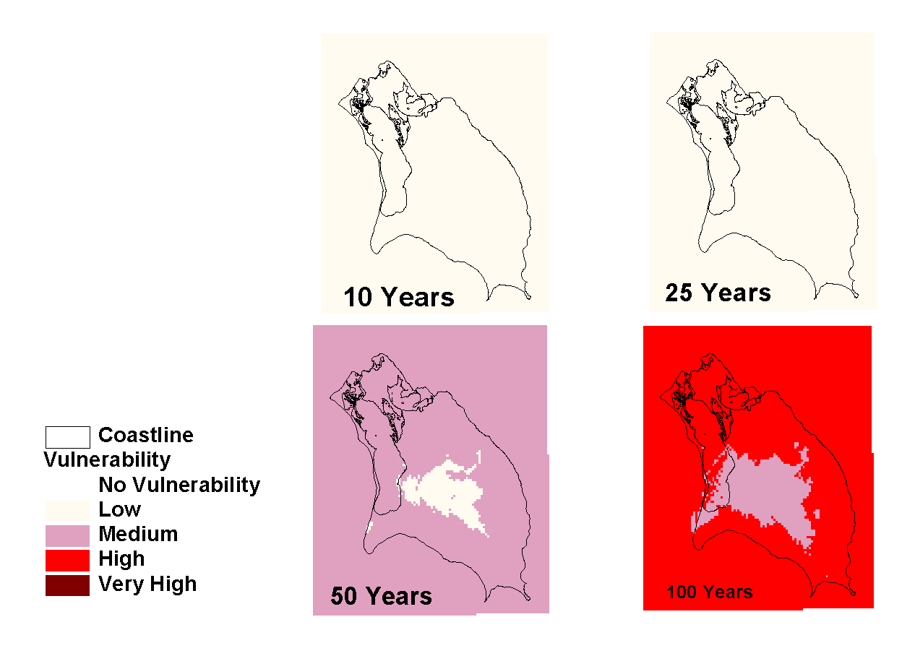

Map 17. Barbuda Wind Vulnerability By Return Interval

The long-term vulnerability of Barbuda is shown on Map 18. It is similar to the 50-year return storm with a small section on western Palmetto Point experiencing low vulnerability to wind.
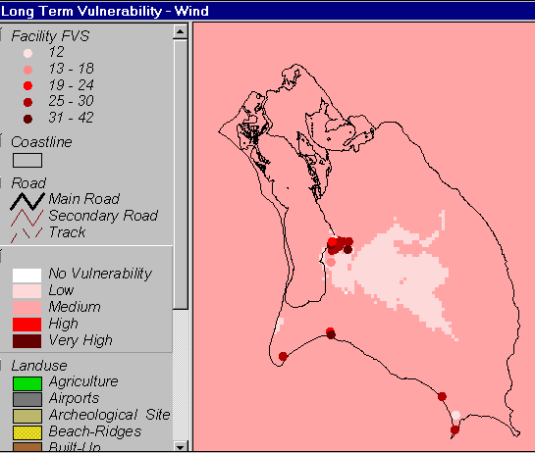
Map 18. Barbuda Long Term Wind Vulnerability
7.1.2 Wind FVS
Map 18 indicates the distribution of critical facilities on Barbuda and their wind FVS. They clustered around Codrington and the south coast. Very few facilities have low FVS values. Map 19 selects all the facilities that have an FVS greater than 21. The only exceptions are the Council Hall, Cocoa Point Airport and Hana Thomas Hospital.

7.1.3 Feature Vulnerability to Wind
As Map 18 indicates that most of the features on Barbuda are moderately vulnerable to wind. The area of low vulnerability is to the south of Codrington and is largely occupied by woodlands.
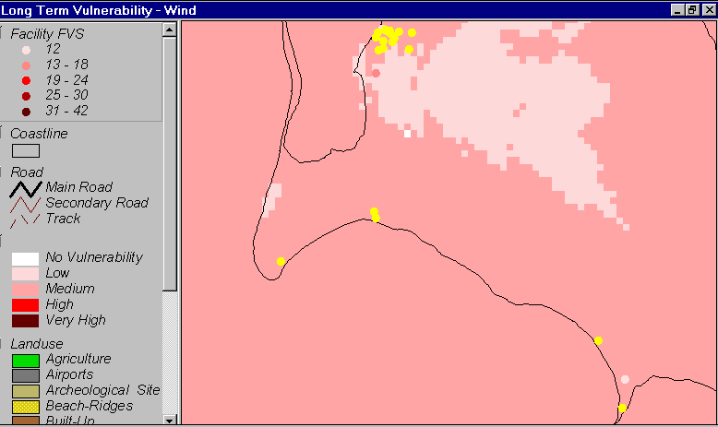
Map 19. Barbuda Features with Wind FVS Greater than 21
7.2 Storm Surge
7.2.1 Storm Surge Zones
Map 20 indicates the storm surge vulnerability of Barbuda for the 10-year, 25-year, 50-year and 100-year storm. It reveals that the 10-year storm is predicted to generate an area of moderate storm surge vulnerability that occupies the lagoon, the mouth of the lagoon and extends into the bird sanctuary. The southern portion of the spit may be breached by the surge that can be expected to range between 0.5 and 1.5 meters.

The 25-year storm subjects the entire northeast of the island to moderate surge vulnerability. The south coast and the peninsula between the lagoon and the south coast are also within an area of moderate vulnerability. The southern portion of the lagoon has a high vulnerability with surge between 1.5 and 3 meters.

The 50-year storm subjects the entrance to the lagoon and its southern portion to high storm surge vulnerability. These areas increase in extent with the 100-year storm to include a section of the south coast and most of the north of the island.
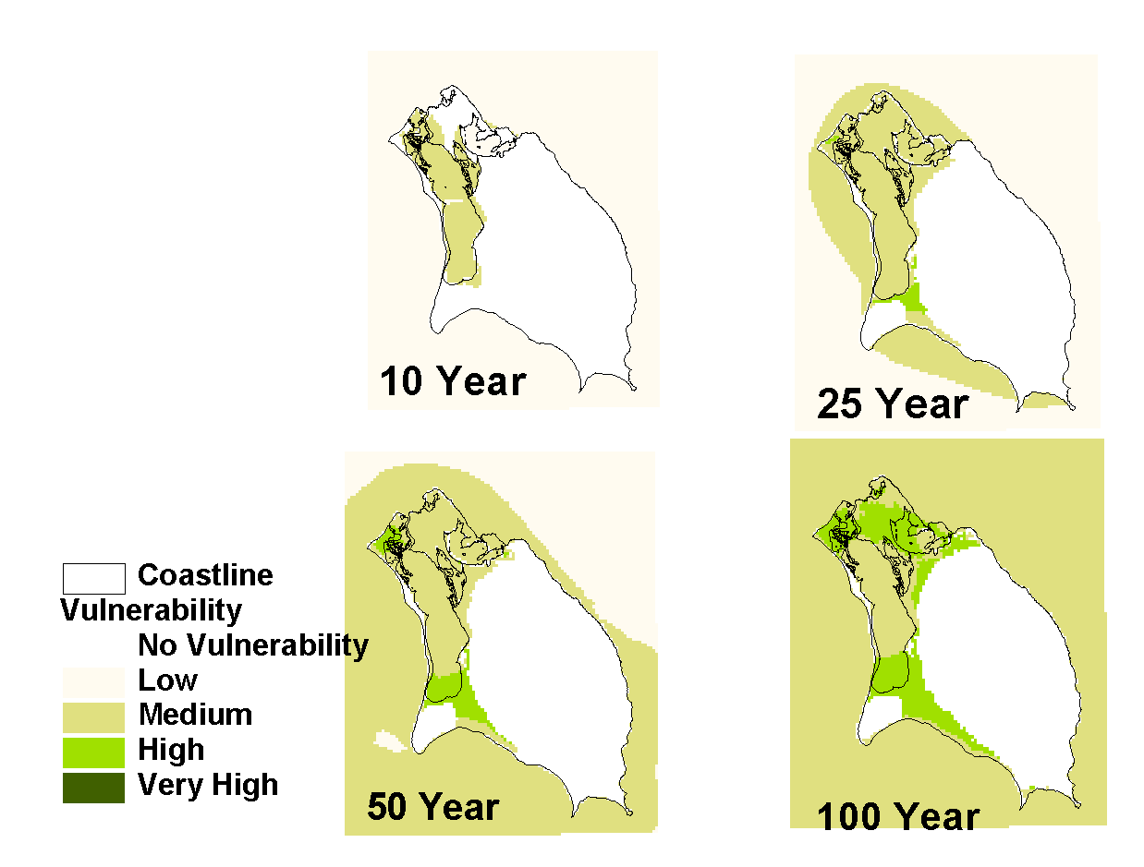

Map 20-. Barbuda Storm Surge by Return Period

Map 21 indicates the expected long-term vulnerability of Barbuda to Storm Surge. The northeast of the island has a low vulnerability. The entire lagoon including the mouth has a high vulnerability with surge building in the south of the lagoon in excess of 3.0 meters. An area of moderate vulnerability extends southwards from the lagoon across the peninsula. The entire coastline has a moderate vulnerability with and intrusion inland along the south coast of low vulnerability.

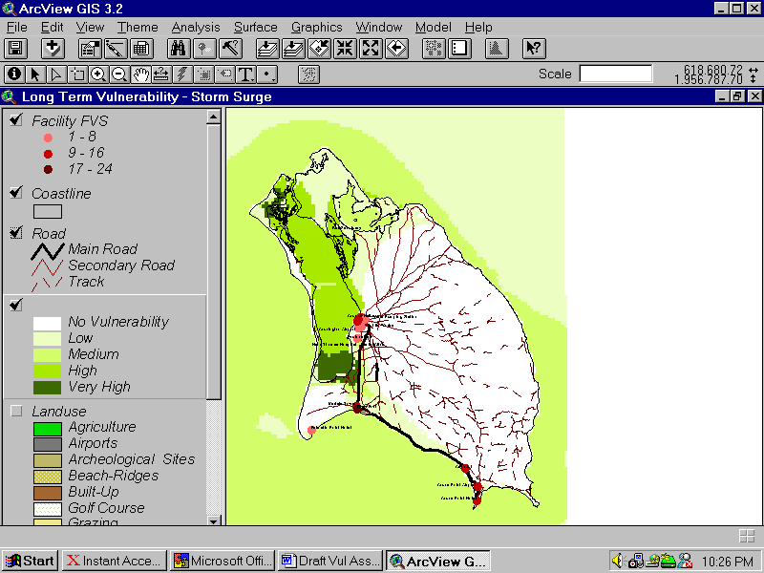
Map 21. Barbuda Long Term Vulnerability to Storm Surge

7.2.2 Storm Surge FVS
The Facilities with the highest FVS are located along the lagoon in Codrington and on the south coast in the moderately vulnerable area south of the lagoon. Map 22 indicates that the facilities are River Port, Council Hall and The Electricity Power Station with FVS of 24, 16 and 16 respectively.

7.2.3 Feature Vulnerability to Storm Surge
The Bird Sanctuary, lagoon, sea ports and approximately half of the town of Codrington can be expected to be affected by Storm surge in the long term. Most of the inland areas affected by storm surge are occupied by mixed grazing / woodlands.
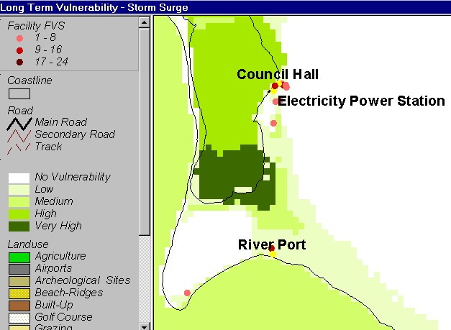
Map 22 – Barbuda Facilities with Highest Storm Surge FVS

7.3 Waves
7.3.1 Wave Zones
Map 23 indicates the vulnerability of Barbuda to waves for each storm return period. The 10-year storm is predicted to subject the lagoon and north coast to moderate vulnerability that would develop waves of 1 to 1.5 meters. Some intrusions of a low vulnerability zone will occur south and east of the lagoon with waves of 0 to 1 meter. The 25-year storm will increase this intrusion and most the north of the island will be within a low wave hazard zone. The north coast will be within a zone of high wave vulnerability. The 50-year return period will marginally increase vulnerability with the further intrusion of moderate waves inland. The 100-year storm will generate a high wave vulnerability zone in the southern and northern sections of the lagoon.

The long term vulnerability of Barbuda to waves is shown on Map 24. The lagoon is within a zone of high vulnerability. The northern section of the island is generally of low vulnerability and a zone of low vulnerability extends southwards from the lagoon to the central portion of the south coast. The southeast tip of the island has high wave vulnerability.

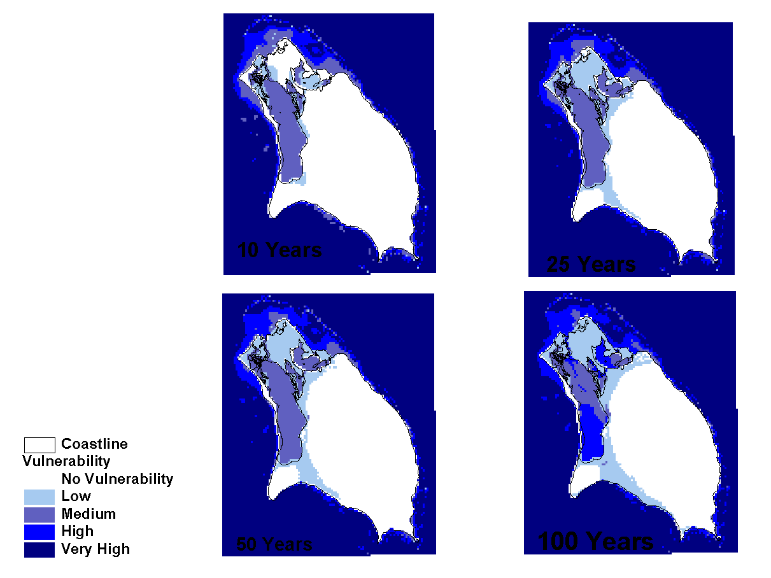
Map 23. Barbuda Wave Vulnerability by Return Period

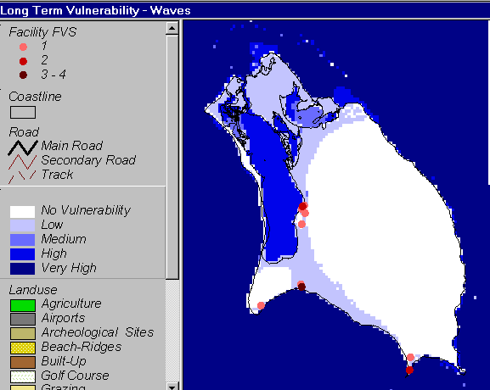
Map 24. Barbuda Long Term Vulnerability to Waves
7.3.2 Wave FVS
Only one facility has a high wave FVS for Barbuda and that is River Port. It is located on the exposed southern coast in the area of the peninsula prone to storm surge and moderate waves.

7.3.3 Feature Vulnerability to Waves
The areas vulnerable to waves are similar to those vulnerable to storm surge. The lagoon, Bird Sanctuary will be most affected. The eastern sections of Codrington and development along the south coast can expect some damage.

8.0 Barbuda - Drought
8.1 Drought Zones
Barbuda was divided into 10 watersheds that were ranked as low, moderate and high vulnerability zones. Map 25 indicates the drought vulnerability zones for Barbuda. The flats lands surrounding Codrington are considered to be the most vulnerable.

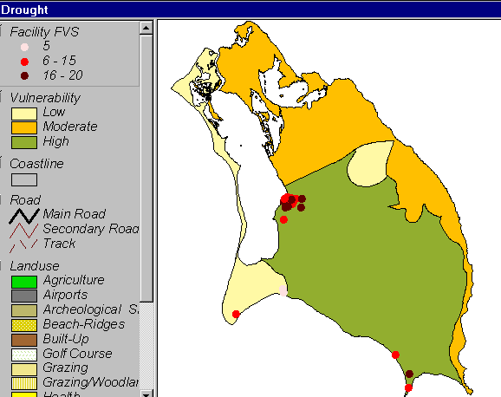
Map 25. Barbuda Drought Vulnerability Zones and Facility FVS

8.2 Drought FVS
The facilities with high drought FVS are all clustered in Codrington with the exception of Cocoa Point Airport. The following facilities have FVS of 20:
- Cocoa Point Airport
- Codrington Airport
- Fire Station
- Water Pumping Station
- Electricity Power Station
- Telephone Sub-Station
- Public Works

8.3 Feature Vulnerability to Drought
Most of the development in Barbuda occurs within the zone of high vulnerability. The town of Codrington and the entire south coast from River Port to Cocoa Point are located in the high zone. Palmetto Point and its agricultural, industrial and tourism development are located in the zone of low vulnerability

9.0 Barbuda - Flooding
9.1 Flood Zones
Map 26 indicates the flood vulnerability zones for Barbuda. A very low vulnerability zone with two small low vulnerability zones to the north and northeast covers most of the island. Codrington is located within a zone of high vulnerability. Two moderate zones of vulnerability are located along the southern section of the island.

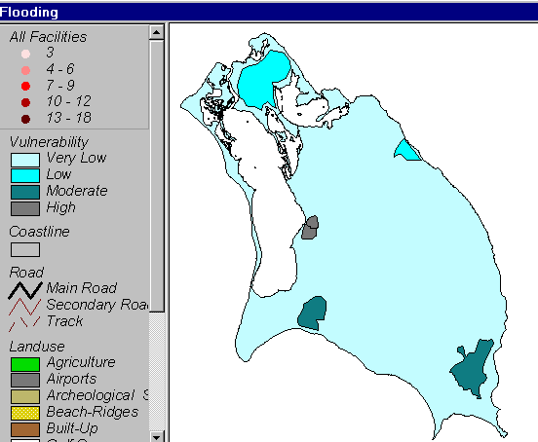
Map 26 Barbuda Flood Vulnerability Zones

9.2 Flood FVS
Map 27 indicates the distribution of facility flood FVS. Most of the facilities with high FVS are clustered within Codrington within the zone of high vulnerability to flooding. Four facilities with high FVS are located in the zone of very low vulnerability. Palmetto Point Hotel and Cocoa Point Hotel are located along the south coast. Hana Thomas Hospital and Public Works is located along the edge of the high flood zone in Codrington. Figure 5 lists the facilities and their FVS value.

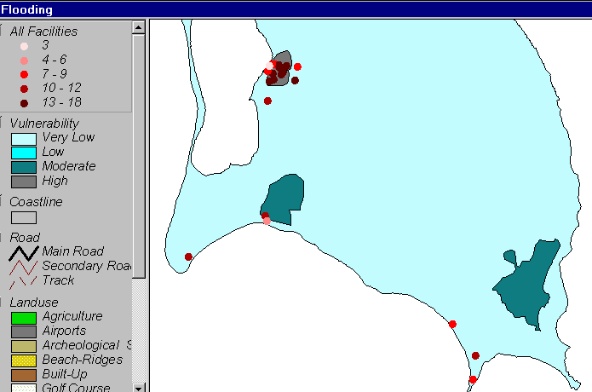
Map 27 Barbuda Flood FVS

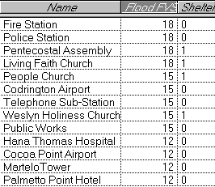
Figure 5 Barbuda Listing of Facilities with High Flood FVS

9.3 Feature Vulnerability to Flooding
The town of Codrington is the most significant feature vulnerable to flooding on the Island of Barbuda. An area of tidal flats and woodland is subjected to low vulnerability in the north. An area of swamp and woodland is moderately to flooding along the south east coast.

10.0 Barbuda - Inland Erosion
10.1 Inland Erosion Zones
Lang indicates that hazards of sheet and rill erosion and of gully erosion in Barbuda are minimal but wind erosion is relatively important and may provide a building development hazard. Rock falls on the edge of and in the highlands are also to be noted. Barbuda shows the highest hazard ratings on areas with parent materials that may have been wind deposited.

Map 28 shows the zones of inland erosion. The southern and western areas of the island are prone to low vulnerability. The eastern section of the island has a moderate vulnerability.

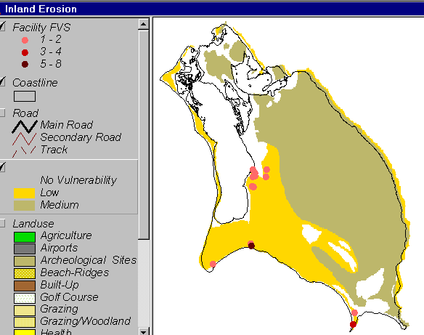
Map 28 Barbuda Inland Erosion and Facility FVS

10.2 Inland Erosion FVS
The facilities on Barbuda are located within the moderate zone of vulnerability. Only River Port has a high FVS value.

10.3 Feature Vulnerability to Inland Erosion
The area of moderate vulnerability is occupied by tidal flats and woodland in the north and grazing / woodland in the east.

11.0 Barbuda - Beach Erosion
11.1 Beach Erosion Zones
Six beaches are monitored quarterly in Barbuda since 1995 by the Fisheries Division. Of the six beaches monitored Two-Foot Bay and Dulcina Bay record accretion as the dominant process. Erosion is more dominant on Palm Beach and Palmetto Point and sections of Cocoa Point vary between accretion and erosion. Beach Erosion in Barbuda varies from very low to very high on Dulcina Bay and Palmetto Point respectively. Map 29 indicates the location of beach erosion zones.

11.2 Beach Erosion FVS
No Facilities in Barbuda were located within Beach Erosion zones. Palmetto Point Hotel and Cocoa Point Hotel were located closet to high and very high Beach Erosion zones.

11.3 Feature Vulnerability to Beach Erosion
The beaches themselves are the features at risk from erosion. Palm Beach places a section of the spit and therefore the lagoon at moderate vulnerability to beach erosion. The beach at Palmetto Point is very vulnerable to beach erosion.

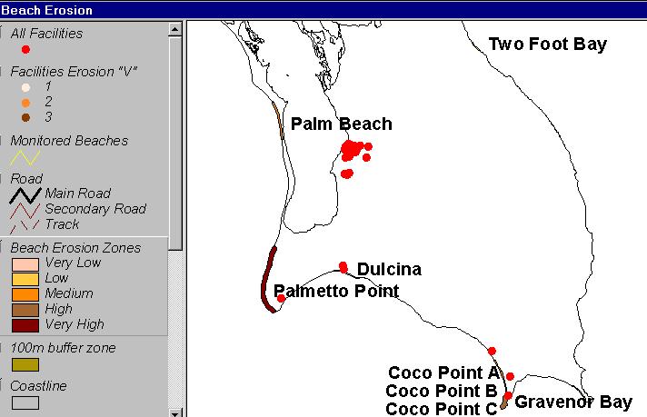
Map 29 Barbuda Beach Erosion Zones and Facility Vulnerability

PART IV - SUMMARY
12.0 Summary
12.1 Cumulative Vulnerability
Cumulative vulnerability attempts to consider the total vulnerability of facilities and areas to hazards in order to determine which facilities and areas are the most vulnerable. The cumulative vulnerability of facilities is the total FVS of all hazard types. The cumulative vulnerability of an area is the total of all the hazard zone scores for the area.

12.2 Antigua
12.2.1 Facilities
The “V” value of facilities considers their damage history, structural and operational vulnerability. An examination of the total “V” value of facilities (Map 30 ) reveals that the facilities with the highest scores are clustered north of St. John’s and in the Runaway Bay / Dickenson bay and Long Bay areas. Map 31. Indicates that the distribution of the total FVS scores is consistent with the distribution of the “V” scores. Map 32. Visually represents the location of the highest FVS values with the use of contours. This method is only for visual impact as it allows “hotspots” to be easily seen. It is not meant to suggest that there is a continuous surface of FVS values.

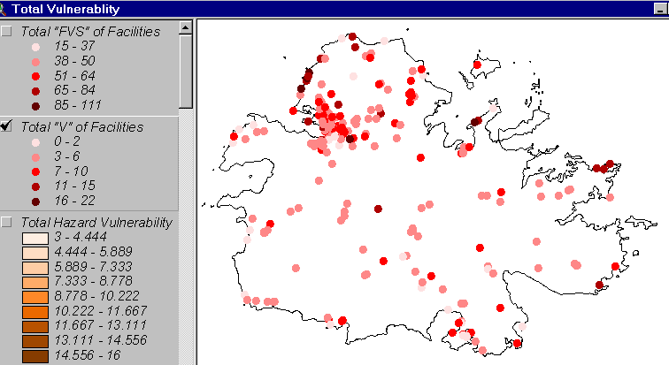
Map 30. Total “V” of Facilities in Antigua
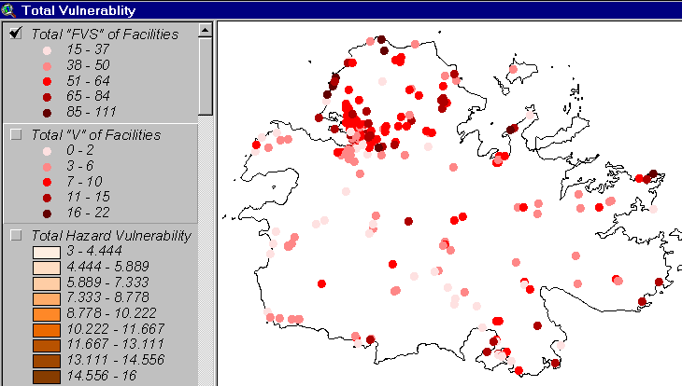
Map 31. Total FVS of Facilities in Antigua

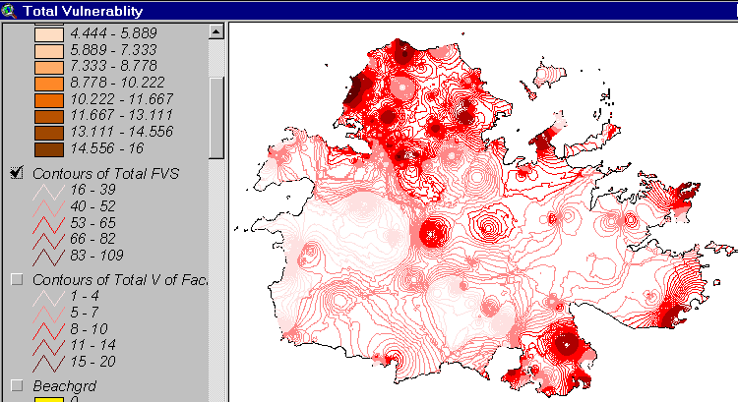
Map 32. Facility “FVS” Hotspots in Antigua

“Hot spots” are caused by a combination of facility distribution patterns and absolute “FVS” values. Areas with higher facility density have a denser contour pattern. Areas with high density and high “FVS” values appear as dark spots. The location of “hot spots” can be used to prioritize further investigation.

12.2.2 Hazard Zones
Map 33. indicates the total hazard vulnerability zones generated from all hazard vulnerability maps. The values generated are divided into equal classes. The highest total scores are located along the southeast coast in the Shirley Heights area. The area southwest of Parham Harbour also has a high score. The lowest scores are located in a strip across central Antigua.
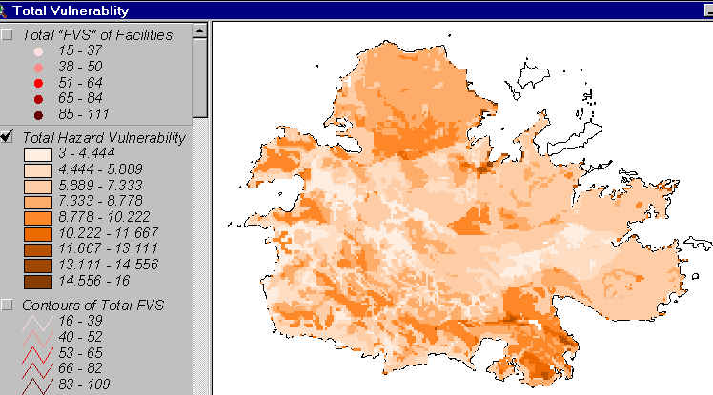
Map 33. Total Hazard Vulnerability Zones in Antigua

12.3 Barbuda
12.3.1 Facilities
River Port and Codrington Power Station have the two highest total FVS scores. The other facilities with high total FVS are Cocoa Point Hotel, Codrington Fire Station, Codrington Airport and Public Works Map 34 indicates the distribution of these facilities.

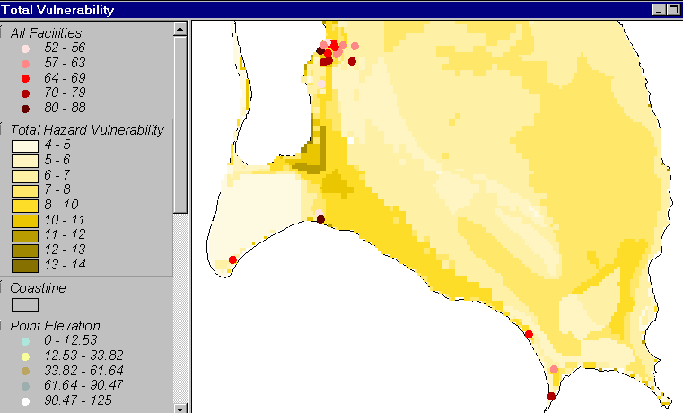
Map 34 Distribution of Facility Total FVS in Barbuda

12.3.2 Hazard Zones
The most vulnerable areas in Barbuda are south east of the lagoon and east of the mouth of the lagoon. Map 35 shows these hazard zones.

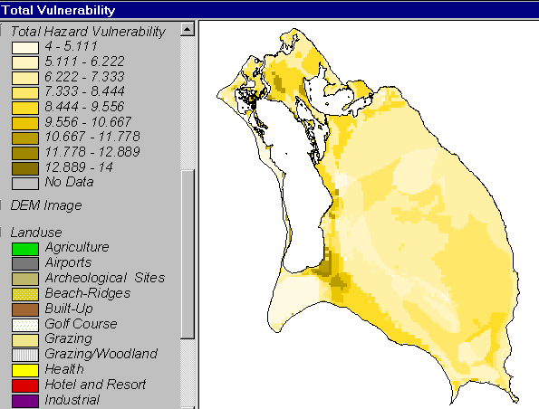
Map 35 Total Hazard Vulnerability in Barbuda
Appendix 1

Antigua- Facilities by Type and Hazard FVS
TYPE NAME ADDRESS Shelter Beach Surge Waves Wind Inland Drought Flood
Airport V.C.BIRD INTERNATIONAL AIRPORT Coolidge 0 0 0 42 2 25 9
Bridges BENDALS BRIDGE BENDALS 0 0 0 6 0 5 12
BIG CREEK BRIDGE VALLEY ROAD 0 0 0 6 2 5 6
FOLLEY GUT BRIDGE FOLLEY'S 0 0 0 12 2 5 15
GILBERT'S BRIDGE GILBERTS 0 0 0 12 2 15 15
NORTH SOUND BRIDGE NORTH SOUND 0 0 0 12 4 5 21
Churches ADVENTIST CHURCH URLINGS 1 0 0 30 0 10 3
ADVENTIST CHURCH GLANVILLES 1 0 0 24 0 15 3
ADVENTIST CHURCH BENDALS 1 0 0 24 2 5 3
ADVENTIST COMMUNITY CENTRE LIBERTA 1 0 0 18 8 5 3
ANGLICAN CHURCH PARHAM 1 0 0 18 2 15 3
ANGLICAN SERVANTS QUARTERS ST. PHILLIPS 1 0 0 30 2 15 3
BAXTER METHODIST CHURCH ENGLISH HARBOUR 1 0 0 30 6 20 3
CASSADA GARDENS METHODIST CASSADA GARDENS 1 0 0 30 2 20 3
CEDAR GROVE ADVENTIST CHURCH CEDAR GROVE 1 0 0 30 2 20 3
CEDAR GROVE WESLEYAN HOLINESS CEDAR GROVE 1 0 0 30 2 20 9
CHURCH OF CHRIST BENDALS 1
CHURCH OF GOD PROPHECY COOKS HILL 1 0 0 24 8 5 3
FIVE ISLAND MORAVIAN CHURCH FIVE ISLAND 1 0 0 24 8 15 3
FIVE ISLANDS SHILOH CHURCH FIVE ISLANDS 1 0 0 24 2 15 3
FORT ROAD ADVENTIST CHURCH FORT ROAD 1 0 0 30 4 20 3
FREEMAN'S VILLAGE METHODIST FREEMAN'S VILLAGE 1 0 0 30 6 15 3
GRACE APOSLOTIC CHURCH LOVELACE ROAD 1 0 0 30 4 20 3
GRAYS HILL PENTECOSTAL PERRY BAY 1 0 0 24 0 20 3
GREEN BAY NAZARENE CHURCH GREEN BAY 1 0 0 24 2 20 3
JEVHOVAH WITNESS KINGDOM HALL GAMBLES TERRACE 1 0 0 24 4 20 3
JOHN HUGHES METHODIST CHURCH JOHN HUGHES 1 0 0 36 8 5 3
LOVELACE ADVENTIST CHURCH LOVELACE ROAD 1 0 0 24 0 20 3
METHODIST CHAPEL BETHESDA 1 0 0 36 2 15 3
METHODIST CHAPEL AND HALL PARHAM 1 0 0 36 2 15 3
METHODIST HALL FREETOWN 1 0 0 24 2 15 3
Wednesday, May 09, 2001 Page 1 of 7
TYPE NAME ADDRESS Shelter Beach Surge Waves Wind Inland Drought Flood
Churches MOUNT OF BLESSING CHURCH WIRELESS ROAD 1 0 0 30 2 20 3
NAZARENE CHURCH VILLA 1 0 0 36 0 20 3
OLD ROAD ANGLICAN CHURCH OLD ROAD 1 0 0 36 0 10 3
PERRY BAY PEOPLE CHURCH PERRY BAY 1 0 0 24 2 20 3
PILGRIM HOLINESS CHURCH NEW WINTHROPES 1 0 0 24 2 20 3
SEVENTH DAY ADVENTIST NEW WINTHROPES 1 0 0 30 2 20 12
SEVENTH DAY ADVENTIST PIGOTTS 1 0 0 24 0 20 12
SHILO GOSPEL HALL ST. JOHNSON 1 0 0 30 2 20 3
ST. JOHN'S CHURCH OF CHRIST GOLDEN GROVE 1 0 0 30 4 5 3
ST. JOSEPH ANGLICAN CHURCH URLINGS 1 0 0 30 0 10 3
ST.MARKS PIGOTTS 1 0 0 30 4 20 3
TINDALE ADVENTIST CHURCH VALLEY ROAD 1 0 0 30 8 5 3
VILLA BETHEL CHURCH VILLA 1 0 0 30 0 20 3
VILLA ST. ANDREW'S CHURCH VILLA 1 0 0 30 4 20 3
WESLEY HOLINESS BOLANS 1 0 0 24 6 10 3
ZION CHURCH OF GOD VILLA 1 0 0 30 0 20 3
Clinics ALL SAINTS HEALTH CENTRE A l Saints 0 0 0 30 8 5 3
BENDALS CLINIC Bendals Rd. 0 0 0 30 2 5 3
BETHESDA CLINIC BETHESDA 0 0 0 12 2 15 3
BISHOPGATE STREET CLINIC ST. JOHN'S 0 0 0 12 0 20 3
BOLANS CLINIC Bolans Village 0 0 0 24 8 10 3
CEDAR GROVE CLINIC & CRES Cedar Grove 0 0 0 30 2 20 3
CLARE HALL & ST. JOHNSON'S VILLAGE Clare Hall Village 0 0 0 18 4 20 3
COBBS CROSS CLINIC Cobbs Cross Villag. 0 0 0 30 2 20 3
FREETOWN CLINIC Freetown 0 0 0 30 2 15 3
GRAYS FARM HEALTH CENTRE Grays Farm 0 0 0 30 2 20 3
JENNINGS CLINIC Jennings 0 0 0 18 2 10 3
JOHN HUGHES CLINIC John Hughes 0 0 0 36 0 5 3
JUDGES HILL CLINIC Judges Hill 0 0 0 30 2 20 3
LIBERTA CLINIC Liberta 0 0 0 30 2 5 12
NEWFIELD CLINIC NEWFIELD 0 0 0 36 2 5 3
OLD ROAD CLINIC Old Road 0 0 0 36 0 10 3
OTTOS NEWTOWN CLINIC Ottos New Town 0 0 0 6 4 20 3
PARES CLINIC Pares Village 0 0 0 36 2 15 3
PARHAM CLINIC Parham Village 0 0 0 36 2 15 3
Wednesday, May 09, 2001 Page 2 of 7
TYPE NAME ADDRESS Shelter Beach Surge Waves Wind Inland Drought Flood
Clinics PIGOTTS CLINIC 0 0 0 12 4 20 3
POTTERS CLINIC & COMMUNITY Potters main Road 0 0 0 30 8 5 3
ST. JOHN'S HEALTH CENTRE BROWN'S AVENUE 0 0 0 6 0 20 3
ST. JOHN'S HEALTH CENTRE All Saints d. 0 0 0 36 0 10 3
SWEETS CLINIC Sweets Village 0 0 0 36 4 5 3
WILLIKIES CLINIC Wilikies 0 0 0 30 2 15 3
Community ADVENTIST CHURCH BOLANS 1 0 0 24 2 10 3
CATHEDRAL CULTURAL CENTRE ST. JOHN'S STREET 1 0 0 30 0 20 12
COMMUNITY CENTRE YORKS 1 0 0 24 4 20 3
Electricity CASSADA POWER STATION BARNES HILL MAIN 0 0 0 48 2 20 12
CRABS POWER STATION CRABBS 0 0 0 48 0 15 9
FRIARS HILL POWER STATION FRIARS HILL ROAD 0 0 0 42 4 20 18
Fire ALL SAINTS FIRE STATION All Saints 0 0 0 36 8 5 3
ST. JOHNS FIRE STATION Factory Rd. 0 0 0 42 0 20 9
V.C. BIRD FIRE STATION Airpo t, Fire Station 0 0 0 30 2 20 3
Government AGRICULTURE EXTENTION OFFICES Valley Rd. 0 0 0 30 0 20 3
ALLIANCE FOR SOCIAL WELL BEING 0 0 0 36 0 20 3
ANTIGUA & BARBUDA TRANSPORT Factory Road 0 0 0 24 4 5 3
APUA MAIN ADMINISTRATION OFFICE CASSADA GARDENS 0 0 0 24 2 20 3
BOARD OF EDUCATION North Street 0 0 0 24 0 20 3
CENTRAL HOUSING & PLANNING All Saints Rd. 0 0 0 24 0 20 3
CLARENCE HOUSE English Harbour 0 0 0 36 0 20 3
CUSTOMS & EXCISE DEPARTMENT Church St. 0 0 0 30 0 20 3
DEPARTMENT OF COOPERATIVES Upper High Street 0 0 0 24 0 20 3
DEPARTMENT OF TOURISM Nevis Street 0 16 3 24 0 20 3
ESTABLISHMENT Redcliffe St. 0 0 0 18 0 20 3
FREE TRADE ZONE COOLIDGE 0 0 0 24 2 20 3
GENDER AFFAIRS (Craft) Cross Street 0 2 0 1 24 2 20 9
GENERAL POST OFFICE High & Long St. 0 12 0 36 0 20 12
GOVERNMENT OFFICE COMPLEX Queen Eliz. Hgh. 0 4 0 2 18 8 20 3
GOVERNMENT PRINTERY Factory Rd. 0 0 0 42 4 20 9
GOVERNMENT WORKSHOP Factory Road 0 0 0 36 4 20 3
GOVERNMENT WORKSHOP OFFICE Factory Road 0 0 0 30 8 20 12
H.C. GRANT BUILDING ST. JOHN'S 0 8 0 24 0 35 12
HEALTH EDUCATION UNIT Factory Rd. 0 0 0 36 6 20 3
Wednesday, May 09, 2001 Page 3 of 7
TYPE NAME ADDRESS Shelter Beach Surge Waves Wind Inland Drought Flood
Government HEALTH INFORMATION DIV. / AIDS Cemetry Road 0 0 0 24 4 20 3
HIGH COURT 0 0 0 42 6 20 9
HUMAN RESOURCES CENTRE Factory Rd. 0 0 0 30 6 20 3
IMMIGRATION DEPARTMENT Old Parham Rd. 0 0 0 24 4 20 3
INDUSTRIAL COURT Redcliffe St. 0 0 30 0 20 3
INLAND REVENUE Newgate St. 0 0 0 24 0 20 3
JOB PROGRAMME Factory Rd. 0 0 0 30 4 20 9
MAGISTRATE COURT Nevis Street 0 0 0 24 0 20 3
MIN. AGRIC., LAND & FISHERIES Nevis Street 0 0 0 30 0 20 3
MIN. COMMERCE, INDUSTRY, Corn Alley 0 0 0 24 0 20 3
MIN. OF JUSTICE & LEGAL AFFAIRS Redcliffe Street 0 0 0 24 0 20 3
MIN. OF LABOUR (HEADQUARTERS) Redcliffe St. & Corn 0 0 0 18 0 20 3
MIN. OF TOURISM & ENVIRONMENT / Queen Eliz. Hgh. 0 0 0 30 4 20 9
MINISTRY OF AGRICULTURE 0 0 0 42 8 5 12
MINISTRY OF EDUCATION Church St. 0 0 0 48 0 20 9
MINISTRY OF PLANNING Church St. 0 0 0 18 0 20 3
MINISTRY OF PUBLIC WORKS ST. JOHN'S STREET 0 0 0 36 0 20 3
NAT. DRUG MONEY LAUNDERING CO. 0 0 0 24 0 20 3
NATIONAL OFFICE OF DIASTER American Rd. 0 0 0 36 4 5 3
OLD ADMIN. MIN. OF FINANCE High & Long St. 0 16 0 30 0 20 12
OMBUDSMAN OFFICE Deanery Lane 0 0 0 30 0 20 3
PARLIAMENT BUILDING Queen Eliz. Hgh. 0 2 0 1 30 6 20 3
PLANT PROTECTION UNIT Friars' Hill 0 0 0 12 2 20 3
PRIME MINISTER OFFICE Queen Eliz. Hgh. 0 0 0 12 4 20 3
TREASURY High Street 0 0 0 30 0 20 3
Guest Houses PARADISE INN 0 0 0 24 4 25 6
STEPHENDALE 0 0 0 36 4 25 6
VIENNA INN 0 0 0 30 4 25 3
Historical BETTY'S HOPE BETTY'S HOPE 0 0 0 24 4 15 3
FORT BARRINGTON GOAT HILL 0 0 0 18 0 3
FORT JAMES FORT JAMES, ST. 0 0 0 42 0 20 3
MONKS HILL FALMOUTH 0 0 0 6 8 5 3
NELSON'S DOCKYARD DOCKYARD, 0 6 16 6 30 12 3
SHIRLEY HEIGHTS ENGLISH H RBOUR 0 0 0 36 0 20 3
Hospitals HOLBERTON HOSPITAL Queen Eliz. Hgh. 0 0 0 54 6 35 9
Wednesday, May 09, 2001 Page 4 of 7
TYPE NAME ADDRESS Shelter Beach Surge Waves Wind Inland Drought Flood
Hospitals MENTAL HOSPITAL Skerrits Pasture 0 0 0 36 4 20 3
MT. ST. JOHN'S MEDICAL CENTRE MIHAEL'S MOUNT 0 0 0 6 0 20 3
Hotels ADMIRALS INN DOCKYARD 0 0 0 6 6 20 3
AIRPORT HO EL 0 0 0 36 2 25 3
AMARYLIS HOTEL AIRPORT ROAD 0 0 0 36 2 20 18
BARRYMORE BEACH HOTEL RUNAWAY BAY 0 20 4 36 0 20 12
BEACHOMBER HOTEL COOLIDGE 0 8 4 12 2 20 3
BLUE WATERS HOTEL BLUE WATERS BAY 0 8 4 12 2 20 3
CARLISLE BAY HOT L 0 2 4 1 36 2 15 6
CATAMARAN FALMOUTH 0 0 0 12 0 20 3
CITY VIEW HOTEL 0 0 0 18 0 20 3
COPPER AND LUMBER INN DOCKYARD 0 4 3 6 6 20 3
COURTSLAND HOTEL 0 0 0 36 2 25 3
CURTAIN BLUFF OLD ROAD 0 0 0 12 0 10 3
DOVE COVE HOTEL DRYHILL ESTATE 0 0 0 12 0 20 3
FALMOUTH HARBOUR BEACH FALMOUTH 0 0 0 12 0 20 3
FALMOUTH HARBOUR HOT L 0 2 8 1 30 8 25 3
FALMOUTH HOTEL 0 2 8 1 30 8 25 6
GALLEY BAR AND BOUTIQUE DOCKYARD 0 0 12 0 20 3
GALLEY BAY HOTEL FIVE ISLANDS 0 0 0 12 0 15 3
GULF VIEW HOTEL NEW GATE STREET 0 0 0 12 0 20 3
HALE HOUSE 0 2 12 1 24 2 20 6
HALF MOON BAY HOTEL 0 6 12 3 30 6 20 6
HAWKSBILL BEACH RESORT FIVE ISLANDS 0 0 0 6 0 15 3
HERITAGE HOTEL HERITAGE QUAY, 0 6 12 3 24 6 20 12
ISLAND INN ANCHORAGE ROAD 0 0 0 24 4 20 3
JOE MIKES HOTEL NEVIS STREET AND 0 0 0 24 0 20 3
JOLLY CASTLE BOLANS 0 0 0 6 0 10 3
JOLLY HARBOUR BOLANS 0 0 0 6 0 10 3
JUMBY BA RESORT 0 8 0 36 0
LASHINGS RUNAWAY BAY 0 10 28 9 36 10 18
LONG BAY RESORT 0 2 12 30 4 20 6
LORD N LSON CLUB 0 4 0 30 2 25 6
MANGO BAY RESORT 0 6 16 7 30 6 20 6
MARINA BAY HOTEL 0 2 12 1 24 2 25 9
Wednesday, May 09, 2001 Page 5 of 7
TYPE NAME ADDRESS Shelter Beach Surge Waves Wind Inland Drought Flood
Hotels MILL REEF HOTEL 0 4 0 2 42 4 15 3
OCEAN VIEW 0 4 8 2 30 6 25 12
PELICAN ISLE H TEL 0 0 0 30 0 15 3
PINEAPPLE RESORT 0 2 8 1 36 2 6
REX BLUE HERON 0 0 0 12 0 3
REX HALYCON COVE DICKENSON BAY 0 0 0 6 0 20 3
ROYAL ANTIGUAN 0 0 0 12 6 15 3
SANDALS DICKENSON BAY 0 6 16 3 30 6 9
SANDPIPER HOTEL 0 4 12 2 30 6 25 9
SIBONEY DICKENSON BAY 0 6 20 3 36 6 20 15
ST. JAMES CLUB 0 4 12 2 36 4 20 3
ST. JAMES CLUB VILLA MAMORA BAY 0 0 0 12 0 20 3
SUNSAIL CLUB COLONNA HODGES BAY 0 4 1 12 0 20 3
SUNSET COVE HOTEL RUNAWAY BAY 0 8 20 6 36 4 20 15
TRADEWINDS HOTEL DICKENSON BAY 0 0 0 30 0 20 3
YEPTON HOTEL 0 2 4 1 24 2 20 3
Military ANTIGUA & BARBUDA DEFENCE Crabbs ( Parham) 0 0 0 12 0 15 3
Nursery GRACE HILL PRE-SCHOOL LIBERTA 1 0 0 24 2 5 6
Other DELUXE THEATRE HIGH STREET 1 0 0 30 0 20 9
KING GEORGE THE V GROUND KING GEORGE PARK 1 0 0 24 0 20 3
Petroleum TEXACO WEST INDIES COOLIDGE 0 0 0 36 2 20 9
WEST INDIES OIL REFINERY FRIAR'S HILL ROAD 0 0 0 24 4 20 9
Police ALL SAINTS POLICE STATION All Saints Village 0 0 0 36 6 5 3
BOLANS POLICE STATION Bolans 0 0 0 30 2 10 3
COLLIDGE POLICE STATION Collidge 0 0 0 30 2 20 9
DOCKYARD POLICE STATION English Harbour 0 0 0 30 6 20 9
FREETOWN POLICE STATION Freetown 0 0 0 30 6 15 3
GRAYS FARM POLICE STATION Grays Farm 0 0 0 30 2 20 3
LIBERTA POLICE STATION Liberta Village 0 0 0 24 2 5 12
PARHAM POLICE STATION Parham town 0 0 0 36 0 15 3
POLICE HEADQUATERS American Rd. 0 0 0 36 4 25 3
ST. JOHNS POLICE STATION Newgate St. 0 0 0 30 0 20 3
WILIKIES POLICE STATION Willikies Village 0 0 0 30 2 15 3
Primary BENDALS PRIMARY SCHOOL Bendals Village 1 0 0 24 6 5 3
BETHESDA PRIMARY SCHOOL Bethesda 1 0 0 30 6 15 3
Wednesday, May 09, 2001 Page 6 of 7
TYPE NAME ADDRESS Shelter Beach Surge Waves Wind Inland Drought Flood
Primary COBBS CROSS PRIMARY SCHOOL Cobbs Cross 1 0 0 30 2 20 3
FIVE ISLANDS PRIMARY SCHOOL Five Islands 1 0 0 24 6 15 3
FREEMAN'S VILLAGE PRIMARY FREEMAN'S VILLAGE 1 0 0 36 6 15 3
GLANVILLES PRIMARY SCHOOL Glanvilles 1 0 0 30 2 15 3
GREEN BAY PRIMARY SCHOOL Green Bay 1 0 0 24 4 20 3
IRENE WILLIAMS PRIMARY SCHOOL Sweets Village 1 0 0 12 2 5 3
JENNINGS PRIMARY SCHOOL Jennings 1 0 0 24 0 10 3
JOHN HUGHES PRIMARY SCHOOL John Hughes 1 0 0 30 2 5 3
LIBERTA PRIMARY SCHOOL Liberta 1 0 0 18 8 5 3
MARY E. PIGOTT PRIMARY SCHOOL Ottos 1 0 0 24 6 20 3
OLD ROAD PRIMARY SCHOOL Old Road 1 8 0 36 0 10 3
PARES PRIMARY SCHOOL Pares Village 1 0 0 24 2 15 9
PARHAM PRIMARY SCHOOL Parham Village 1 0 0 36 2 15 9
T. N. KIRNON SCHOOL Coronation Rd. 1 0 0 36 4 20 9
URLINGS PRIMARY SCHOOL Urlings 1 0 0 36 0 10 3
VILLA PRIMARY SCHOOL 1 0 0 30 0 20 12
WILIKIES PRIMARY SCHOOL Wilikies 1 0 0 36 2 15 3
Prisons PRISON Coronation Rd. 0 0 0 12 0 20 3
PRISON ( REHABILIATION CENTRE) Factory Rd. 0 0 0 42 6 20 3
Sea Port DEEP WATER HARBOUR ST. JOHN'S 0 4 20 2 12 4 20 3
ENGLISH HARBOUR DOCKYARD, 0 2 8 1 6 2 6
HERITAGE QUAY HERITAGE QUAY, 0 4 16 2 6 4 20 3
JOLLY HARBOUR JOLLY BEACH 0 0 0 6 0 10 6
Secondary ALL SAINTS SECONDARY SCHOOL All Saints Village 1 0 0 30 4 5 3
ANTIGUA GIRL HIGH SCHOOL NEWGATE STREET, 1 0 0 36 0 20 9
ANTIGUA GRAMMER SCHOOL Old Factory Road 1 0 0 36 4 20 3
CLARE HALL SECONDARY SCHOOL Clare hall 1 0 0 30 4 20 3
VALLEY HIGH BOLANS 1 0 0 24 0 10 12
Telecommunic BOGGY PEAK BOGGY PEAK 0 0 0 30 8 10 3
PUBLIC INFORMATION & A.B.S RADIO OLD PARHAM 0 0 0 24 4 20 6
Water CRABS DESALINATION PLANT CRABBS PENINSULA 0 4 0 48 2 15 18
DELAPS PUMPING AND TREATMENT BODKIN'S ESTATE, 0 0 0 36 2 5 3
GRAYS HILL RESERVOIR AND PUMPING GRAYS HILL 0 0 0 30 8 5 3
Wednesday, May 09, 2001 Page 7 of 7
Appendix 2
Barbuda Facilities by Type and Hazard FVS
Type Name Address Shelter Wind Waves Surge Drought Flood Inland
Airport
COCO POINT AIRPORT COCO POINT 0 12 1 12 20 12 2
CODRINGTON AIRPORT CODRINGTON 0 30 0 8 20 15 2
Churches
LIVING FAITH CHURCH CODRINGTON 1 30 0 0 15 18 0
PENTECOSTAL ASSEMBLY CODRINGTON 1 30 0 0 15 18 2
PEOPLE CHURCH CODRINGTON 1 30 0 0 15 15 0
WESLYN HOLINESS CHURCH CODRINGTON 1 30 0 0 15 15 0
Electricity
ELECTRICITY POWER STATION 0 42 1 16 20 9 0
Fire
BARBUDA FIRE STATION 0 30 1 8 20 18 2
Government Administration
BARBUDA COUNCIL HALL CODRINGTON 0 12 1 16 15 9 0
NEW BARBUDA COUNCIL CODRINGTON 0 24 0 4 15 9 0
POST OFFICE AND TREASURY CODRINGTON 0 30 0 12 15 9 0
PUBLIC WORKS 0 36 0 0 20 15 2
Historical
MARTELO TOWER 0 24 1 12 5 12 2
Hospitals
HANA THOMAS HOSPITAL CODRINGTON 0 18 1 4 15 12 2
Hotels
CAY CLUB 0 30 0 12 15 9 0
COCO POINT HOTEL COCO POINT 0 30 2 12 15 9 4
Wednesday, May 09, 2001 Page 1 of 2
Type Name Address Shelter Wind Waves Surge Drought Flood Inland
PALMETTO POINT HOTEL PALMETTO POINT 0 30 1 8 15 12 2
Police
BARBUDA POLICE STATION CODRINGTON 0 30 0 4 15 18 0
Sea Port
CODRINGTON WHARF 0 24 2 12 15 3 2
RIVER PORT 0 36 4 24 5 6 8
Telecommunication
TELEPHONE SUB-STATION 0 30 0 4 20 15 0
Water
WATER PUMPING STATION 0 30 0 0 20 9 2
Wednesday, May 09, 2001 Page 2 of 2

Rogers, C. 2000, Hazard Mapping / Vulnerability Assessment Prioritization Workshop Report. http://www.oas.org/pgdm
“V” is defined as the total of the damage history, structural vulnerability and operational vulnerability scores.
Jackson, I, 2001, Drought Technical Report – Antigua and Barbuda. http://www.oas.org/pgdm
Cooper, V. 2001, Flood Methodology Notes. Email .
Lang, D.M., 2001, ‘Inland’ Erosion Hazards in Antigua, Barbuda. http://www.oas.org/pgdm
James, P. 2001, Beach Erosion Technical Report – Antigua and Barbuda. http://www.oas.org/pgdm

