GENERAL SECRETARIAT
EXECUTIVE ORDEN N° 13-2
SUBJECT: EXECUTIVE SECRETARIAT FOR INTEGRAL DEVELOPMENT
THE SECRETARY GENERAL,
In exercise of the powers conferred upon him by Articles 109 and 113 of the Charter and Articles 4, 8, 12, and 14 of the General Standards to Govern the Operations of the General Secretariat (General Standards); and
CONSIDERING:
That the structure of the Executive Secretariat for Integral Development needs to be adapted in order to achieve greater synergies and complementarities in dealing with the issues it covers and to maximize its human and financial resources,
RESOLVES:
- To replace "Appendix D" to Executive Order No. 08-01 Rev. 5 with the attached document contained in Appendix I to this Executive Order.
- To repeal from the date this Executive Order enters into effect such provisions established in previous administrative instruments of the General Secretariat as may be inconsistent with the attached document.
- This Executive order shall enter into effect on the date of its signing.

Date: June 27, 2013

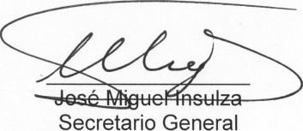
Secretary General
Original: Spanish

