CREATING A BRIGHTER FUTURE OF WORK, TOGETHER
Commemorating the First International Labour Conference and the Impact of the ILO
19 NOVEMBER 2019 • OAS Main Building, Washington, DC

The International Labour Organization (ILO), established in 1919 by signing of the Treaty of Versailles (Part XIII), held its first International Labour Conference (ILC) at the Pan American Union Building, now the Organization of American States (OAS), in Washington, D.C., from 29 October to 29 November 1919.

During its 100 years of existence, the ILO has laid the foundations for the modern world of work and promoted better lives for people everywhere through decent work. This event will commemorate ILO´s historic achievements and present its vision for a human-centered approach to the future of work.

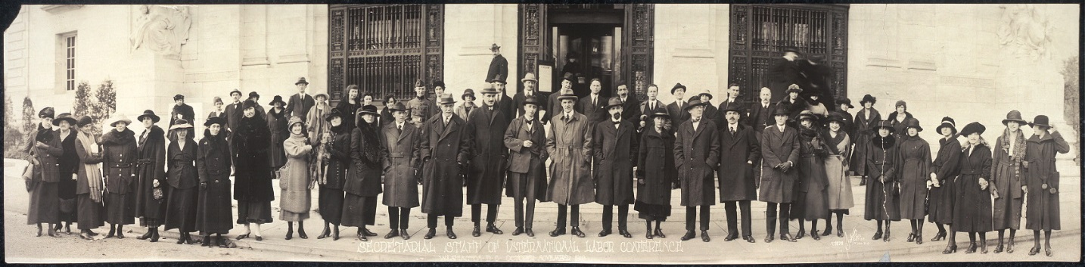
Secretariat staff of the 1st International Labour Conference: Secretary General: Mr. Harold B. Butler (Great Britain); Deputy Secretaries General: Mr. Ernest H. Greenwood (United States), Dr. Guido Pardo (Italy); Legal Adviser: Dr. Manley 0. Hudson (United States) with staff of the first International Labour Conference, in Washington, D.C., in 1919, in front of the Pan American Union, now Organization of American States Building.

REGISTRATION AND REFRESHMENTS (Gathering of invited guests) – HALL OF THE HEROES, OAS BUILDING

8:30am | Coffee and light breakfast
9:15am | Conclusion of Breakfast (move to Main entrance for commemorative photograph)
COMMEMORATIVE PHOTOGRAPH – MAIN ENTRANCE STEPS TO THE OAS BULDING

9:30am | Although the International Labour Organization (ILO) and the League of Nations were both established by the Treaty of Versailles, the ILO held it first Conference in October 1919 in the OAS building (then called the Pan American Union Building) before the League held its first council meeting in Paris in February 1920.  A famous photograph from October 1919 captured the ILO Secretary-General (Harold Butler), the U.S. delegation with the staff of the first International Labour Conference at the entrance to the building.  We seek to recapture that historic moment when the ILO became the first ever international organization to meet around internationally agreed tenants that shaped the modern world of work.
COMMEMORATIVE EVENT FOR ILO CENTENARY ANNIVERSARY
HALL OF THE AMERICAS – OAS BUILDING

10:00am | CALL TO ORDER AND WELCOME  Mr. Kevin Cassidy – Director and Representative to the Bretton Woods and Multilateral Organizations, ILO Office for the United States
10:05am | OPENING REMARKS  Mr. Luis Almagro – Secretary General, Organization of American States (OAS)
10:15am | A FUTURE-READY WORKFORCE FOR SUSTAINED ECONOMIC GROWTH  The Honorable Eugene Scalia – Secretary of Labor, U.S. Department of Labor
10:30am | THE IMPACT OF RIGHTS IN THE WORLD OF WORK  The Honorable Robert Destro – Assistant Secretary of State for Democracy, Human Rights, and Labor, U.S. Department of State
10:45am | CREATING A BRIGHTER FUTURE OF WORK, TOGETHER  Mr. Guy Ryder – Director-General, International Labour Organization
11:05am | DIALOGUE AND COOPERATION FOR DECENT WORK  Moderator: Tim Noah, Labor Policy Editor, Politico  - Minister Colin Jordan - Minister of Labour and Social Partnership Relations of Barbados and Chair of the Inter-American Conference of Ministers of Labor (IACML);  - Ms. Martha Newton - Deputy Undersecretary for International Affairs, U.S. Department of Labor;  - Mr. Richard Trumka – President, AFL-CIO;  - Mr. Peter Robinson – President, United States Council for International Business (USCIB);
12:15pm | OBSERVATIONS AND FEEDBACK  Mrs. Kim Osborne – Executive Secretary for Integral Development, Organization of American States (OAS)
12:25pm | CLOSING REMARKS  Mr. Kevin Cassidy – Director and Representative to the Bretton Woods and Multilateral Organizations, ILO Office for the United States
12:30pm | LUNCH RECEPTION – PATIO AZTECA, OAS BUILDING  OPENING OF PHOTO EXHIBIT: “DIGNITY AT WORK” – MARCUS GARVEY HALL OF CULTURE, OAS BUILDING
2:00pm | CLOSE OF COMMEMORATION

