NINTH REGULAR MEETING OF THE OEA/Ser.W/XIII.6.9
INTER-AMERICAN COMMITTEE ON EDUCATION CIDI/CIE/doc.13/21
November 18-19, 2021 15 November 2021
Washington, D.C., United States of America Original: Spanish
VIRTUAL

EXECUTIVE SUMMARY

Roundtable: Exchanges and Thoughts on the Return to In-person Education

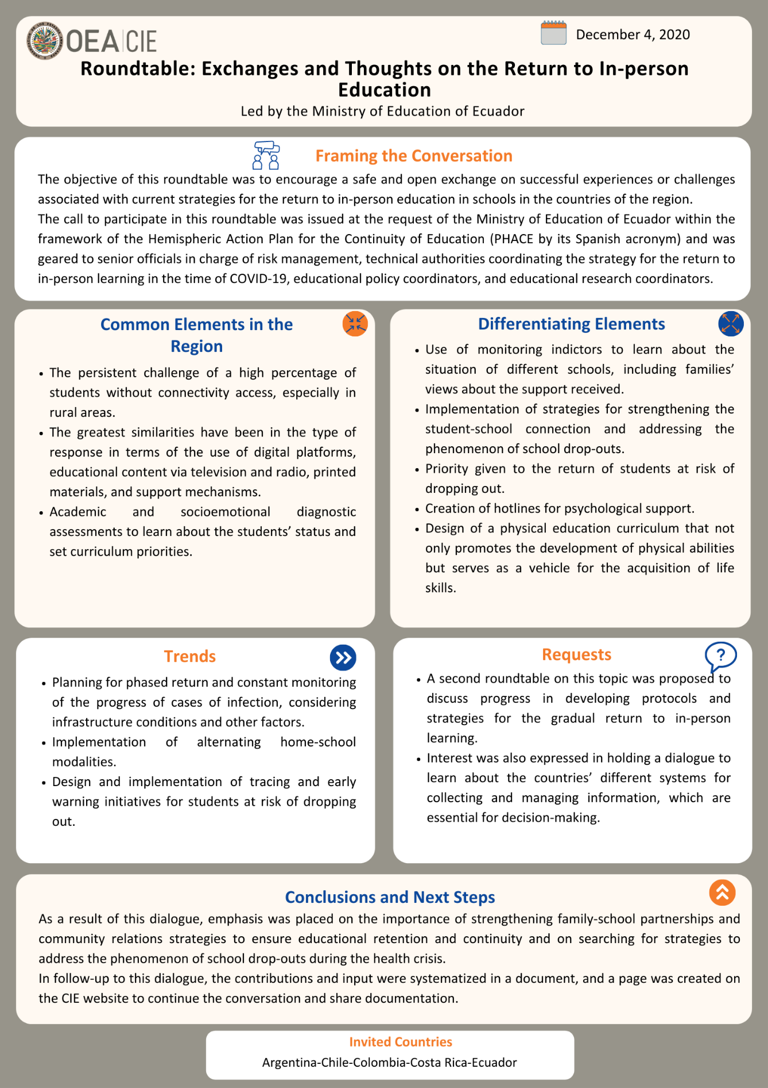

Access to the full document:
Spanish
English
CIDED00230E01

