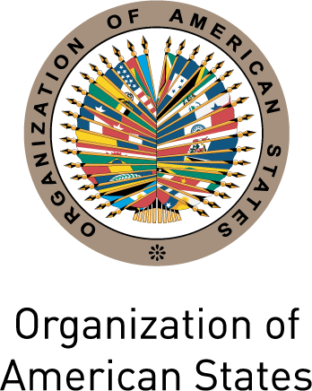
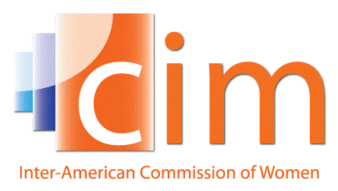

INTER-AMERICAN COMMISSION OF WOMEN

EXECUTIVE COMMITTEE 2013-2015 OEA/Ser.L/II.5.32
FIFTH REGULAR SESSION CIM/CD/doc.22/15 Rev.1
Washington, DC May 6th 2015
May 7th and 8th 2015 Original: Spanish

AGENDA

(Draft)

  - Adoption of the agenda
(CIM/CD/doc.22/15)

  - Adoption of the organization of work
(CIM/CD/doc.23/15)

  - Report of the President and the Executive Secretary of the CIM and budget execution through April 30th 2015
(CIM/CD/doc.24/15)

  - Report of the Technical Secretariat of the MESECVI and budget execution through April 30th 2015
(CIM/CD/doc.25/15)

  - Preparations for the XXXVII Assembly of Delegates of the CIM
(CIM/CD/doc.26/15, CIM/CD/doc.27/15)

  - Triennial Program of Work of the CIM 2016-2018
(CIM/CD/doc.28/15)

  - Violence against women in the realm of politics

  - Tools for monitoring women’s rights and evaluating the impact of gender policies: A working agenda

  - Adoption of agreements of the Fifth Regular Session of the CIM Executive Committee 2013-2015

  - Other matters

