
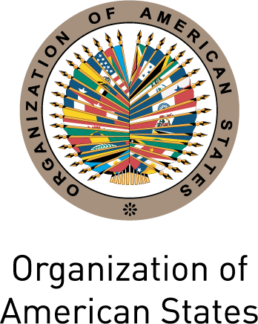

INTER-AMERICAN COMMISSION OF WOMEN

THIRTY-SIXTH ASSEMBLY OF DELEGATES OEA/Ser.L/II.2.36
October 29th to 30th 2012 CIM/doc.52/12
San José, Costa Rica January 9th 2013
Original: textual

NATIONAL REPORT: ANTIGUA AND BARBUDA

Item 4 on the agenda

National Report of the Government of Antigua and Barbuda: http://scm.oas.org/pdfs/2013/CIM03429.pdf
CIM03429T01

