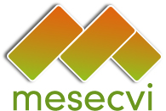 | 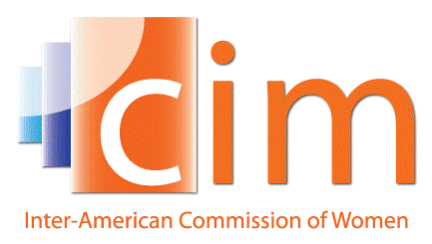 | 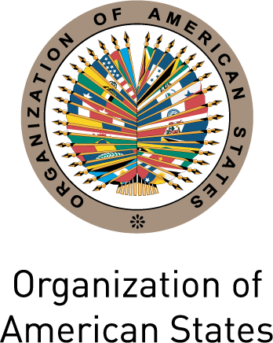 |  | 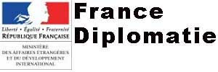

Violence, Health, and Sexual and Reproductive Rights

Friday, June 19th, 2015

8:30 am-2:00 pm

Hall of the Americas | Organization of American States
17th Street and Constitution Ave. NW, Washington, DC 20006

The violation of sexual and reproductive rights is a form of gender-based violence…these rights can be grossly violated in legislation that does not recognize or protect them, and women who are victims of multiple forms of discrimination have the least effective access to sexual and reproductive health services.

Committee of Experts of the MESECVI (2014)

Declaration on Violence against Women, Girls and Adolescents, and their Sexual and Reproductive Rights
The numerous forms of violence that are exercised against women pose an obstacle to their individual development, violate their rights and limit their freedoms. Violence against women blocks the full development of their capacities and autonomy, and limits their public, economic, social, and political participation. From sexual violence to domestic violence, violence against women is linked to sexual and reproductive health and rights. For instance, an estimated 1.68 million women in the Americas are raped each year, but only eight countries in the region allow abortion in cases of rape and two have a total ban on emergency contraception. In general, Latin American countries have some of the most restrictive reproductive health laws and policies in the world: from access to information to access to basic health services.
Building upon the Declaration on Violence against Women, Girls and Adolescents, and their Sexual and Reproductive Rights, adopted by CEVI, this event aims to position reproductive rights, particularly in the context of sexual violence and adolescent pregnancy, as a key priority among the region’s states. It will also be an opportunity for an in depth conversation on the relationship between violence against women and sexual and reproductive rights. During the event, the Centre for Reproductive Rights will disseminate the findings of its advocacy document, “Violence and Reproductive Rights in the Americas”.
Agenda

7:30-8:30 Breakfast and registration
8:30-9:00 Opening session
    - Karen Hanrahan, Chief Program Officer, Center for Reproductive Rights (CRR)
    - Francisco Becerra Posada, Assistant Director, Pan-American Health Organization (PAHO)
    - Jean-Claude Nolla, Ambassador and Permanent Observer of France to OAS
    - Luis Almagro Lemes, OAS Secretary General

9:00-10:30 Panel 1: Violence and Reproductive Rights

- Caroline Bettinger-López, White House Advisor on Violence against Women
- Gilda Rivera, Executive Coordinator of the Women's Rights Center in Honduras
- Diana González, Principal Expert of Uruguay to the Follow-up Mechanism to the Belém do Pará Convention (MESECVI)
- Alessandra Guedes, Regional Advisor on Family Violence, PAHO/WHO

Moderator: Luz Patricia Mejía, Technical Secretary of the MESECVI

10:45 – 12:30 Panel 2: Public Health and Reproductive Rights

- Leonel Briozzo, Regional Expert in women's health and sexual and reproductive rights and Professor, Faculty of Medicine, University of the Republic (Uruguay)
- Javier Vasquez, Advisor on Human Rights and Law, PAHO
- Ana Cristina González, Regional Expert on Health and Human Rights, Lead doctor, Global Doctors for Choice (Colombia)

Moderator: Mónica Arango, Regional Director for Latin America and the Caribbean, CRR

12:30-12:45 Closing
- Jacinth Lorna Henry-Martin, Chief of Staff of the OAS Secretary General
12:45 – 2:00 Lunch
To register visit:
https://www.eventbrite.com/e/symposium-on-violence-health-and-sexual-and-reproductive-rights-tickets-17306464100

The event will be live streamed at:
http://www.oas.org/en/media_center/webcast_schedule.asp

