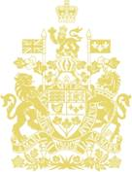  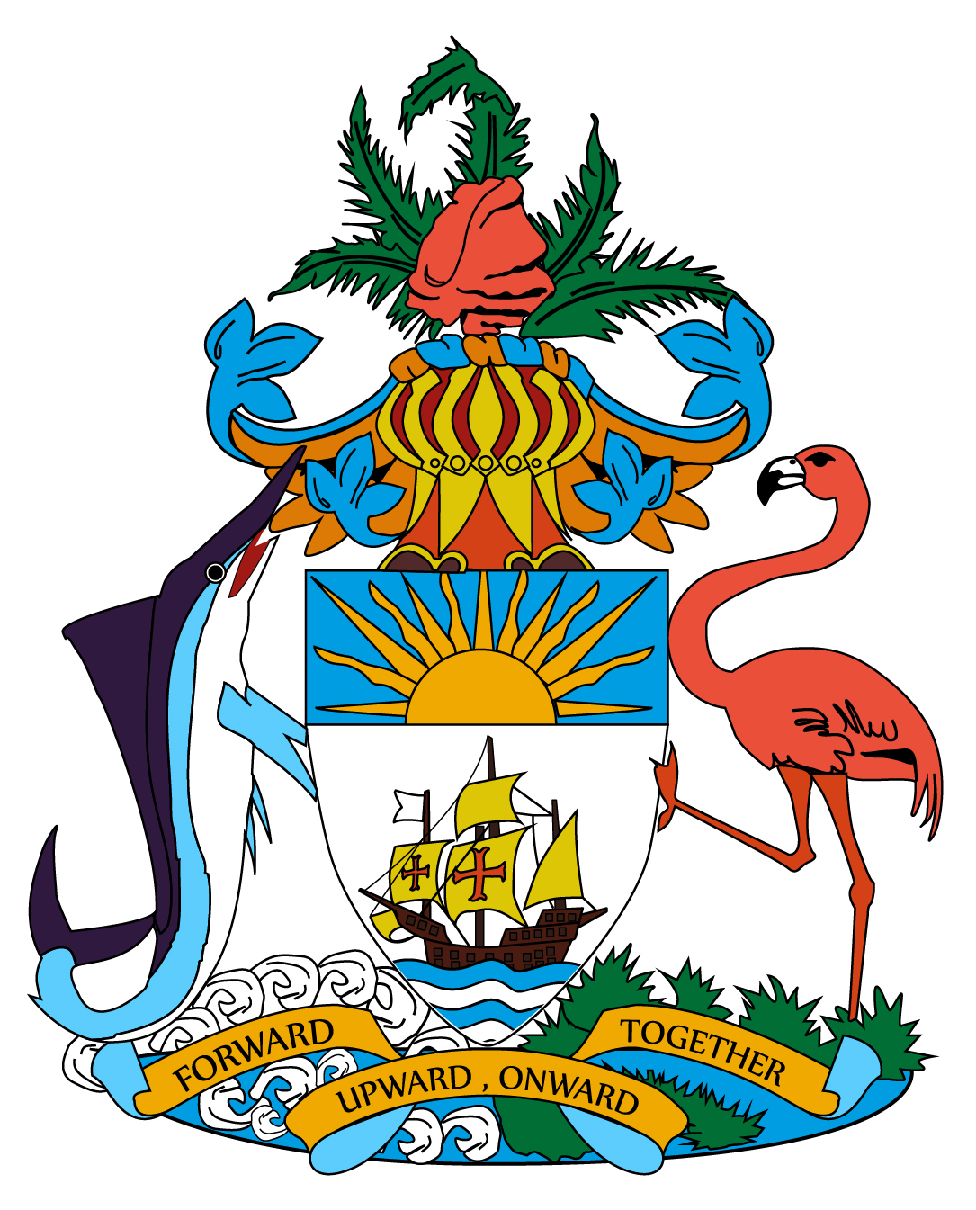  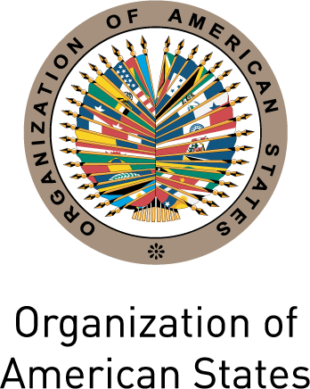  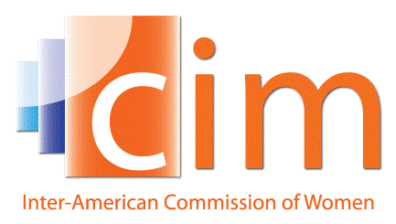 | In honour of International Women’s Day 2014  The Permanent Mission of Canada to the OAS,  The Permanent Mission of the Bahamas to the OAS, and  The Inter-American Commission of Women  are pleased to invite you to the screening of  “Womanish Ways”  a history of the women’s suffrage movement in the Bahamas  Followed by a conversation with the film’s director, Marion Bethel  March 11th 2014  6:00pm to 8:00pm  Theatre of the Embassy of Canada  501 Pennsylvania Avenue NW, Washington, DC 20001  Spaces are limited. Please bring government-issued ID and R.S.V.P. to daniele.dragon@international.gc.ca to reserve a space.

