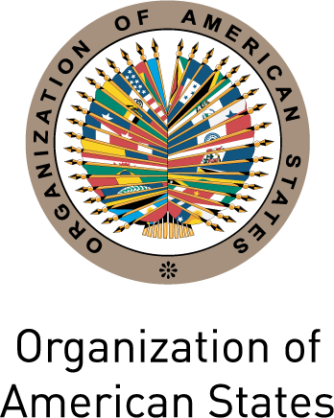
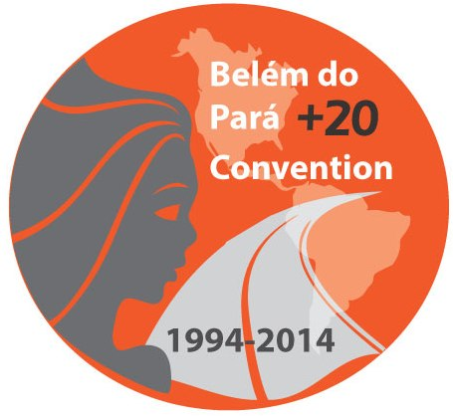
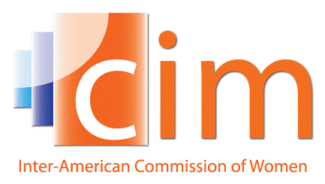

INTER-AMERICAN COMMISSION OF WOMEN

EXECUTIVE COMMITTEE 2013-2015 OEA/Ser.L/II.5.32
FOURTH REGULAR SESSION CIM/CD/doc.18/14
Mexico City October 1st 2014
October 24th 2014 Original: Spanish

AGENDA

(Draft)

  - Adoption of the agenda
(CIM/CD/doc.18/14)

  - Adoption of the organization of work
(CIM/CD/doc.19/14)

  - Report of the President and the Executive Secretary of the CIM and Budget execution through September 30th 2014
(CIM/CD/doc.20/14)

  - Integrated System of Indicators for Women’s Human Rights

  - Other matters
input.doc

