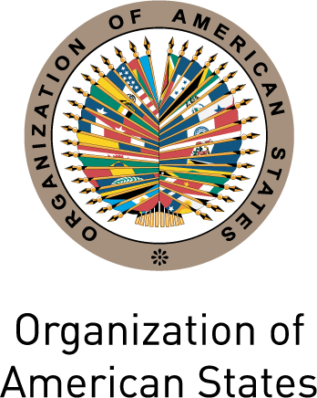
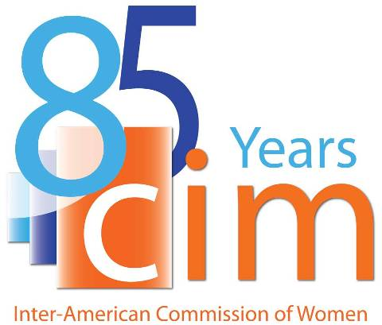

INTER-AMERICAN COMMISSION OF WOMEN

EXECUTIVE COMMITTEE 2013-2015 OEA/Ser.L/II.5.32
SECOND REGULAR SESSION CIM/CD/doc.12/13
Washington, D.C. November 20th 2013
November 20th 2013 Original: Spanish

AGREEMENTS ADOPTED BY THE SECOND REGULAR SESSION OF THE EXECUTIVE COMMITTEE OF THE CIM 2013-2015
input.doc

Agreement 1

In view of the current debates on the Strategic Vision of the OAS, the Executive Committee agrees:
- To transmit, through the President, a communication to the Chair of the Working Group on the Strategic Vision of the OAS in order to highlight the importance of the work of the CIM, as well as the need to assign regular human and financial resources;
- Request that the Secretariat keep the Delegates informed of the results of the work of this Group
- Request that this issue be included in the agenda of the next session of the Executive Committee of the CIM 2013-2015.

Agreement 2

In view of the advances of the CIM in the area of women’s political citizenship in the Americas, the Executive Committee agrees:
- To disseminate and promote the CIM studies on women’s political citizenship at the national level, including, as appropriate, through launch events; and
- Transmit to the Secretariat of the CIM concrete proposals for events to support the political participation, representation and leadership of women so that it may establish a calendar.

Agreement 3

In view of the draft Strategy for strengthening coordination between the CIM and civil society, contained in document CIM/CD/doc.6./13 rev.1, the Executive Committee agrees:
- To request that the Secretariat of the CIM incorporate the comments suggested by the Delegates and circulate a revised draft of the document for consideration during the next session of the CIM Executive Committee 2013-2015.

