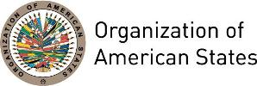

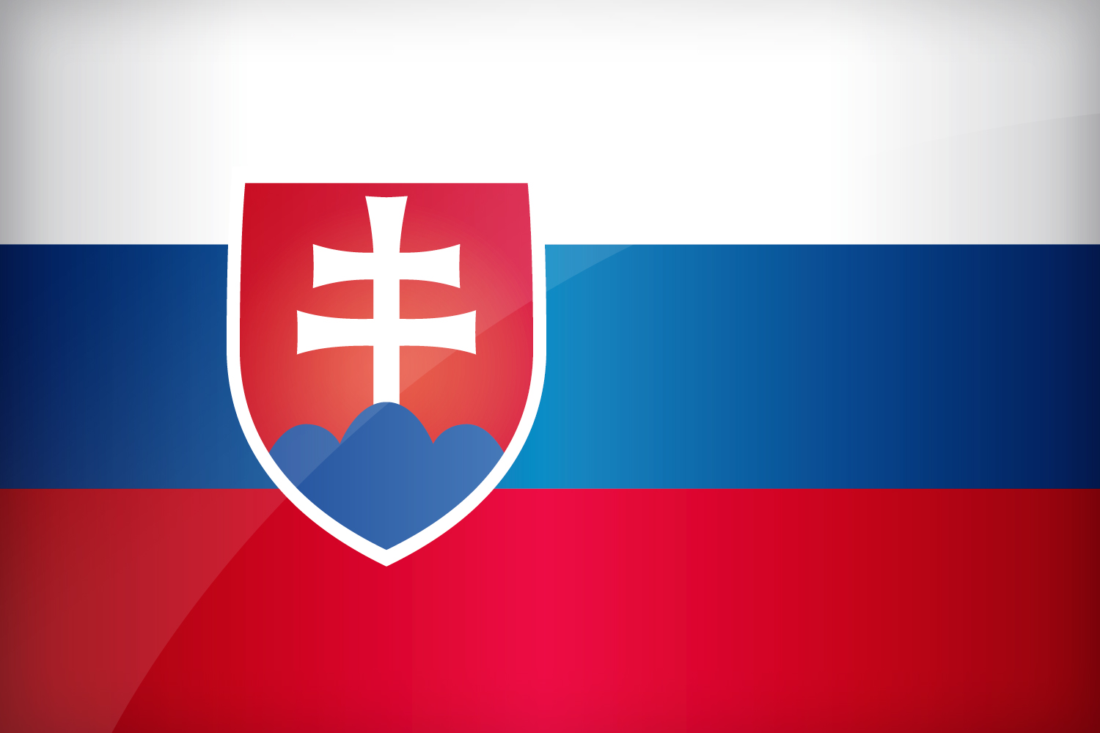
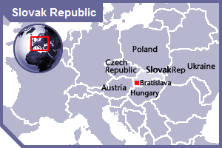

SLOVAK REPUBLIC
PERMANENT OBSERVER

Date of Entry: April 24, 2002
National Holiday: September 1
Capital: Bratislava
Type of Government: Parliamentary Democracy
Head of State: President Andrej Kiska (June 15, 2014)
Head of Government: Prime Minister Robert Fico (April 4, 2012)
Deputy Prime Minister and Minister of Foreign and European Affairs: Miroslav Lajcak (April 4, 2012)
Permanent Observer: Ambassador Ivan Korčok

ECONOMIC INDICATORS | 2010 | 2011 | 2012 | 2013 | 2014 | 2015 | 2016
Population (in millions) | 5.42 | 5.43 | 5.44 | 5.41 | 5.41 | 5.42 | 5.43
GDP (US$ in billions) | 87.2 | 87.1 | 93.41 | 98.48 | 100.77 | 87.28 | 89.5
GDP per capita (US$) | 23,347 | 18,187 | 17,274 | 18,191 | 18,595 | 16,089 | 16,495
Source: www.tradingeconomics.com World Bank

FOREIGN RELATIONS POLICIES:
- The Slovak foreign policy promotes and protects democratic values and principles, such as the right to life, personal freedom, and the preservation of human dignity, sustainable development and stability.
- Its foreign policy is based on a Manifesto of the Government of the Slovak Republic for the period of 2012-2016, and places great importance on its membership in the European Union for its political, economic and social development, as well as in the North Atlantic Treaty Organization (NATO) for national security.
- Foreign policy priorities are based on 21st century challenges, including:
  - Trusted and respected Slovakia in Europe;
  - Stable and reliable partner of NATO as a safety guarantee in SR;
  - Development of bilateral relations with the member states of EU and NATO, and Specially structured and equivalent relationship with the neighbors;
  - Support the area of stability, democracy and partnership with emphasis on the states of the Western Balkans and the eastern partnership;
  - Support of economic interests, investment, innovations and energy security;
  - Responsible approach to global challenges, using the potential of international organizations;
  - Help and protection of Slovak citizens abroad;
  - Respect and fostering of law binding force on international level and institutions,
  - Its enforcement as the key tool to protect the state´s sovereignty.
- Bilateral relations remain one of the primary Slovak foreign policy instruments, based on the principles of democracy, rule of law, universality and indivisibility of human rights and fundamental freedoms while respecting human dignity, equality and solidarity, international law and the United Nations Charter.
- Emphasis will be given to strengthening bilateral relations with EU and NATO member states.
- The Slovak Republic seeks to expand its economic cooperation with the BRICS countries (Brazil, Russia, India, China and South Africa), as well as other key partners, including Australia, Japan, South Korea, and others in the Arab world, Asia, Africa and Latin America.
- The Slovak Republic is a member of multiple international organizations and believes in actively participating in multilateral cooperation to address global threats and challenges to socio-economic stability, peace and security. It is an active member of the United Nations, Organization for Security and Cooperation in Europe (OSCE), Council of Europe, Organization for Economic Cooperation and Development (OECD), World Trade Organization, Food and Agriculture Organization and the International Labor Organization.

INVOLVEMENT WITH THE AMERICAS:
- The Slovak Republic has diplomatic relations with all countries in Latin American and the Caribbean, and has embassies in Brazil, Argentina, Canada, Cuba, Mexico, and the United States of America.

SOURCES:
GOVERNMENT OFFICE OF THE SLOVAK REPUBLIC  http://www.vlada.gov.sk/  PRESIDENCY OF THE SLOVAK REPUBLIC  https://www.prezident.sk/?introduction  MINISTRY OF FOREIGN AFFAIRS, SLOVAKIA  http://www.mzv.sk | EMBASSY OF THE SLOVAK REPUBLIC, WASHINGTON DC  http://www.mzv.sk/App/WCM/ZU/WashingtonZU/main.nsf/vw_ByID/index_EN  WORLD BANK – TRADING ECONOMICS  www.tradingeconomics.com

This page was last updated on July 7, 2017.

