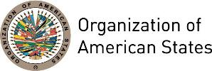

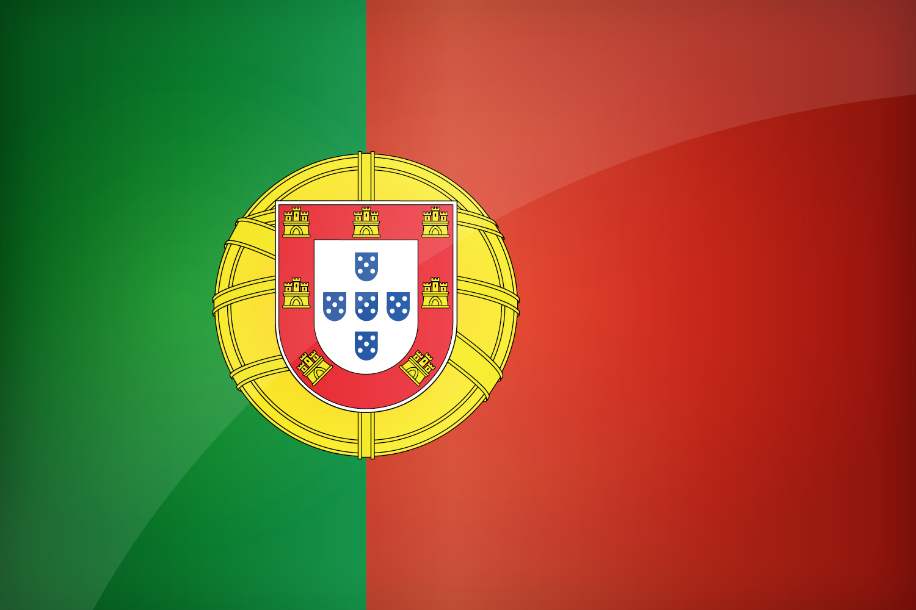
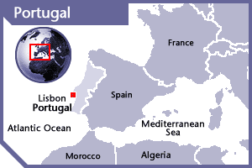

PORTUGAL
PERMANENT OBSERVER

Date of Entry: March 26, 1975
National Holiday: June 10
Capital: Lisbon
Type of Government: Republic, Parliamentary Democracy
Chief of State: President Marcelo Rebelo de Sousa (March 9, 2021)
Head of Government: Prime Minister António Costa (October 26, 2019)
Minister of State and Foreign Affairs: Augusto Santos Silva (October 26, 2019)
Permanent Observer: Ambassador Francisco Duarte Lopes (April 2022)

FOREIGN RELATIONS POLICIES:
- The Ministry of Foreign Affairs implements foreign policy, development cooperation policy and the policy for connecting Portugal to the Portuguese communities around the world. It is also responsible for coordinating the other ministries' external actions.
- The European Union (EU) is at the heart of Portuguese foreign and economic policies. Portugal has held the rotating six-monthly Presidency of the European Council on four occasions: in 1992, 2000, 2007, and in the first half of 2021.
- Portugal belongs to a number of international organizations, including the United Nations, Euro-Atlantic Partnership Council, Organization for Security and Cooperation in Europe, Organization for Economic Cooperation and Development, International Monetary Fund, World Bank, World Trade Organization, and Community of Portuguese Language Countries.
- Portugal became a charter member of the North Atlantic Treaty Organization (NATO) in 1949; it is an active member of the Alliance, and Portuguese forces participate in NATO operations in Afghanistan, Romania, Iraq, and in maritime operations in the Atlantic and the Mediterranean.
- At a European Union level, Portugal participates in EU civil missions in Georgia, Mali, Niger, Somalia, Ukraine and Central African Republic, and in EU military missions in Somalia, Mali, Central African Republic and in the Mediterranean.
- At a UN level, Portugal participates in MINUSMA (Mali), MINUSCA (Central African Republic) and UNVMC (Colombia).

PORTUGUESE DEVELOPMENT COOPERATION:
- The Portuguese development cooperation policy is a key vector of Portugal’s foreign policy, building on a broad national consensus between major political forces and civil society. It aims at eradicating poverty and ensuring the sustainable development of partner countries, advocating at the same time for the full respect of human rights, democracy and rule of law.
- For Portugal, cooperation is perceived rather as an investment than a mere financial expenditure; and as development promotion rather than mere aid. This nexus has the logical and causal effect of complementing, strengthening and mutually benefiting other aspects of foreign policy, such as economic diplomacy and external cultural action.
- The key areas of Portuguese development assistance are sustainable development, human development, including capacity building in education and health, rural development, environment and sustainable use of natural resources, economic growth, and private sector development. Cross-sectorial priorities include good governance, rule of law, democracy and gender equality.
- With these goals in mind, Portuguese cooperation policy works proactively in engaging with civil society, the private sector, and other bilateral donors and multilateral organizations, in order to achieve maximum consensus and effectiveness of its policies.
- Geographically, Portuguese development assistance focuses on Portuguese speaking countries in Africa (Angola, Cape Verde, Guinea-Bissau, Mozambique and São Tomé e Príncipe), East Timor in Asia, and other partner countries with which Portugal has tight historical bonds.
- In fostering complementarity between Portugal’s bilateral and multilateral development action, priority is given to entities that work towards poverty reduction, in particularly in Least Developed Countries (LDCs) and Fragile States. For example, Portugal not only actively participates in the implementation of some of European Commission’s (EC) programs and projects, but is also involved in other multilateral development programs, such as UNDP projects and relevant UN agencies, funds and programs.
- Portugal is also increasingly investing in the development of triangular development cooperation, where it is partnering mainly with countries from the Southern hemisphere, in particular from Latin America, in the implementation of projects in the priority countries already mentioned.

CAMÕES – COOPERATION AND LANGUAGE INSTITUTE
- Camões – Cooperation and Language Institute is a public institute, integrated in the indirect administration of the State, whose mission is to coordinate Portugal’s foreign policy in both Portuguese language and culture promotion and international cooperation.
- Concerning international cooperation, Camões, I.P. is responsible for the coordination and supervision of all Portuguese development cooperation activities developed by different line ministries and public entities. Furthermore, it guarantees national representation and participation in the activities carried out by the main international organizations that concur to the promotion of cooperation and development aid.
- To this purpose, Camões, I.P. promotes, finances, co-finances, and implements development cooperation programs and projects in several partner countries, with special focus on African Portuguese-speaking countries and Timor-Leste. These activities target areas, such as education, health, social affairs, justice, security, finance, or environment.

INVOLVEMENT WITH THE AMERICAS:
- Portugal has historically good ties with the Latin American nations, particularly Brazil. Portugal has also given close attention to its relations with Venezuela, which has a community of about 450,000 Portuguese working primarily in the trade and services sectors. The country maintains diplomatic relations with all Latin American and Caribbean countries.
- Portugal is a member of the Ibero-american Conference. It provides for close political interaction with all Latin American countries.
- Portugal maintains embassies in 12 countries of the Americas: Argentina, Brazil, Canada, Chile, Colombia, Cuba, Mexico, Panama, Peru, United States of America, Uruguay and Venezuela.

CASH CONTRIBUTIONS 2007-2019:

YEAR | PORTUGAL | P.O. FINANCIAL CONTRIBUTIONS | %
2007 | $18,200.00 | $20,398,686.00 | 0.09%
2008 | - | $22,684,500.00 | 0.00%
2009 | - | $20,318,115.00 | 0.00%
2010 | - | $15,781,991.00 | 0.00%
2011 | $5,000.00 | $15,692,757.00 | 0.03%
2012 | - | $13,239,105.00 | 0.00%
2013 | - | $16,926,686.00 | 0.00%
2014 | - | $10,999,882.00 | 0.00%
2015 | - | $17,489,205.00 | 0.00%
2016 | - | $13,886,256.00 | 0.00%
2017 | $55,000.00 | $14,586,712.00 | 0.38%
2018 | $11,391.00 | $16,135,361.00 | 0.07%
2019 | - | $21,072,075.00 | 0.00%
2020 | - | $15,637,009.00 | 0.00%
2021 | - | $14,396,171.00 | 0.00%
2022 | $66,924.00 | $3,064,493.00* | 2.18%
Total US$ | $156,515.00 | $252,309,004.00 | 0.06%

* The amount includes contributions from January 01 to April 30, 2022.

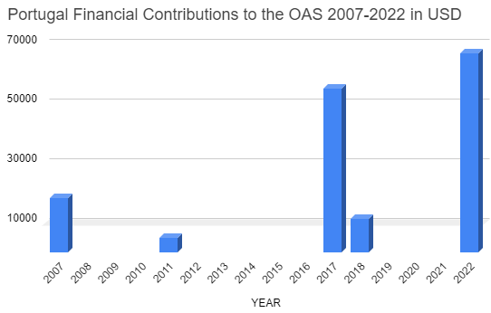

PORTUGAL CONTRIBUTIONS:
YEAR | PROJECTS | FINANCIAL CONTRIBUTIONS  IN US$ | IN-KIND CONTRIBUTIONS  IN US$
2007 | AP-Seminar OAS-African Union (Bridging Democracy Project). | $18,200.00
SUBTOTAL |  | $18,200.00
2011 | Secretariat for Political Affairs / Department for Electoral Cooperation and Observation – OAS Electoral Observation Mission to Observe the Second Round of the Presidential and Legislative Elections in Haiti | $5,000.00
SUBTOTAL |  | $5,000.00
2017 | Department of Sustainable Development (74I) Bridging Project DSD / UNEP | $35,000.00
2017 | Department of Effective Public Management (94B)  Strng Civ Reg Id Proc Colombia | $20,000.00
SUBTOTAL |  | $55,000.00
2018 | Department of Electoral Cooperation and Observation (64C)  EOM 2018 Brazil | $11,391.00
SUBTOTAL |  | $11,391.00
2022 | Department of Social Inclusion  Comprehensive Regional Protection and Solutions Framework MIRPS | $55,780.00
2022 | Secretariat of the Inter‐American Commission of Women (CIM)  Democracy and Leadership | $11,144.00
SUBTOTAL |  | $66,924.00
TOTAL |  | $156,515.00

SOURCES:
PRESIDENCY OF THE PORTUGUESE REPUBLIC  http://www.presidencia.pt/?idl=2  PORTUGUESE REPUBLIC GOVERNMENT  https://www.portugal.gov.pt/en/gc22  CAMÕES – COOPERATION AND LANGUAGE INSTITUTE  http://www.instituto-camoes.pt/ | EMBASSY OF PORTUGAL, WASHINGTON DC  https://washingtondc.embaixadaportugal.mne.gov.pt/pt/  WORLD BANK  https://data.worldbank.org/  OAS FINANCIAL REPORTS  http://www.oas.org/saf/dfams/previous.asp

This page was last updated on June 2022.

