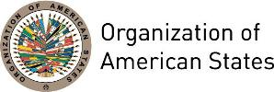

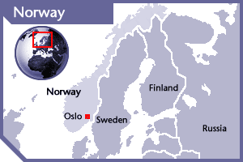
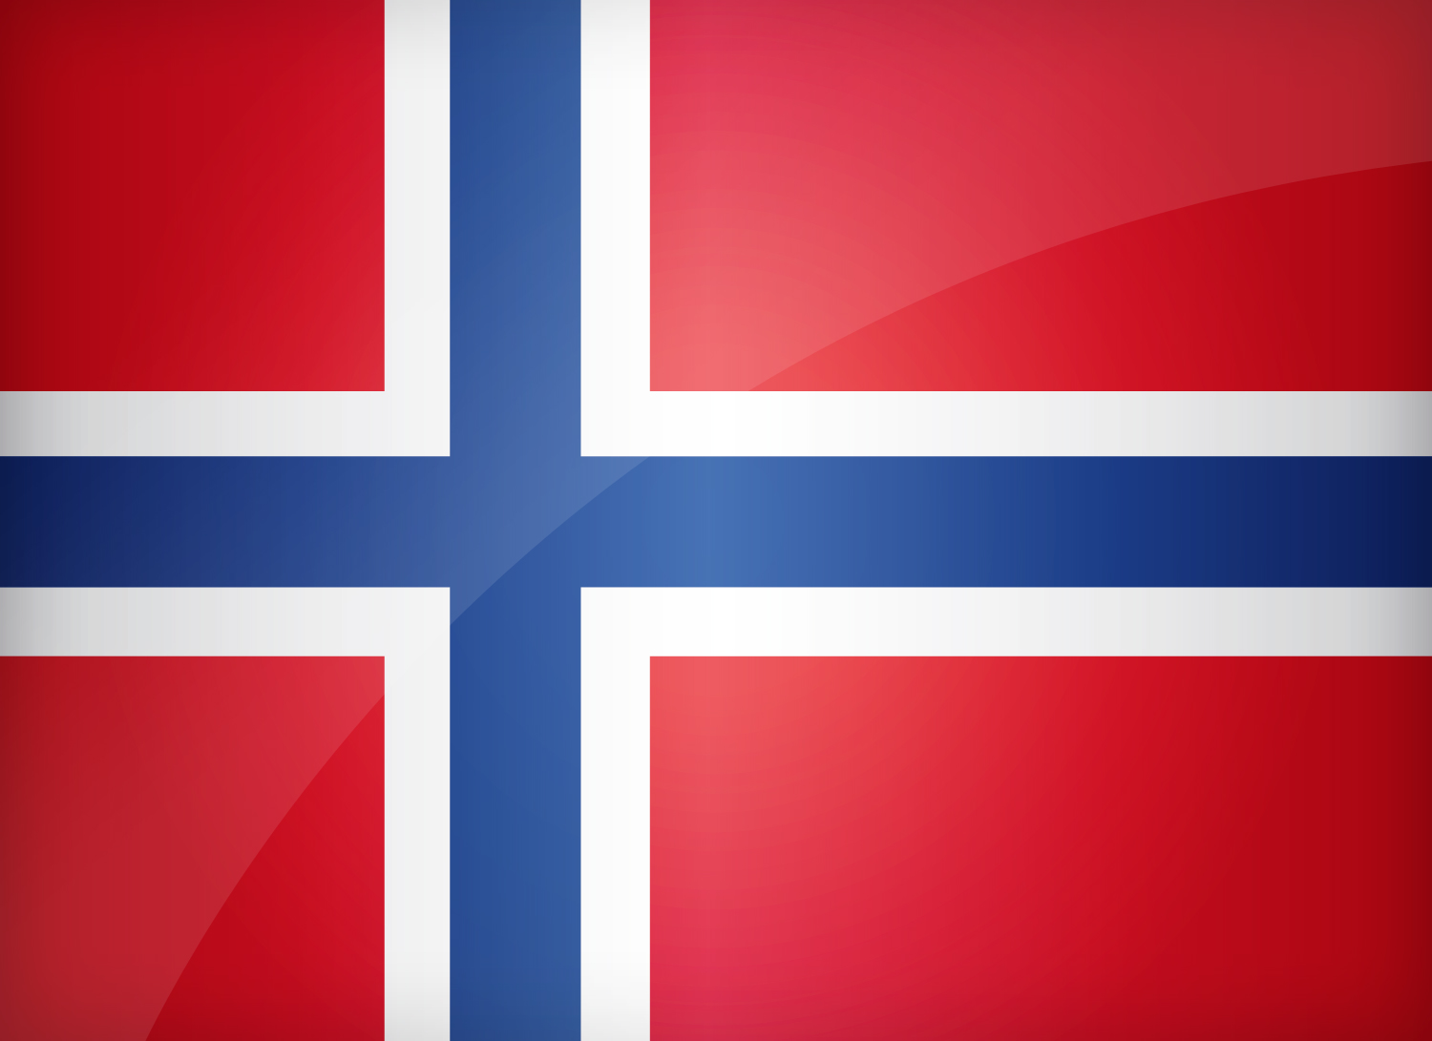

NORWAY
PERMANENT OBSERVER

Date of Entry: November 8, 2000
National Holiday: May 17
Capital: Oslo
Type of Government: Constitutional Monarchy
Chief of State: H. M. King Harald V of Norway (January 17, 1991)
Head of Government: Prime Minister Erna Solberg (October 14, 2013)
Minister of Foreign Affairs: Ine Eriksen Soreide (October 20, 2017)
Permanent Observer: Ambassador Anniken Ramberg Krutnes (September 17, 2020)

ECONOMIC INDICATORS | 2010 | 2011 | 2012 | 2013 | 2014 | 2015 | 2016 | 2017 | 2018 | 2019
Population  (in millions) | 4.89 | 4.95 | 5.02 | 5.08 | 5.14 | 5.20 | 5.23 | 5.27 | 5.31 | 5.34
GDP  (US$ in billions) | 428.525 | 498.157 | 509.705 | 522.746 | 498.34 | 388.315 | 370.55 | 398.39 | 434.16 | 403.33
GDP per capita (US$) | 87,646.3 | 100,575.1 | 101,563.7 | 102,910.4 | 97,429.7 | 74,505.6 | 70,812 | 75,496.75 | 81,734.46 | 75,419.63
Source: www.tradingeconomics.com | The World Bank Group

FOREIGN RELATIONS POLICIES:
- The essential task of the Norwegian foreign policy is to work for Norway’s interests internationally: to safeguard the country’s freedom, security and prosperity. Norway’s interests are determined by such factors as its geographical location in a strategically important area, its open economy, its position as a coastal state and steward of substantial marine resources, and its extensive exports of oil and gas.
- The Ministry of Foreign Affairs of Norway also works to promote peace and security, an international legal system, an economically just world order and sustainable development.
- Bilateral relations are of great importance to achieve the main goals of Norwegian foreign policy, especially those related to the member countries of the European Union (EU) as well as the Nordic countries.
- Norway has played a leading role in promoting gender equality, sexual and reproductive health, and human rights for sexual orientation and gender identity on the international agenda.
- In carrying out its foreign policy, Norway participates actively in many International Organizations such as the United Nations (UN), the Artic Council; the North Atlantic Treaty Organization, the Euro-Atlantic Partnership Council, the Organization for Security and Cooperation in Europe, the Organization for Economic Cooperation and Development, the International Monetary Fund, the World Bank, and World Trade Organization among many others.

DEVELOPMENT COOPERATION:
- The objective of Norway’s development policy is to fight poverty and bring about social justice. The Government has achieved its target of allocating 1% of gross national income (GNI) to international development.
- Norway’s development policy is designed to promote economic development, democratization, implementation of human rights, good governance and measures that can lift people out of poverty for good. Priority is given to education, humanitarian assistance, health and vaccination, private sector development, climate change adaptation and mitigation, and human rights.

NORWEGIAN AGENCY FOR DEVELOPMENT COOPERATION (NORAD):
- The Norwegian Agency for Development Cooperation is a specialized directorate under the Ministry of Foreign Affairs.
- Norad assures the quality of Norwegian development assistance by means of: technical advisory services, quality assurance, grant administration, communication, and evaluation.
- The majority of Norwegian development assistance is administered by the Ministry of Foreign Affairs and Norwegian foreign missions. In the case of aid funds that are not administered by Norad, the agency provides advice on what is required to achieve results, communicates results and contributes to debate on the effects of development assistance.
- The following are Norad’s main tasks in International Development Cooperation for the period up to 2015:
- Help to empower recipient countries to achieve their own development goals
- Concentrate most resources on following up on the main priority areas of Norwegian development policy
- Help to promote a focus on and communicate the results of Norwegian development assistance activities
- Produce and apply knowledge of what works and what doesn’t in order to improve development assistance
- Be an instigator of public debate on development assistance and development
- Develop expertise, working methods and leadership that enable Norad to solve complex tasks effectively
- In 2013, Norway contributed approximately $4.2 billion (32.8 billion NOK) in aid internationally, of which 14.5% was allocated to Latin America, with the majority directed to Brazil.
- Development Aid in 2013 focused on the following sectors in the Americas: economic development and trade, good governance, health and social services, education and environment and energy

INVOLVEMENT WITH THE AMERICAS:
- Norway maintains diplomatic relations with all OAS Members States and has established embassies in Argentina, Brazil, Canada, Chile, Colombia, Cuba, Mexico, and the United States of America.
- In Central America, Norway's assistance to the Center for Justice and International Law (CEJIL) was extended in May 2013 for another three years and the organization is continuing its efforts to provide training to human rights organizations in Central America to enable them to bring their cases before the Inter-American Human Rights System, organize seminars and spread information material. In 2012 CEJIL set a greater focus on women's rights, and it has also begun work within the rights of the indigenous people.

COOPERATION AGREEMENTS WITH OAS:
- In March 2012, the Norwegian Ministry of Foreign Affairs, through its Embassy in Guatemala, signed a contract with the Inter-American Institute of Human Rights (IIDH) to provide up to NOK 18 million (approximately US$2.8 million) to support the Strategic Plan 2012-2014: “Human Rights Education as a Key to the Democratic Future”, which seeks to promote human rights education; strengthen access to justice and citizen security, especially for women and indigenous populations; impulse democracies with more participation and inclusion of vulnerable populations; promote the respect for and guarantee of social, economic and culture rights; and strengthen the capacity of the IIDH to implement its institutional Strategic Plan 2012-2014 in the region.
- On November 22, 2012, the Inter-American Court of Human Rights and the Norwegian Ministry of Foreign Affairs, through its Embassy in Guatemala, signed an agreement in which Norway will make a grant of up to NOK 14,100,000 (approximately US$2.2 million)

CASH CONTRIBUTIONS 2000-2020:

YEAR | NORWAY | P.O. FINANCIAL CONTRIBUTIONS | %
2000 | $294,396.00 | $9,515,678.00 | 3.09%
2001 | $1,662,000.00 | $6,923,000.00 | 24.01%
2002 | $2,443,679.00 | $8,460,084.00 | 28.88%
2003 | $1,866,488.00 | $12,125,944.00 | 15.39%
2004 | $2,550,263.00 | $11,908,651.00 | 21.42%
2005 | $2,112,651.00 | $11,650,039.00 | 18.13%
2006 | $1,765,092.00 | $19,060,470.00 | 9.26%
2007 | $1,659,517.00 | $20,398,686.00 | 8.14%
2008 | $733,659.00 | $22,684,500.00 | 3.23%
2009 | $356,985.00 | $20,318,115.00 | 1.76%
2010 | $1,222,660.00 | $15,781,991.00 | 7.75%
2011 | $643,056.00 | $15,692,757.00 | 4.10%
2012 | $605,817.00 | $13,239,105.00 | 4.58%
2013 |  | $16,926,686.00 | 0.00%
2014 | $2,587,749.19 | $10,999,882.00 | 23.53%
2015 |  | $17,489,205.00 | 0.00%
2016 |  | $14,048,254.00 | 0.00%
2017 |  | $14,587,212.00 | 0.00%
2018 | $114,111.00 | $16,135,360.00 | 0.70%
2019 | $501,143.00 | $21,072,075.00 | 2.37%
2020 | $185,878.00 | $15,637,009.00 | 1.2%
Total US$ | $21,305,144.19 | $265,721,346.00 | 8.00%

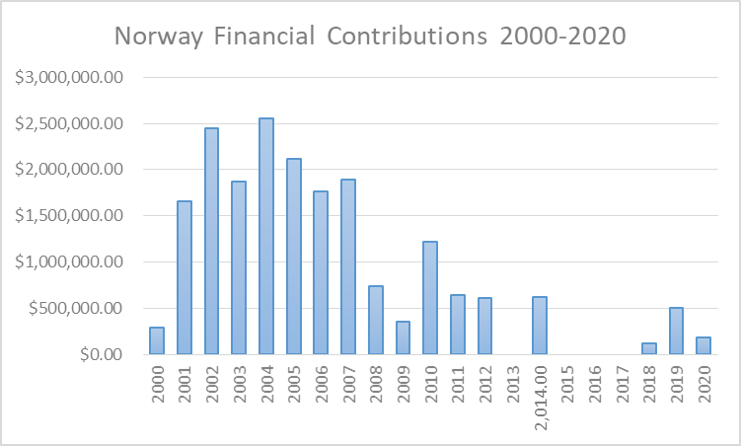

NORWAY CONTRIBUTIONS TO OAS PROGRAMS:
YEAR | PROJECTS | FINANCIAL CONTRIBUTIONS  IN US$ | IN-KIND CONTRIBUTIONS  IN US$
1999 | Unit for the Promotion of Democracy (UPD) | $1,687,166.00
SUBTOTAL |  | $1,687,166.00
2000 | Unit for the Promotion of Democracy (UPD) | $294,396.00
SUBTOTAL |  | $294,396.00
2001 | Unit for the Promotion of Democracy (UPD)- Electoral observation mission, Nicaragua | $40,000.00
2001 | Unit for the Promotion of Democracy (UPD)- Electoral observation mission, Peru | $25,000.00
2001 | Unit for the Promotion of Democracy (UPD)- PROPAZ II | $167,000.00
2001 | Unit for the Promotion of Democracy (UPD)- Policy management, Guatemala | $274,000.00
2001 | Unit for the Promotion of Democracy (UPD)- Demining Project | $1,156,000.00
SUBTOTAL |  | $1,662,000.00
2002 | Unit for the Promotion of Democracy (UPD)- Technical Assistance Plan Guatemala | $412,221.00
2002 | Unit for the Promotion of Democracy (UPD)- EOM Nicaragua 2002 | $9,895.00
2002 | Unit for the Promotion of Democracy (UPD)- PROPAZ Foundation | $134,588.00
2002 | Unit for the Promotion of Democracy (UPD)- Central American Program | $273,081.00
2002 | Unit for the Promotion of Democracy (UPD)- Political Management Guatemala | $457,917.00
2002 | Unit for the Promotion of Democracy (UPD)- Demining Program | $1,045,072.00
2002 | Peace Fund- General Fund | $52,539.00
2002 | Special Mission in Haiti | $58,366.00
SUBTOTAL |  | $2,443,679.00
2003 | Unit for the Promotion of Democracy (UPD)- Elections 2003, Guatemala | $433,860.00
2003 | Unit for the Promotion of Democracy (UPD)- EOM Guatemala 2003 | $69,371.00
2003 | Unit for the Promotion of Democracy (UPD)- Political Management Guatemala | $546,443.00
2003 | Unit for the Promotion of Democracy (UPD)- Demining Program | $670,558.00
2003 | Special Mission in Haiti | $146,256.00
SUBTOTAL |  | $1,866,488.00
2004 | Inter-American Children’s Institute (IIN) - Family and Rights book | $3,000.00
2004 | Unit for the Promotion of Democracy (UPD)- Demining program | $1,262,802.00
2004 | Department of Democratic and Political Affairs (DDPA) | $1,284,461.00
SUBTOTAL |  | $2,550,263.00
2005 | Office of Summit Follow-up- Declaration on the Rights of Indigenous Peoples | $39,749.00
2005 | Department of Democratic and Political Affairs (DDPA)- Conflict Resolution Program Guatemala | $542,205.00
2005 | Department of Democratic and Political Affairs (DDPA)- Electoral Observation Mission Venezuela 2005 | $107,159.00
2005 | Department of Democratic and Political Affairs (DDPA)- Political Management Guatemala | $542,081.00
2005 | Department of Democratic and Political Affairs (DDPA)- Special Mission Strengthening Democracy in Haiti | $157,376.00
2005 | Department of Multidimensional Security (DMS)- Demining AICMA/PADCA NI F04 | $506,969.00
2005 | Department of Multidimensional Security (DMS)- Demining PADCA Guatemala | $214,136.00
2005 | Executive Secretariat for Integral Development (SEDI)- Special Ports Program | $976.00
2005 | Inter-American Children’s Institute (IIN) - Children’s Rights Video | $2,000.00
SUBTOTAL |  | $2,112,651.00
2006 | Department of Democratic Sustainability and Special Missions (DSDSM) - Mission to Support the Peace Process in Colombia (MAPP) | $301,643.00
2006 | Secretariat for Political Affairs (SPA) - Crisis Prevention and Specialized Missions | $267,320.00
2006 | Secretariat for Political Affairs (SPA) - Promotion of Democracy Guatemala | $504,771.00
2006 | Secretariat for Political Affairs (SPA) - Promotion of Democracy MOE 2006 Nicaragua | $30,460.00
2006 | Secretariat for Political Affairs (SPA) - Promotion of Democracy MOE 2006 Peru | $18,602.00
2006 | Secretariat for Political Affairs (SPA) - Promotion of Democracy MOE 2006 Regional Peru | $3,398.00
2006 | Secretariat for Multidimensional Security (SMS)- Department of Prevention of Threats against Public Security - Demining programs | $638,898.00
SUBTOTAL |  | $1,765,092.00
2007 | Secretariat for Multidimensional Security (SMS) - Demining | $785,792.00
2007 | Department for the Prevention of Threats against Public Security – AICMA/Mine Victim Assist. Program | $100,000.00
2007 | Department for the Prevention of Threats against Public Security – AICMA/PADCA-NI-FO4 | $685,792.00
2007 | Secretariat for Political Affairs (SPA) – Electoral Observation Mission Guatemala | $159,753.00
2007 | Secretariat for Political Affairs (SPA) – Electoral Observation Mission Colombia | $105,967.00
2007 | Secretariat for Political Affairs (SPA) – Electoral Observation Mission Ecuador | $19,480.00
2007 | Secretariat for Political Affairs (SPA) – International Forensic Commission | $52,480.00
2007 | Secretariat for Political Affairs (SPA) – Conflict Resolution Guatemala | $21,271.00
2007 | Secretariat for Political Affairs (SPA) – Democratic Values and Good Governance Guatemala | $514,774.00
SUBTOTAL |  | $1,659,517.00
2008 | Support to Ecuador Mine Clearance Operations | $300,000.00
2008 | Nicaragua Mine Clearance Operations | $406,550.00
2008 | OAS Electoral Observation Mission (OAS/EOM) Recall Referendum in Bolivia | $22,147.00
 | Unprogrammed Funds | $4,962.00
SUBTOTAL |  | $733,659.00
2009 | Department of Public Security (DPS) - Demining Assistance Program in Nicaragua | $160,643.00
2009 | Department of Public Security (DPS) - Demining Assistance Program in Ecuador-Peru | $196,342.00
SUBTOTAL |  | $356,985.00
2010 | Demining Programs in Nicaragua, Ecuador and Peru | $148,444.00
2010 | Demining Programs in Nicaragua, Ecuador and Peru | $121,454.00
2010 | Demining Programs in Nicaragua, Ecuador and Peru | $603,076.00
2010 | Department of Electoral Cooperation and Observation (DECO) - Mission to Haiti | $167,128.00
2010 | Department of Electoral Cooperation and Observation (DECO) - Electoral Observation Mission to Haiti - Second Round | $168,764.00
2010 | Department of Electoral Cooperation and Observation (DECO) - Electoral Observation Mission to Colombia | $8,799.00
2010 | Department of Electoral Cooperation and Observation (DECO) - Electoral Observation Mission to Colombia | $4,995.00
SUBTOTAL |  | $1,222,660.00
2011 | Secretariat for Political Affairs / Department for Electoral Cooperation and Observation – EOM Unprogrammed | $18,584.00
2011 | Secretariat for Multidimensional Security / Department of Public Security - Demining | $624,472.00
SUBTOTAL |  | $643,056.00
2012 | Secretariat for Multidimensional Security / Ecuador & Peru Humanitarian Demining in the Cordillera del Condor Border Region | $605,817.00
SUBTOTAL |  | $605,817.00
2014 | Inter-American Human Rights Institute (IIDH) - Strengthening the Judicial Capacities of the Inter-American Court of Human Rights and the Dissemination of its Work 2013-2015 | $757,462.00
2014 | Inter-American Court of Human Rights - Strengthening the Judicial Capacities of the Inter-American Court of Human Rights and Diffusion of its Work | $1,211,945.87
2014 | Inter-American Commission on Human Rights (IACHR) | $540,756.32
2014 | Secretariat for Political Affairs / Department for Electoral Cooperation and Observation – Electoral Observation Mission for the Regional Elections in Peru (October 5, 2014) | $77,585.00
SUBTOTAL |  | $2,587,749.19
2018 | Department of Sustainable Democracy and Special Missions – Support Peace Process in Colombia | $108,789.00
2018 | Department of Electoral Cooperation and Observation – EOM 2018 Colombia | $5,322.00
Subtotal |  | $114,111.00
2019 | Department of Sustainable Democracy and Special Missions – Support Peace Process in Colombia | $122,395.00
2019 | Executive Secretariat of the Inter-American Commission on Human Rights (IACHR) – Objective 2, Monitoring Capacity | $378,478.00
Subtotal |  | $501,143.00
2020 | Executive Secretariat of the Inter-American Commission on Human Rights (IACHR) – Objective 2, Monitoring Capacity | $185,878.00
Subtotal |  | $185,878.00
TOTAL |  | $22,992,310.19

SOURCES:
OFFICE OF THE PRIME MINISTER OF NORWAY  http://www.regjeringen.no/en/dep/smk.html?id=875  MINISTRY OF FOREIGN AFFAIRS  http://www.regjeringen.no/en/dep/ud.html?id=833  THE NORWEGIAN AGENCY FOR DEVELOPMENT ASSISTANCE (NORAD)  http://www.norad.no/en/front-page | ROYAL NORWEGIAN EMBASSY IN WASHINGTON  http://www.norway.org/Embassy/washington/  WORLD BANK – TRADING ECONOMICS  www.tradingeconomics.com

This page was last updated on February 11, 2021.

