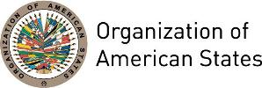

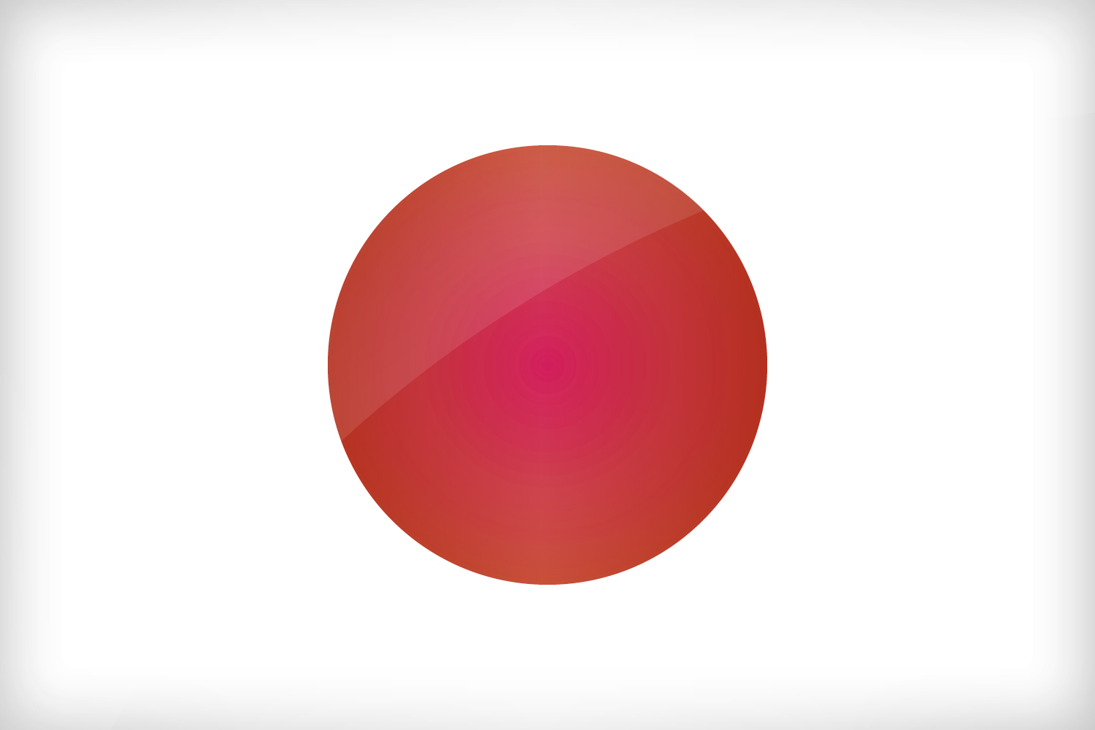
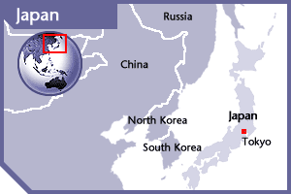

JAPAN
PERMANENT OBSERVER

Date of Entry: December 12, 1973
National Day: December 23
Capital: Tokyo
Type of Government: Parliamentary government with a constitutional monarchy
Head of State: Emperor Akihito (January 7, 1989)
Head of Government: Prime Minister Shinzo Abe (since 2012)
Minister of Foreign Affairs: Fumio Kishida (since 2012)
President of the Japan International Cooperation Agency (JICA): Shinichi Kitaoka (since October 2015)
Permanent Observer: Ambassador Kenichiro Sasae (November 19, 2012)

ECONOMIC INDICATORS | 2010 | 2011 | 2012 | 2013 | 2014 | 2015 | 2016
Population (in millions) | 128.07 | 127.83 | 127.62 | 127.44 | 127.27 | 127.14 | 126.99
GDP (in trillions) | 5.7 | 6.157 | 6.203 | 5.156 | 4.849 | 4.383 | 4.939
GDP per capita (US$) | 44,507.676 | 48,167.997 | 48,603.477 | 40,454.447 | 38,096.212 | 34,474.137 | 38,894.468
Source: www.tradingeconomics.com | The World Bank Group

FOREIGN RELATIONS POLICIES:
- The basic policies of Japan’s development cooperation: A. Contributing to peace and prosperity through cooperation for non-military purposes, B. Promoting human security, C. Cooperation aimed at self-reliant development through assistance for self-help efforts as well as dialogue and collaboration based on Japan’s experience and expertise.
- The International Cooperation Bureau was established within the Ministry of Foreign Affairs (MFA) to coordinate ODA planning, formulate and implement ODA policies.
- The International Cooperation Bureau takes charge of the following:
- policy formulation and implementation of Official Development Assistance;
- foreign policy on global issues and development cooperation with international organizations;
- issues related to human security and global health;
- foreign policy on UN and other specialized agencies concerning social and economic affairs;
- issues related to global environment and climate change;
- survey of the international economic cooperation situation and compilation of statistics and collection of data concerning international economic cooperation;
- issues related to the Japan International Cooperation Agency;
- matters concerning humanitarian assistance and enforcement of the law concerning dispatch of Japan disaster relief teams,
- assistance to NGO's as well as other matters relating to economic cooperation.

Japan International Cooperation Agency (JICA):
- Since joining the Colombo Plan in 1954, Japan has been providing financial and technical assistance to developing countries through Official Development Assistance (ODA). The JICA is an implementation agency of Japan's ODA such as grant aid, yen loans, and technical cooperation, working on human security and quality growth in accordance with the Development Cooperation Charter of Japan.
- Latin America and the Caribbean receive approximately 3.0% of Japan’s bilateral assistance.

INVOLVEMENT WITH THE AMERICAS
- Japan maintains diplomatic relations with all OAS Member States and has embassies in Argentina, Barbados, Bolivia, Brazil, Canada, Chile, Colombia, Costa Rica, Cuba, Dominican Republic, Ecuador, El Salvador, Guatemala, Haiti, Honduras, Jamaica, Mexico, Nicaragua, Panama, Paraguay, Peru, Trinidad and Tobago, United States, Uruguay and Venezuela.
- In 2015, Japan’s Official Development Assistance to Latin America and the Caribbean exceeded US$400 million.
- In August 2014, Prime Minister Abe visited Latin America and the Caribbean and announced the Japanese Government’s three-pillar cooperation policy for Official Development Assistance in the region:
  - Progress Together: Economic cooperation for monetary bold monetary policy and flexible fiscal policy; private sector cooperation; human capital development
  - Lead Together: Development of Economic Partnership Agreements, human rights, democracy and the rule of law, climate change, biological diversity and disaster relief
  - Inspire Together: Exchange programs to more than 1000 young leaders and Japanese descendants in Latin America and the Caribbean
- Japan maintains three pillars in its relations with the Latin American and Caribbean region: (1) the strengthening of economic relations; (2) support for the stable development of the region; and (3) the advancement of cooperation in the international arena.
- Japan supports the initiatives and goals of the Forum for East Asia-Latin America Cooperation (FELAC), which seeks to promote greater understanding and cooperation between the two regions. The forum holds ministerial meetings to foster its objectives. 8th Foreign Ministers’ Meeting will be held this August in Busan.
- In 2016, Japan actively developed the relationship with Latin America and Caribbean Countries. In September, Japan held 5th Foreign Ministers’ Meeting with CARICOM. Bilaterally Japan Prime Minister Abe had summit with 6 Latin American countries; Panama (April), Cuba (September), Brazil (October), Peru (November), Columbia (September & November) and Argentina (November). Also Foreign Minister Kishida held ministerial meetings for 5 times with foreign ministers from Latin America and Caribbean Countries ; Paraguay (March), El Salvador (May), Argentina (July) and Peru (November) and Jamaica (December).
- There are approximately 2.1 million Japanese descendants residing in the Latin American and Caribbean regions.
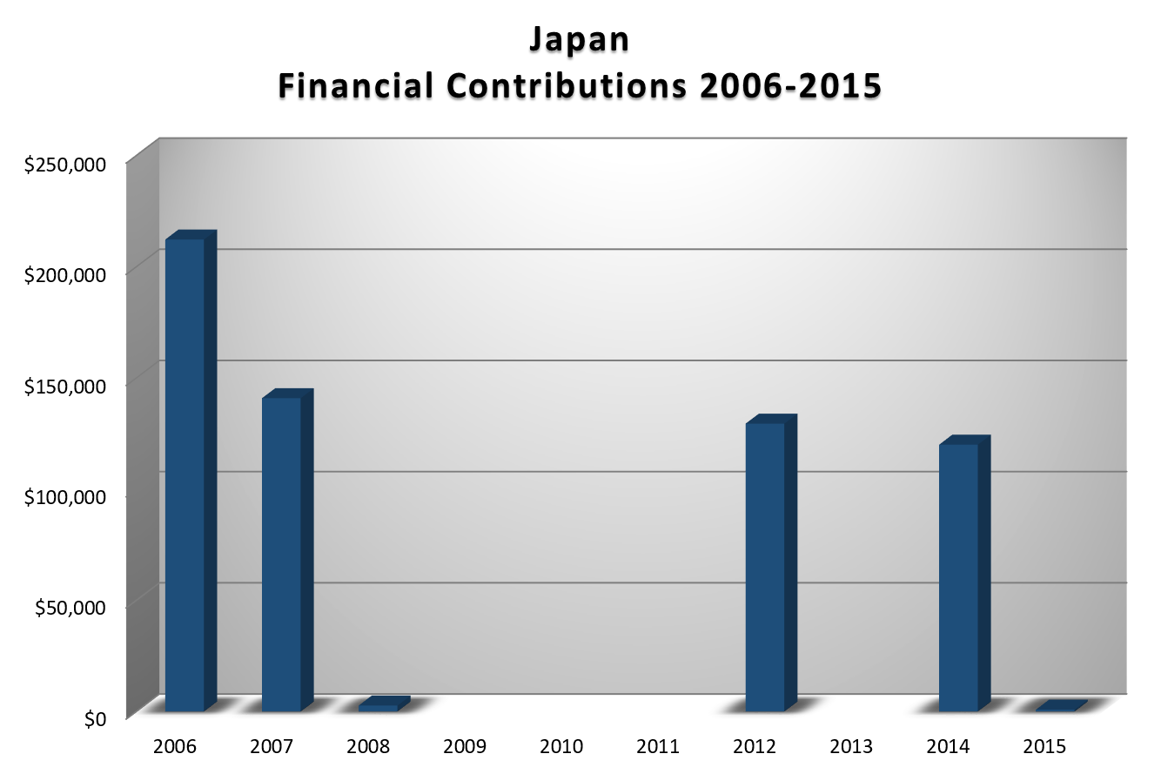
CASH CONTRIBUTIONS TO THE OAS 2006-2014:
YEAR | JAPAN | P.O. FINANCIAL CONTRIBUTIONS | %
2006 | $212,250.00 | $19,060,470.00 | 1.11%
2007 | $140,900.00 | $20,398,686.00 | 0.69%
2008 | $2,689.00 | $22,684,500.00 | 0.01%
2009 |  | $20,318,115.00 | 0.00%
2010 |  | $15,781,991.00 | 0.00%
2011 |  | $15,692,757.00 | 0.00%
2012 | $89,461.00 | $13,239,105.00 | 0.68%
2013 |  | $16,926,686.00 | 0.00%
2014 | $120,000.00 | $10,999,882.00 | 1.09%
2015 | $826.00 | $17,489,205.00 | 0.00%
2016 |  | $14,048,254.00 | 0.00%
Total US$ | $566,126.00 | $186,639,651.00 | 0.30%

JAPAN CONTRIBUTIONS:
YEAR | PROJECTS | FINANCIAL CONTRIBUTIONS  IN US$ | IN-KIND CONTRIBUTIONS  IN US$
1999 | Inter-American Drug Abuse Control Commission (CICAD) – Training | $155,000
1999 | Unit for the Promotion of Democracy (UPD) | $45,234
SUBTOTAL |  | $200,234.00
2000 | UPD | $377,026
SUBTOTAL |  | $377,026.00
2001 | CICAD – Graduate-level Training in the Prevention and Treatment of Drug Abuse | $155,000
2001 | UPD – Demining Project | $45,000
2001 | UPD – Electoral Observation Mission (EOM) Peru | $200,000
2001 | UPD – EOM Nicaragua | $90,000
2001 | USDE – Inter-American Dialogue on Water Management | $40,000
SUBTOTAL |  | $530,000.00
2002 | UPD – Demining Program | $45,000
2002 | CICAD – Nursing School Project for Demand Reduction | $155,000
2002 | USDE – Project: Achieving a Hemispheric Water Vision | $217,485
SUBTOTAL |  | $417,485.00
2003 | UPD – EOM Guatemala | $89,960
2003 | UPD – Demining Program | $17,000
2003 | CICAD – Nursing School Project for Demand Reduction | $85,840
SUBTOTAL |  | $192,800.00
2004 | CICAD – Nursing School Project for Demand Reduction | $29,850
2004 | UPD – Demining Project | $17,000
2004 | Department of Democratic and Political Affairs (DDPA) | $79,550
SUBTOTAL |  | $126,400.00
2006 | Secretariat for Political Affairs (SAP) – Promotion of Democracy EOM Nicaragua | $100,000
2006 | SAP – Promotion of Democracy EOM Peru | $92,250
2006 | SAP – Promotion of Democracy EOM Ecuador | $20,000
SUBTOTAL |  | $212,250.00
2007 | SAP – Promotion of Democracy EOM Guatemala | $86,000
2007 | SAP – Promotion of Democracy EOM Colombia | $54,900
SUBTOTAL |  | $140,900.00
2008 | CICAD – School of Nursing in Latin America | $2,689
SUBTOTAL |  | $2,689.00
2012 | Secretariat for Multidimensional Security / Department of Public Security - Support for Monitoring and Quality Control for Humanitarian Demining Operations in Colombia AICMA | $89,461.41
SUBTOTAL |  | $89,461.41
2013 | Secretariat for Political Affairs / Department of Electoral Cooperation and Observation - Electoral Observation Mission in Honduras |  | $10,000.00
SUBTOTAL |  |  | $10,000.00
2014 | Secretariat for Political Affairs / Department for Effective Public Management - Modernization and Integration of the Civil Registry in Haiti | $120,000.00
SUBTOTAL |  | $120,000.00 | $0.00
2015 | Electoral Observation Mission in Guatemala | $826.00
SUBTOTAL |  | $826.00 | $0.00
TOTAL |  | $2,410,071.00 | $10,000.00

SOURCES:
MINISTRY OF FOREIGN AFFAIRS OF JAPAN  http://www.mofa.go.jp  JAPAN INTERNATIONAL COOPERATION AGENCY (JICA)  http://www.jica.go.jp | JAPAN BANK FOR INTERNATIONAL COOPERATION  https://www.jbic.go.jp  WORLD BANK – TRADING ECONOMICS  www.tradingeconomics.com

This page was last updated on July 12, 2017.

