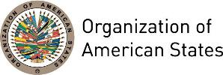


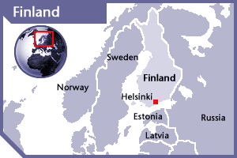

FINLAND
PERMANENT OBSERVER

Date of Entry: January 6, 1988
National Day: December 6
Capital: Helsinki
Type of Government: Parliamentary Republic
Head of State: President Sauli Väinämö Niinistö (March 1, 2012)
Head of Government: Prime Minister Juha Sipila (2015)
Minister for Foreign Affairs: Timo Soini (2015)
Permanent Observer: Ambassador Kristi Kauppi (September 17, 2015)

ECONOMIC INDICATORS | 2010 | 2011 | 2012 | 2013 | 2014 | 2015 | 2016
Population (in millions) | 5.36 | 5.38 | 5.41 | 5.43 | 5.46 | 5.47 | 5.49
GDP (US$ in billions) | 247.8 | 273.674 | 256.706 | 269.98 | 272.609 | 232.362 | 236.785
GDP per capita (US$) | 46,205.4 | 50,790.7 | 47,415.5 | 49,638.07 | 49,914.6 | 42,405.3 | 43,090.2
Source: www.tradingeconomics.com | The World Bank Group

FOREIGN RELATIONS POLICIES:
- Three core objectives link all the activities of the Finnish Government and all its decision-making together: the reduction of poverty, inequality and social exclusion; the consolidation of public finances; and the strengthening of sustainable economic growth, employment and competitiveness.
- The Ministry of Foreign Affairs promotes the achievement of these objectives always promoting the foreign relations, security policy, and assistance to other branches of government in coordination of international affairs, and encouraging the security and welfare of Finland and the Finns. As a result, the Finnish’s foreign and security policy is based on good bilateral and international relations, a strong role in the European Union's (EU) Common Foreign and Security Policy (CFSP), and an effective multilateral cooperation and credible national defense.
- In addition, the development of relations with the neighboring areas – the Nordic countries, Russia and the Baltic States - is of key importance. Finland's foreign policy is based on democracy, the rule of law, and respect for human rights emphasizing the importance of these values at the international level.

International Development POLICY Program:
- The Finnish Development Policy Program aims at strengthening international stability, security, peace, justice and sustainable development, as well as promoting the rule of law, democracy and human rights.
- As its basis, Finland’s Development Policy Program emphasizes that all people have an equal right to affect and participate in both the planning of their development and the activities involved in the implementation of development plans.
- The Program focuses on four main areas:
  - A democratic and accountable society that promotes human rights
  - An inclusive green economy that promotes employment
  - Sustainable natural resources management and environmental protection
  - Human development
- Finland is committed to the UN Millennium Declaration and Millennium Development Goals, focused at eradicating extreme poverty.
- Finland’s development policy objectives are promoted both through development funding and by effective policy dialogue bilaterally, regionally, multilaterally as well as through civil society organizations and the European Union. For Finland, the most important implementer of multilateral cooperation are the UN agencies, followed by development finance institutions such as the World Bank, regional development institutions, and the International Fund for Agricultural Development (IFAD).
- The program emphasizes the results and quality of development cooperation and its implementation, effectiveness and results will be assessed in an annual report to the Parliament. Implementation and results are also monitored in the Development Policy Committee appointed by the Government as well as in the Development Policy Steering Group of the Ministry for Foreign Affairs under the direction of the Minister for International Development.
- Finland’s eight long-term partner countries are Ethiopia, Kenya, Mozambique, Nepal, Zambia, Tanzania and Vietnam. Development cooperation priorities are shifting to the least developed African countries, as well as the so-called fragile states, such as Afghanistan, South Sudan and Palestine.

INVOLVEMENT WITH THE AMERICAS:
- Finland maintains diplomatic relations with all countries of Latin America and the Caribbean.
- Finland has embassies in seven countries of the Americas: Argentina, Brazil, Canada, Chile, Mexico, Peru, and the United States.
- Finland’s Latin America and the Caribbean Action Plan seeks to leverage its diplomatic missions in the region to promote Finland’s brand image and increase cooperation in the following areas: Political relations, trade and investment, research-innovation-education, development cooperation, cultural relations and public diplomacy.

CURRENT COOPERATION AGREEMENTS WITH THE OAS:
- Agreement between the Ministry of Foreign Affairs of Finland and the General Secretariat of the Organization of American States (GS/OAS), signed June 29, 2012, to support the Inter-American Commission on Human Rights, Office of the Special Rapporteur for Freedom of Expression, project Strengthening Freedom of Expression in the Americas, for a three-year period.

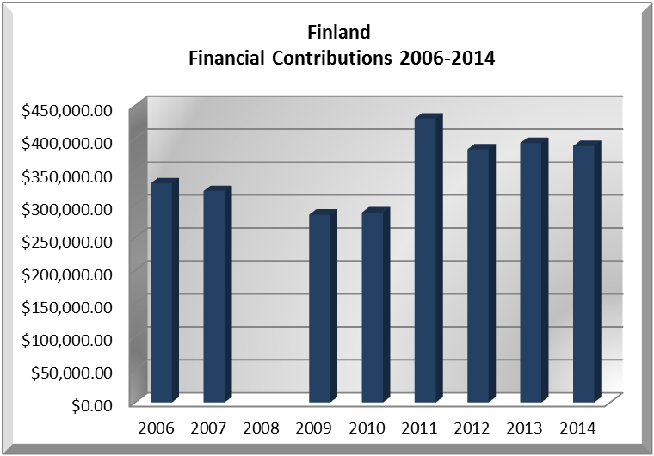
CASH CONTRIBUTIONS TO THE OAS 2005-2016:
YEAR | FINLAND | P.O. FINANCIAL CONTRIBUTIONS | %
2005 |  | $11,650,039.00 | 0.00%
2006 | $332,337.00 | $19,060,470.00 | 1.74%
2007 | $320,559.00 | $20,398,686.00 | 1.57%
2008 |  | $22,684,500.00 | 0.00%
2009 | $284,740.00 | $20,318,115.00 | 1.40%
2010 | $288,099.00 | $15,781,991.00 | 1.83%
2011 | $430,470.00 | $15,692,757.00 | 2.74%
2012 | $383,880.00 | $13,239,105.00 | 2.90%
2013 | $393,480.00 | $16,926,686.00 | 2.32%
2014 | $388,800.00 | $10,999,882.00 | 3.53%
2015 |  | $17,489,205.00 | 0.00%
2016 |  | $14,048,254.00 | 0.00%
Total US$ | $2,822,365.00 | $198,289,690.00 | 1.42%

FINLAND CONTRIBUTIONS:
YEAR | PROJECTS | FINANCIAL CONTRIBUTIONS  IN US$ | IN-KIND CONTRIBUTIONS  IN US$
2001 | Unit for the Promotion of Democracy (UPD) – Electoral Observation Mission (EOM) Nicaragua | $60,000.00
SUBTOTAL |  | $60,000.00
2002 | Unit for the Promotion of Democracy (UPD) – Decentralization of Local Government | $8,046.00
2002 | General Secretariat | $42,544.00
SUBTOTAL |  | $50,590.00
2003 | Summits of the Americas Secretariat – Inter-American Declaration on the Rights of Indigenous Peoples | $98,648.00
SUBTOTAL |  | $98,648.00
2004 | General Secretariat – Declaration of Indigenous Peoples | $181,306.00
2004 | Inter-American Commission on Human Rights (IACHR) – Support to Rapporteurship on the Rights of Women | $411,543.00
SUBTOTAL |  | $592,849.00
2006 | Inter-American Commission on Human Rights (IACHR) – Support to Rapporteurship on the Rights of Women | $282,337.00
2006 | Department of Electoral Cooperation and Observation (DECO) – EOM Venezuela | $50,000.00
SUBTOTAL |  | $332,337.00
2007 | Inter-American Commission on Human Rights (IACHR) – Rapporteur for the Rights of Women | $320,559.00
SUBTOTAL |  | $320,559.00
2009 | Inter-American Commission on Human Rights (IACHR) – Access to Justice for Women Victims of Sexual Violence | $79,914.00
2009 | Department of Sustainable Development (DSD) – Protection and Sustainable Use of Cross-boundary Aquifers in Mesoamerica | $79,914.00
2009 | Inter-American Commission on Women (CIM) – Democracy and Gender Perspective in Local Public Finances | $124,912.00
SUBTOTAL |  | $284,740.00
2010 | Department of Electoral Cooperation and Observation (DECO) - OAS Electoral Observation Mission to Haiti | $288,099.00
SUBTOTAL |  | $288,099.00
2011 | Inter-American Commission on Human Rights – Promoción de Principios y mejores prácticas para la Protección de las Defensoras y Defensores de Derechos Humanos en las Américas | $215,235.00
2011 | Secretariat for Integral Development / Department of Sustainable Development – Payment for Environmental Services and Climate Change and Variability in the Andean/Amazon Region | $215,235.00
SUBTOTAL |  | $430,470.00
2012 | Inter-American Commission of Human Rights / Office of the “Special Rapporteur of Expression” “Strengthening Freedom of Expression in the Americas” | $383,880.00
SUBTOTAL |  | $383,880.00
2013 | Inter-American Commission of Human Rights / Office of the Special Rapporteur of Freedom of Expression – Strengthening Freedom of Expression in the Americas” | $393,480.00
SUBTOTAL |  | $393,480.00
2014 | Inter-American Commission of Human Rights / Office of the Special Rapporteur of Freedom of Expression – Strengthening Freedom of Expression in the Americas” | $388,800.00
SUBTOTAL |  | $388,800.00
TOTAL |  | $3,624,452.00

SOURCES:
THE PRESIDENT OF THE REPUBLIC OF FINLAND  http://www.tpk.fi/public/default.aspx?culture=en-US&contentlan=2  FINNISH GOVERNMENT WEBSITE  http://valtioneuvosto.fi/etusivu/en.jsp | MINISTRY FOR FOREIGN AFFAIRS OF FINLAND  http://formin.finland.fi/  THE WORLD BANK  http://www.worldbank.org

This page was last updated on July 10, 2017.

