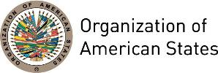

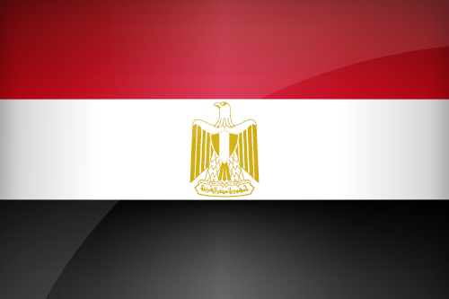
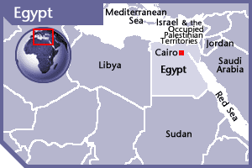

EGYPT
PERMANENT OBSERVER

Date of Entry: September 23, 2008
National Day: July 23
Capital: Cairo
Type of Government: Presidential Republic
Head of State: President Abdel Fattah el-Sisi (June 8, 2014)
Head of Government: Prime Minister Sherif Ismail (June 17, 2014)
Minister of Foreign Affairs: Sameh Hassan Shoukry (June 17, 2014)
Permanent Observer: Ambassador Yasser Reda (September 15, 2015)

ECONOMIC INDICATORS | 2010 | 2011 | 2012 | 2013 | 2014 | 2015 | 2016
Population (in millions) | 84.10 | 85.89 | 87.81 | 89.80 | 91.81 | 93.77 | 95.68
GDP (US$ in billions) | 218.88 | 236.002 | 279.373 | 288.586 | 305.53 | 332.69 | 336.29
GDP per capita (US$) | 2,602.48 | 2,747.48 | 3,181.442 | 3,213.389 | 3,327.754 | 3,547.713 | 3,514.49
Source: www.tradingeconomics.com | The World Bank Group

FOREIGN RELATIONS AND DEVELOMENT COOPERATION GOALS:
- The Egyptian Ministry of Foreign Affairs oversees the foreign relations of Egypt. It aims to attract foreign investments, acquire economic assistance, and facilitate technology transfer. Specialized departments for international cooperation and economic relations have been established within the Ministry to achieve these goals.
- The Foreign Ministry also seeks to maintain strong bilateral and multilateral relationships as one of the main goals of Egyptian foreign policy. Strengthening traditional friendly relations as well as building new relationships enables Egypt to exercise influence and pursue Egyptian interests all over the globe.
- Another essential goal for Egyptian general policy is the maintenance of strong bilateral and multilateral relationships. Traditional relationships with other Arab and African states are maintained mainly through interactions with regional organizations such as the Arab League, and the African Union. Bilateral relations with these states are also promoted through undertaking continuous consultations, widening the scope of cooperation in various fields, as well as exchanging expertise in the different areas of development.
- The Ministry also tries to boost the country’s strategic relationships such as those with the United States and the European countries so that Egypt can enhance its sustainable development efforts and serve Egyptian strategic regional and international objectives.
- The Ministry also helps to promote understanding of Egyptian culture through the cultural sector of the Foreign Ministry. The cultural sector cooperates with other Egyptian institutions, such as Al-Azhar University, the Supreme Council for Islamic Affairs, and the Egyptian Ministry of Education, to offer scholarships and training courses to African and Asian students. The Ministry also coordinates between the Egyptian cultural institutions and their counterparts in those countries to organize cultural activities and folkloric events to bring diverse nations closer together.
- Egypt belongs to a number of international organizations, including the United Nations (UN), the International Monetary Fund (IMF), the World Bank, and the World Trade Organization, playing an active role in the UN and its specialized agencies, as well as in various other international institutions to foster international peace, security, and economic development.
- Egypt is also a Partner for Cooperation with the Organization for Security and Cooperation in Europe (OSCE), and is a non-party state to the International Criminal Court. The United Nations began providing development assistance to Egypt in 1953 in its effort to reduce poverty and to promote sustainable development policies. The United Nations Development Programme (UNDP)-Egypt supports activities in four practice areas: poverty reduction, energy and the environment, democratic governance, and crisis prevention and recovery.

INTERNATIONAL COOPERATION:
- On July 1, 2014, the Egyptian Agency of Partnership for Development (EAPD) was established with the objective to grant technical cooperation and humanitarian assistance to African and Islamic countries, through the organization of training courses and workshops, collaboration with international and regional organizations, and funding of development projects in which Egypt has expertise:
  - Diplomacy; transportation; communication and information technology; healthcare; agriculture; police, crime prevention and counter terrorism; water management and irrigation; tourism; industrialization; relief and emergency assistance; electricity and energy resources; security and defense; privatization and public sector reform; industrial management; environment; pilot farms.
- EAPD seeks to expand into trilateral cooperation with interested governments, regional and international organizations, especially Japan, United Arab Emirates, Italy, Brazil, China, Singapore, African Development Bank, Arab Bank for Economic Development in Africa, Islamic Development Bank, and the Arab Fund for Technical Assistance to African Countries

INVOLVEMENT WITH THE AMERICAS:
- Egypt maintains embassies in Argentina, Bolivia, Brazil, Canada, Chile, Colombia, Cuba, Ecuador, Guatemala, Mexico, Panama, Peru, United States of America, Uruguay and Venezuela.
- Egyptian-Latin American relations originated from historical Latino-Arab relations that sprouted with the support of Arab Latino immigrants. Egypt’s strategic position has enhanced its role in the Arab world and in the African continent, and as a result, its role in Latin America. Egypt coordinates with Latin American countries to support commercial exchanges and investment between both parties.

Arab-Latin American Summit
- The Arab-Latin American Summits are a bi-regional mechanism for cooperation and political coordination. It was created upon the proposal of then Brazilian President Luiz Inácio Lula da Silva in 2005.
- The Arab-Latin American Summit was held on May 10, 2005 in Brazil with the participation of 22 Arab and 12 Latin American countries. The aim of the summit was to enhance relations between the two sides.
- The Summit dealt with the different means to enhance cooperation between the two regions in economic, political, cultural, and social terms, and considered trade, tourism and investment opportunities, as well as coordination concerning issues presented at the World Trade Organization (WTO). It aimed to coordinate between the two regions over international issues and mutual interests, to unite the Arab and the Latin perspectives, and to enhance cultural cooperation.
- The II Summit of Heads of State and Government was held in Qatar on March 31, 2009. In this Summit, discussion focused on the importance of making efforts to forge close relationships between the two regions to achieve a fairer and more equitable structure of international relations, and the creation of a new framework of international cooperation based on equivalence and equality. The Summit also emphasized the fact that the attainment of peace, security and stability in the world calls for cooperation between the two regions.
- The III Summit of Heads of State and Government was held in Lima, Peru, on October 1-2, 2012. As a result, a joint declaration was adopted calling for peaceful mediation in the Middle East and greater inter-regional cooperation.

SOURCES:
ARAB REPUBLIC OF EGYPT  MINISTRY OF FOREIGN AFFAIRS  http://www.mfa.gov.eg/English/Pages/default.aspx  EGYPT’S GOVERNMENT WEBSITE  http://www.egypt.gov.eg/english/  EGYPT STATE INFORMATION SERVICE  http://www.sis.gov.eg/En/Default.aspx | EGYPT ONLINE SERVICES PORTAL  http://www.egypt.gov.eg/english/home.aspx  CENTRAL INTELLIGENCE AGENCY  https://www.cia.gov/library/publications/the-world-factbook/geos/fr.html  STATE INFORMATION SERVICE YOUR GATEWAY TO EGYPT  http://www.sis.gov.eg

This page was last updated on July 10, 2017.

