PERMANENT COUNCIL OF THE OEA/Ser.G
ORGANIZATION OF AMERICAN STATES CP/CAAP-3240/13
14 May 2013
COMMITTEE ON ADMINISTRATIVE Original: English
AND BUDGETARY AFFAIRS

REPORT ON FUNDRAISING: PERMANENT OBSERVERS

(Presented by the Department of International Affairs / Secretariat for External Relations
in compliance with resolution AG/RES. 1 (XLIII-E/12)

This analysis, prepared by the Department of International Affairs / Secretariat for External Relations (DIA/SER) of the Organization of American States (OAS), seeks to inform the Committee on Administrative and Budgetary Affairs (CAAP) about the support received from Permanent Observers to the OAS during the fiscal year 2012, based on official data from the Department of Financial and Administrative Management Services and corroborated by the OAS technical areas and the Permanent Observer Missions, following the mandate AG/RES. 1 (XLII-E/12) rev. 1 Paragraph A. 3, “To instruct the Secretary General, as part of his fundraising efforts, to promote and encourage, through the Secretariat for External Relations, in coordination with member states, support for the implementation of the mandates of the General Assembly, and to submit a report to the CAAP on an annual basis on the results of these efforts.”

As described in Executive Order 08-01 rev. 5 the Department of International Affairs (DIA), as part of the Secretariat for External Relations, is responsible for coordinating the relations with the Permanent Observers with the goal of providing information regarding the mission of the Organization and the priorities of the hemispheric agenda. DIA also identifies opportunities and negotiates financing and cooperation agreements with the Permanent Observers to obtain substantive support for the programs of the General Secretariat.

BACKGROUND

The status of Permanent Observer to the OAS has its origin in 1972 to promote the participation of the non-Member States in activities related to development cooperation. Similarly, Resolution CP/RES. 407 (573/84) indicates that the Permanent Council, in examining the application of a non-member state to be granted the status of Permanent Observer, will consider, as well as the points of view of the member states, “the contributions that the petitioning State could offer to the programs of the Organization.”

To date, Permanent Observer status has been granted to 67 non-OAS member states through its General Assembly, as well as to the European Union (EU). This status offers an approach for non-member states to participate in OAS activities and to provide financial and in-kind cooperation for its programs. 35 Permanent Observers have supported OAS initiatives through training opportunities, expert services, equipment, and financial contributions since 1999. From 1999 to 2012, Permanent Observers have contributed more than US$210 million; US$199 million in cash to the Organization’s activities and programs, and an estimated US$12.54 million dollars for in-kind contributions.

Contributions from Permanent Observers significantly improve the quality of the OAS’ work conducted in the Americas and are an important factor in the successful implementation of the OAS pillars, particularly in the areas of democracy promotion, human rights, demining, conflict resolution, combating drug trafficking, the fight against terrorism, fostering gender equality and sustainable development, among others.

ORIGIN OF FUNDS

Permanent Observers participate in different activities and programs of the Organization by providing financial and in-kind support, as well as sharing their technical expertise with the General Secretariat through exchanges of information and best practices on issues of the inter-American agenda. Out of the 68 Permanent Observers, one-third provide significant sources of funding for OAS programs. During the 1970s and 1980s, most of the Permanent Observers supported OAS efforts in the area of human development, by providing scholarships, training courses, and expertise.

In the 1990s, Permanent Observers shifted their interest to programs geared toward the promotion of democracy, the protection of human rights, conflict resolution, and regional security, which prompted significant cash contributions to support programs such as demining, electoral observation missions and democratic governance activities.

From 1999 to 2011, Permanent Observers contributed more than US$185 million in cash to the Organization’s activities and programs, of which 80% came from the Governments of Spain (US$57 million), Sweden (US$45 million), the Netherlands (US$18 million), Norway (US$19 million), and the European Union (US$12 million).

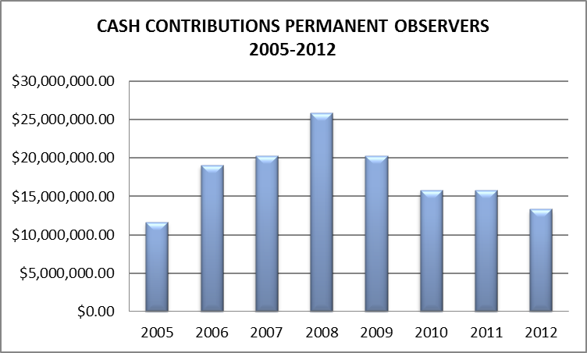

Despite initial signs of the recovery of the world economy, the global economic crisis of 2008 and the Eurozone crisis of 2010 have forced major donors to redirect their international development cooperation to domestic fiscal and social strategies, causing significant reductions in specific funds received by the OAS from Permanent Observers.

2012 COOPERATION FROM PERMANENT OBSERVERS

In 2012, the Organization received cash and in-kind contributions from Permanent Observers totaling US$14,607,632.
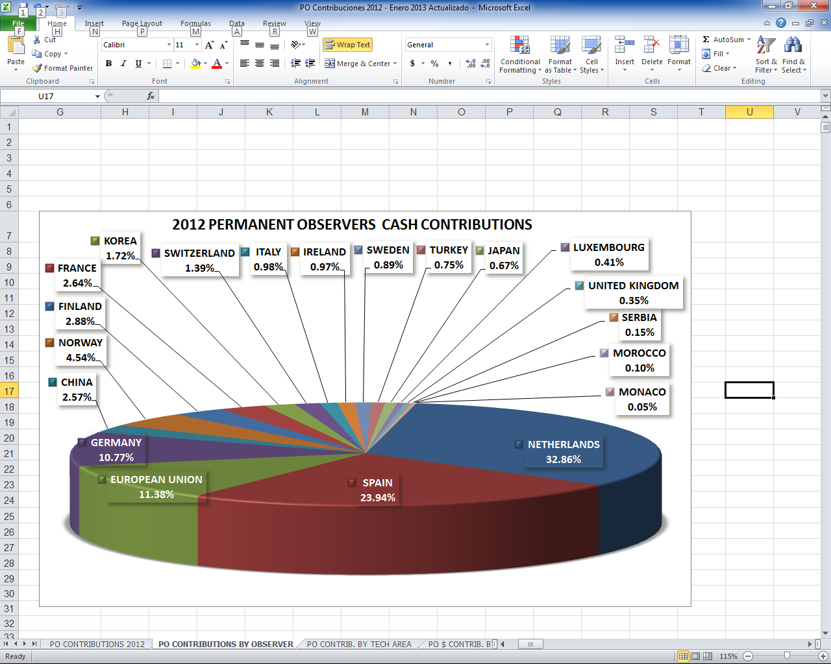

Of the cash contributions received in 2012, 32.86% came from the Netherlands, 23.94% from Spain, 11.38% from the European Union, 10.77% from Germany, and 4.54% from Norway. The People’s Republic of China, Finland, France, Korea, and Switzerland together contributed 11.2% of the total. Contributions were also received from Italy, Ireland, Japan, Luxembourg, Monaco, Morocco, Serbia, Sweden, Turkey and the United Kingdom.

In addition, in-kind contributions from Permanent Observers totaled US$1,266,801 in 2012. Spain was the principal in-kind donor through its support of training scholarships valued at US$601,670 for courses at the Instituto de Empresa (IE), Structuralia, Universidad Politécnica de Valencia and the Universidad Nacional de Educación a Distancia (UNED). Israel also supported the execution of training seminars through the Young Americas Business Trust. This in-kind contribution, valued at US$300,000, serves to provide young entrepreneurs with skills and tools such as training, contacts to start businesses, access to markets and business opportunities, among others. Similarly, China hosted two OAS specialists in seminars for Diplomats and OAS Officials, and provided courses and capacity-building training valued at US$298,110.

Likewise, Italy offered six scholarships through the International Training Center of the International Labor Organization Ministry of Education worth US$11,300, and the Netherlands offered three scholarships at the International Institute of Social Studies from the University of Rotterdam equivalent to US$16,113.

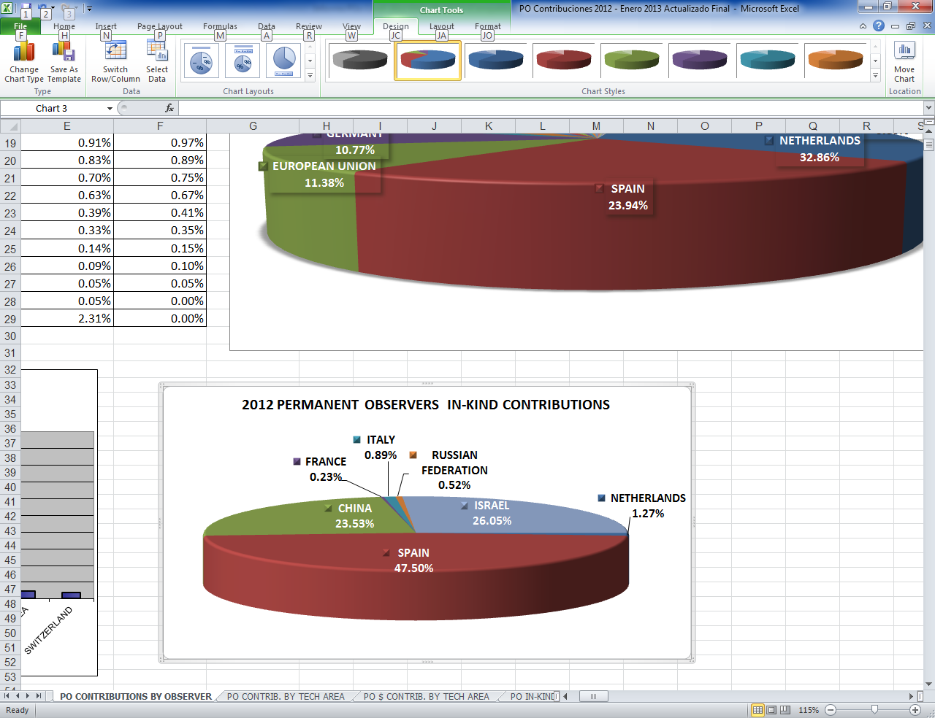

- Programs Receiving Support

The main recipient of cash contributions in 2012 was the Secretariat for Political Affairs (36%), followed by the Secretariat for Legal Affairs (19%), the Inter-American Commission on Human Rights (13%), the Secretariat for Multidimensional Security (8%) and the Executive Secretariat for Integral Development (11%).

PERMANENT OBSERVERS 2012 CONTRIBUTIONS
TECHNICAL AREA | TOTAL CONTRIBUTIONS
SPA | $5,351,937.53
SLA | $2,886,736.36
IACHR | $2,013,880.73
SEDI | $1,696,191.93
SMS | $1,286,145.41
CIM | $509,600.00
SER | $191,500.00
SAF | $30,000.00
YABT | $300,000.00
IIN | $47,390.00
Spanish Fund | $294,250.00
TOTAL | $14,607,631.96

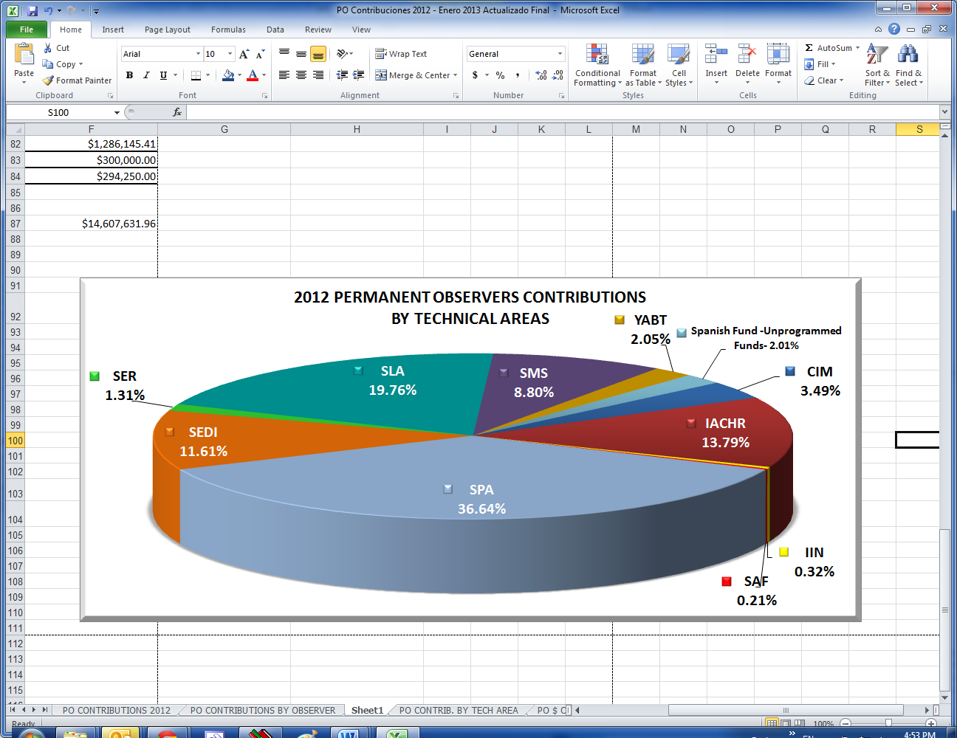
The majority of the contributions received in the Secretariat for Political Affairs were earmarked for activities of the Mission to Support the Peace Process (MAPP) in Colombia and the Peace Fund for the Implementation of Confidence-Building Measures in the Belize-Guatemala Adjacency Zone.

Programs related to Democracy received total funds of US$5,351,937.53 which were allocated to the MAPP (21.03%), the Universal Civil Registry and the Right to Identity Program (PUICA) (6.72%), the Belize-Guatemala Adjacency Zone Mission (5.09%) and the Electoral Observation Missions (3.73%), followed by the area of Legal Affairs with US$2,886,736 to support the Inter-American Judicial Facilitators Program (19.76%).

In the area of Human Rights, contributions from Permanent Observers totaled US$2,013,880.73 distributed among the Strategic Plan 2011-2015 from the Inter-American Commission on Human Rights (8.05%) and the OAS Rapporteurship for Freedom of Expression (5.74%).

Along the same line, Integral Development programs received US$1,696,191 from Permanent Observers with the areas of Education and Culture (6.66%), Sustainable Development (2.350%) and Economic Development, Trade and Tourism (2.60%) receiving the most support. In relation to the Multidimensional Security Pillar, the US$1,286,145.41 received from Permanent Observers were directed to support Demining Activities (5.38%) and the Report on Drugs (3.42%). The Inter-American Commission of Women, the Office of the Secretary General, and other dependencies of the Organization also received contributions that helped to strengthen their programs.

- Cooperation Agreements

During 2012, the General Secretariat signed agreements related to the financial support of OAS-programmed initiatives in the Americas with Belgium, European Union, France, Finland, Ireland, the Netherlands, Norway and Spain.

Through the Spanish Fund the OAS received a financial contribution of US$3,194,250 in 2012, which will support the Inter-American Commission on Human Rights and the Inter-American Court of Human Rights, electoral cooperation and observation, MAPP, Universal Civil Identity Program in the Americas (PUICA), Inter-American Drug Abuse Control Commission (CICAD), and other projects of the Secretariats for Integral Development, Political Affairs, Multidimensional Security and Legal Affairs, as well as the Inter-American Commission of Women (CIM) and the Inter-American Children’s Institute (IIN).

On May 8, 2012, through an agreement between the OAS General Secretariat and the French Republic, the Government of France provided US$250,000 toward the Mission to Support the Peace Process (MAPP) in Colombia. Likewise, on June 18, 2012, under the Agreement signed between the Norwegian Ministry of Foreign Affairs and the General Secretariat, the Government of Norway granted US$610,000 to provide logistical, technical and management support, as well as quality assurance for humanitarian demining activities coordinated and executed by the OAS and the Governments of Ecuador and Peru in the Cordillera del Condor border region.

On June 29, 2012, the Ministry of Foreign Affairs of Finland and the General Secretariat of the OAS formalized the Finnish contribution through an exchange of letters for US$1,150,000 to support the project “Strengthening Freedom of Expression in the Americas,” executed by the Office of the Special Rapporteur for Freedom of Expression of the Inter-American Commission on Human Rights.

On July 6, 2012, an Arrangement between the Minister for European Affairs and International Cooperation of the Kingdom of the Netherlands and the OAS, through the Secretariat for Legal Affairs, was signed to support the Inter-American Judicial Facilitators Program for a period of three years (2012-2015) and with a total contribution of approximately US$15,000,000.

Similarly, on October 3, 2012, a contribution Agreement between the Ministry of Foreign Affairs of the Government of Belgium and the General Secretariat was signed supporting the project “Landmine Victim Assistance in Ecuador and Peru,” which is executed by the Department of Public Security of the Secretariat for Multidimensional Security.

On December 3, 2012 the European Union signed a contribution Agreement for the implementation of the program “Guatemala-Belize: Support to the peaceful resolution of the long-standing territorial dispute,” through which it contributed US$2,500,000. Lastly, the Minister of Foreign Affairs and Trade of Ireland, represented by Irish Aid, signed an Agreement with the Executive Secretariat of the Inter-American Commission on Human Rights for US$125,000 to support the project “Protecting the Rights of Human Rights Defenders in Colombia, Venezuela and Ecuador” identified under the IACHR’s Strategic Plan 2011-2015.

- Other activities aimed at strengthening cooperation with Permanent Observers during 2012

The General Secretariat promoted the active participation and cooperation of the 68 Permanent Observers in order to identify the areas in which the OAS and potential donors share priorities, create opportunities for exchanges with OAS technical units, and arrange multiple visits with senior government officials in order to negotiate support for specific activities.

The General Secretariat also continued its efforts to increase Permanent Observers’ involvement in the activities of the Organization through briefings, information exchanges, special events, and ongoing working meetings in Washington and during the General Assembly. Of particular note is the first policy dialogue between officials of the European Union and the OAS held in Brussels in February 2012. The Assistant Secretary General, Ambassador Albert Ramdin, led the delegation of OAS officials who met with the Secretary General of the European Union’s External Action Service, Pierre Vimont, and Head of the Americas Division, Christian Leffler. These meetings served to strengthen relations between the EU and the OAS, and focused on electoral observation and follow up, democratic institutions and promoting human rights as areas for deepened collaboration.

The OAS Secretary General also met with the Director of the Spanish Agency of International Cooperation for Development (AECID), Juan López-Dóriga Pérez, which served as an opportunity to discuss the implementation of the Spanish Fund, discuss current issues of hemispheric importance and identify future priorities, both for the OAS and the Spanish Government, in order to strengthen cooperation over the long term.

Another meeting of special interest that took place was between the OAS Secretary General and the Director General of the Department of Latin America and the Caribbean of the Ministry of Foreign Relations of China, Yang Wanming, in which the Secretary General discussed a proposal to develop a new cooperation agreement with the Government of China to establish a framework for increased political dialogue and financial support to the Organization. The Chinese Representative also reiterated an invitation for the Secretary General to visit China and discuss continued cooperation with high-level government officials.

In the period covered by this report, the OAS also received visits by Ministers and other Senior-level representatives of the Ministries of Foreign Affairs and Ministries of Cooperation and Development of Permanent Observers, including the Deputy Minister of Foreign Affairs of the Russian Federation, Sergey Ryabkov; the Minister of Foreign Affairs of Serbia, Vuk Jeremic; the Director for the Americas of the United Kingdom's Foreign Commonwealth Office, Angus Lapsley; the Head of Israel's Agency for International Development Cooperation MASHAV, Daniel Carmon; the Finance Minister of Finland, Jutta Urpilainen; and the Secretary of State for Cooperation and Iberoamerica of the Government of Spain, Jesús Gracia Aldaz.

In addition, meetings were arranged with senior officials from Permanent Observer in the framework of the United Nations General Assembly to discuss cooperation with the OAS, including with the Minister of Foreign Affairs and Cooperation of Spain, José Manuel García-Margallo, and the Minister of Foreign Affairs of the Netherlands, Uri Rosenthal.

The accomplishments of the General Secretariat to successfully implement outreach efforts to Permanent Observers, both in Washington, D.C. and in their respective capital cities, culminated with two important events in December 2012. On December 3, 2012 a Memorandum of Understanding was signed between the General Secretariat and the Netherlands through the OAS Secretariat for Multidimensional Security. This Agreement formalizes and strengthens cooperation in areas of mutual interest, such as the fight against the production, use and illegal trafficking of drugs and psychotropic substances, terrorism, and emerging threats to public security, transnational crime and trafficking in persons, firearms, and money laundering.

On December 11, 2012 a working session was held in which the OAS Department of Planning and Evaluation from the Secretariat for Administration and Finance shared with Permanent Observers the tools developed by the OAS General Secretariat, through its Project Evaluation Committee, to ensure the efficiency and transparency in the design, execution and evaluation of projects and programs. The Permanent Mission of Canada and the Permanent Observer Mission of Spain to the OAS also shared their experiences of applying this methodology to their annual contributions to the Organization.

- Future priority areas of activity

The General Secretariat has created a “Strategic Plan for Resource Mobilization of External Funds in the OAS with Permanent Observers 2013-2015” in compliance with the mandate of the General Assembly and Executive Order No. 08-01 Rev. 5, which states that the Secretariat for External Relations (SER) “serves as the focal point of the General Secretariat with regard to fundraising efforts” and “promotes cooperation with member states, Permanent Observers, international and regional organizations, nongovernmental organizations, academic institutions, and the private sector in order to generate active support for the Organization, taking into account all its goals and activities.”

As such, the General Secretariat has established the primary objectives in the area of resource mobilization with Permanent Observers, including:

- To increase support among Permanent Observers, other key Observer government institutions, OAS Member States, and the General Secretariat by strengthening and facilitating the links of cooperation, the exchange of information and best practices;

- To implement a mechanism to identify High-Impact Programs and Priority Projects for the different technical areas within the Secretariats by the beginning of 2013;

- To enhance the OAS’ capacity to coordinate its fundraising policies and activities, and improve resource mobilization efforts within the OAS technical areas.

- To provide technical support to the areas within the Secretariats in the provision and promotion of the different programs and projects to be presented to the Permanent Observers.

To achieve those goals, the General Secretariat will continue high-level talks with the cooperation authorities of the Permanent Observers and their representatives accredited to the OAS with a view to build a substantial and lasting cooperation in support of priority OAS programs in areas of common interest.

 |  |  |  |  |  |  | ANNEX 1
CONTRIBUTIONS FROM PERMANENT OBSERVERS TO THE OAS 2012
OBSERVERS |  | PROGRAMS & ACTIVITIES | OAS SECRETARIATS |  | CASH CONTRIBUTIONS |  | IN-KIND CONTRIBUTIONS
PEOPLE'S REPUBLIC OF CHINA |  | Video - "This is the way" | SER - Press & Communications |  | $25,000.00
 |  | Inter-American Programme for the Prevention and Eradication of Sexual Commercial Exploitation, Illegal Trafficking and Trade in Children and Adolescents | IIN |  | $47,390.00
 |  | Promoting Democracy among the Youth of the Americas through the Model OAS General Assembly (MOAS) for University and High School Students of the Hemisphere | SER - DIA |  | $45,000.00
 |  | Public Policies and Institutional Strengthening for Promoting the Productivity, Innovation and Internationalization of Micro, Small and Medium Enterprises (MSMEs) | SEDI - DEDTT |  | $40,000.00
 |  | Small Tourism Enterprises Network | SEDI - DEDTT |  | $30,000.00
 |  | Culture in Development: An Inter-American Information Network II | SEDI - DHDEC |  | $20,000.00
 |  | Capacity Building for the implementation of the Early Warning System for Floods in the Aguan River Basin in Honduras -Phase I- | SEDI-DSD |  | $20,000.00
 |  | Student Participation and Leadership in Educational Institutions in the Americas | SEDI-DHDEC |  | $20,000.00
 |  | Images of America -Recovering the Audiovisual memory of the OAS, Images of the America. | SER - Press & Communications |  | $47,650.00
 |  | Modernization of Offices and Multimedia Equipments of the General Secretariat. | SER |  | $47,650.00
 |  | OAS Scholarship Program Chinese and English (9 scholarships) | SEDI - DHDEC |  |  |  | $269,310.00
 |  | Professional Program for Diplomats from Pacific Islands and Caribbean Countries (2 participants) | CIM & SLA |  |  |  | $9,600.00
 |  | Seminar on Practical Chinese for Government Officials from Latin American, Caribbean and South Pacific Countries (2 participants) | SEDI & SER |  |  |  | $19,200.00
 |  | Total |  |  | $342,690.00 |  | $298,110.00
EUROPEAN UNION |  | Strengthening Freedom of Expression in the Americas | IACHR |  | $397,372.00
 |  | Promotion of Ethnic and Racial Rights in Latin America | IACHR |  | $369,336.00
 |  | Sustainable Energy Sector Caribbean | SEDI - DSD |  | $98,615.00
 |  | Increasing Sustainability of the Energy Sector in the Caribbean | SEDI - DSD |  | $217,709.00
 |  | OAS/CARICOM Joint Electoral Observation Mission for the Second Round of Haiti Presidential and Parliamentary Elections | SAP - DECO |  | $41,334.00
 |  | Peace Fund - Implementation of Confidence-Building Measures in the Belize-Guatemala Adjacency Zone | SAP - DSDSM |  | $394,200.00
 |  | Total |  |  | $1,518,566.00
FINLAND |  | Strengthening Freedom of Expression in the Americas | IACHR |  | $383,880.00
 |  | Total |  |  | $383,880.00
FRANCE |  | OAS Strengthening of and Support to Victims and their Organizations in Colombia - MAPP | SAP - DSDSM |  | $250,000.00
 |  | Strengthening Freedom of Expression in the Americas | IACHR |  | $10,475.40
 |  | Strategic Plan 2011-2015 | OAS Special Rapporteur for Freedom of Expression of the Inter-American Commission on Human Rights. | IACHR |  | $28,471.11
 |  | Electoral Observation Mission Fund | SAP - DECO |  | $62,790.00
 |  | Exchange between Electoral Organizations  Agreement Electoral Cooperation SG/Observatorio de America Latina y el Caribe (OPALC) | SAP - DECO |  |  |  | $2,958.00
 |  | Total |  |  | $351,736.51 |  | $2,958.00
GERMANY |  | Promotion of Right to Identity in Bolivia, Ecuador, Paraguay and Peru (PUICA) | SAP - DEPM |  | $478,619.91
 |  | Support to the OAS Activities Promoting the Rights of Indigenous Peoples in Latin America | SLA - DIL |  | $353,796.36
 |  | OAS Strengthening of and Support to Victims and their Organizations in Colombia - MAPP | SAP - DSDSM |  | $554,000.00
 |  | Peace Fund - Implementation of Confidence-Building Measures in the Belize-Guatemala Adjacency Zone | SAP - DSDSM |  | $50,000.00
 |  | Total |  |  | $1,436,416.27
IRELAND |  | Protecting the Rights of Human Rights Defenders in Colombia, Venezuela and Ecuador | IACHR |  | $129,365.00
 |  | Total |  |  | $129,365.00
ISRAEL |  | Training seminars | YABT |  |  |  | $300,000.00
 |  | Mashav/Weitz Center onsite OAS Scholarship Program (15 scholarships) | SEDI - DHDEC |  |  |  | $30,000.00
 |  | Total |  |  |  |  | $330,000.00
ITALY |  | Reconstruction of Civil Registry Information and Regularization of People Affected by the Armed Conflict in Huancavelica | SAP - DEPM |  | $7,421.00
 |  | Demining Activities in Honduras and Ecuador | SMS - DPS |  | $90,867.00
 |  | Electoral Observation Mission - Paraguay | SAP - DECO |  | $32,230.00
 |  | International Training Center of the International Labour Organization - ITCILO Onsite & Online OAS Scholarship Program (6 scholarships) | SEDI - DHDEC |  |  |  | $11,300.00
 |  | Total |  |  | $130,518.00 |  | $11,300.00
JAPAN |  | Support to Monitoring and Quality Control for Humanitarian Demining Operations in Colombia (AICMA) | SMS - DPS |  | $89,461.41
 |  | Total |  |  | $89,461.41
KOREA |  | OAS - Internship Program | SAF - DHR |  | $30,000.00
 |  | Electoral Observation Mission - Dominican Republic | SAP - DECO |  | $30,000.00
 |  | Electoral Observation Mission - Bahamas | SAP - DECO |  | $10,000.00
 |  | Civil Registry and Identity Project of the Organization of Eastern Caribbean States (OECS) PUICA | SAP - DEPM |  | $140,000.00
 |  | Electoral Observation Mission - Paraguay | SAP - DECO |  | $20,000.00
 |  | Total |  |  | $230,000.00
LUXEMBOURG |  | Civil Registry and Identity Project of the Organization of Eastern Caribbean States (OECS) PUICA | SAP - DEPM |  | $49,989.00
 |  | Leo Rowe Fund | SEDI - DHDEC |  | $4,989.00
 |  | Total |  |  | $54,978.00
MONACO |  | ReeFix: ICZM Ecosystem Services Valuation Capacity-Building Demonstration Project for the Caribbean | SEDI - DSD |  | $6,485.93
 |  | Total |  |  | $6,485.93
MOROCCO |  | Civil Registry and Identity Project of the Organization of Eastern Caribbean States (OECS) PUICA | SAP - DEPM |  | $6,000.00
 |  | Strengthening Civil Society Participation in OAS Activities | SER - DIA |  | $7,000.00
 |  | Total |  |  | $13,000.00
NETHERLANDS |  | Electoral Observation Mission Colombia 2011 | SAP-DECO |  | $1,615.00
 |  | Judicial Facilitators Program - Nicaragua | SLA |  | $222,970.00
 |  | Strategic Plan 2011-2015 | IACHR |  | $248,746.22
 |  | OAS Strengthening of and Support to Victims and their Organizations in Colombia - MAPP | SAP - DSDSM |  | $572,154.00
 |  | Judicial Facilitators Inter-American Program | SLA |  | $1,909,970.00
NETHERLANDS |  | OAS Strengthening of and Support to Victims and their Organizations in Colombia MAPP - Basket Fund | SAP - DSDSM |  | $1,427,806.00
 |  | The International Institute of Social Studies- University of Rotterdam Onsite OAS Scholarship Program (3 scholarships) | SEDI - DHDEC |  |  |  | $16,113.00
 |  | Total |  |  | $4,383,261.22 |  | $16,113.00
NORWAY |  | Demining - Ecuador-Peru | SMS - DPS |  | $605,817.00
 |  | Total |  |  | $605,817.00
RUSSIAN FEDERATION |  | Exchange -Central Election Commission (CEC) and OAS Department of Electoral Cooperation and Observation (DECO)- | SAP-DECO |  |  |  | $6,650.00
 |  | Total |  |  |  |  | $6,650.00
SERBIA |  | Electoral Observation Mission Fund | SAP - DECO |  | $10,000.00
 |  | Small Tourism Enterprises Networks in the Caribbean | SEDI - DEDTT |  | $10,000.00
 |  | Total |  |  | $20,000.00
SPAIN |  | Inter-American Commission on Human Rights | IACHR |  | $400,000.00
 |  | Crisis Prevention | SAP - DSDSM |  | $300,000.00
 |  | Electoral Cooperation | SAP - DECO |  | $300,000.00
 |  | Civil Registry and Identity Program (PUICA) | SAP - DEPM |  | $300,000.00
 |  | Public Security | SMS-DPS |  | $400,000.00
 |  | Inter-American Commission on Women (Natural Disasters) | CIM |  | $500,000.00
 |  | Executive Secretariat for Integral Development | SEDI |  | $300,000.00
 |  | Secretariat for Legal Affairs | SLA |  | $400,000.00
 |  | Unprogrammed Funds |  |  | $294,250.00
 |  | IE- Instituto de Empresa | Onsite OAS Scholarship Program | Spanish & English (12 scholarships) | SEDI - DHDEC |  |  |  | $135,600.00
 |  | IE- Instituto de Empresa | Onsite OAS Scholarship Program | Spanish & English (8 scholarships) | SEDI - DHDEC |  |  |  | $74,600.00
 |  | Structuralia | Online OAS Scholarship Program | Spanish (6 scholarships) | SEDI - DHDEC |  |  |  | $16,500.00
 |  | Structuralia | Online OAS Scholarship Program | Spanish (115 scholarships) | SEDI - DHDEC |  |  |  | $315,250.00
 |  | Universidad Politecnica de Valencia | Online OAS Scholarship Program | Spanish (49 scholarships) | SEDI - DHDEC |  |  |  | $34,300.00
 |  | Universidad Nacional de Educación a Distancia UNED | Online OAS Scholarship Program | Spanish (15 scholarships) | SEDI - DHDEC |  |  |  | $10,200.00
 |  | Universidad Nacional de Educación a Distancia UNED | Online OAS Scholarship Program | Spanish (18 scholarships) | SEDI - DHDEC |  |  |  | $15,220.00
 |  | Total |  |  | $3,194,250.00 |  | $601,670.00
SWEDEN |  | OAS Strengthening of and Support to Victims and their Organizations in Colombia - MAPP | SAP - DSDSM |  | $118,491.00
 |  | Total |  |  | $118,491.00
SWITZERLAND |  | Electoral Observation Mission Mexico | SAP - DECO |  | $19,975.00
 |  | Monitoring the Situation of the Right to Freedom of Expression in the Americas and Annual Report of the Office of the Special Rapporteur for Freedom of Expression in the IAHRS | IACHR |  | $46,235.00
 |  | OAS Strengthening of and Support to Victims and their Organizations in Colombia - MAPP | SAP - DSDSM |  | $119,020.62
 |  | Total |  |  | $185,230.62
TURKEY |  | Report on the Drug Problem in the Americas | SMS - CICAD |  | $100,000.00
 |  | Total |  |  | $100,000.00
UNITED KINGDOM |  | OAS Strengthening of and Support to Victims and their Organizations in Colombia - MAPP | SAP - DSDSM |  | $30,443.00
 |  | Electoral Observation Mission Guyana 2011 | SAP - DECO |  | $3,841.00
 |  | Electoral Observation Mission St. Lucia 2011 | SAP - DECO |  | $6,400.00
 |  | Electoral Observation Mission Belize 2012 | SAP - DECO |  | $6,000.00
 |  | TOTAL |  |  | $46,684.00
 |  | CASH & IN-KIND CONTRIBUTIONS UP TO DATE |  |  | $13,340,830.96 |  | $1,266,801.00
 |  | TOTAL CASH & IN-KIND CONTRIBUTIONS FOR 2012 |  |  | $14,607,631.96

http://scm.oas.org/pdfs/2013/CP31090E.ppt
input.doc

At its First Regular Meeting in April 1971, the OAS General Assembly established the status of Permanent Observer (AG/RES. 50 (I/71).
Albania, Algeria, Angola, Armenia, Austria, Azerbaijan, Benin, Belgium, Bosnia and Herzegovina, Bulgaria, Croatia, Cyprus, China, the Czech Republic, Denmark, Egypt, Equatorial Guinea, Estonia, European Union, Finland, France, Germany, Georgia, Ghana, Greece, the Holy See, Hungary, Iceland, India, Ireland, Israel, Italy, Japan, Kazakhstan, Korea, Latvia, Lebanon, Lithuania, Luxembourg, former Yugoslav Republic of Macedonia, Malta, Monaco, Morocco, Nigeria, Netherlands, Norway, Pakistan, Philippines, Poland, Portugal, Qatar, Romania, Russian Federation, Saudi Arabia, Serbia, Slovak Republic, Slovenia, Spain, Sri Lanka, Sweden, Switzerland, Thailand, Tunisia, Turkey, Ukraine, the United Kingdom of Great Britain and Northern Ireland, Vanuatu and Yemen.

