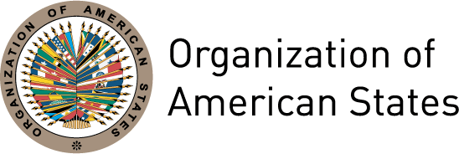

FORTY-FIFTH REGULAR SESSION OF THE GENERAL ASSEMBLY
“PRESENT AND FUTURE OF THE ORGANIZATION OF AMERICAN STATES”

DIALOGUE OF THE HEADS OF DELEGATION, THE SECRETARY GENERAL, AND THE ASSISTANT SECRETARY GENERAL WITH THE HEADS OF DELEGATION OF THE PERMANENT OBSERVERS

REMARKS BY MONSIGNOR JOSEPH GRECH
ALTERNATE HEAD OF THE HOLY SEE DELEGATION

Washington, D.C., June 14, 2015

Mr. Secretary General,

The Permanent Observer Mission of the Holy See to the OAS wishes to express to Your Excellency its warmest congratulations on your election as the new Secretary General of this hemispherical body. We would like to assure you of the Holy See’s intention to collaborate actively with you in your very important task of leading this organization.

Mr. Secretary General,

The Holy See shares the four pillars identified in the Strategic Plan for the revitalization of the OAS, namely democracy, security, human rights and sustainable development. In view of a more detailed study of the Plan, it might be helpful to ask the following questions:

First, where do the comparative advantages of the OAS lie vis-à-vis other multilateral bodies in this Hemisphere? In what specific areas the OAS wants to make a difference? Should it focus its efforts and resources in fostering democratic institutions in its member countries? Should it get involved in projects in which other entities might be better placed to lead?

Second, in which regional areas of this Hemisphere should it focus its efforts? The Holy See is confident that the OAS carefully monitors the delicate political situations in some of its members and assist them organize and hold fair and credible elections.

Third, what are the most important priorities that the OAS must be able to deliver by 2020, the achievement of which or the lack thereof would be an important indicator of the success or failure of the revitalization of the organization? This prioritization of projects might be necessary, also in the context of the OAS budget constraints.

Mr. Secretary General,

The Holy See believes that three areas of the Strategic Plan deserve special priority:

First, strengthening the democratic process in countries where it is still fragile. This could be the heart of the “comparative advantage” of the OAS with respect to other regional and international organizations active in the Hemisphere.

Second, fostering negotiations and dialogue to resolve border disputes and other security issues, including the fight against gang violence, in which the Catholic Church has always been actively engaged, especially in Central America.

Third, promoting of human rights. OAS must focus its efforts on those human rights where there is a clear consensus among member countries. We believe the right to life is the most basic and fundamental right and the condition for all other personal rights to exist. In this regard, the OAS should not pressure member countries that believe in the protection of human life from the moment of conception.

Mr. Secretary General,

In closing, my delegation expresses gratitude for the references you made to Pope Francis in your Inaugural Speech. His Holiness invites the OAS to be the voice of the voiceless who seek justice, the peacemaker in the resolution of conflicts, and a pillar for the strengthening of democracy throughout the Hemisphere.

Thank you, Mr. Secretary General.

